

Course Name: Computer Graphics Fundamentals
Project Title: Assignment 4 — Bézier Patches, Anti-aliasing and Picking, Texture Mapping
Team Members: Yessen Zhumagali, SE-2419
Instructor: Nazira Shaimerdenova
Date of Submission: 08.11.2026
Demonstration video: [Insert YouTube link]

Table of Contents
1. Introduction
2. Literature Review
3. Project Description
3.1 Objective
3.2 Problem Statement
3.3 Scope
4. Technical Implementation
4.1 Tools and Technologies Used
4.2 Development Process
4.3 Algorithms and Techniques
5. Graphics and Rendering
5.1 2D/3D Rendering Techniques
5.2 Lighting and Shading
5.3 Texturing and Animation
6. Testing and Evaluation
6.1 Testing Methodology
6.2 Performance Evaluation
6.3 Issues and Debugging
7. Conclusion and Future Work
8. References
Appendix A. Build and Run Commands

1. Introduction
This report describes the three programs of Assignment 4 of Computer Graphics Fundamentals. The assignment combines three classic topics of interactive graphics: modelling a curved surface with a bicubic Bézier patch (Part 1), anti-aliasing together with frame-buffer-object (FBO) based picking (Part 2), and texture mapping with both an image texture and a procedural 3D texture (Part 3).
These topics are the building blocks of most real-time renderers. Parametric patches are how CAD tools and film pipelines describe smooth shapes; off-screen rendering and buffer reading are the standard way to select objects with the mouse; multisampling is the most common hardware anti-aliasing technique; and texture mapping is the main way surfaces get colour detail without extra geometry. Implementing them from scratch, without the Ed Angel example code and without lecture texture code, shows how each piece works internally.
The result is four independent executables built from one CMake project: part1 (interactive Bézier patch), part2 (anti-aliasing and picking), part3_2d (an image texture mapped over a 12×12 Bézier mesh) and part3_3d (a procedural marble texture on an SMF model). All of them were built and run on macOS with Apple Silicon. This report explains the implementation steps, the libraries used, the key code snippets and the results, as the assignment requires.
2. Literature Review
Parametric surfaces. Bézier curves and surfaces express a shape as a weighted sum of control points, where the weights are Bernstein polynomials. Forrest showed early on how Bézier polynomials support interactive interpolation and approximation, which is exactly the interaction model of Part 1: the user moves control points and the surface follows smoothly [1]. Farouki's centennial review of the Bernstein basis explains why this basis is numerically stable, non-negative and sums to one, so every surface point is a convex combination of control points [2]. Piegl's survey places Bézier patches inside the larger NURBS family that modern modelling software uses [3]. These properties justify evaluating the patch directly from the Bernstein polynomials with a simple iterative double loop, as the assignment requires, instead of recursive subdivision.
Shading models. Gouraud introduced smooth shading by computing intensities at vertices and interpolating them across polygons [4]. Phong improved on this by interpolating the normal and evaluating the illumination at every pixel, and introduced the ambient + diffuse + specular reflection model that is still the reference model in teaching [5]. Blinn reformulated the specular term with the half-vector and related it to physically based reflection [6]. Part 1 uses the diffuse part of the Phong model per triangle (flat shading), while Parts 2 and 3 use full per-fragment Phong shading with interpolated normals, so the report can compare both approaches directly.
Aliasing and anti-aliasing. Crow analysed the aliasing problem in shaded images and explained that jagged edges come from sampling a continuous image at too few points [7]. Cook showed that distributing samples within each pixel turns aliasing into much less objectionable noise [8]. Hardware multisample anti-aliasing (MSAA), used in Part 2, follows the same idea: coverage and depth are stored at several sub-pixel samples and resolved into one colour per pixel.
Picking with item buffers. Weghorst, Hooper and Greenberg introduced the item buffer: an image in which each pixel stores the identifier of the visible object instead of a colour, originally to speed up ray tracing [9]. Hanrahan and Haeberli used the same idea for interactive 3D painting, reading the buffer under the cursor to find which surface point the user is pointing at [10]. Part 2 implements this technique in an off-screen FBO: every object is drawn with a unique constant colour, and the pixel under the mouse identifies the object.
Texture mapping. Blinn and Newell introduced texture and reflection mapping, attaching an image to a surface through its parameters [11]. Heckbert's survey formalised texture mapping as a mapping from texture space to object space to screen space, and discussed filtering [12]. Williams introduced mipmaps (pyramidal parametrics) to filter textures when they are minified [13]; the Part 3A texture uses mipmaps for this reason. Mapping the patch parameters (u, v) directly to texture coordinates, as the assignment asks, is the original Blinn–Newell idea.
Solid and procedural textures. Peachey [14] and Perlin [15] showed in 1985 that a texture can be a function of 3D position rather than an image, so a solid object looks as if it were carved from the material. Perlin's gradient noise, later improved with a quintic fade curve [16], became the standard building block of procedural textures. Lagae et al. give a broad survey of noise functions and their properties [17]. Summing noise octaves produces a fractal signal related to fractional Brownian motion, described by Mandelbrot and Van Ness [18]. Part 3B combines these ideas: Perlin-style gradient noise, an fBm sum and domain warping produce a marble pattern from world-space coordinates.
Models and platform. The SMF format comes from Garland and Heckbert's mesh simplification work [19], and the bunny model descends from the Stanford range-scanning work of Turk and Levoy [20]. The implementation follows the OpenGL 4.1 and GLSL 4.10 specifications [21] and Apple's OpenGL guide for macOS [22].
3. Project Description
3.1 Objective
The objective is to implement every requirement of Assignment 4 as clean, modular C++17 code:
• Part 1: draw a flat-shaded, tessellated bicubic Bézier patch with its 16 control points and the X/Y/Z axes, and let the user rotate the camera, select and move control points, and change the tessellation.
• Part 2: draw three smooth-shaded triangle meshes with a camera-attached light, let the user rotate and reset the view, pick an object with the mouse through an FBO to give it a random diffuse colour, and toggle anti-aliasing.
• Part 3: map a 2D RGB image over a 12×12 Bézier mesh using (u, v) as texture coordinates, and apply an interesting procedural 3D texture to an SMF model, both inside Phong shading in the fragment shader.
3.2 Problem Statement
Each part addresses a practical rendering problem. A Bézier patch is defined by only 16 points but must be turned into triangles before the GPU can draw it, and it must update immediately when a point moves. A mouse click gives a 2D pixel, but the application needs to know which 3D object is under it, independent of camera angle and window size. Straight polygon edges look jagged because each pixel is sampled only once. Finally, a surface needs colour detail that follows its shape: an image must stick to the patch as it bends, and a procedural material must look like it is carved from a solid block, without sliding when the camera moves.
3.3 Scope
Included in the final implementation:
• Four independent executables (part1, part2, part3_2d, part3_3d) built from one CMake project.
• Hard-coded control points plus optional loading from a text file in the required X–Y ordering.
• FBO picking with an RGBA8 colour texture and a depth renderbuffer, and real MSAA through a multisampled FBO.
• A procedurally generated 2D RGB image (no image files or loaders) and a GLSL procedural marble texture.
• An automated self-test for Part 2 and off-screen frame captures used for the figures in this report.
Excluded: selecting control points with the mouse (the assignment asks for keyboard selection), animation, loading textures from image files, and any third-party libraries such as GLFW, GLEW or GLM.
4. Technical Implementation
4.1 Tools and Technologies Used
Tool / library | How it is used
C++17 | All application code; standard library containers, <random> for random colours.
OpenGL 2.1 (legacy context) | Parts 1 and 2: immediate-mode/vertex-array drawing, fixed-function matrices, FBOs through the ARB_framebuffer_object functions.
GLSL 1.20 | Part 2 Phong vertex/fragment shader (embedded in Renderer.cpp).
OpenGL 4.1 core profile, GLSL 4.10 | Part 3: VAO/VBO meshes, own matrices, shaders loaded from shaders/.
GLUT (macOS framework) | Window creation, display/reshape/keyboard/mouse callbacks, core-profile request with GLUT_3_2_CORE_PROFILE.
GLU | gluLookAt, gluPerspective, gluProject (self-test) in Parts 1–2.
CMake 4.4 + Xcode 26.4 | Builds a shared common library, a core_gl library and four executables.
Git | Version control; one commit per finished part.

The hardware used for all runs and measurements was an Apple M3 Pro. The driver reports "OpenGL 2.1 Metal - 90.5" for the legacy context and "OpenGL 4.1 Metal - 90.5, GLSL 4.10" for the core-profile context.
4.2 Development Process
The work was done incrementally, one part at a time, with Git commits after each working stage (initial project, Bézier patch, modular refactoring, Part 2, Part 3). Part 1 was first written as a single file and then refactored into modules without changing its behaviour; later parts were designed modular from the start. Code that more than one program needs lives in src/common:
Module | Responsibility
Vec3 | 3D vector maths: add, subtract, scale, dot, cross, normalize.
Camera | Orbit camera (yaw, pitch, distance, Z up) with reset, clamped pitch and zoom.
BezierPatch | 16 control points, Bernstein evaluation, cached tessellation; shared by Part 1 and Part 3A.
Mat4, ViewSetup | Matrices and the camera-attached light for the core-profile programs.
ShaderProgram, GpuMesh | Shader loading/compilation and VAO/VBO/EBO meshes for Part 3.

Each program follows the same structure: main.cpp creates the window and owns the application state, a Renderer module draws, and an Input module handles keys and the mouse. Geometry generation (BezierMesh, Mesh, SmfLoader) is kept separate from rendering. All GPU resources (programs, textures, buffers, FBOs) are released explicitly before the program exits with ESC.
4.3 Algorithms and Techniques
4.3.1 Iterative Bézier evaluation (Part 1)
A point on the bicubic patch is S(u, v) = Σᵢ Σⱼ Bᵢ(v) Bⱼ(u) Pᵢⱼ, where B₀ = (1−t)³, B₁ = 3t(1−t)², B₂ = 3t²(1−t) and B₃ = t³. The evaluation is a plain double loop, with no recursion:
Vec3 BezierPatch::evaluate(float u, float v) const {
Vec3 result = {0.0f, 0.0f, 0.0f};
for (int i = 0; i < kSize; i++) {
for (int j = 0; j < kSize; j++) {
float weight = bernstein(i, v) * bernstein(j, u);
result.x += points_[i][j].x * weight;
result.y += points_[i][j].y * weight;
result.z += points_[i][j].z * weight;
}
}
return result;
}
For a resolution n the patch is sampled on an (n+1)×(n+1) grid, and each grid cell is split into two triangles, giving 2n² triangles (200 at the initial 10×10). The grid is cached in BezierPatch::rebuildMesh() and recomputed only when a control point moves or the resolution changes. The control-point file is read as 16 lines of three floats; line k is stored at points_[k / 4][k % 4], so the first index varies fastest, exactly as the assignment's X–Y ordering [0,0], [1,0], [2,0], [3,0], [0,1], … specifies.
4.3.2 Flat shading with the Phong diffuse term (Part 1)
Each triangle gets one normal from the cross product of two edges and one diffuse intensity. The light direction is the camera's viewing direction, recomputed once per frame, so the light is attached to the camera:
float calculateDiffuse(Vec3 a, Vec3 b, Vec3 c, Vec3 lightDir) {
Vec3 edge1 = subtract(b, a);
Vec3 edge2 = subtract(c, a);
Vec3 normal = normalize(cross(edge1, edge2));
return 0.2f + 0.8f * std::fmax(0.0f, dot(normal, lightDir));
}
4.3.3 Colour-ID picking with a framebuffer object (Part 2)
PickingBuffer owns an FBO with an RGBA8 colour texture and a 24-bit depth renderbuffer. Its completeness is checked with glCheckFramebufferStatus, and the attachments are recreated whenever the window is resized. On a click the scene is drawn into the FBO with the same camera and projection as the visible pass, but with no shader, lighting, blending, dithering or multisampling, and every object in one constant colour that encodes its ID:
for (const SceneObject& object : scene.objects()) {
glColor3ub(object.id & 0xFF, (object.id >> 8) & 0xFF, (object.id >> 16) & 0xFF);
drawObject(object, false);
}
...
glReadPixels(x, y, 1, 1, GL_RGBA, GL_UNSIGNED_BYTE, pixel);
return pixel[0] | (pixel[1] << 8) | (pixel[2] << 16);
The mouse position from GLUT has its origin at the top left, so it is converted to framebuffer pixels by flipping Y and multiplying by the Retina pixel scale: py = (windowHeight − y − 0.5) · scale. ID 0 is the background and is ignored; any other ID gets a new random diffuse colour (random hue, saturation 0.55–0.95, value 0.70–1.0, so it always stands out from the dark background). OpenGL state is saved and restored around the picking pass, and the visible scene is always drawn to the GLUT window framebuffer.
4.3.4 Anti-aliasing with a multisampled FBO (Part 2)
On macOS, enabling and disabling GL_MULTISAMPLE on a multisampled window does not reliably change the output. To make the toggle real, the window is created without multisampling. When anti-aliasing is on, the scene is rendered into an FBO whose colour and depth renderbuffers have min(8, GL_MAX_SAMPLES) samples (4 on the M3 Pro) and then resolved into the window:
glBindFramebuffer(GL_READ_FRAMEBUFFER, gMsaaFbo);
glBindFramebuffer(GL_DRAW_FRAMEBUFFER, 0);
glBlitFramebuffer(0, 0, gWidth, gHeight, 0, 0, gWidth, gHeight,
GL_COLOR_BUFFER_BIT, GL_NEAREST);
When anti-aliasing is off, the scene is drawn straight into the single-sampled window framebuffer.
4.3.5 Bézier mesh with analytic normals and UVs (Part 3A)
Part 3A reuses BezierPatch and samples it at 12×12 (169 vertices, 288 triangles). Every vertex stores the surface point, the analytic normal from the partial derivatives, and the parameters (u, v) themselves as the texture coordinate, so the parameter square [0,1]² maps onto exactly one copy of the image:
for (int i = 0; i < n; i++) {
float v = (float)i / resolution;
for (int j = 0; j < n; j++) {
float u = (float)j / resolution;
mesh.vertices.push_back({patch.evaluate(u, v), surfaceNormal(patch, u, v), u, v});
}
}
surfaceNormal() computes ∂S/∂u = Σ Bᵢ(v) B′ⱼ(u) Pᵢⱼ and ∂S/∂v = Σ B′ᵢ(v) Bⱼ(u) Pᵢⱼ with the Bernstein derivatives, and returns normalize(∂S/∂u × ∂S/∂v).
4.3.6 SMF loading (Part 3B)
loadSmf() reads v x y z and f i j k … records. Indices are 1-based (negative values count back from the last vertex) and are converted to 0-based; polygons with more than three vertices are split into a triangle fan. Comments, blank lines and unknown records are ignored, and malformed vertices, faces with fewer than three indices and faces with out-of-range indices are skipped with a warning. Vertex normals are the normalised sum of the unnormalised face normals, so larger faces weigh more. The model matrix centres the model, scales it to unit radius and turns its +Y up axis into +Z.
4.3.7 Gradient noise, fBm and domain warping (Part 3B)
The procedural texture is computed entirely in the fragment shader. gradientNoise() hashes the 8 corners of the lattice cell to pseudo-random gradients, takes the dot product of each with the offset to the point, and blends them with the quintic fade 6t⁵ − 15t⁴ + 10t³. fbm() adds 5 octaves, each at roughly double frequency and half amplitude. Domain warping then samples noise at a position that is itself displaced by noise, twice:
vec3 q = vec3(fbm(p), fbm(p + vec3(5.2, 1.3, 2.8)), fbm(p + vec3(1.7, 9.2, 4.4)));
vec3 r = vec3(fbm(p + 1.6 * q + vec3(8.3, 2.8, 1.1)),
fbm(p + 1.6 * q + vec3(3.1, 7.4, 5.9)),
fbm(p + 1.6 * q + vec3(6.6, 0.7, 9.3)));
float warped = fbm(p + 1.4 * r);
float phase = dot(p, normalize(vec3(1.0, 0.6, 0.35))) * 4.0 + 5.0 * warped;
float vein = 1.0 - smoothstep(0.0, 0.10, abs(sin(phase)));
Dark veins appear where sin(phase) is close to zero, finer secondary veins come from a second phase, and a gold halo surrounds the main veins. The base colour blends cream, warm grey and rose using the warp values. Because every step uses the full 3D point, all three world coordinates affect the result; without the warping the phase would only produce straight parallel bands.
5. Graphics and Rendering
5.1 2D/3D Rendering Techniques
All four programs use perspective projection (45° vertical field of view) and an orbit camera that always looks at the origin with Z as the up axis; pitch is clamped to ±85° so the view never flips. Parts 1 and 2 run in the legacy OpenGL 2.1 context: Part 1 draws with glBegin/glEnd, and Part 2 uses client-side vertex arrays with glDrawElements. Part 3 requests an OpenGL 4.1 core-profile context and draws indexed meshes stored in a VAO with vertex and index buffers.
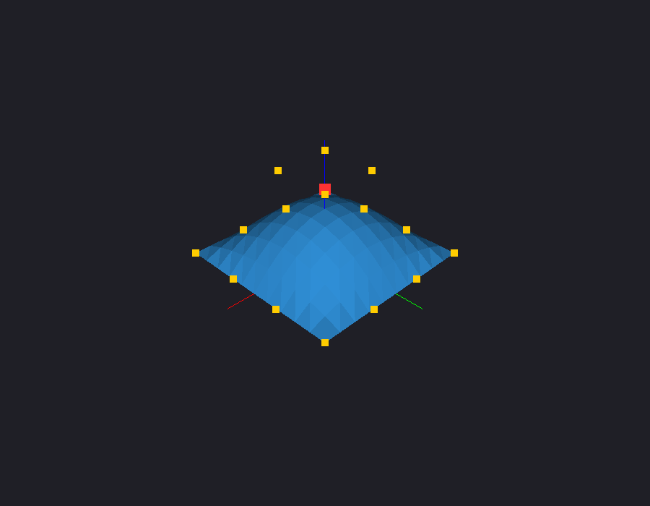
Fig.1 Part 1 at start-up: 10×10 flat-shaded Bézier patch, control points and axes
Figure 1 illustrates Part 1 at start-up. The patch is centred in the window, the 16 control points are drawn as GL_POINTS, the selected point (index 0) is larger and red, and the X, Y and Z axes are short red, green and blue lines at the origin.
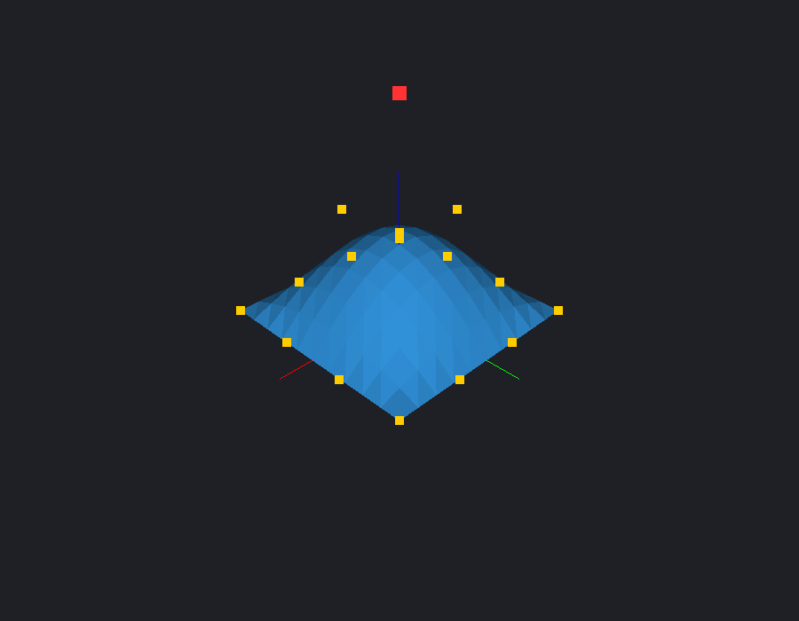
Fig.2 Part 1 after selecting control point 5 (Tab ×5) and raising it (U ×6)
Figure 2 shows interactive editing: after pressing Tab five times, control point 5 is selected and highlighted; pressing U six times raised it by 1.2 units, and the surface was re-tessellated immediately.
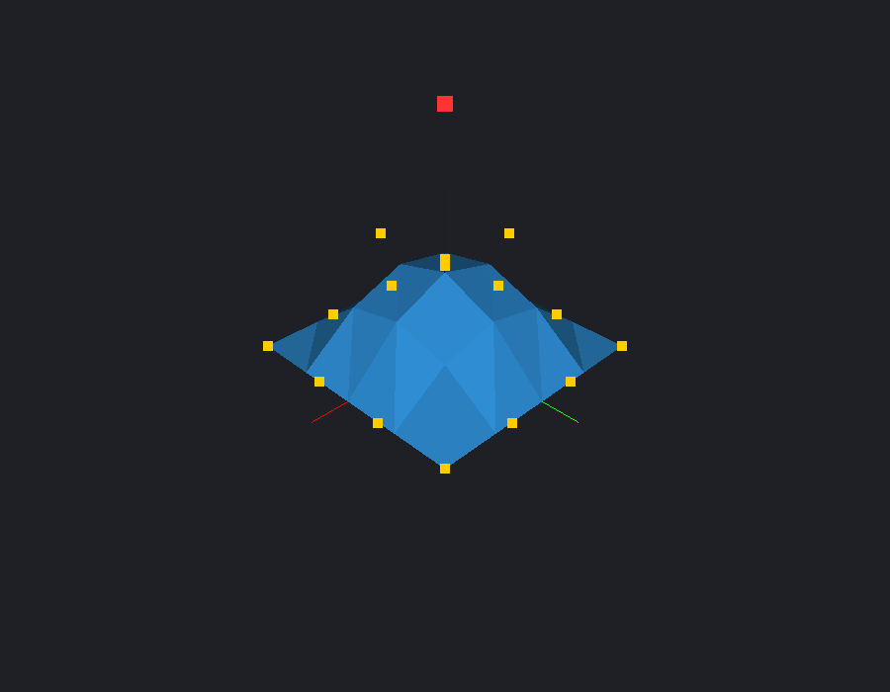
Fig.3 Part 1 at 4×4 resolution (32 triangles)
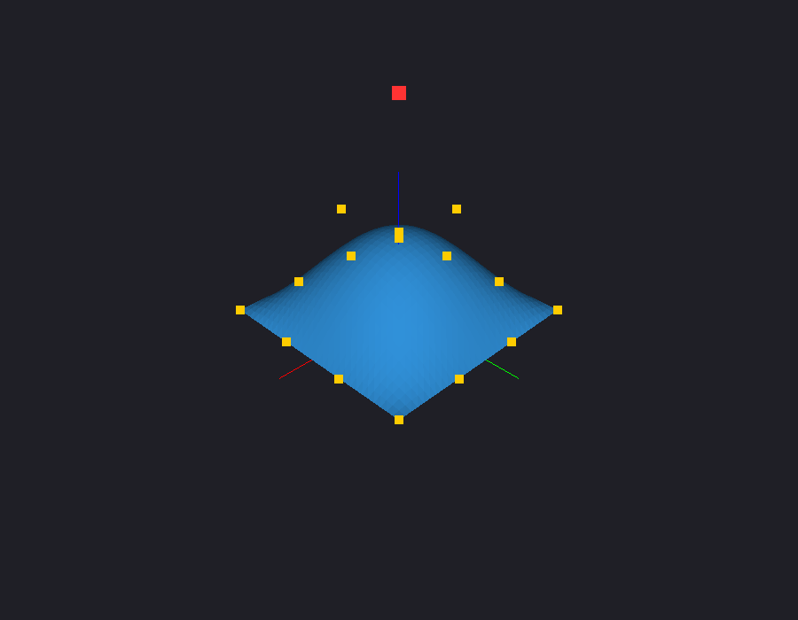
Fig.4 Part 1 at 30×30 resolution (1,800 triangles)
Figures 3 and 4 compare tessellation levels changed with − and +. At 4×4 the individual flat-shaded facets are large; at 30×30 the surface looks almost smooth even though each triangle still has one colour. The resolution is limited to the range 2–50.
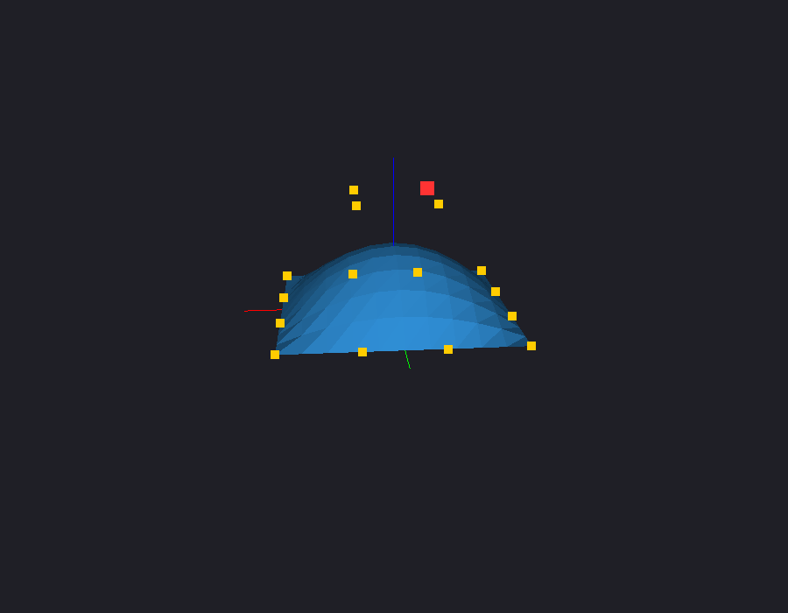
Fig.5 Part 1 after rotating the camera with the arrow keys
Figure 5 shows the same patch after rotating the camera with the arrow keys. The camera still looks at the patch, and R returns it to the initial view.
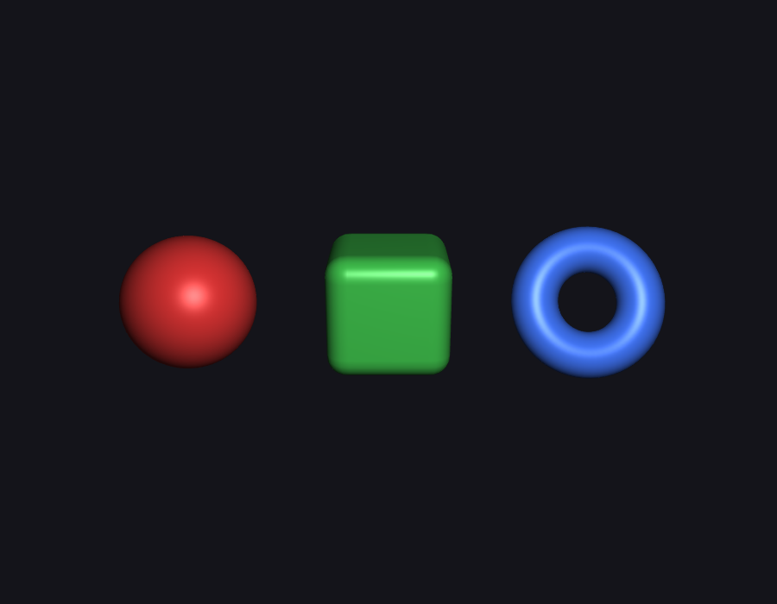
Fig.6 Part 2 at start-up: sphere, rounded cube and torus, smooth Phong shading
Figure 6 illustrates the Part 2 scene. Three triangle meshes are generated in code: a sphere (48×32 segments), a rounded cube (16 divisions per face) and a torus (64×32), placed so that they do not overlap and are all visible at start-up, each with its own diffuse colour.
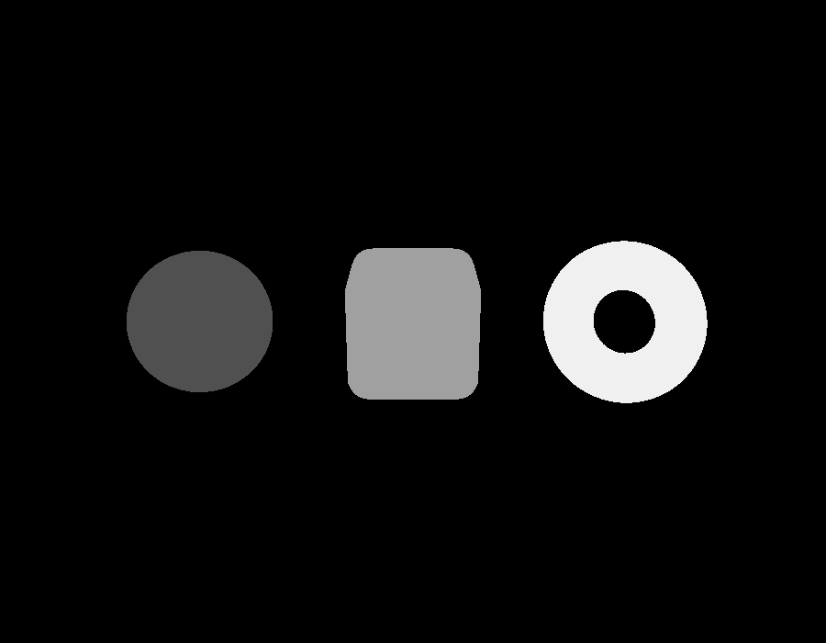
Fig.7 Part 2 picking pass: object IDs 1, 2, 3 (multiplied by 80 so they are visible)
Figure 7 visualises the off-screen picking pass. The real buffer stores the byte values 1, 2 and 3 in the red channel, which would look black; for this figure they were multiplied by 80. There is no shading, so every pixel of an object has exactly the same value.
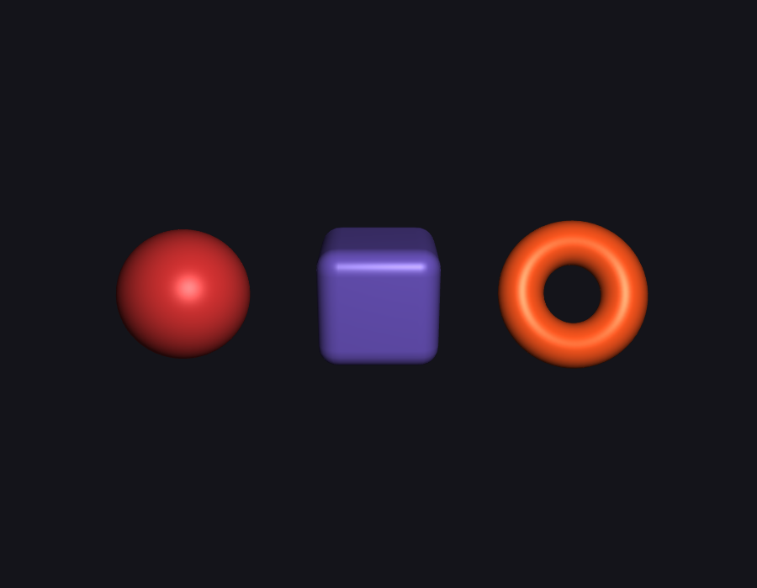
Fig.8 Part 2 after clicking the cube and the torus: only those two objects changed colour
Figure 8 shows the result of clicking the rounded cube and the torus: each received a new random diffuse colour, while the sphere kept its colour and the lighting and smooth shading were preserved.

Fig.9 Torus edge magnified 5×: anti-aliasing OFF (left) and ON, 4× MSAA (right)
Figure 9 compares the same silhouette with anti-aliasing off and on. Without MSAA the edge is a staircase of fully covered and empty pixels; with 4× MSAA the edge pixels take intermediate colours and the outline looks smooth.
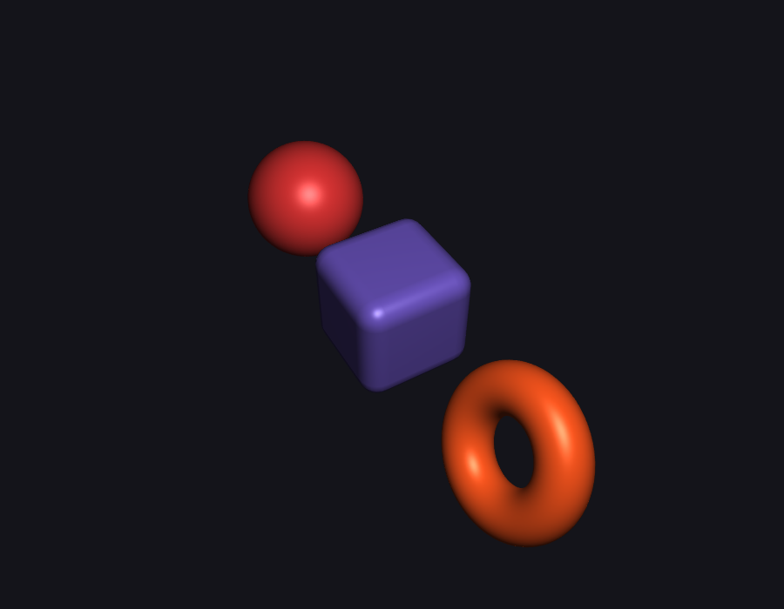
Fig.10 Part 2 after orbiting the camera; picking keeps working from any view
Figure 10 shows the scene after orbiting the camera. Because the picking pass uses the same matrices as the visible pass, picking keeps working after rotation, reset and resizing (verified by the self-test in Section 6).
5.2 Lighting and Shading
Two shading strategies are used, as the assignment requires for each part:
• Flat shading (Part 1). One normal and one colour per triangle: colour = base · (0.2 + 0.8 · max(0, N·L)). Facets are visible, which makes the tessellation easy to see.
• Phong shading (Parts 2 and 3). Each vertex has its own normal; the rasteriser interpolates it, and the fragment shader evaluates ambient + diffuse + specular per pixel, so surfaces look smooth and specular highlights are sharp.
The light is always attached to the camera. In Part 1 it is the viewing direction, in Part 2 it is a point light at a fixed eye-space position (1.5, 2.0, 0), and in Part 3 computeView() places it at eye + 0.3·distance·(right + up) every frame. The Part 3 Phong function, shared by both fragment shaders, is:
vec3 phong(vec3 diffuseColor, vec3 P, vec3 N) {
vec3 L = normalize(uLightPosition - P);
vec3 V = normalize(uCameraPosition - P);
vec3 R = reflect(-L, N);
float NdotL = max(dot(N, L), 0.0);
vec3 ambient = uAmbient * diffuseColor;
vec3 diffuse = diffuseColor * NdotL;
vec3 specular = NdotL > 0.0 ? uSpecularColor * pow(max(dot(R, V), 0.0), uShininess) : vec3(0.0);
return ambient + uLightColor * (diffuse + specular);
}
The material is a single set of properties that produces a specular highlight: ambient 0.18, white light, specular colour 0.6 with shininess 40 for the patch, and 0.7 with shininess 60 for the polished marble. The specular colour is constant, so highlights stay white and do not take the texture's colour.
5.3 Texturing and Animation
2D image texture (Part 3A). The 512×512 RGB image is generated in C++ by generatePatchImage(); no image file or lecture code is used. It contains a two-way colour gradient, grid lines every 1/8 in u and v, a central rosette, and corner markers whose colours identify the orientation: red at (0,0), green at (1,0), blue at (0,1) and yellow at (1,1). Image row 0 is v = 0, so no vertical flip is needed. The image is uploaded as GL_RGB8 with mipmaps, trilinear filtering and clamp-to-edge wrapping.
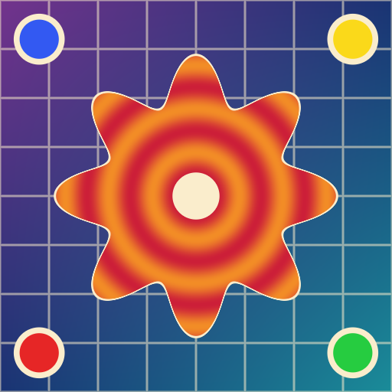
Fig.11 Part 3A: the procedurally generated 512×512 RGB texture image
Figure 11 shows the texture image itself. In the fragment shader the sampled colour replaces the constant diffuse colour of Phong shading:
vec3 diffuseColor = texture(uDiffuseTexture, vTexCoord).rgb;
fragColor = vec4(clamp(phong(diffuseColor, vWorldPosition, N), 0.0, 1.0), 1.0);
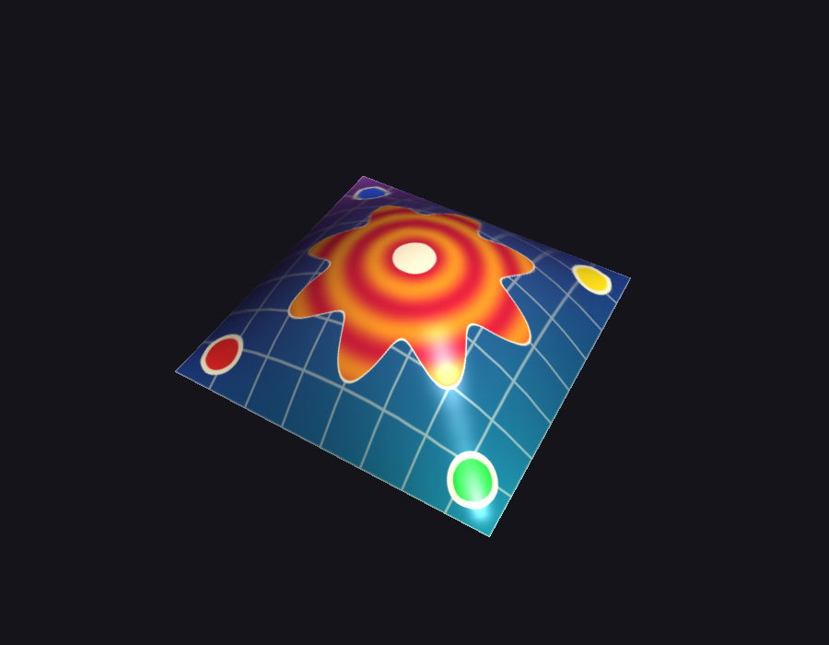
Fig.12 Part 3A: the image mapped over the whole 12×12 Bézier patch with Phong shading
Figure 12 illustrates the mapped patch. One complete image covers the patch, the grid lines bend with the surface (so the texture follows the geometry, not the screen), the corner markers appear in the expected order (the mapping is not mirrored), and the white specular highlight is visible on top of the texture.
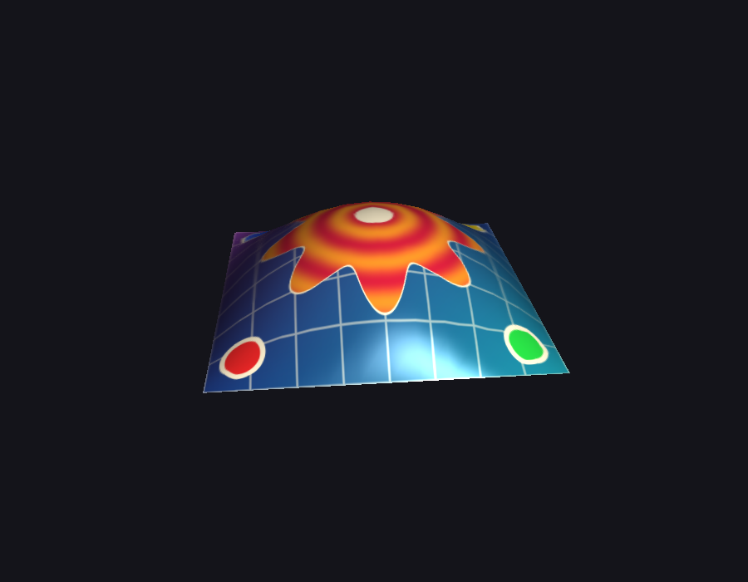
Fig.13 Part 3A from another camera angle
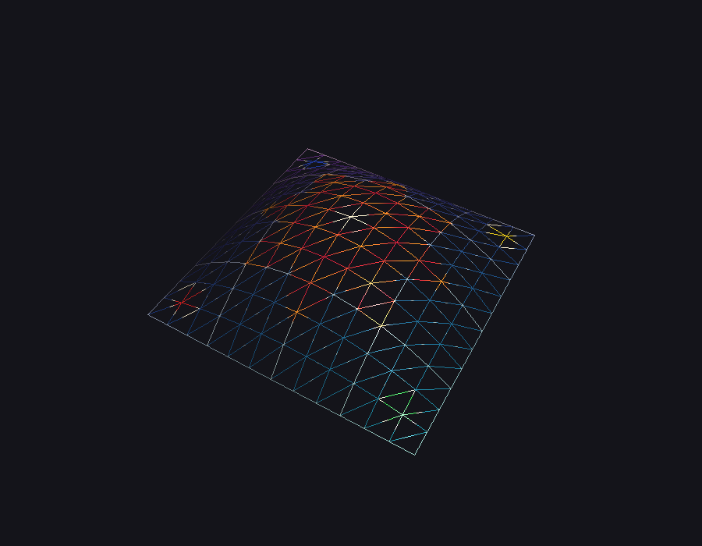
Fig.14 Part 3A wireframe (W): 12×12 cells, 288 triangles
Figure 13 shows the patch from a different angle, with the highlight moving because the light follows the camera. Figure 14 shows the wireframe mode, which confirms the 12×12 grid of 144 cells split into 288 triangles.
3D procedural texture (Part 3B). The fragment shader receives the interpolated world-space position (uModel · position), computes the marble colour from it as described in Section 4.3.7, and uses it as the Phong diffuse colour:
vec3 proceduralColor = proceduralTexture(vWorldPosition);
fragColor = vec4(clamp(phong(proceduralColor, vWorldPosition, N), 0.0, 1.0), 1.0);
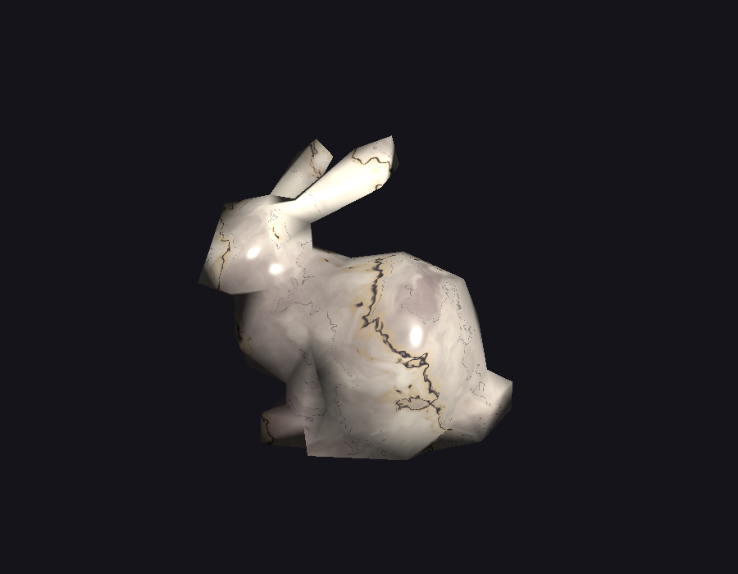
Fig.15 Part 3B: domain-warped marble on the Stanford bunny SMF model
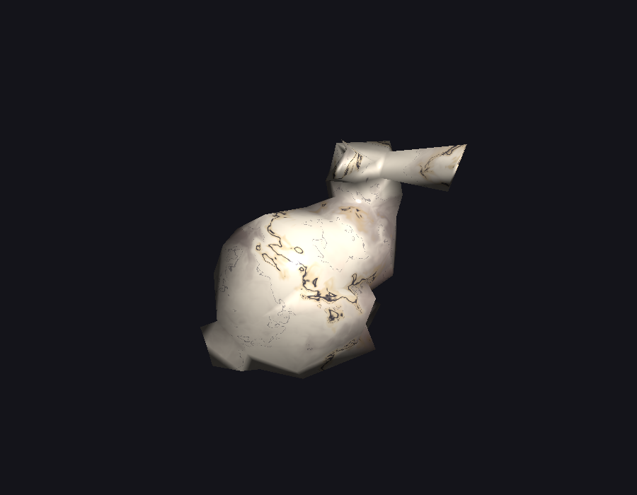
Fig.16 Part 3B: the bunny after rotating the camera; the veins stay on the surface
Figures 15 and 16 show the bunny (102 vertices, 200 triangles) from two camera positions. The veins stay at the same places on the model, because the texture depends only on world-space position and never on the view matrix. Specular highlights are visible on the ears, head and back.
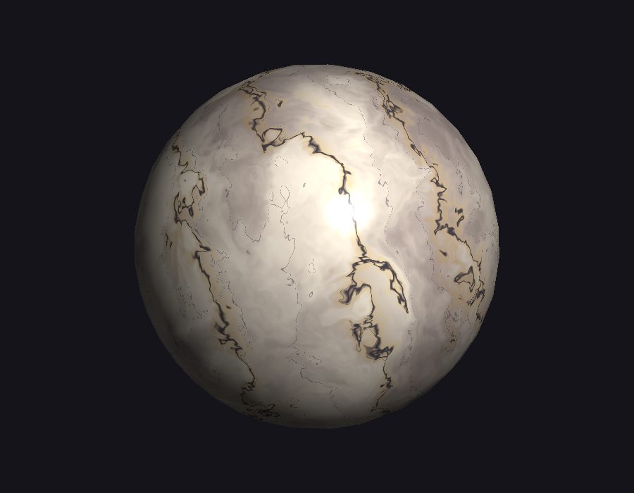
Fig.17 Part 3B: the same marble on the sphere SMF model (546 vertices, 1,088 triangles)
Figure 17 shows the same shader on the sphere model. The larger smooth surface shows the flowing, irregular veins and the cloudy rose and grey tones more clearly. The pattern is not a checkerboard, stripes or an extruded 2D map: it varies along all three axes.
Animation. The assignment does not require animation, so none was implemented; all motion comes from user interaction (camera rotation, zoom and control-point editing).
6. Testing and Evaluation
6.1 Testing Methodology
Testing combined automated checks, off-screen frame captures and manual interaction:
• Build tests. A clean rebuild with cmake --build build --config Debug --clean-first builds all four executables with no compiler warnings or errors.
• Part 2 self-test. ./build/Debug/part2 --self-test projects a surface point of each object to window coordinates with gluProject, simulates a click there through the same code path as the mouse callback, and checks that the right ID is returned and that only that object's colour changed. It also clicks the background. This is repeated in the initial view, after rotating the camera, after resetting it, and after resizing the window to 700×520. It then renders the scene with anti-aliasing off and on and compares the frames.
• Geometry and loader tests. A test program checked that the 12×12 Bézier mesh has 169 vertices, 288 triangles and UVs from (0,0) to (1,1). A hand-written malformed SMF file checked that bad vertices, short faces and out-of-range faces are skipped with warnings, that a quad is split into two triangles and that negative indices resolve correctly.
• Visual checks. A capture program rendered frames with the real Renderer code and read them back with glReadPixels; these frames are the figures in this report. glGetError() reported no errors in any program.
• Manual tests. Keyboard controls, real mouse clicks, window resizing and ESC were tried interactively in the running programs.
Test | Result
Part 2 self-test: 20 automated checks (picking in 4 states, background clicks, resize, AA difference, GL errors) | PASSED, 0 failures
AA on vs off: frames differ only at edges | 3,490 of 630,000 pixels differ (900×700)
Part 3A mesh: vertices / triangles / UV range | 169 / 288 / [0,1]×[0,1]
SMF loader edge cases (malformed vertex, short face, out-of-range face, quad, negative index) | All handled as expected
Missing SMF file | Error message, exit code 1
Control-point file loading (models/patch_control_points.txt), missing file | Loaded / error message, exit code 1

6.2 Performance Evaluation
Performance was measured on the Apple M3 Pro with a 900×700 window and vertical sync disabled (CGL swap interval 0). Each number is the average over 600 frames after 30 warm-up frames, including the buffer swap and a final glFinish. Peak memory is the process's peak resident set size reported by getrusage; it is dominated by the macOS OpenGL/Metal driver and GLUT, not by the application data.
Program / configuration | Triangles | Time per frame | Frame rate | Peak RSS
part1, 10×10 patch | 200 | 0.33 ms | ≈3,050 FPS | 97.9 MB
part1, 50×50 patch | 5,000 | 0.32 ms | ≈3,130 FPS | 97.9 MB
part2, AA on (4× MSAA + blit) | ≈11,800 | 0.35 ms | ≈2,830 FPS | 99.6 MB
part2, AA off | ≈11,800 | 0.28 ms | ≈3,580 FPS | 99.6 MB
part2, one picking pass + glReadPixels | ≈11,800 | 0.28 ms | — | —
part3_2d, textured patch | 288 | 0.33 ms | ≈3,070 FPS | 100.3 MB
part3_3d, marble bunny | 200 | 1.03 ms | ≈970 FPS | 96.6 MB
part3_3d, marble sphere | 1,088 | 2.13 ms | ≈470 FPS | 96.6 MB

All programs are far above interactive frame rates. Geometry is not the bottleneck: Part 1 costs the same at 200 and 5,000 triangles. MSAA adds about 0.07 ms per frame for the multisampled rendering and the resolve blit. The most expensive program is Part 3B, because the marble shader evaluates fBm seven times per fragment (5 octaves × 8 gradients each), so its cost grows with the number of covered pixels: the sphere fills more of the window than the bunny and takes about twice as long. A picking pass costs about one frame and runs only on a click.
6.3 Issues and Debugging
• Anti-aliasing toggle had no effect. Turning GL_MULTISAMPLE on and off on a multisampled macOS window does not reliably change the image. Solution: create a single-sampled window, render into a multisampled FBO when AA is on and resolve it with glBlitFramebuffer. The self-test confirms that the two modes produce different edge pixels.
• Self-test missed the torus. The first version of the picking test clicked the projected centre of each object, which falls into the hole of the torus and returned the background. Each object now has a probe point on its visible surface (a point on the torus ring).
• Retina coordinates. GLUT reports mouse positions in points, while framebuffers are in pixels. The pixel scale is measured from the initial viewport and applied to the mouse position and the FBO size, together with the Y flip.
• Legacy and core-profile headers. Including <GLUT/glut.h> pulls in the legacy gl.h, which conflicts with gl3.h. GL3.h includes gl3.h first and defines __gl_h_ so GLUT does not include the legacy header.
• Marble too noisy. The first marble version used strong warping (4·q, 3·r) and produced fragmented speckles instead of veins. Reducing the warp strength (1.6·q, 1.4·r) and the texture scale produced flowing veins.
• Silent loader failure. Faces with out-of-range indices were skipped without a message; a warning was added after the edge-case test revealed it.
• Build directory generator mismatch. The build directory had been configured with Unix Makefiles; switching to the required Xcode generator needed removing only CMakeCache.txt and CMakeFiles/.
7. Conclusion and Future Work
All requirements of the three parts of Assignment 4 were implemented and verified. Part 1 draws a flat-shaded, iteratively evaluated bicubic Bézier patch with interactive control-point editing and tessellation control. Part 2 renders three smooth-shaded meshes with a camera-attached light, picks objects through an off-screen colour-ID framebuffer and provides a real 4× MSAA toggle. Part 3 maps a generated RGB image over a 12×12 Bézier mesh with (u, v) texture coordinates and applies a domain-warped 3D marble texture to an SMF model, both as the diffuse colour of per-fragment Phong shading with visible specular highlights. The code is modular, shares common modules between programs and uses no third-party libraries.
Possible improvements:
• Port Parts 1 and 2 to the core profile as well, so all programs share one rendering path.
• Add mouse picking of control points in Part 1 by reusing the Part 2 colour-ID technique.
• Use a higher-resolution bunny model and an analytic noise derivative for bump mapping the marble veins.
• Precompute the procedural texture into a 3D texture to reduce fragment-shader cost on large screens.
• Move to a modern API (Metal or Vulkan through MoltenVK), since OpenGL is deprecated on macOS.
8. References
[1] A. R. Forrest, “Interactive interpolation and approximation by Bézier polynomials,” The Computer Journal, vol. 15, no. 1, pp. 71–79, 1972.
[2] R. T. Farouki, “The Bernstein polynomial basis: A centennial retrospective,” Computer Aided Geometric Design, vol. 29, no. 6, pp. 379–419, 2012.
[3] L. Piegl, “On NURBS: A survey,” IEEE Computer Graphics and Applications, vol. 11, no. 1, pp. 55–71, 1991.
[4] H. Gouraud, “Continuous shading of curved surfaces,” IEEE Transactions on Computers, vol. C-20, no. 6, pp. 623–629, 1971.
[5] B. T. Phong, “Illumination for computer generated pictures,” Communications of the ACM, vol. 18, no. 6, pp. 311–317, 1975.
[6] J. F. Blinn, “Models of light reflection for computer synthesized pictures,” ACM SIGGRAPH Computer Graphics, vol. 11, no. 2, pp. 192–198, 1977.
[7] F. C. Crow, “The aliasing problem in computer-generated shaded images,” Communications of the ACM, vol. 20, no. 11, pp. 799–805, 1977.
[8] R. L. Cook, “Stochastic sampling in computer graphics,” ACM Transactions on Graphics, vol. 5, no. 1, pp. 51–72, 1986.
[9] H. Weghorst, G. Hooper, and D. P. Greenberg, “Improved computational methods for ray tracing,” ACM Transactions on Graphics, vol. 3, no. 1, pp. 52–69, 1984.
[10] P. Hanrahan and P. Haeberli, “Direct WYSIWYG painting and texturing on 3D shapes,” ACM SIGGRAPH Computer Graphics, vol. 24, no. 4, pp. 215–223, 1990.
[11] J. F. Blinn and M. E. Newell, “Texture and reflection in computer generated images,” Communications of the ACM, vol. 19, no. 10, pp. 542–547, 1976.
[12] P. S. Heckbert, “Survey of texture mapping,” IEEE Computer Graphics and Applications, vol. 6, no. 11, pp. 56–67, 1986.
[13] L. Williams, “Pyramidal parametrics,” ACM SIGGRAPH Computer Graphics, vol. 17, no. 3, pp. 1–11, 1983.
[14] D. R. Peachey, “Solid texturing of complex surfaces,” ACM SIGGRAPH Computer Graphics, vol. 19, no. 3, pp. 279–286, 1985.
[15] K. Perlin, “An image synthesizer,” ACM SIGGRAPH Computer Graphics, vol. 19, no. 3, pp. 287–296, 1985.
[16] K. Perlin, “Improving noise,” ACM Transactions on Graphics, vol. 21, no. 3, pp. 681–682, 2002.
[17] A. Lagae, S. Lefebvre, R. Cook, T. DeRose, G. Drettakis, D. S. Ebert, J. P. Lewis, K. Perlin, and M. Zwicker, “A survey of procedural noise functions,” Computer Graphics Forum, vol. 29, no. 8, pp. 2579–2600, 2010.
[18] B. B. Mandelbrot and J. W. Van Ness, “Fractional Brownian motions, fractional noises and applications,” SIAM Review, vol. 10, no. 4, pp. 422–437, 1968.
[19] M. Garland and P. S. Heckbert, “Surface simplification using quadric error metrics,” in Proc. SIGGRAPH ’97, pp. 209–216, 1997.
[20] G. Turk and M. Levoy, “Zippered polygon meshes from range images,” in Proc. SIGGRAPH ’94, pp. 311–318, 1994.
[21] The Khronos Group, The OpenGL Graphics System: A Specification, Version 4.1 (Core Profile), and The OpenGL Shading Language, Version 4.10, 2010.
[22] Apple Inc., OpenGL Programming Guide for Mac, Apple Developer Documentation.
Appendix A. Build and Run Commands
The source code is submitted together with this report. From the project root:
cmake -S . -B build -G Xcode
cmake --build build --config Debug
./build/Debug/part1 # optional: models/patch_control_points.txt
./build/Debug/part2 # optional: --self-test
./build/Debug/part3_2d
./build/Debug/part3_3d # optional: models/bound-lo-sphere.smf
Program | Controls
part1 | Arrows rotate · R reset · Tab next point · J/L, I/K, U/O move point along X, Y, Z · +/− tessellation · ESC quit
part2 | Arrows rotate · R reset · A toggle anti-aliasing · left click pick object · ESC quit
part3_2d, part3_3d | Arrows rotate · +/− zoom · W wireframe · R reset · ESC quit

