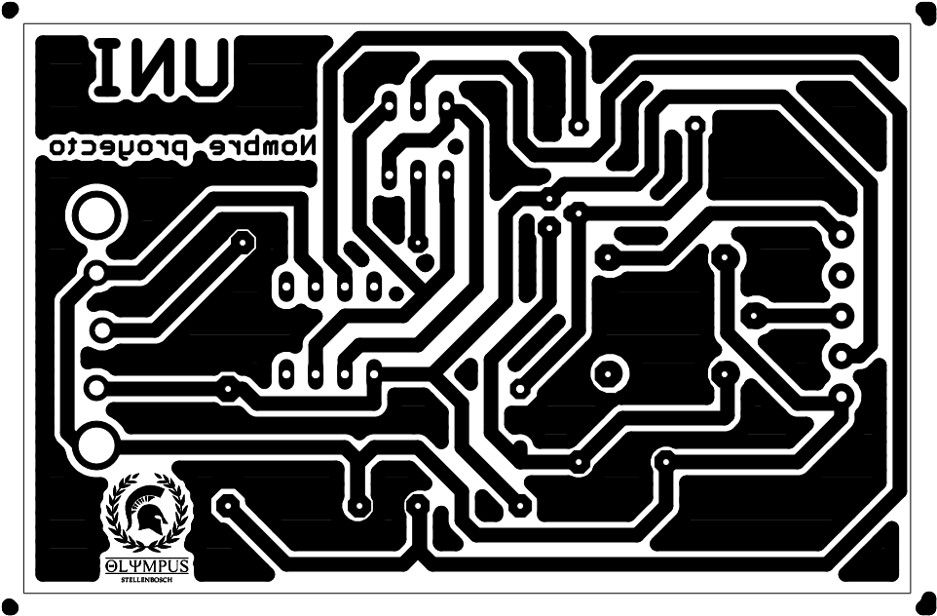



25/10/2017 18:18 C:\Users\yesse\Desktop\eagle\TALLER\TALLER3.brd