## 直播间发送信息

本地地址：ws://localhost:8080/jeecg-boot/liveWebsocket/1523497318079721473(直播间ID)/f0019fdebedb443c98dcb17d88222c38(用户唯一ID)

提交方法：webSocket Json数据

| **名称** | **类型** | **说明** |
| --- | --- | --- |
| Json字符串 | JsonString | {  "pushType": "0", --0 消息 1福袋 2禁言 3礼物  "message": "大家好哈喽", --用户消息内容  "messageType": "0" --发送消息时传递该字段 0文字 1图片 2 视频  } |

**返回值：(JSON)**

| **名称** | **类型** | **说明** |
| --- | --- | --- |
| result | JsonString | 服务端回应 2022-05-20 17:02:09 {"messageType":"0","handlerName":"liveSocketHandler","avatar":"https://static.jeecg.com/temp/国炬软件logo_1606575029126.png","message":"哈你买马匹的肉","liveId":"1523497318079721473","realname":"jeecg","pushType":"1","status":200} |

调用实例：

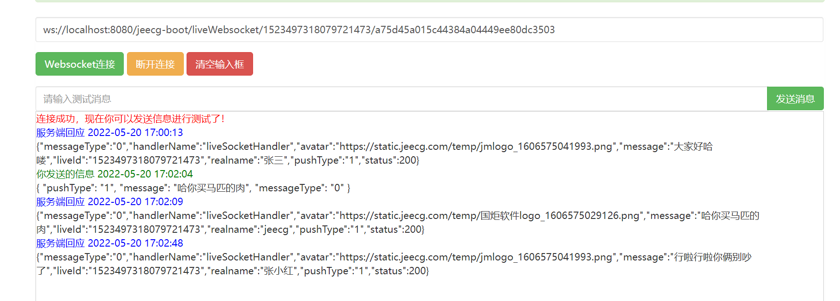

## 直播间送礼物

本地地址：ws://localhost:8080/jeecg-boot/liveWebsocket/1523497318079721473(直播间ID)/f0019fdebedb443c98dcb17d88222c38(用户唯一ID)

提交方法：webSocket Json数据

| **名称** | **类型** | **说明** |
| --- | --- | --- |
| Json字符串 | JsonString | {  "pushType": "3", --0 消息 1福袋 2禁言 3礼物  "giftId": "0bf3fa23-ae2d-4f06-8a2e-321b3d30afb0"  } |

**返回值：(JSON)**

| **名称** | **类型** | **说明** |
| --- | --- | --- |
| result | JsonString | 服务端回应 2022-05-20 17:02:09 {"giftSwf":"https://qiniumalls.sdwanyue.com/a7058202109281019594795.gif","giftName":"招财猫","handlerName":"liveSocketHandler","avatar":"https://static.jeecg.com/temp/国炬软件logo_1606575029126.png","liveId":"1523497318079721473","realname":"管理员","pushType":3,"status":200} |

调用实例：

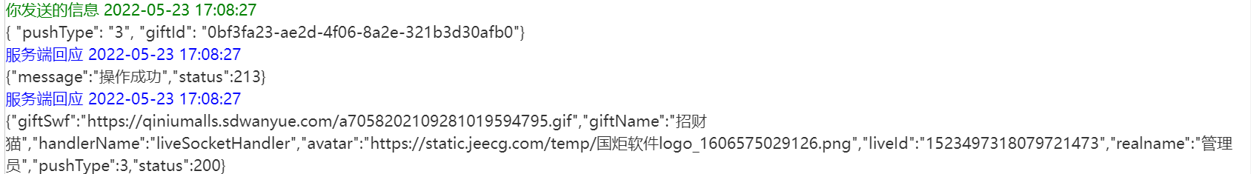

## 新上福袋

**返回值：(JSON)**

| **名称** | **类型** | **说明** |
| --- | --- | --- |
| result | JsonString | 服务端回应 2022-05-20 17:02:09 {  "countDownLong": 600000, --倒计时毫秒数  "liveGoodBagId": "1529729222772678658",  "sendMessageType": "1", --忽略  "goodBagType": "0", --0 新上福袋 1 福袋开奖  "handlerName": "liveSocketHandler",  "countDownString": "10:00", --用于展示的福袋时间  "liveId": "e5f303d9-97ec-6bc0-2fd8-8107ad15fa85",  "pushType": "1", --0 消息 1福袋 2禁言 3礼物  "status": 200  } |

## 福袋开奖

**返回值：(JSON)**

| **名称** | **类型** | **说明** |
| --- | --- | --- |
| result | JsonString | 服务端回应 2022-05-20 17:02:09 {  "winPrizeFlag": true, 是否中将 true中将了 false未中奖  "goodBagType": "1", --0 新上福袋 1 福袋开奖  "sendMessageType": "2", --可以忽略  "goldCoin": "20", --中将所得金币  "handlerName": "liveSocketHandler",  "message": "恭喜您中奖啦",  "userId": "1530487874215399425",  "liveId": "1530060216528699393",  "pushType": "1",  "status": 200  } |