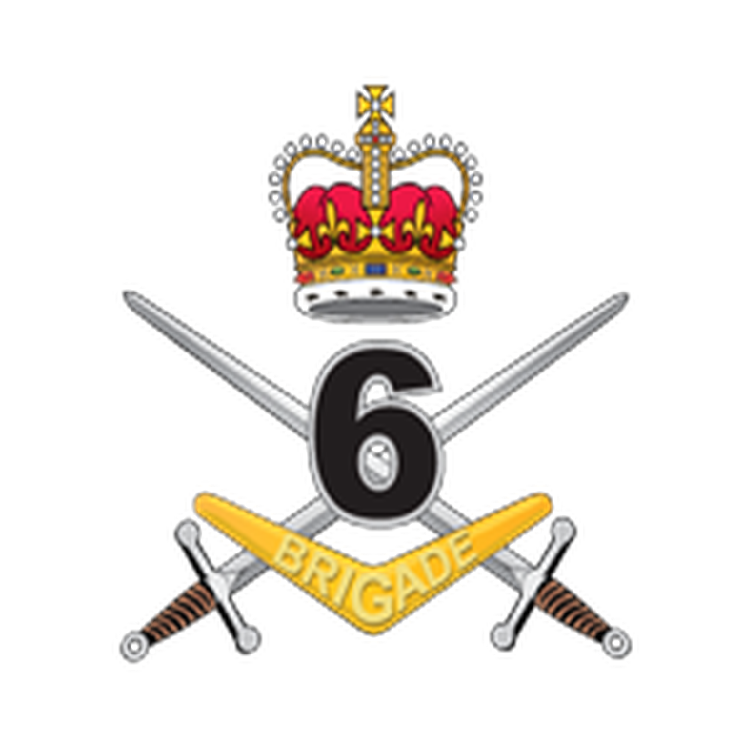

Hello Jerome Mercado,

We have taken some time to consider the immediate ramifications of the events of last night and today and we would like to reassure you all that there has been no change to Australia's commitment to the defence of East Timor. In fact, as we noted in our media release, Australia's commitment is to bolster the East Timorese Army through a variety of measures including training, equipment and logistics, intelligence, surveillance, target acquisition and reconnaissance, and air superiority capabilities. As part of this, the Army is investing $8.5 billion over the next four years, bringing total spending to over $10 billion. We understand that the threat to East Timor has increased and we understand the concerns that the public have had with the situation. We are acutely aware that in this climate, there are some voices that are calling for the end of the deployment. This will be a mistake. The Defence Force is prepared to carry out operations until the threat to our territory has passed.

Sincerely

Alicia Dunlap