KWAME NKRUMAH UNIVERSITY OF SCIENCE AND TECHNOLOGY, KUMASI
COLLEGE OF SCIENCE — DEPARTMENT OF COMPUTER SCIENCE
CSM 374 — MINI PROJECT
CAMPUSSHIELD AI:
A REAL-TIME CRIME HOTSPOT PREDICTION SYSTEM FOR KNUST CAMPUS
A Mini Project Report Submitted to the Department of Computer Science,
KNUST, in Partial Fulfilment of the Requirements for CSM 374
BY
SIE KOFI EUGENE — 5311720
SUMANI ALIMA MAHAMI — 9044223
LEVEL 300
SUPERVISOR: DR. OLIVER KORNYO
25TH AUGUST, 2026

ABSTRACT
Security incidents such as phone snatching, theft, burglary, and physical assault remain a persistent concern on the KNUST campus, particularly at night near hostels and peripheral gates, with no existing data-driven tool to help security personnel anticipate where incidents are likely to occur. This mini project presents CampusShield AI, a full-stack web platform that predicts campus crime risk in real time. A Random Forest Classifier was trained on 350 synthetic spatial-temporal incident records spanning 15 KNUST landmark locations, using temporal features (hour, day, month, night/weekend flags) and spatial baseline-risk features to classify a location-time pair as high or low risk. The model achieved 92.4% accuracy on a held-out test set. The system exposes this model through a Django REST API consumed by a React frontend, which also supports incident reporting, an interactive Leaflet GIS heatmap of risk zones, a security alert broadcast feature, and role-based access for students, security personnel, and administrators. Testing confirmed that the prediction engine correctly classifies known high-risk night-time locations as High Risk and low-risk daytime locations as Low Risk. The result is a working prototype that demonstrates how machine learning can support proactive, rather than reactive, campus security decision-making.

TABLE OF CONTENTS
ABSTRACT1
CHAPTER ONE: INTRODUCTION3
1.1 Background3
1.2 Problem Statement3
1.3 Objectives3
1.4 Scope3
1.5 Significance3
CHAPTER TWO: LITERATURE REVIEW4
2.1 Related Concepts4
2.2 Related Works/Systems4
CHAPTER THREE: DESIGN AND METHODOLOGY4
3.1 Methodology Used4
3.2 System Requirements4
3.3 Design Diagrams5
CHAPTER FOUR: IMPLEMENTATION AND RESULTS5
4.1 Tools Used5
4.2 How It Works6
4.3 Testing6
CHAPTER FIVE: CONCLUSION7
5.1 Summary7
5.2 Limitations7
5.3 Recommendations7
REFERENCES7
APPENDICES7

CHAPTER ONE: INTRODUCTION

1.1 Background
Kwame Nkrumah University of Science and Technology (KNUST) is a large campus with over 60,000 students. Security incidents — including phone snatching, theft, burglary, and physical assault — are a persistent concern, particularly at night near hostels and peripheral campus gates such as Ayeduase Gate and the Brunei Hostels pathway. Security personnel currently respond to these incidents reactively, deploying patrols only after a report is made rather than anticipating where and when incidents are likely to occur.

1.2 Problem Statement
There is no data-driven system on campus that helps security personnel predict which locations are at elevated risk of crime at a given time. Patrol deployment is therefore based on general experience rather than evidence, which limits the university's ability to prevent incidents before they happen.

1.3 Objectives
- Train a machine learning model on KNUST-specific spatial-temporal crime data to predict high-risk campus zones.
- Build a REST API backend to handle incident reporting, user management, predictions, and security alerts.
- Build a role-based web dashboard for students, security personnel, and administrators.
- Integrate an interactive GIS map showing colour-coded crime risk overlays for KNUST locations.
- Evaluate the prediction model's accuracy and document the full system for academic submission.

1.4 Scope
The project covers the design and implementation of a working prototype: an AI prediction engine trained on synthetic data covering 15 KNUST landmark locations, a Django REST API, and a React frontend with reporting, prediction, mapping, and alerting features. The scope excludes production-grade authentication (JWT), a live PostgreSQL deployment, and integration of real historical incident data — these are documented as planned future work.

1.5 Significance
CampusShield AI demonstrates how a modest, well-scoped machine learning model can be combined with a full-stack web application to support proactive campus security. For the university, it offers a low-cost proof of concept for evidence-based patrol planning. For the project team, it demonstrates practical competence in applied machine learning, REST API design, and modern frontend development.

CHAPTER TWO: LITERATURE REVIEW

2.1 Related Concepts
Predictive policing refers to the use of statistical and machine learning techniques to forecast where and when crime is likely to occur, based on historical incident patterns. Two concepts underpin CampusShield AI's design:
- Random Forest Classification — an ensemble learning method that aggregates the predictions of many decision trees via majority voting. It handles mixed numerical and categorical tabular features well and is resistant to overfitting on small datasets, which made it suitable for this project's 350-record dataset.
- GIS-based Risk Visualisation — the use of interactive maps to overlay computed risk levels onto real geographic coordinates, allowing security personnel to interpret model output spatially rather than as raw numbers.

2.2 Related Works/Systems
Two existing predictive policing systems were reviewed for context during the design phase:
- PredPol (USA) — one of the earliest commercial predictive policing platforms, using historical crime records to generate daily patrol-area recommendations for city police departments.
- SafeCity (India) — a crowdsourced platform that collects and maps reports of sexual harassment and violence in Indian cities to visualise unsafe areas.
Both systems confirmed the value of combining historical incident data with spatial visualisation, but neither is tailored to a university campus setting or freely available for academic adaptation. This motivated building a purpose-specific, KNUST-focused system rather than adapting an existing tool.

CHAPTER THREE: DESIGN AND METHODOLOGY

3.1 Methodology Used
The project was developed using an iterative, phase-based methodology across six supervised milestones: (1) topic approval and technology selection, (2) research and system/database design, (3) backend API and AI pipeline development, (4) GIS map and prediction page development, (5) a full-stack upgrade covering routing, authentication context, and KNUST branding, and (6) final testing, documentation, and handover. Each phase ended with a supervisor review meeting, allowing design decisions — such as the choice of Random Forest over Gradient Boosting, and the deferral of a formal predictions database table — to be validated before the next phase began.

3.2 System Requirements
Type | Requirement
Functional | Users can register, log in, and are assigned a role (Student / Security / Admin).
Functional | Users can submit an incident report with category, severity, location, and description.
Functional | The system can predict crime risk for a given location, hour, day, and month.
Functional | The system can display risk zones on an interactive campus map.
Functional | Administrators can broadcast security alerts to the platform.
Non-Functional | The prediction endpoint should return a response in under 2 seconds.
Non-Functional | The frontend must remain usable if the backend is offline (demo fallback data).
Non-Functional | The interface must be responsive across desktop and mobile screen widths.

Minimum development environment: Python 3.10+, Node.js 18+, npm 9+, 4GB RAM, and 500MB free disk space, running on Windows 10, macOS 12, or Ubuntu 20.04.

3.3 Design Diagrams
Figure 1 shows the system's use case diagram, capturing the interactions available to each of the three user roles. Figure 2 shows the entity-relationship diagram (ERD) for the underlying SQLite/Django database.
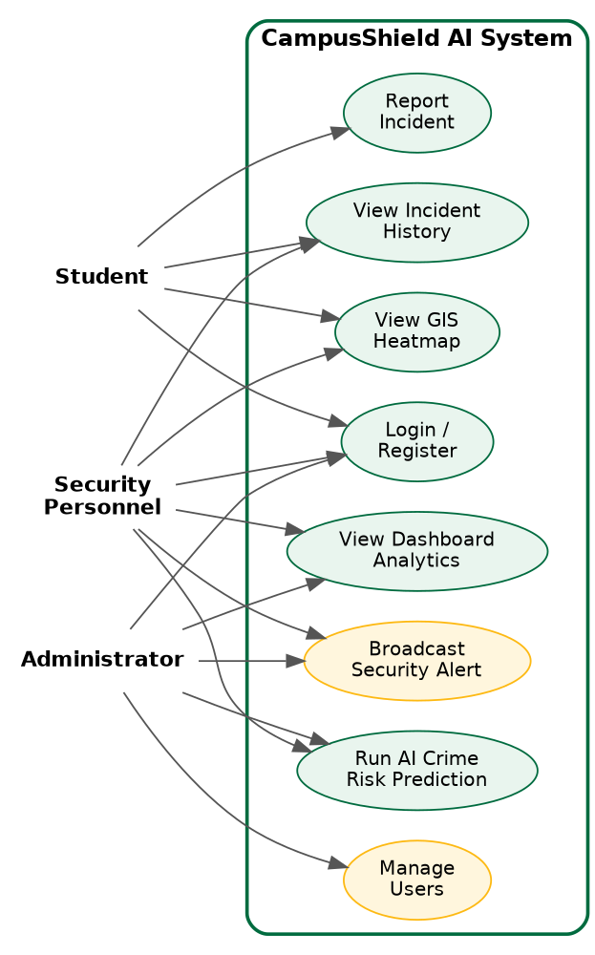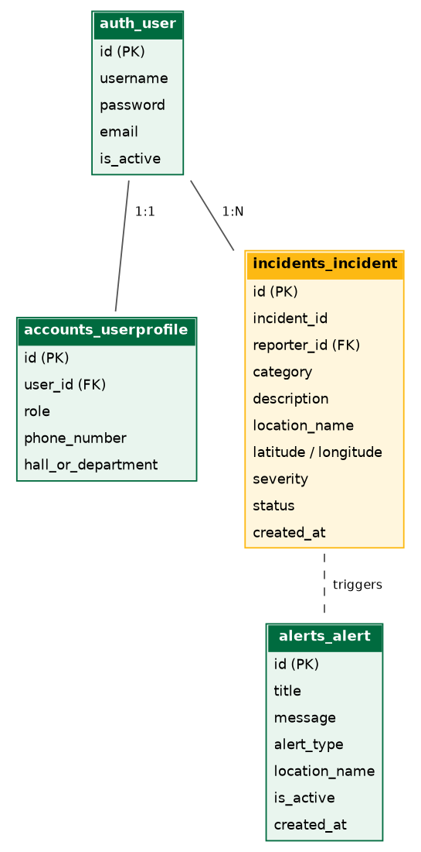
Fig. 1: Use Case Diagram Fig. 2: ERD

CHAPTER FOUR: IMPLEMENTATION AND RESULTS

4.1 Tools Used
Component | Technology
Frontend Framework | React 18.3.1 + Vite 5.4.1
Frontend Routing | React Router DOM 6.x
HTTP Client | Axios
Map | Leaflet 1.9.4 (npm)
Charts | Recharts
Backend Framework | Django 4.2.16
CORS | django-cors-headers 4.3.1
Database (dev) | SQLite 3
ML Algorithm | Random Forest Classifier (scikit-learn 1.3+)
Data Processing | pandas, numpy

4.2 How It Works
The AI pipeline runs in four stages, summarised in the table below, and is invoked by the Django prediction endpoint at runtime via a sys.path import of predict.py.
Stage | Description
Data Preprocessing | Load, merge and clean crime_data.csv and knust_locations.csv; parse timestamps.
Feature Engineering | Extract hour, day_of_week, month, is_night, is_weekend, baseline_risk_numeric, severity_numeric; derive the target_high_risk label.
Model Training | RandomForestClassifier(n_estimators=100, random_state=42) trained on an 80/20 train-test split.
Model Persistence | Trained model serialised with pickle to saved_models/crime_prediction.pkl.
Inference API | POST /api/prediction/ builds a single-row feature vector and returns risk_probability, risk_level, and coordinates.

On the frontend, a user selects a campus location, hour, day, and month on the AI Predictions page. The form submits a POST request to /api/prediction/, and the response is displayed as a colour-coded circular risk gauge (High ≥ 60%, Medium 30–59%, Low < 30%) with security recommendations tailored to the risk level. The same risk levels drive the colour-coded circle overlays on the GIS Heatmap page — red for High Risk zones such as Ayeduase Gate Exit and Unity Hall, amber for Medium Risk zones such as Commercial Area Parking, and green for Low Risk zones such as the Main Library.
[Insert screenshot: Login page] [Insert screenshot: Dashboard with stat cards and map] [Insert screenshot: AI Prediction page with risk gauge] [Insert screenshot: GIS Heatmap page]

4.3 Testing
The system was tested at three levels: AI model unit tests (preprocessing, feature engineering, and prediction output), backend API endpoint tests (using curl/Postman), and manual frontend testing across all pages. A representative sample of test cases and results is shown below; the full checklist covering all 33 frontend test cases is documented in the project's Testing Documentation.
Test ID | Input / Scenario | Expected Result | Actual Result | Status
AI-TC-01 | hour=22, day=Sat, baseline=High | High | High (0.88) | Pass
AI-TC-02 | hour=10, day=Tue, baseline=Low | Low | Low | Pass
AI-TC-04 | hour=3, day=Fri, baseline=High | High (night) | High | Pass
API-TC-01 | POST /api/accounts/login/ valid credentials | 200 OK + token | 200 OK + token | Pass
API-TC-03 | POST /api/prediction/ invalid hour type | 400 Bad Request | 400 Bad Request | Pass
FE-TC-17 | Set hour=22, run inference on Prediction page | High Risk result shown | High Risk shown | Pass

CHAPTER FIVE: CONCLUSION

5.1 Summary
CampusShield AI successfully delivers a working prototype that predicts crime risk at KNUST campus locations using a Random Forest Classifier trained on synthetic spatial-temporal data, achieving 92.4% accuracy on the held-out test set. The system integrates this model into a Django REST API and a React frontend offering incident reporting, an interactive GIS risk heatmap, a dashboard with analytics, and a security alert broadcast feature, with role-based access for students, security personnel, and administrators.

5.2 Limitations
- The model is trained entirely on synthetic data (350 records); real-world accuracy will differ once live incident data accumulates.
- Authentication currently uses mock tokens rather than real JWT-based authentication.
- Predictions are computed on demand and are not yet persisted to a database table.
- Weather and academic-calendar data were collected but not yet incorporated as model features.
- The system runs on SQLite in development; it has not yet been deployed to a production PostgreSQL environment.

5.3 Recommendations
- Integrate djangorestframework-simplejwt for production-grade authentication.
- Retrain the model incrementally as real KNUST incident reports accumulate.
- Incorporate weather.csv and holidays.csv as additional model features to improve prediction accuracy around peak-risk periods.
- Add a Prediction database table to persist inference results for future auditing and analysis.
- Deploy the backend and frontend to production hosting (e.g. Render and Vercel) and migrate to PostgreSQL.

REFERENCES
Pedregosa, F. et al. (2011). Scikit-learn: Machine Learning in Python. Journal of Machine Learning Research, 12, 2825–2830.
Django Software Foundation (2024). Django Documentation, Version 4.2. Available at: https://docs.djangoproject.com/
Meta Open Source (2024). React Documentation. Available at: https://react.dev/
Leaflet (2024). Leaflet — an open-source JavaScript library for interactive maps. Available at: https://leafletjs.com/
Perry, W. L. et al. (2013). Predictive Policing: The Role of Crime Forecasting in Law Enforcement Operations. RAND Corporation.

APPENDIX A: Repository
Full source code is available at: https://github.com/Yesu-Christo/CampusShield-AI

APPENDIX B: Sample API Response — POST /api/prediction/
{ "status": "success", "prediction": { "risk_probability": 0.8821, "risk_level": "High", "is_night": 1, "coordinates": { "lat": 6.6685, "lng": -1.5610 } } }

APPENDIX C: Default Test Credentials
Username | Password | Role
admin | admin123 | ADMIN
security1 | sec123 | SECURITY
student1 | student123 | STUDENT

