1. Introduction to the project
In today's data-driven world, businesses and organizations rely heavily on data analytics to guide strategic decisions, optimize operations, and uncover hidden insights. This final report is divided into two main parts, each focusing on a comprehensive analysis of datasets using business intelligence tools such as Power BI and Tableau.
Part 1 of the report explores the Global Sales Dataset, providing an in-depth summary of key performance indicators such as Gross Sales, Total Sales, Total Profit, and Total Units Sold. Additional analyses break down sales by segments, years, products, discounts, and countries. This section aims to identify trends and patterns that could be useful for business decision-making, sales strategy, and marketing insights.
Part 2 involves selecting a dataset from either Kaggle or Data.gov to showcase data visualization skills. The chosen dataset is analyzed through at least four distinct and informative charts or maps to provide a clear understanding of the data. The goal of this part is to demonstrate the ability to transform raw data into meaningful insights using modern visualization techniques.
This report not only highlights technical data analysis and visualization capabilities but also emphasizes critical thinking and interpretation of real-world datasets, preparing the foundation for data-informed decision-making in professional environments.

2. Part 1
Data Source: Global Sales dataset
Analysis Tool: Tableau Desktop
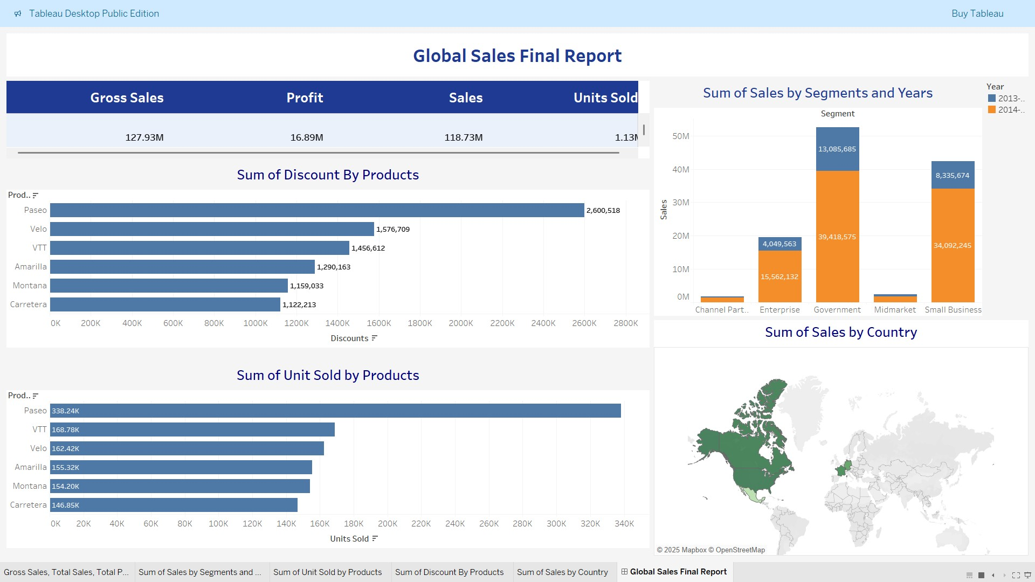

2.1 Summary of Key Metrics
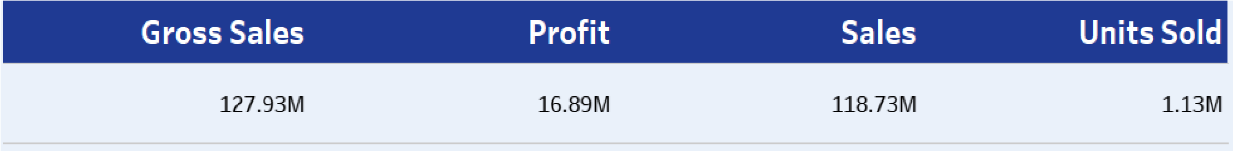
The key metrics provide a snapshot of overall business performance based on the Global Sales dataset:
- Gross Sales ($127.93 Million): This is the total revenue generated from all sales before any discounts were applied. It reflects the overall market demand and volume of products sold.
- Total Sales ($118.73 Million): This represents the net sales revenue after accounting for discounts given to customers. The difference between gross sales and total sales highlights the impact of discounting strategies on revenue.
- Total Profit ($16.89 Million): Profit is calculated as the net sales revenue minus the cost of goods sold (COGS). This figure indicates how much money the company retains after covering production costs, representing overall business profitability.
- Total Units Sold (1.13 Million): This metric indicates the total quantity of products sold across all segments, countries, and years. It reflects product demand and helps in understanding sales volume trends.
Together, these metrics provide a comprehensive overview of sales performance, pricing effectiveness, cost management, and customer demand, which are crucial for strategic business decisions.

2.2 Sales by Segment and Year
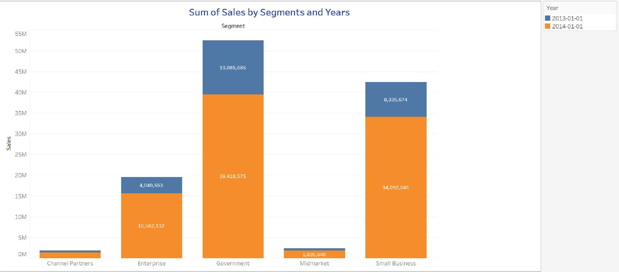
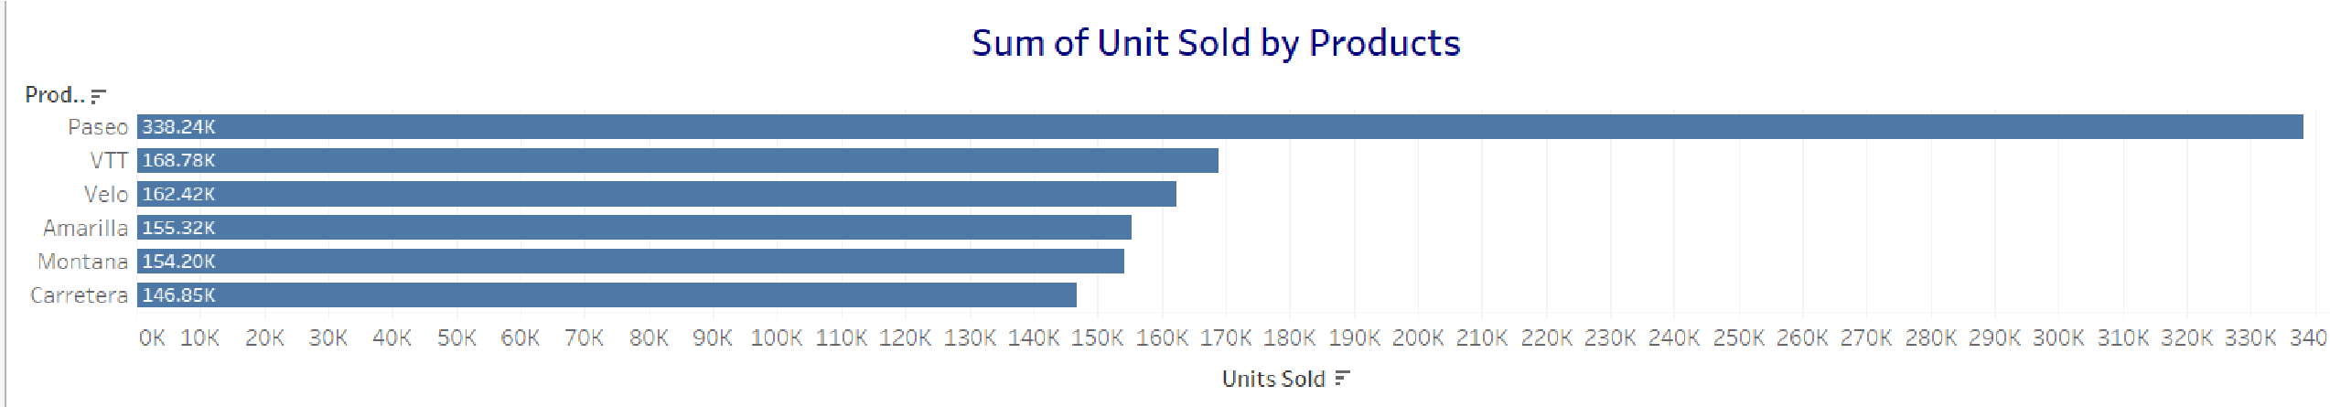
The analysis of sales by segment for 2013 and 2014 shows that the Government segment consistently outperformed all other segments in sales. It demonstrated steady growth across both years and contributed the largest share of total revenue.
The Small Business segment followed closely behind, showing strong performance as well. The Enterprise segment had moderate contributions, while Channel Partners and Midmarket segments recorded the lowest sales volumes during this period.
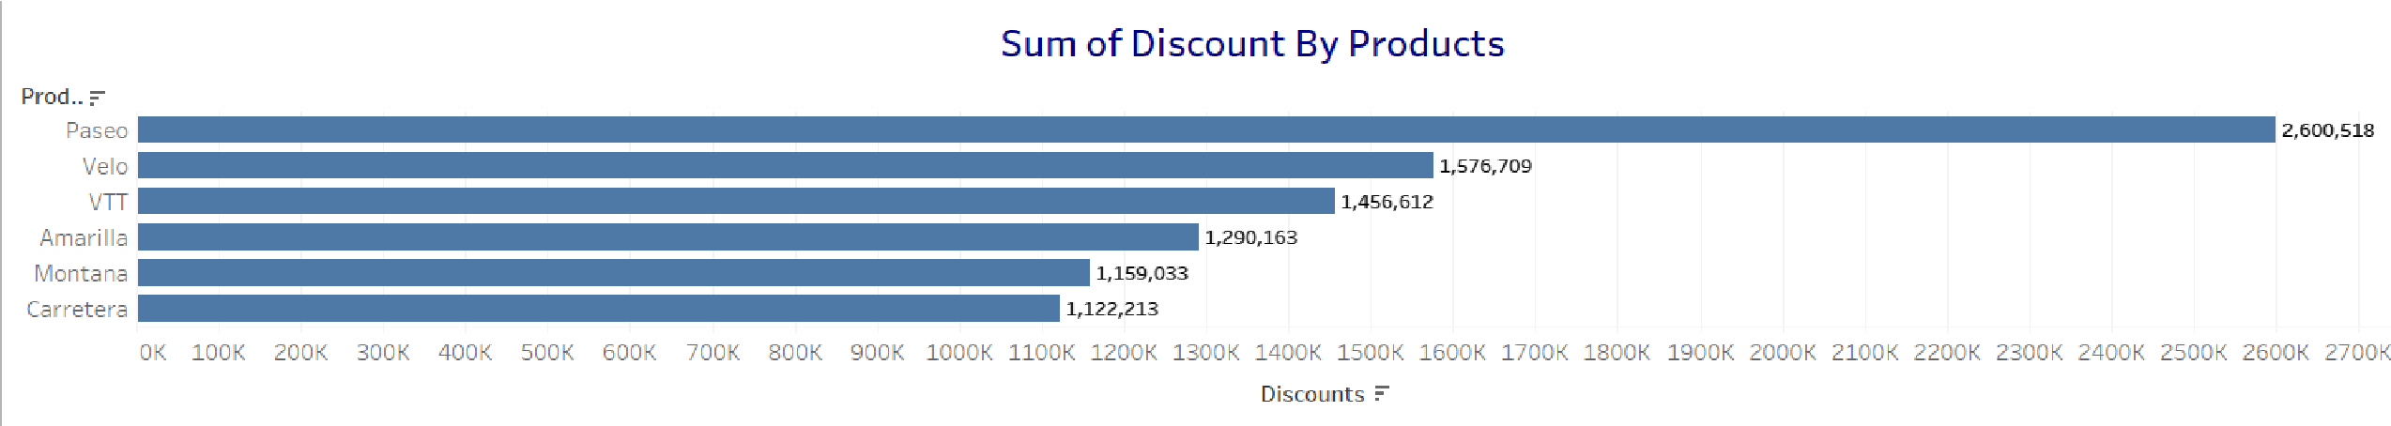
The consistent performance of the Government and Small Business segments over these two years indicates strong and reliable demand, making them key areas for continued business focus and strategic investment.

2.3 Units Sold by Products
The Paseo product leads in units sold, followed by other top products. This indicates strong market demand for Paseo.

2.4 Discounts by Products
The analysis of units sold by product shows that the Paseo product leads in total units sold during 2013 and 2014. This suggests a strong market demand and high customer preference for Paseo. Interestingly, Paseo also received the highest total discounts, indicating that discounting may have played a key role in driving its high sales volume.
On the other hand, the Carretera product recorded the lowest number of units sold and received little to no discounts, implying it was sold at full price. This could mean that Carretera targets a more niche or premium market with lower volume but possibly higher margins.

2.5 Sales by Country
USA and Canada are the top countries by sales volume, representing key markets driving revenue growth.
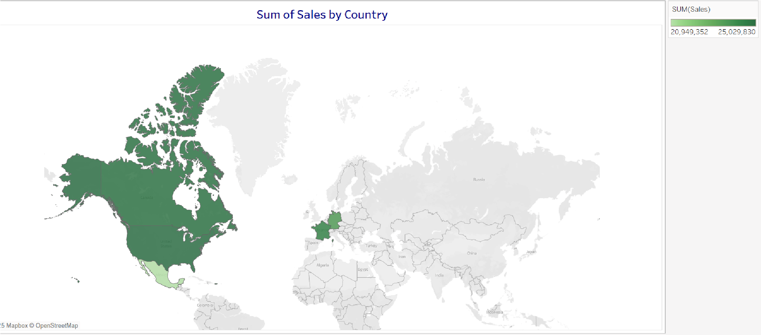

2.6 Analysis and Insights
The Global Sales dataset analysis, visualized using Tableau, highlights clear patterns in customer behavior, product performance, and regional dynamics across 2013 and 2014. The findings provide meaningful guidance for data-driven decision-making and future business strategy.
The Government and Small Business segments emerged as the most consistent and profitable customer groups, showcasing strong purchasing power and reliability. These segments should remain key targets for growth and retention strategies.
Among products, Paseo stands out as the market leader in unit sales, likely driven by effective discounting strategies. However, this also underscores the importance of monitoring profit margins when using aggressive promotions. In contrast, Carretera, though low in volume, reflects the potential of premium, high-value product positioning with minimal discounts.
Regionally, the United States and Canada are the company’s strongest markets, contributing significantly to overall sales. These countries represent strategic opportunities for further expansion and investment.
Overall, the analysis reveals a healthy balance between volume-driven and margin-focused products, with clear performance leaders across customer segments and geographic regions. To maintain momentum and optimize growth, the company should:
- Strengthen engagement with high-performing customer segments
- Tailor discount strategies based on product positioning
- Prioritize expansion in top-performing regions
This well-rounded approach can help ensure sustained revenue growth, improved profitability, and long-term market competitiveness.

3.1 Part 2
This report presents an in-depth analysis of crime data collected across the United States from 2020 to the present. The dataset, sourced from the official Data.gov portal, comprises detailed records of criminal incidents including the date, type of crime, location, and reporting agency. The objective of this study is to explore crime patterns over time and geography, identify predominant crime types, and derive actionable insights to support public safety efforts and policy formulation.

3.1.2 Data Cleaning and Preparation
Prior to analysis, the raw dataset required thorough cleaning and preprocessing to ensure accuracy and consistency:
Data Source: Crime data obtained in CSV format from Data.gov.
Cleaning Steps:
- Missing Values: Records missing critical fields such as Crime Type, Date, or Location were removed to maintain data integrity.
- Date Formatting: Dates were standardized to the ISO 8601 format (YYYY-MM-DD) to ensure consistent temporal analysis.
- Duplicate Removal: Duplicate incident records were identified and excluded to avoid skewed results.
- Column Standardization: Column names were revised for clarity and uniformity (e.g., renaming “offense_description” to “Crime Type”).
- Filtering: Data was filtered to include only reports from January 2020 through the most recent available data in 2023.
The cleaned dataset was then imported into Power Bi to facilitate the creation of comprehensive visualizations.

3.2 Visualizations

3.2.1 KPI Cards Using DAX Measures

1. Total Number of Crimes
Purpose: Counts the total number of reported crime incidents.
Used in: Card visualization to show total crime records filtered by time, location, or crime type.

2. Crime Types Count
Purpose: Displays the number of distinct crime types recorded.
Used in: Helps to identify the diversity and frequency of crime categories.

3. Average Victim Age
Purpose: Shows the average age of victims to understand demographic trends.
Insight: Useful for identifying which age groups are more vulnerable to certain types of crimes.

4. YoY Crime Growth (Year-over-Year)
This DAX measure calculates the percentage change in crime volume between the current and previous year. It’s useful for identifying whether crime is increasing or decreasing year over year and helps track long-term trends.
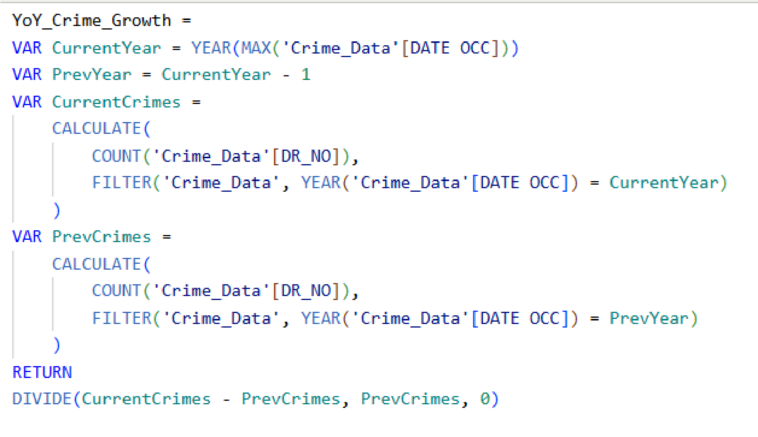

3.2.2 Victim Sex Distribution
Data Summary:

Male Victims: 48% Female Victims: 45% Unknown/Other: 7%
The chart reveals a relatively balanced distribution of crime victims between male and female:
- Male victims slightly outnumber females at 48%, indicating a modest dominance in reported cases.
- Female victims make up 45%, highlighting that women are nearly as frequently affected, possibly in different crime categories (e.g., domestic violence, harassment).
- The 7% unknown/other category suggests some records lack gender identification, possibly due to incomplete reporting or anonymized data.

This near parity between male and female victimization suggests that crime affects both genders significantly, and further analysis by crime type or age group would provide deeper context.

3.2.3 Crime Frequency by Day and Time of Day
To identify temporal crime patterns by visualizing how crime frequency varies across different days of the week and times of day. This helps stakeholders understand when law enforcement presence or preventive measures may be most needed.
Key Insights:
- Afternoon and Evening periods show the highest concentration of crimes, especially on Fridays and Saturdays.
- Nighttime consistently has the lowest crime rates, contrary to common assumptions.
- Crime activity appears to rise as the day progresses, likely linked to increased public movement, social interaction, and business hours.

3.2.4 Top 10 Weapons Used in Crimes
This bar chart ranks the ten most frequently used weapons in reported crimes, helping stakeholders understand the most common tools of violence and inform strategies for prevention, regulation, and enforcement.
The most common weapon used is “Strong Arm”, referring to physical force without any external weapon (e.g., hands, fists, feet). This indicates that a significant portion of crimes involve unarmed physical assaults.

3.2.5 Slicer
The slicer enables users to filter the dataset dynamically based on key fields such as Year, Crime Type, Weapon Used, or Area. This interactivity allows for customized exploration and more granular insights into crime patterns.

3.2.6 Monthly Crime Trend Analysis
To observe how crime incidents fluctuate over months, identifying seasonal patterns or spikes that could inform timing for law enforcement and prevention efforts.
- January recorded the highest number of crimes, possibly influenced by post-holiday factors such as increased social tensions or economic pressures.
- December showed the lowest crime rates, which might be attributed to holiday season activities or increased community vigilance.
The trend suggests a decline in crime as the year progresses from January to December.

3.2.7 Los Angeles Crime Map
This map visualizes the geographic distribution of crimes across Los Angeles, highlighting crime hotspots and areas with lower incident rates.

3.3 Analysis and Insights
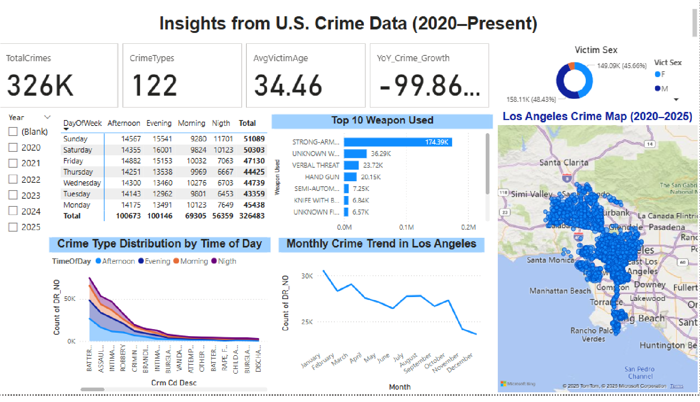
Data Source: Global Sales datasetThe crime data from 2020 to the present reveals important patterns and trends that can inform public safety strategies and resource allocation.

Crime Volume and Trends
- The total number of crimes shows variability across months and years, with a noticeable peak in January and the lowest crime incidents occurring in December. This seasonal trend may reflect social and environmental factors influencing criminal activity.

Victim Demographics
- The victim sex distribution indicates that males represent the majority of victims at 48%, closely followed by females at 45%, while the remaining 7% of cases are unclassified. This near parity suggests that crime prevention efforts must consider risks faced by all genders.

Temporal Patterns of Crime
- Analysis of crime frequency by day of the week and time of day highlights that crimes most frequently occur during the afternoon and evening hours, while the nighttime records the lowest incidents. This suggests that heightened vigilance and law enforcement presence during peak hours could be effective in crime reduction.

Weapon Usage in Crimes
- The top 10 weapons used in crimes feature “Strong Arm” as the most common weapon, indicating a high incidence of physical assaults without firearms. This insight may guide focused interventions on violent crimes involving physical force.

Geographic Crime Hotspots
- Spatial analysis using heatmaps reveals concentrated crime hotspots in areas such as Skid Row, South Central Los Angeles, Compton, Westlake, and Hollywood. These areas show higher crime density and may require targeted community programs and increased policing efforts.

Interactive Filtering and Exploration
- The inclusion of slicers allows for dynamic filtering by crime type, date range, and location, enabling stakeholders to explore specific facets of the data and derive actionable intelligence.

4. Conclusion

Part 1 Conclusion (Global Sales)
The analysis of the Global Sales dataset revealed that the Government segment consistently led sales and profit during 2013 and 2014, demonstrating strong and stable demand. The Paseo product stood out with the highest units sold and received the most discounts, highlighting the effectiveness of discount strategies in driving sales volume. Key markets such as the USA and Canada dominated sales revenue. These insights suggest focusing on high-performing segments and products, while optimizing discounting strategies to maximize profitability and market penetration.

Part 2 Conclusion (Crime Data)
The crime data analysis from 2020 to present identified clear temporal and geographic patterns. Crime incidents peak in the afternoon and evening, with January having the highest monthly counts and December the lowest. Victim distribution between males and females is nearly balanced. “Strong Arm” is the most frequently used weapon in reported crimes. High-density crime hotspots were found in specific Los Angeles neighborhoods including Skid Row and Compton. These insights provide valuable direction for law enforcement to prioritize resources and implement targeted crime prevention strategies.

