4-2: Object and Driver Classes

Practice Activities

Vocabulary

**1.A group of related Java classes**: Package

**2.Sections of code that are enclosed inside a set of curly braces** {}: Block

**3.First letter uppercase and the first letter of each internal word capitalized**: Upper Camel Case (Pascal Case)

**4.A named value that does not change**: Constant

**5.First letter lowercase and the first letter of each internal word capitalized**: Lower Camel Case

**6.A class that contains a main method**: Driver Class

**7.A code statement in a Java class file that includes Java code from another package or class**: Import Statement

**8.A class that defines instances of objects to be used in another class**: Object Class

**9.Code that is preceded by** //**. Comments are used to clarify programming logic. Comments are ignored by the compiler**: Single-line Comment

**10.A word that has a special function in the Java language, and cannot be used as names for classes, methods, or variables**: Keyword

**11.The library of Java classes available to import into a programmer-created class**: API (Application Programming Interface)

**12.The outline of an object, including class variables, constructors, and methods**: Class Blueprint

**13.A special kind of method that is a template for an object**: Constructor

**14.Values that are sent into a method or constructor to be used in a calculation or substituted with values from the class**: Parameters

**15.Values, such as numbers, characters, or booleans. References to objects, such as a BankAccount object**: Data Types

**16.Keywords used to specify the accessibility of a class (or type) and its members. Ex:** public**,** private**,** protected**,** default: Access Modifiers

**17.A block of code inside a class that is used to change or access information about the class**: Method

### Try It/Solve It

#### 1. Components of a .java File

A typical .java file includes the following components in this order:

1. **Package Declaration** (if applicable)
2. **Import Statements** (if applicable)
3. **Class Declaration**
   1. **Class Variables** (if any)
   2. **Constructors** (if any)
   3. **Methods**

#### 2. Upper Camel Case vs. Lower Camel Case

* **Upper Camel Case** (Pascal Case): The first letter of each word is capitalized. Typically used for class names.
  + Example: StudentInfo, BankAccount
* **Lower Camel Case**: The first letter of the first word is lowercase, and the first letter of subsequent words is capitalized. Typically used for method names and variables.
  + Example: studentName, getAccountBalance

#### 3. Import Syntax

* To import the entire Java utilities package:

java

Copy code

If you import an entire package, you do not need to import additional classes from that package separately, unless you want to import specific classes explicitly.

#### 4. Java Object Class Student

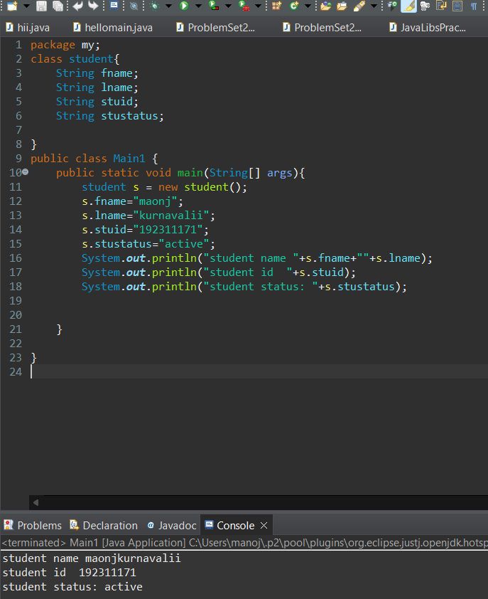

#### 6. List of 10 Java Keywords

1. abstract
2. assert
3. boolean
4. break
5. byte
6. case
7. catch
8. class
9. const
10. continue

#### 7. Complete the Programmer-Created Object Class

Assuming you have the comments for instructions, here's a possible completion for a Person class:

java

### 8. Driver Class to Test Person Class

