### Java Fundamentals 4-4: Strings Practice Activities

### Vocabulary Definitions

1. **Concatenation**: Joining multiple String objects together.
2. **Escape Sequences**: Specific characters that are preceded by a \ character. When evaluated, the special character is evaluated as a special function, such as tabs, newlines, etc.
3. **Assignment**: Assigning a value to a String object reference.
4. **Reference Data Type**: A data type that references the location in memory where an object is stored rather than a single, specific value.
5. **String Methods**: Code available in the Java API to manipulate or return strings.
6. **String**: An Object type that stores sentences, words, or multiple characters.

### Practice Activities

1. **Declare and Instantiate a String**

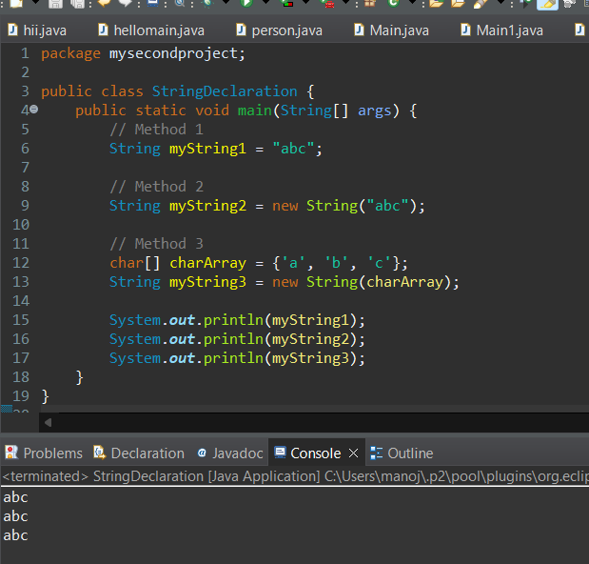

1. String Comparisons

String s1 = "ABC";

String s2 = new String("DEF");

String s3 = "AB" + "C";

a. s1.compareTo(s2);

* + This will return a negative number because "ABC" comes before "DEF" lexicographically.

b. s2.equals(s3);

* + This will return false because "DEF" is not equal to "ABC".

c. s3 == s1;

* + This will return true because s3 and s1 both reference the same string literal "ABC" in the string pool.

d. s2.compareTo(s3);

* + This will return a positive number because "DEF" comes after "ABC" lexicographically.

e. s3.equals(s1);

* + This will return true because "ABC" is equal to "ABC".

1. **Concatenate Strings**

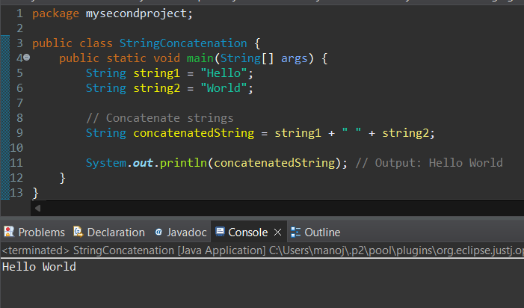

### Additional Points

* **Instantiation of Strings**: Strings in Java can be instantiated using string literals, the new keyword, or by converting a character array.
* **String Modifications**: Strings are immutable, meaning that any modification creates a new String object.
* **Concatenation Operators**: The + operator and += operator are used to concatenate strings.
* **Escape Sequences**: Special characters like \n (newline), \t (tab), \\ (backslash) are used within strings to represent specific actions.
* **String vs. char**: String is a class that can hold multiple characters, while char is a primitive type that holds a single character.
* **String Comparison**: The compareTo() method compares two strings lexicographically, and the equals() method checks for value equality. The == operator checks for reference equality, not value equality.
* **String Methods**: Methods like length(), substring(), indexOf(), and charAt() provide various ways to manipulate and retrieve information from strings.

4o