241501253 YESWANTH

Experiment 8

User Management and Role-Based Access Control in Zoho Creator

To implement User Management and Role-Based Access Control in Zoho Creator to manage users, assign roles and control access to the features and data of the Vehicle Service application based on the permissions granted to each role.

Roles Planned for the Vehicle Service Application

Role | Who | Access
Service Manager | Service center manager | Full access; reports, export to Excel, approvals, command center
Front Office | Reception staff | Add and edit service requests; spreadsheet status edits; command center
Technician | Mechanics | View assigned requests; update repair status on Kanban
Pickup/Drop Team | Drivers | View pickup addresses and map report only
Vehicle Owner (Portal User) | Customers | Submit a request and view own records only

Planned Users (Sample)

User | Email (sample) | Role | Permission
Service manager | manager@example.com | Service Manager | Full access
Reception staff | frontoffice@example.com | Front Office | Add / edit
Mechanic | technician@example.com | Technician | Status update
Driver | pickup@example.com | Pickup/Drop Team | Read (map report)

Process Diagram
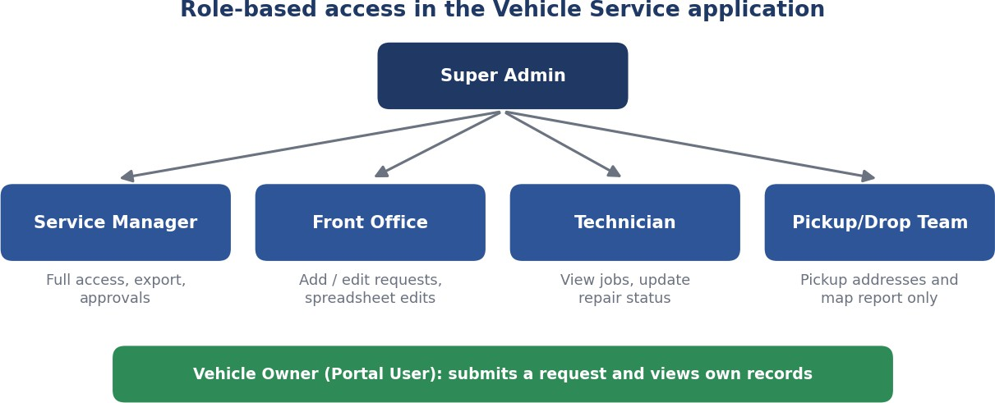
Figure 8.1: Diagram of the roles planned for the application (illustrative diagram, not a screenshot).

Role Tests

Login As | Action | Expected Result
Service Manager | Open Full_Service_Requests_Report and export | Allowed
Front Office | Edit status in the spreadsheet report | Allowed; other columns locked
Technician | Delete a request | Not allowed
Pickup/Drop Team | Open Service_Request_Form | Not available; map report only
Deactivated user | Log in | Access denied; status shows Inactive

Result
User Management and Role-Based Access Control were implemented in Zoho Creator for the Vehicle Service application.

