Rapid-I vision measuring System Project

Internship activity - <Day 32>

Author:Yeswanthram R

**Program debugging Build in Order:**

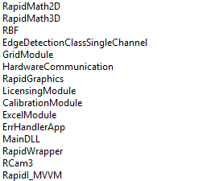

Read Binary

**Main View:**

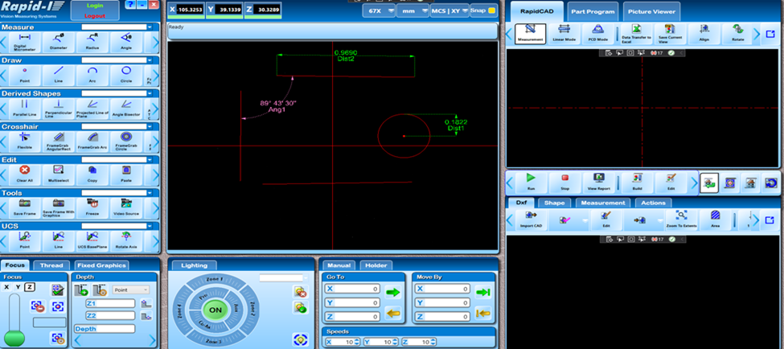

**Drawing multiple lines and shapes:**

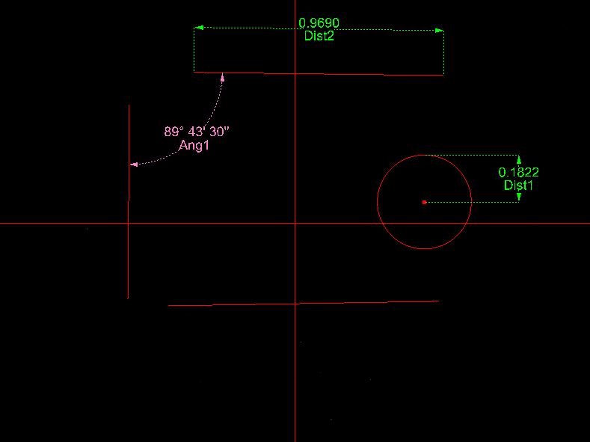

**Program Build:**

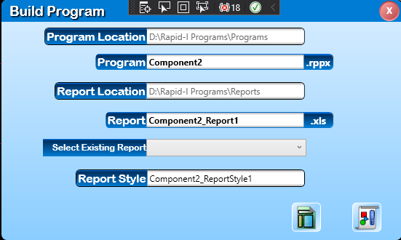

**Part program selection:**

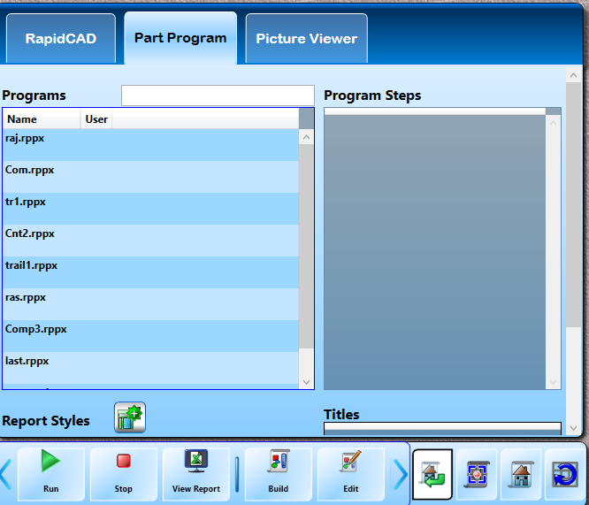

**Shapes in the Rcad app:**

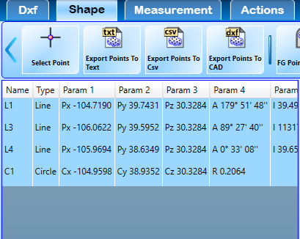

**Calculate measurements:**

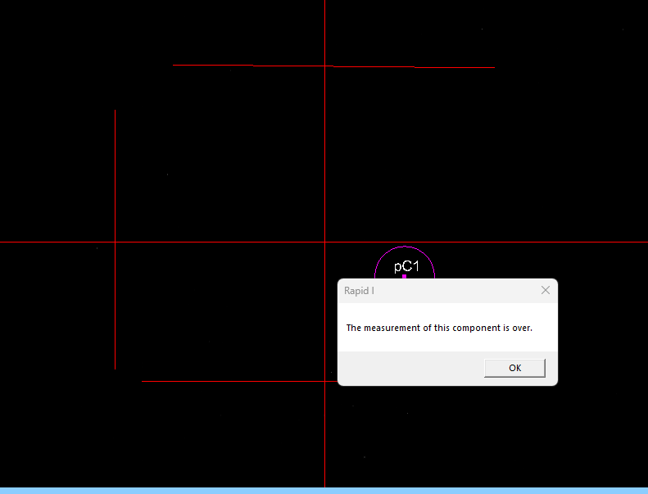

After running of your project all the measurements of shapes are calculated.