Rapid-I vision measuring System Project

Internship activity - <Day 33>

Author:Yeswanthram R

**Lights:**

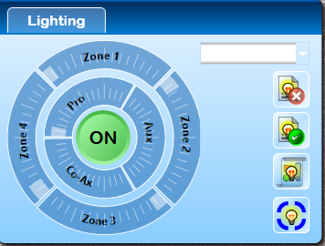

Top view -Zone 1,2,3,4

Bottom view – Pro

Side view – Aux, Co Ax

**Login:**

Three login is there:

User

System

Admin login

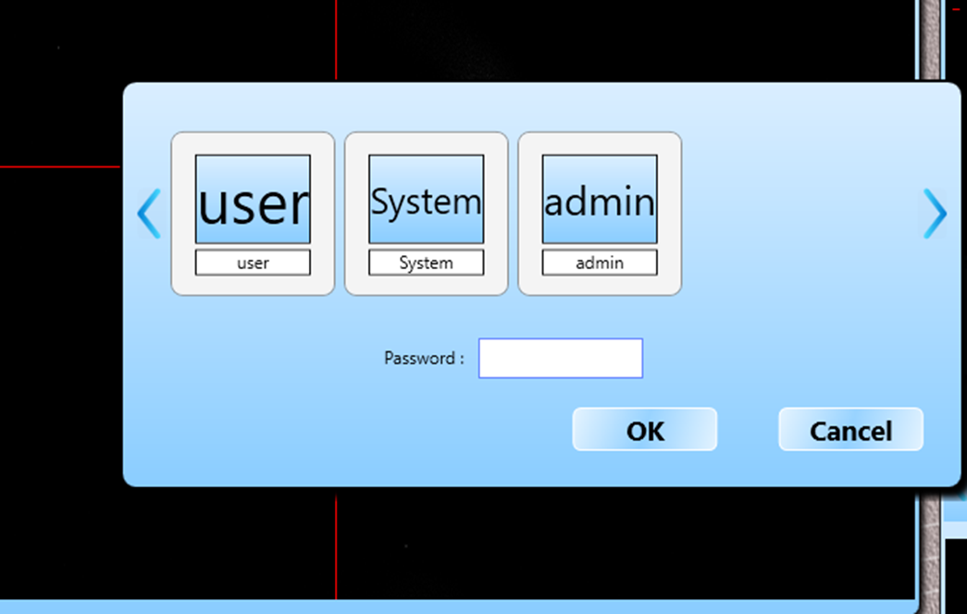

**Picture Viewer:**

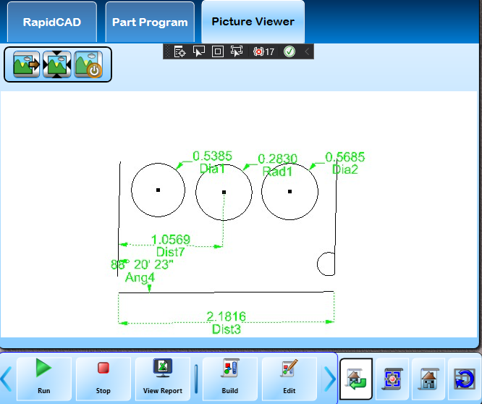

**Part Program loading:**

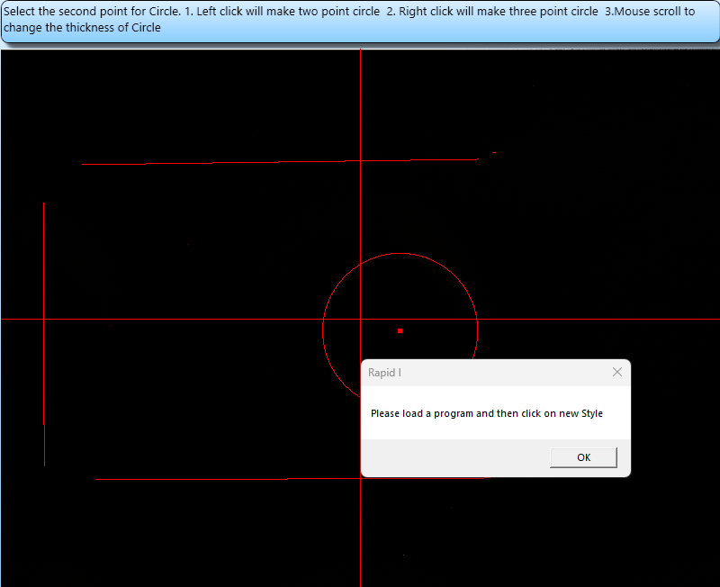

**Rapid Cad Window view**

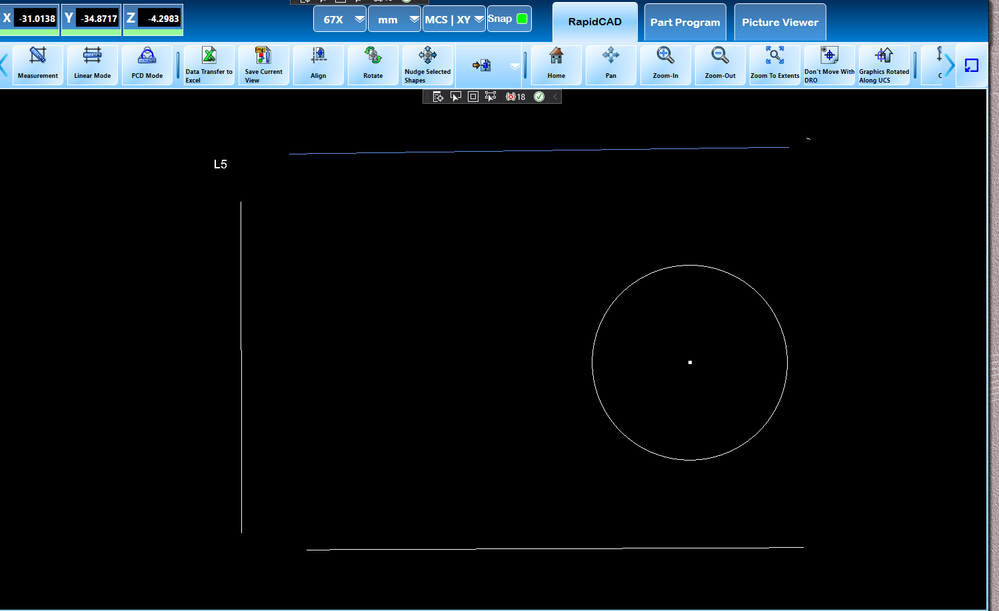

**X,Y,Z measurements:**

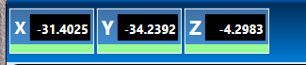

**Snap use:**



**There are three colors in snap:**

Red,green,Yellow.

**Zoom options:**

