Rapid-I vision measuring System Project

Internship activity - <Day 34>

Author:Yeswanthram R

**Camera top view:**

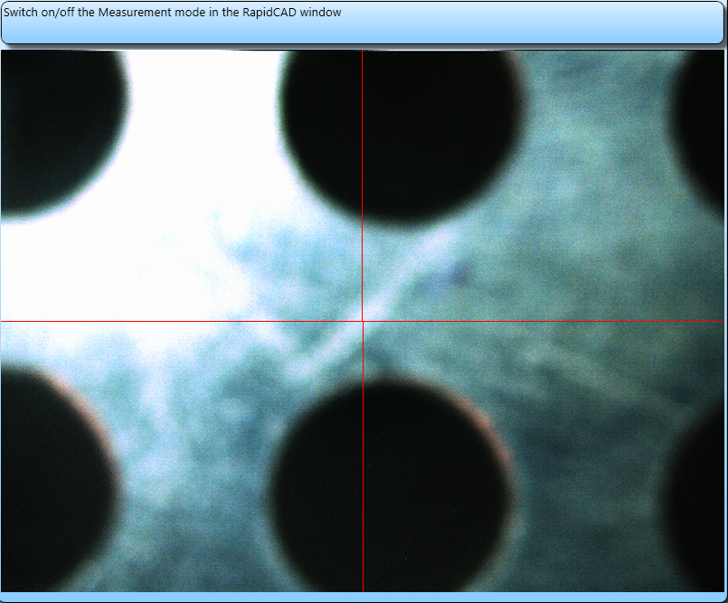

**Camera Bottom View:**

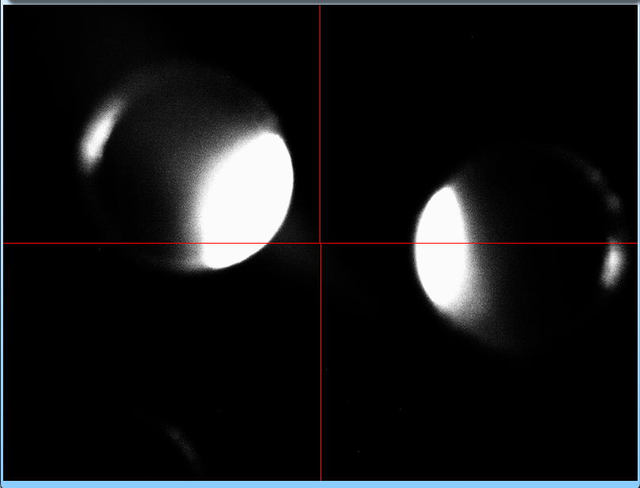

**Measurements of X,Y,Z:**

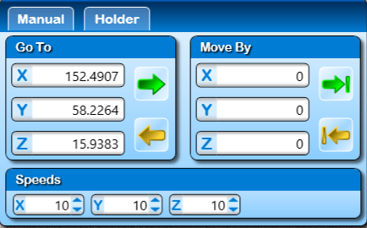

**Actions table:**

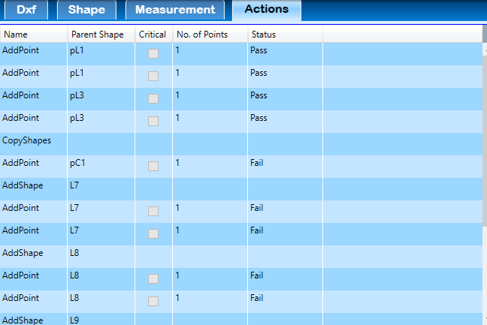

**Save raw data:**

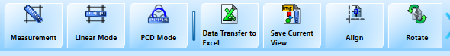

**Data saved in XL file Example:**

