**KARANAM YESWANTH TEJA**

**289224**

**SHELL SCRIPTING PROJECT**

1. **Sum of 2 inputs**

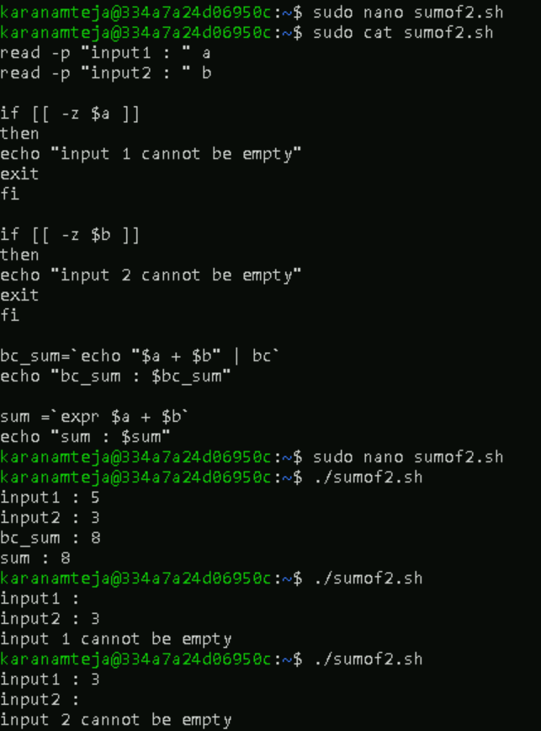

1. **Sum of elements in an array**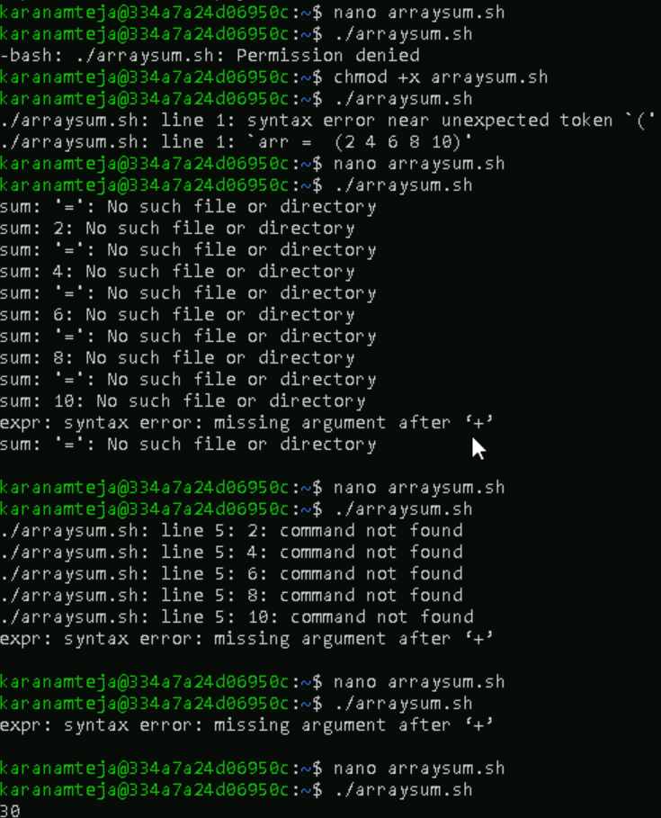

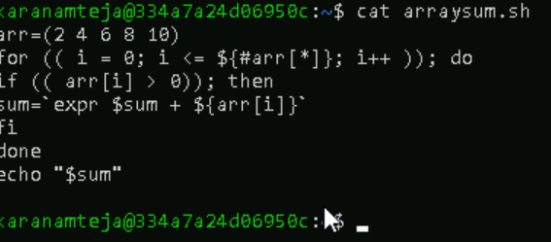

1. **palindrome**

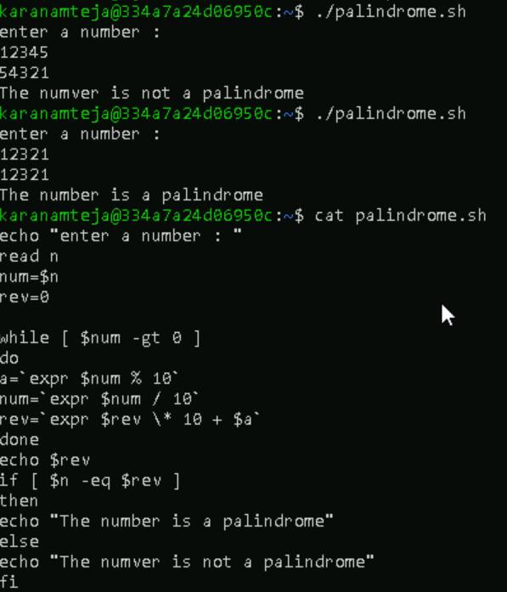

1. **Reverse number**

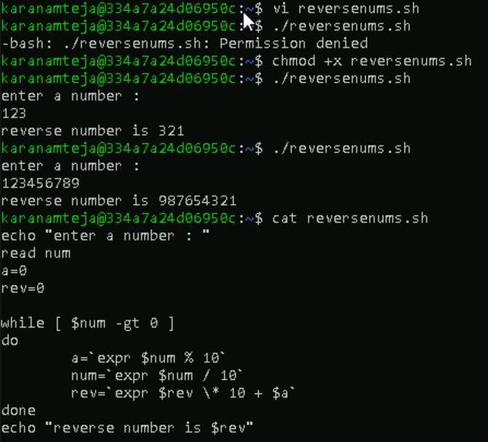

1. **Pascal triangle**

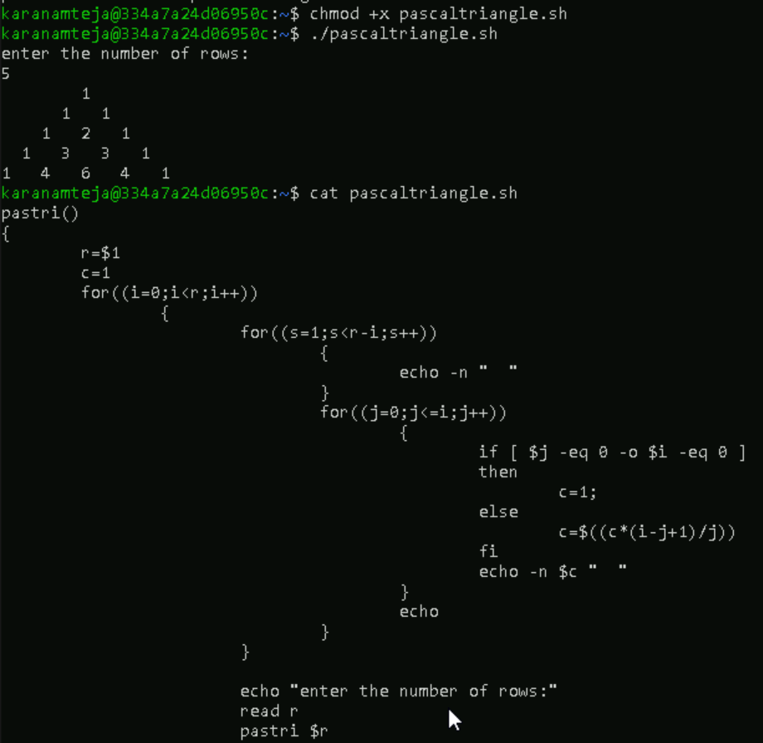

1. **Bubble sort**

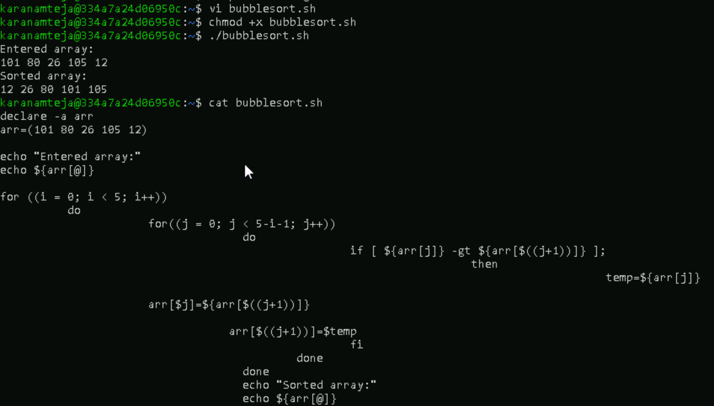

1. **Your Scripts**

