**KARANAM YESWANTH TEJA**

**289224**

**BASH ASSIGNMENT**

1. **BASH – IF**
2. **Entered value greater than a number**

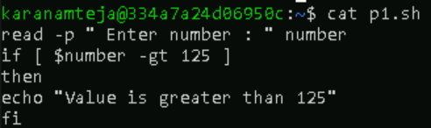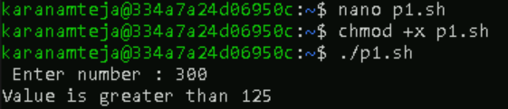

1. **Equal strings**

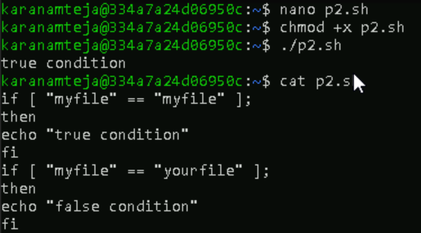

1. **Operators using if statements**

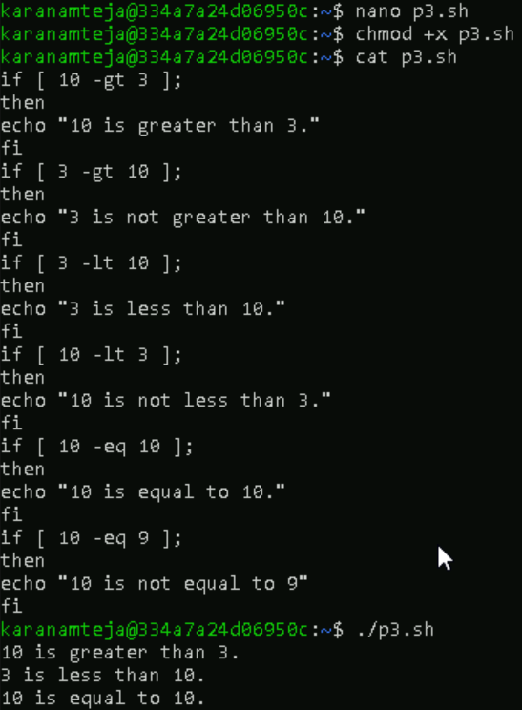

1. **AND operator**

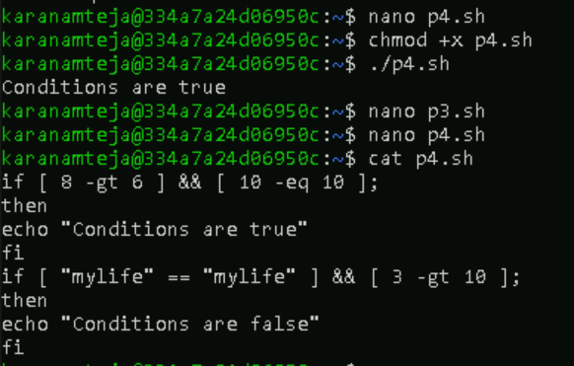

1. **OR operator**

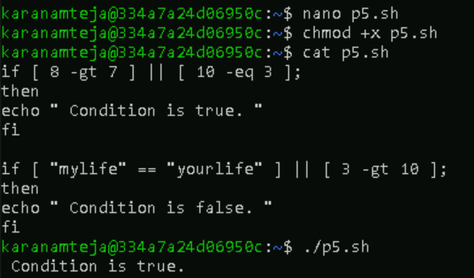

1. **AND & OR**

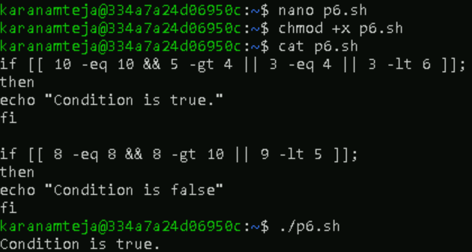

1. **ARITHMETIC OPERATORS**
2. **Bash scripting arithmetic operators**

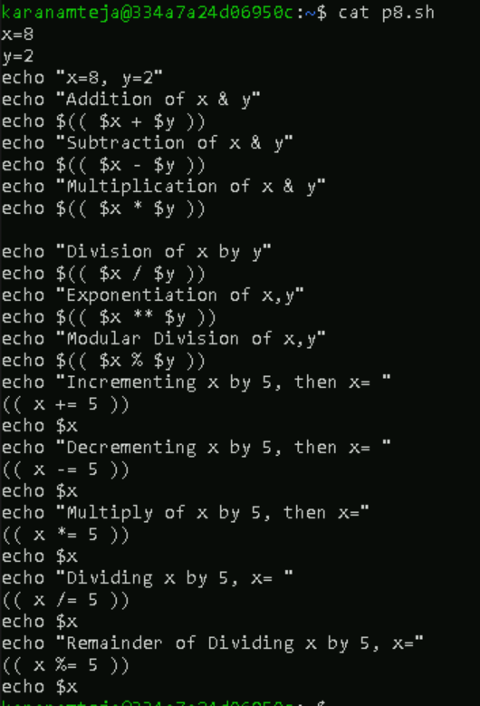

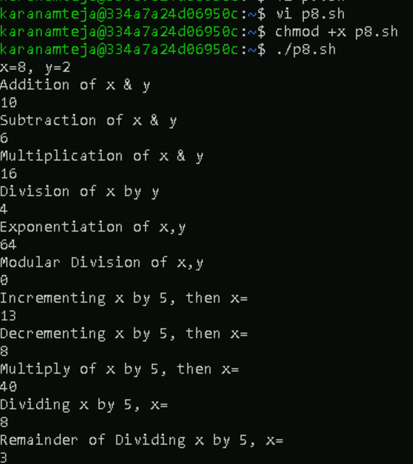

1. **Let construction**

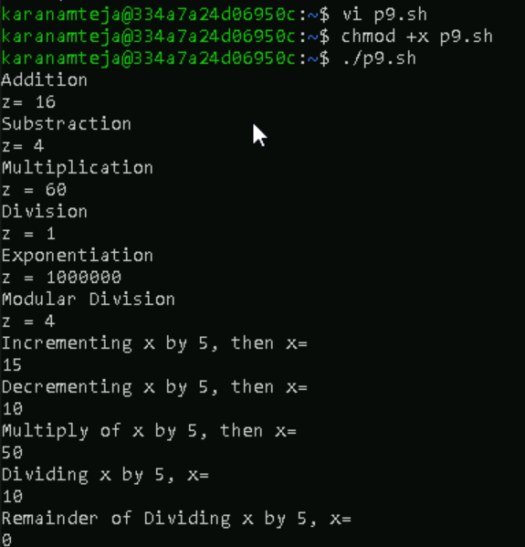

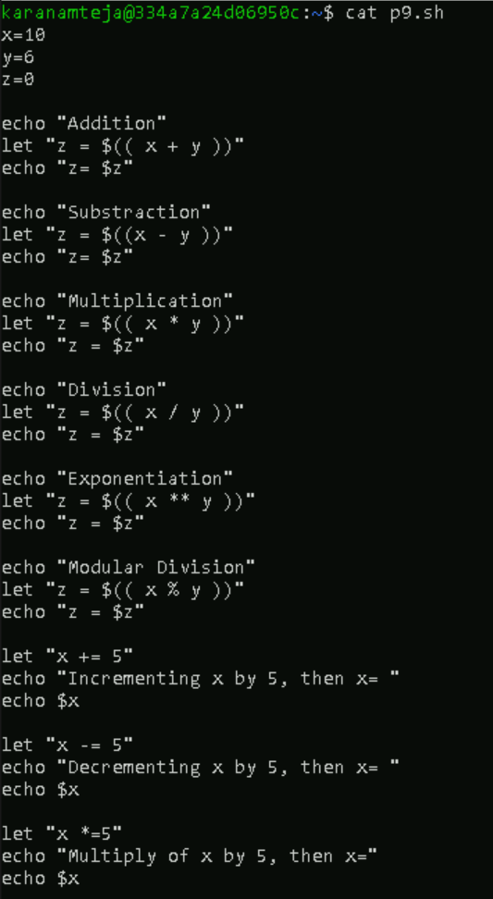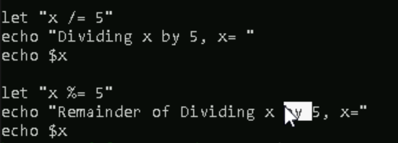

1. **Expr**

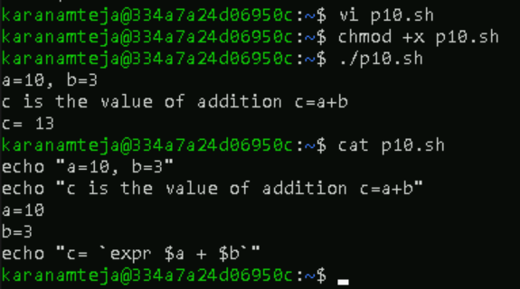

1. **IF ELSE**
2. **If else - 1**

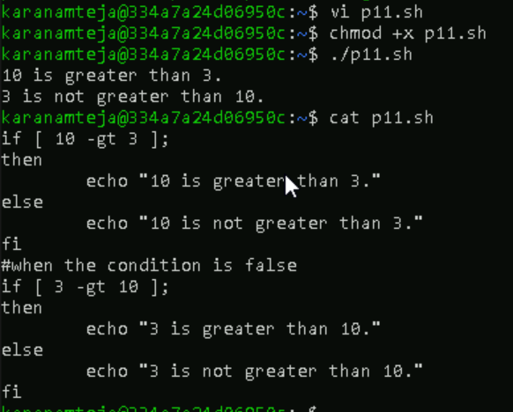

1. **If else – 2**

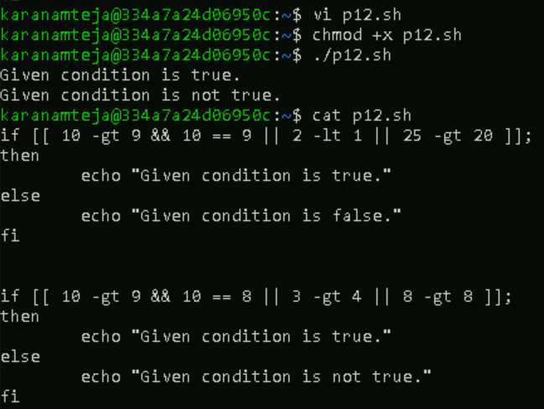

1. **If else – 3 ( single line )**

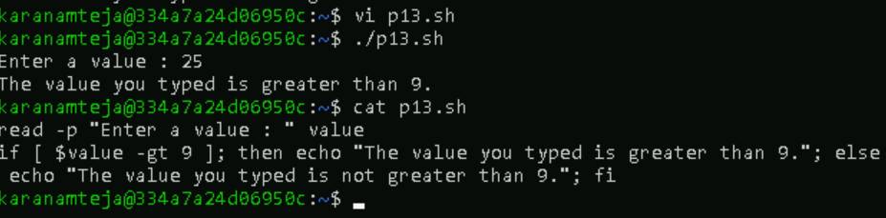

1. **Bash nested if else**

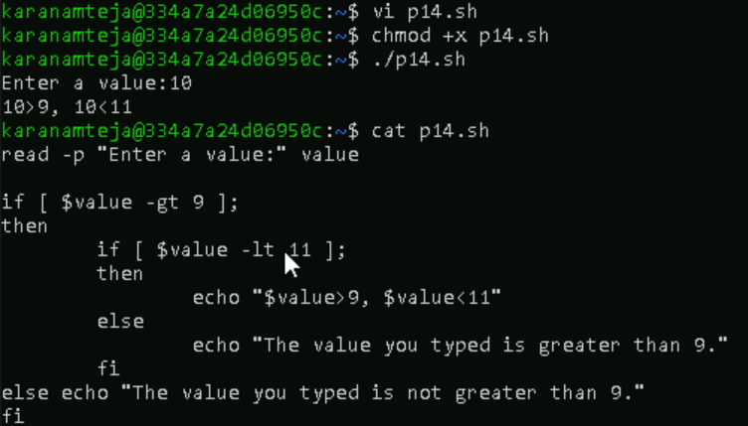

1. **ELIF**
2. **Bash elif - 1**

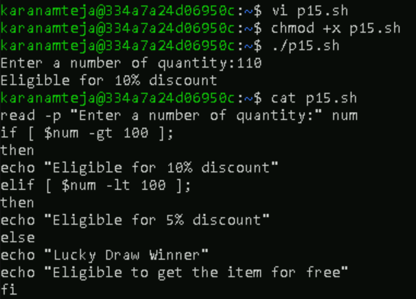

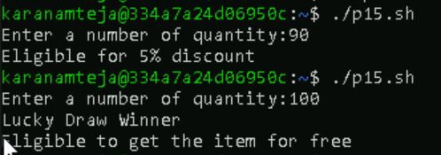

1. **Bash elif – 2**