**KARANAM YESWANTH TEJA**

**289224**

**PYTHON BASICS**

**Arithmetic Operators**

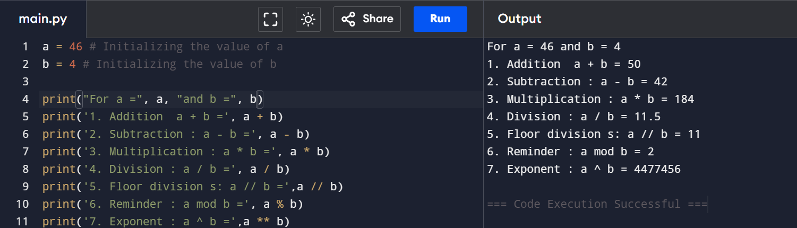

**Comparison Operators**

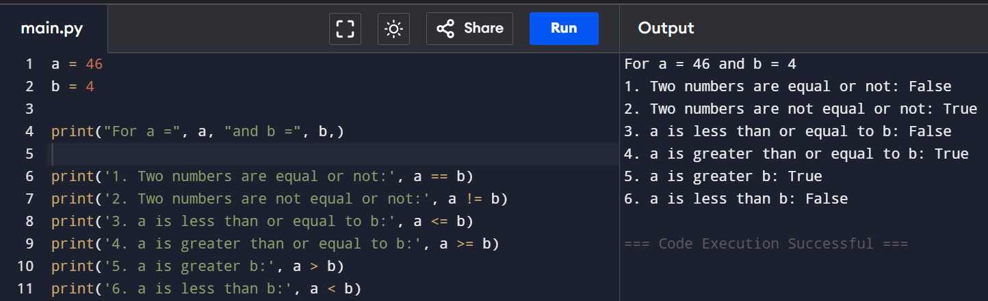

**Assignment Operators**

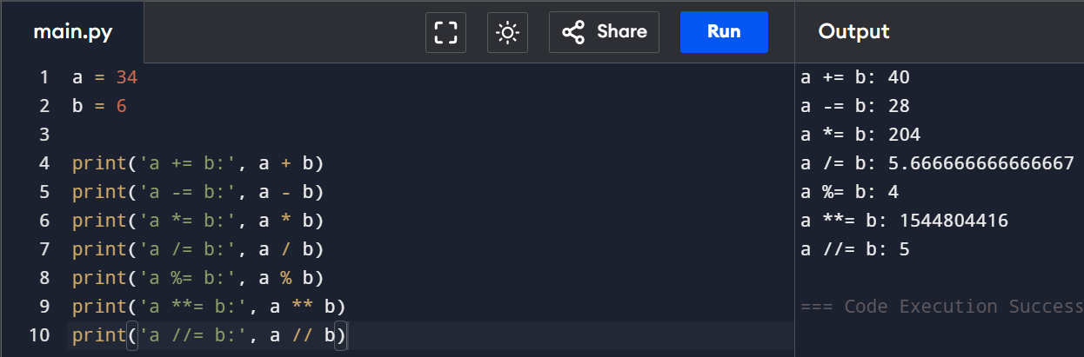

**Bitwise Operators**

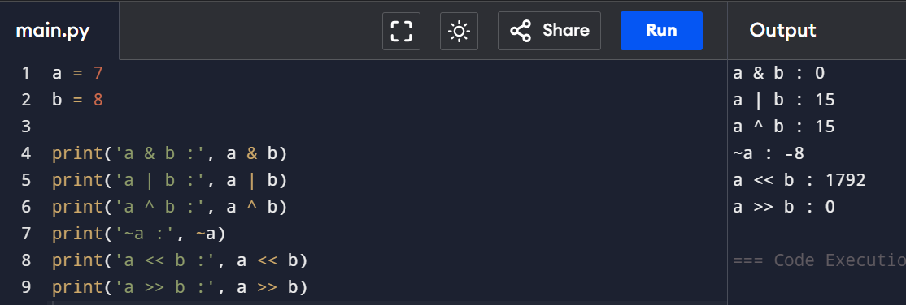

**Logical Operators**

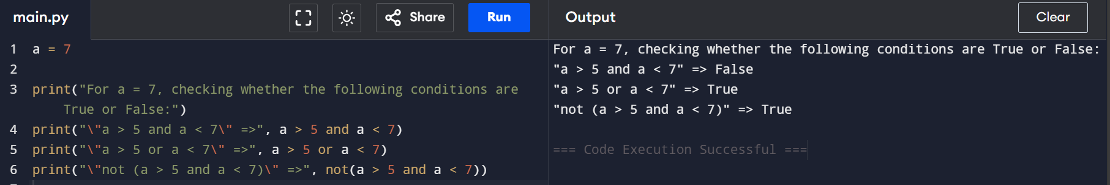

**Membership Operators**

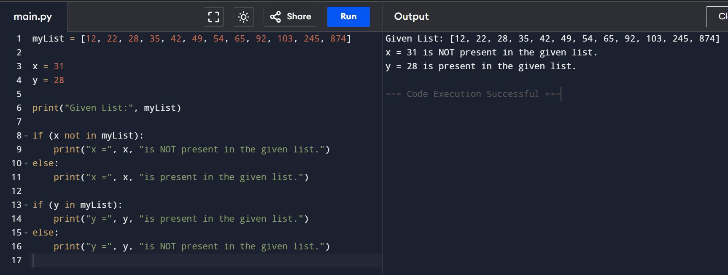

**Identity Operators**

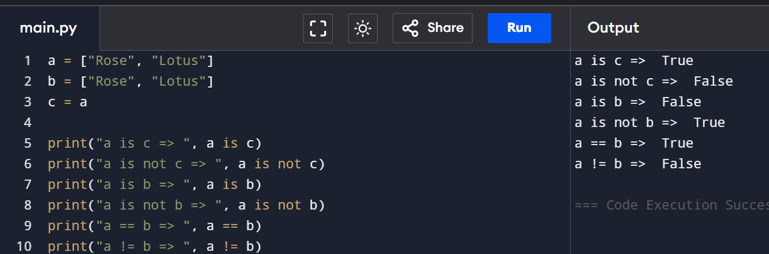

**How to reverse a string in Python?**

1. Using for loop

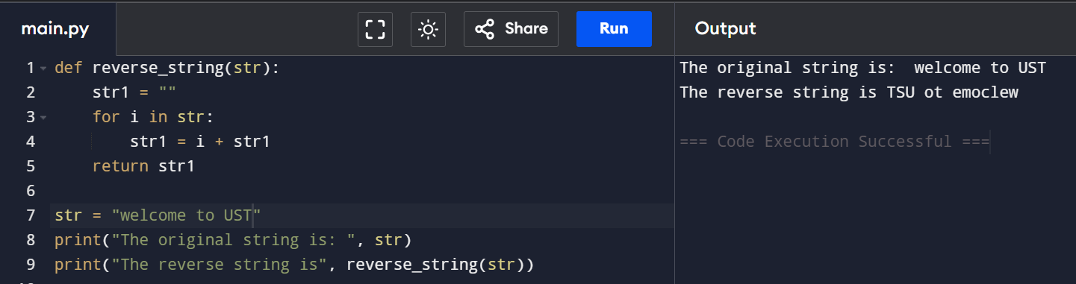

1. Using while loop

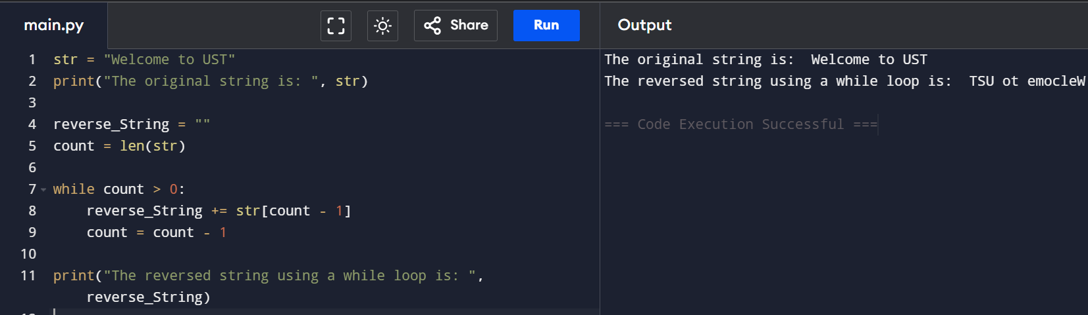

1. Using the slice operator

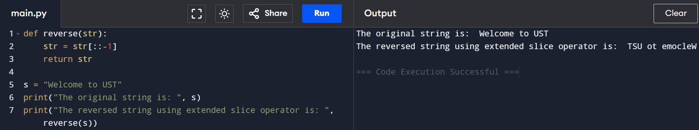

1. Using the reversed() function

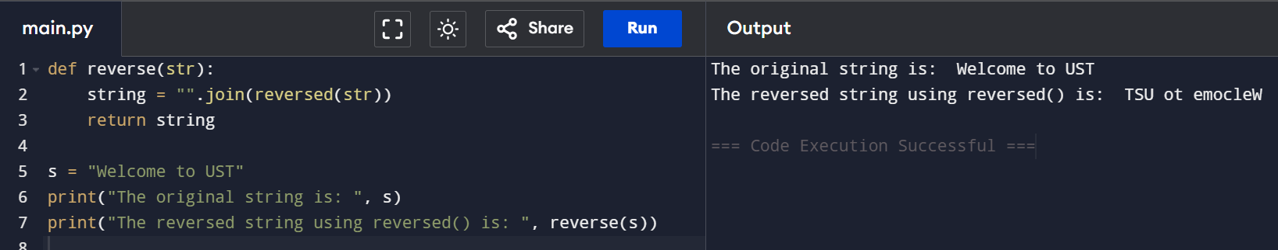

1. Using the recursion

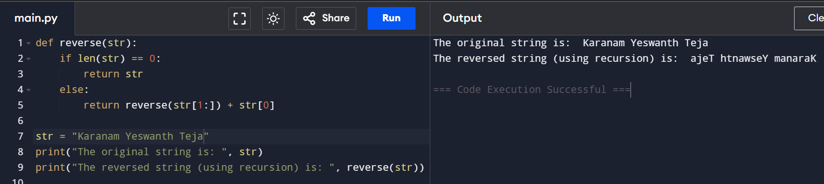

How to read CSV file in Python?

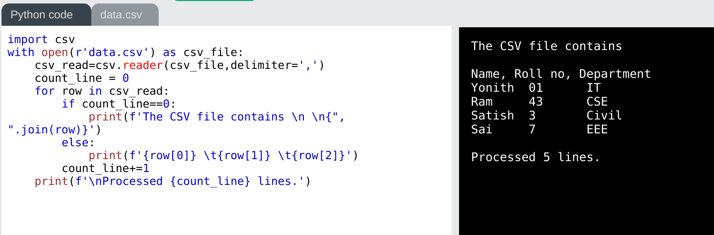

**If Statement:**

**1:**

**2:**

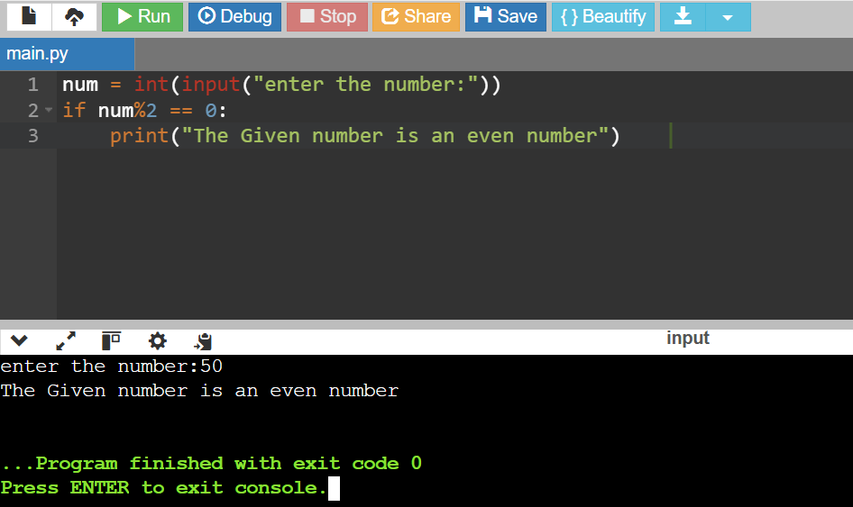

**If-Else Statement:**

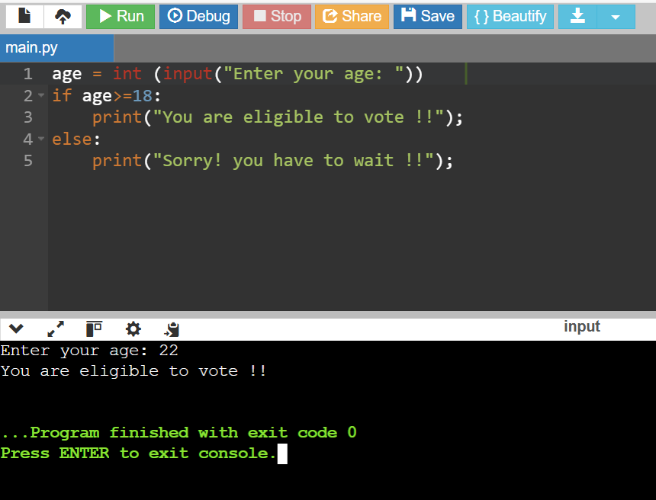

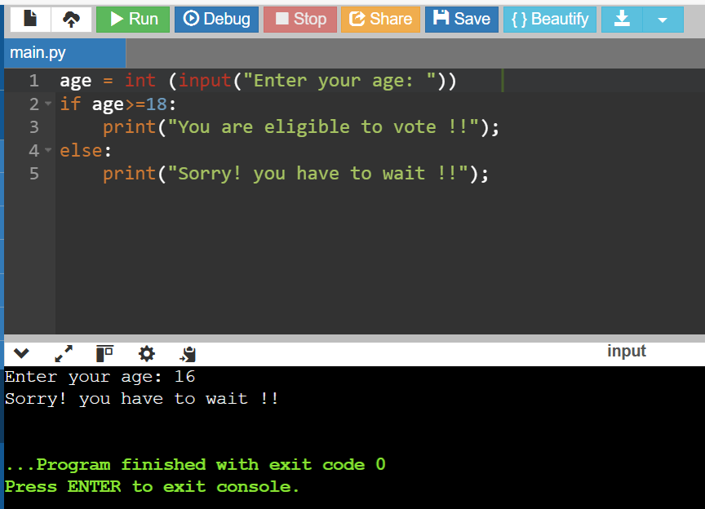

**Elif Statement:**

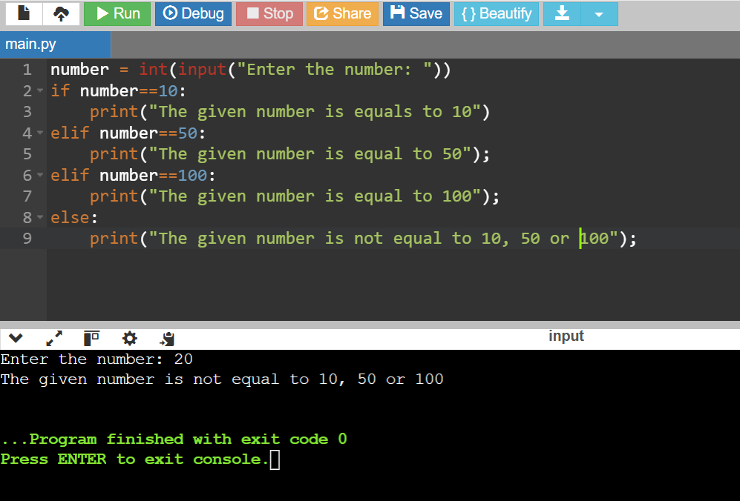

**FOR Loops:**

1. **Iterating by using index of sequence**

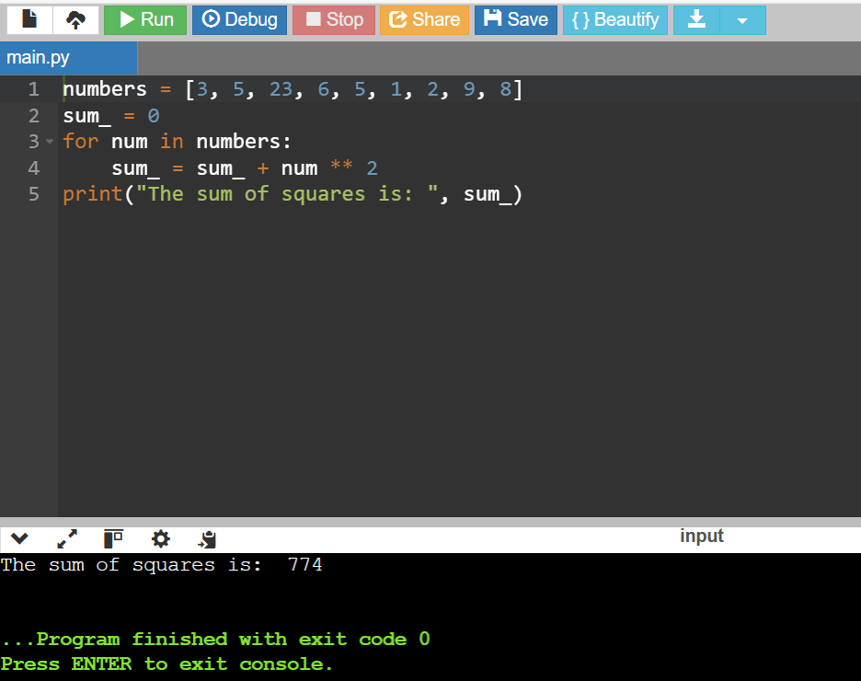

1. **Using Range ()**

1. **Using else statement with loop**

1. **Nested loop**

**WHILE Loops:**

1. **Sum of squares**

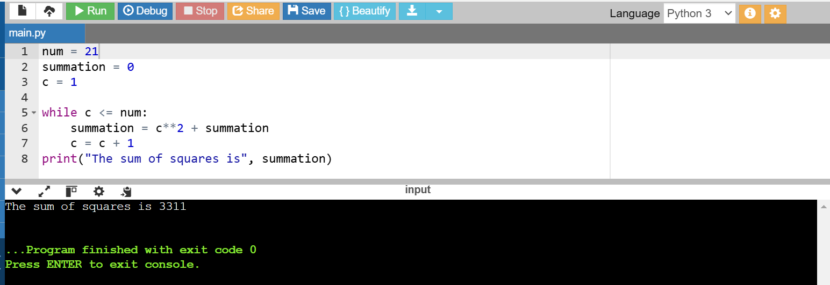

1. **To check whether given number is Prime or not**

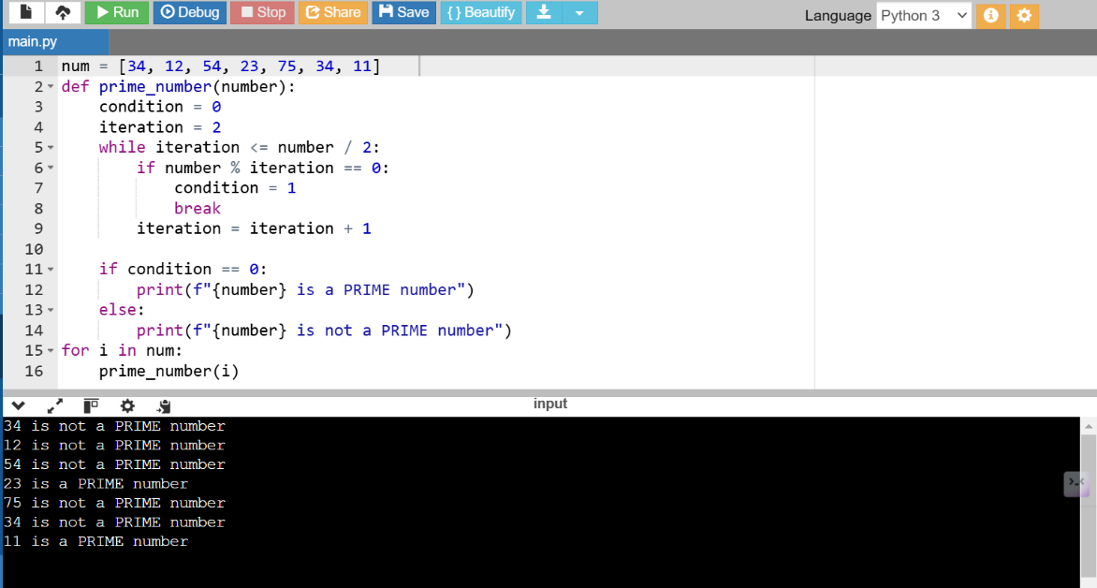

1. **Armstrong number**

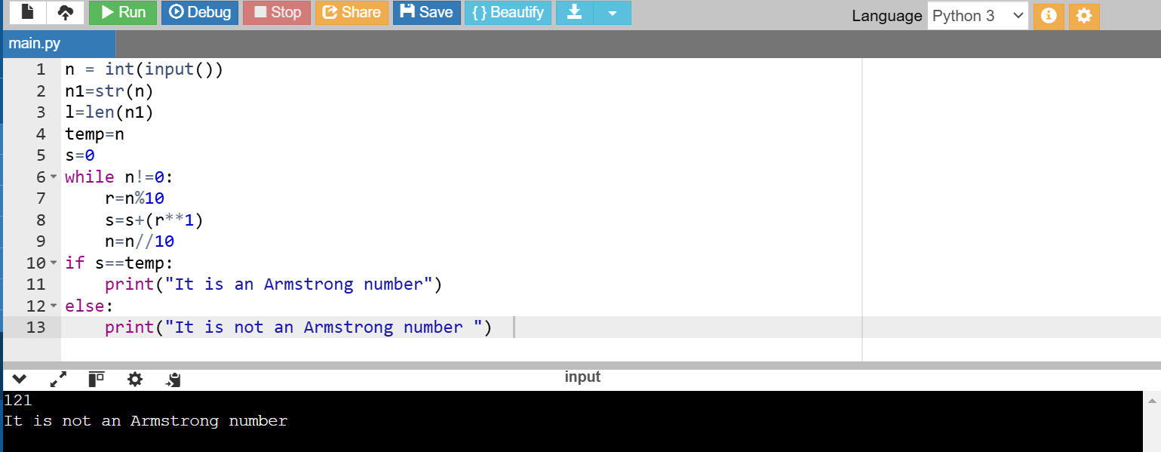

1. **Multiplication Table**

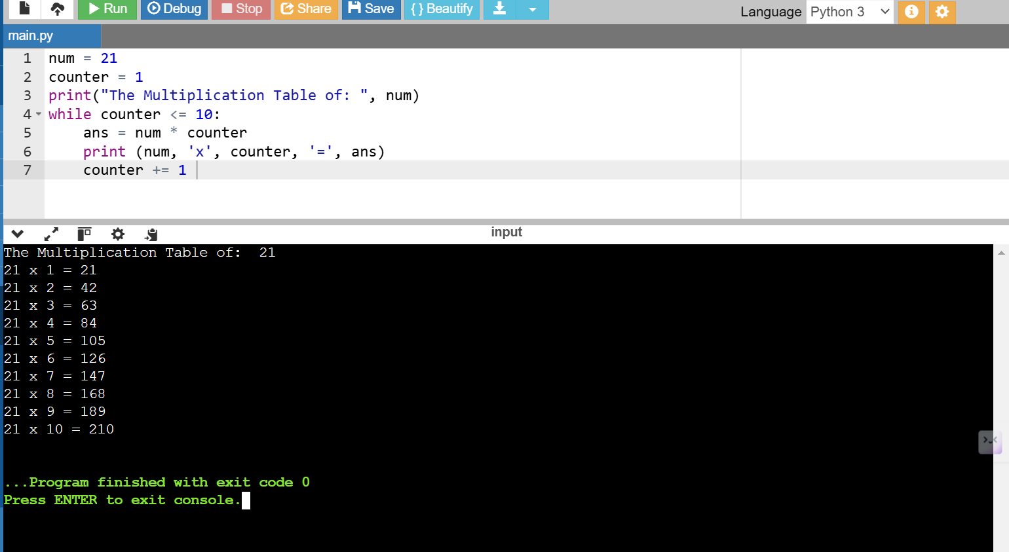

**BREAK Statement:**

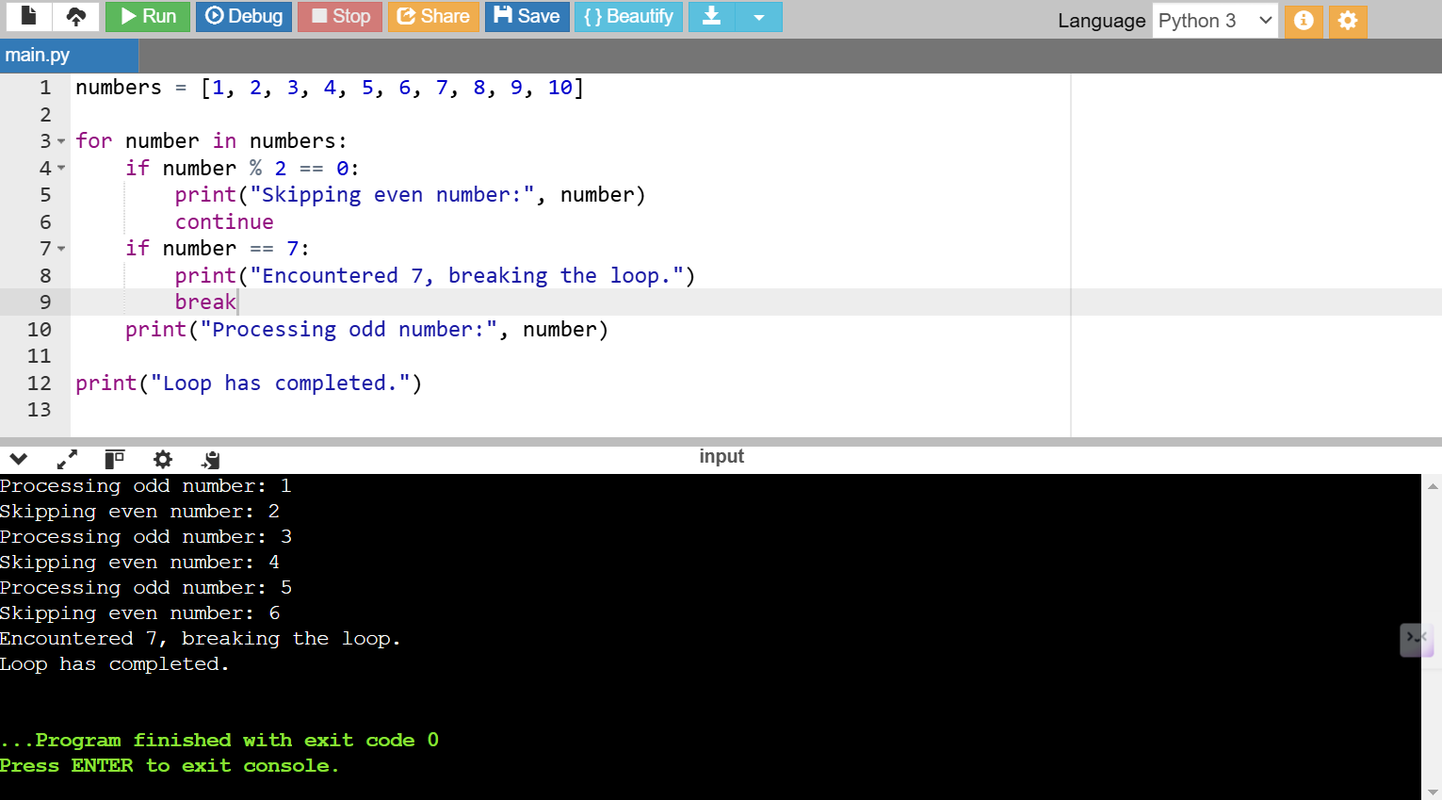

**PYTHON STRINGS**

Creating String in Python

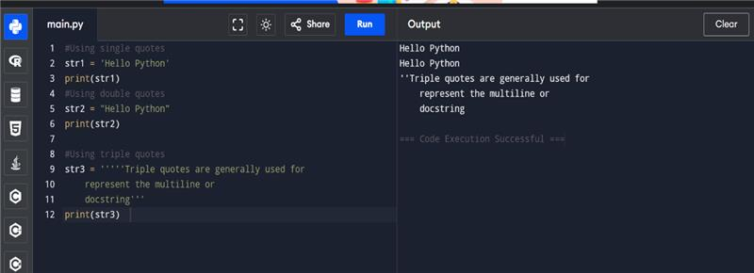

Strings indexing and splitting

Example 1:

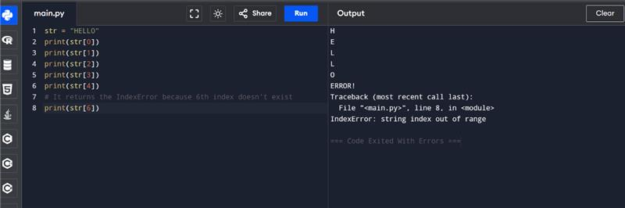

Example 2

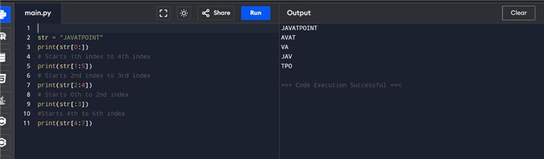

Strings Operators

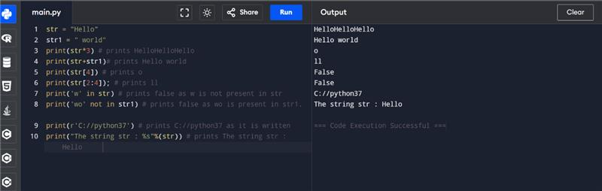

String formatting

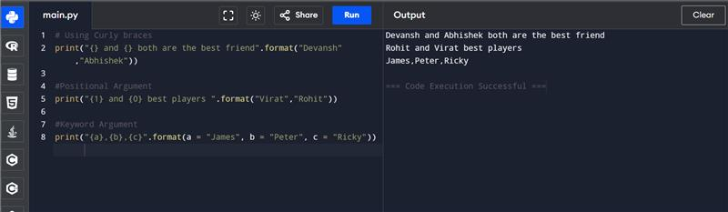

**List and Tuple Syntax Differences**

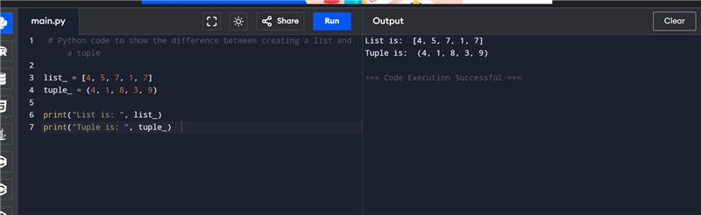

**Updating the element of list and tuple at a particular index**

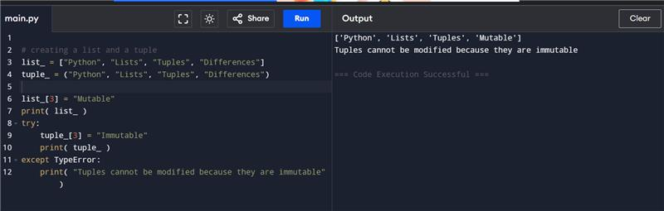

**Code to show the difference in the size of a list and a tuple**

