KARANAM YESWANTH TEJA

289224

GROOVY ASSIGNMENT

GROOVY BASIC SYNTAX

1. WITH COMMENTS

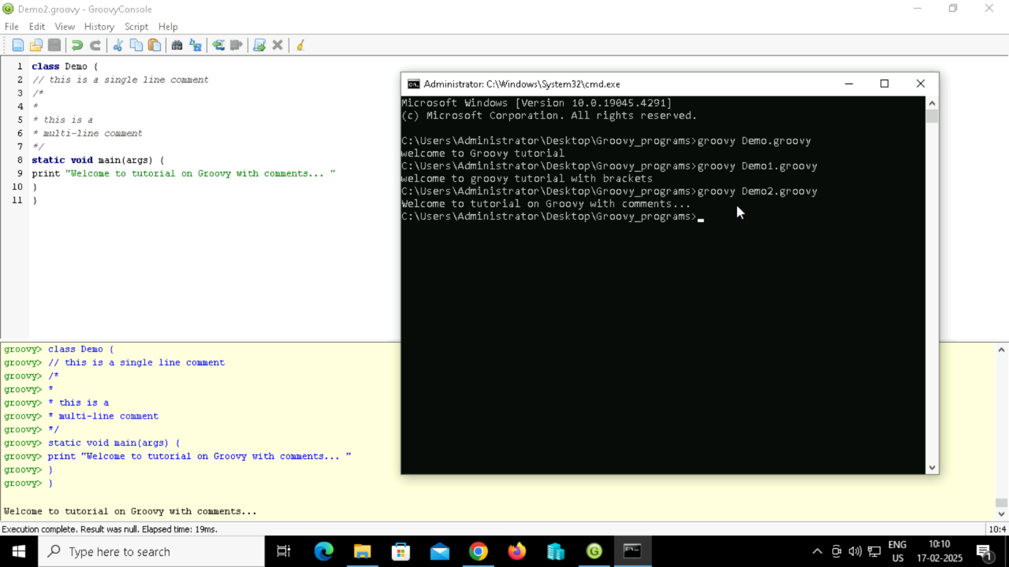

1. WITHOUT BRACKETS

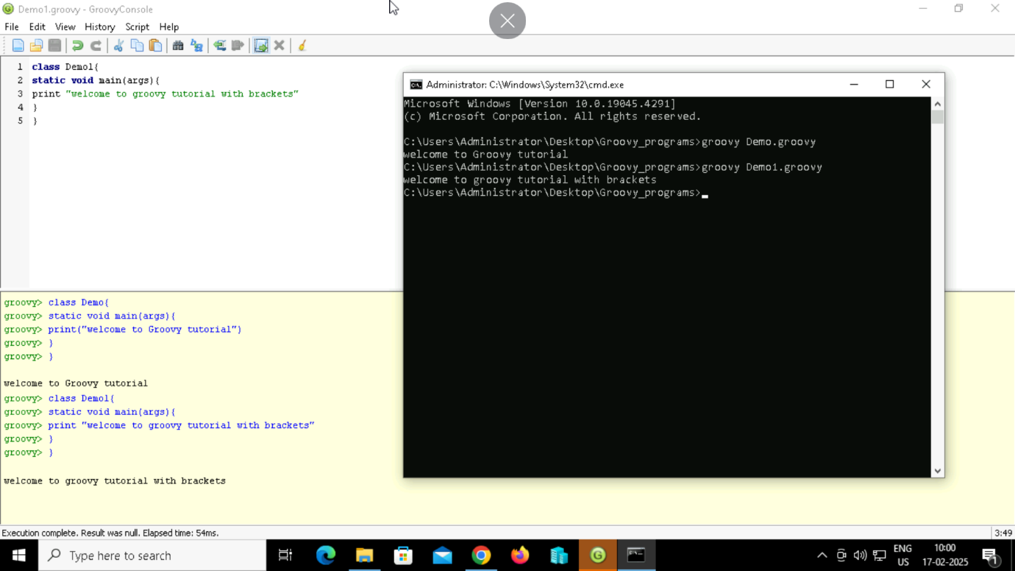

1. WITH BRACKETS

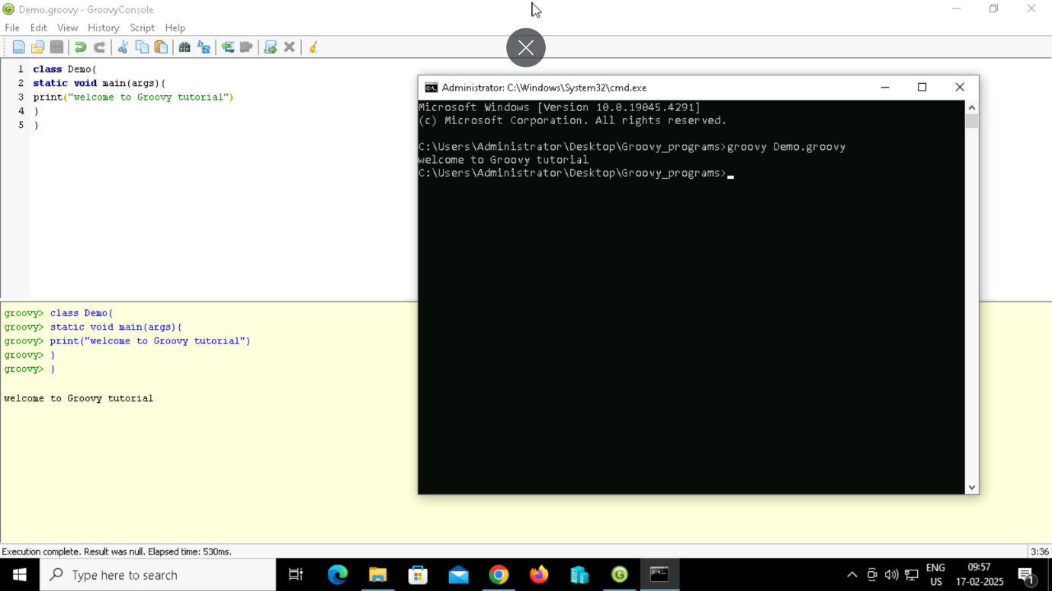

1. WITHOUT MAIN CLASS

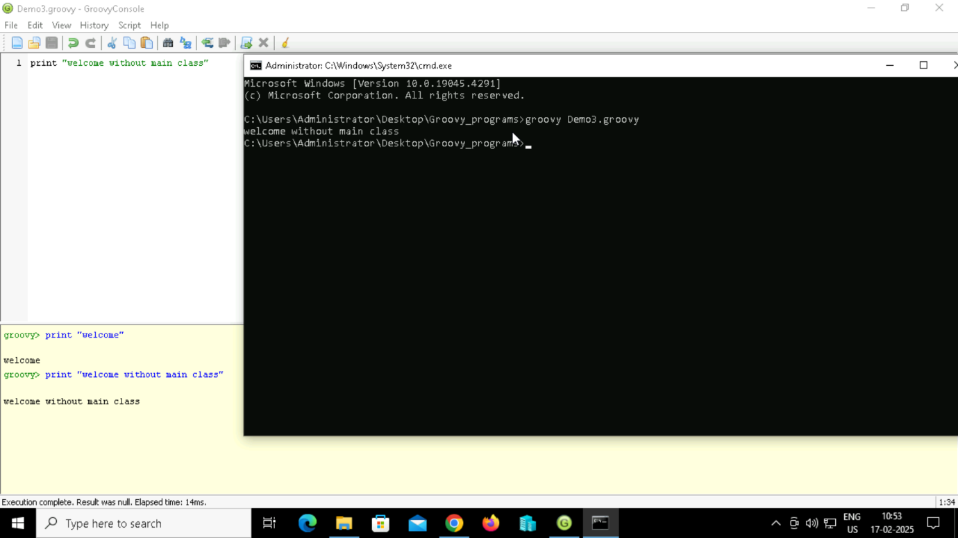

**GROOVY OPERATORS**

1. **Arithmetic operators**

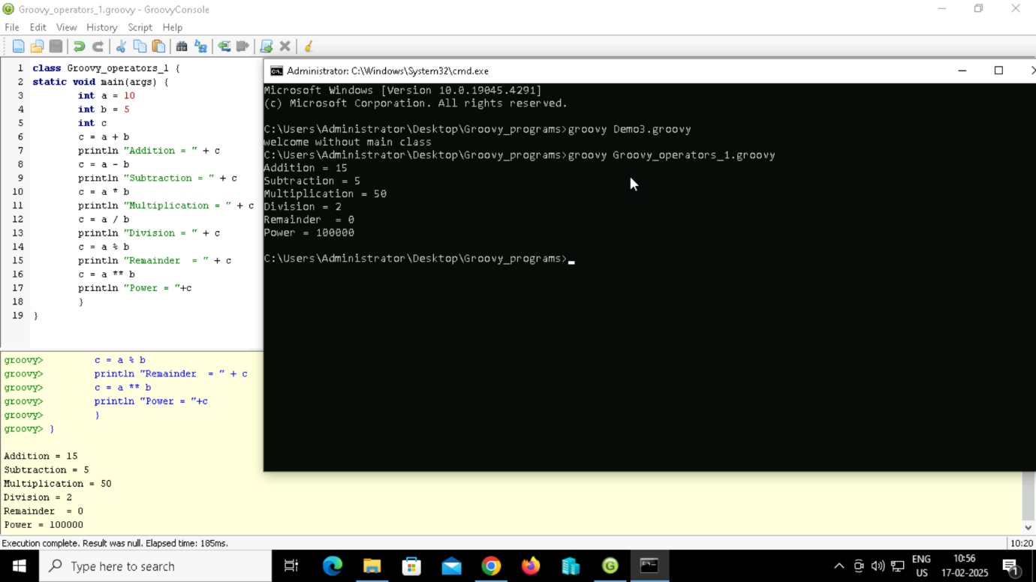

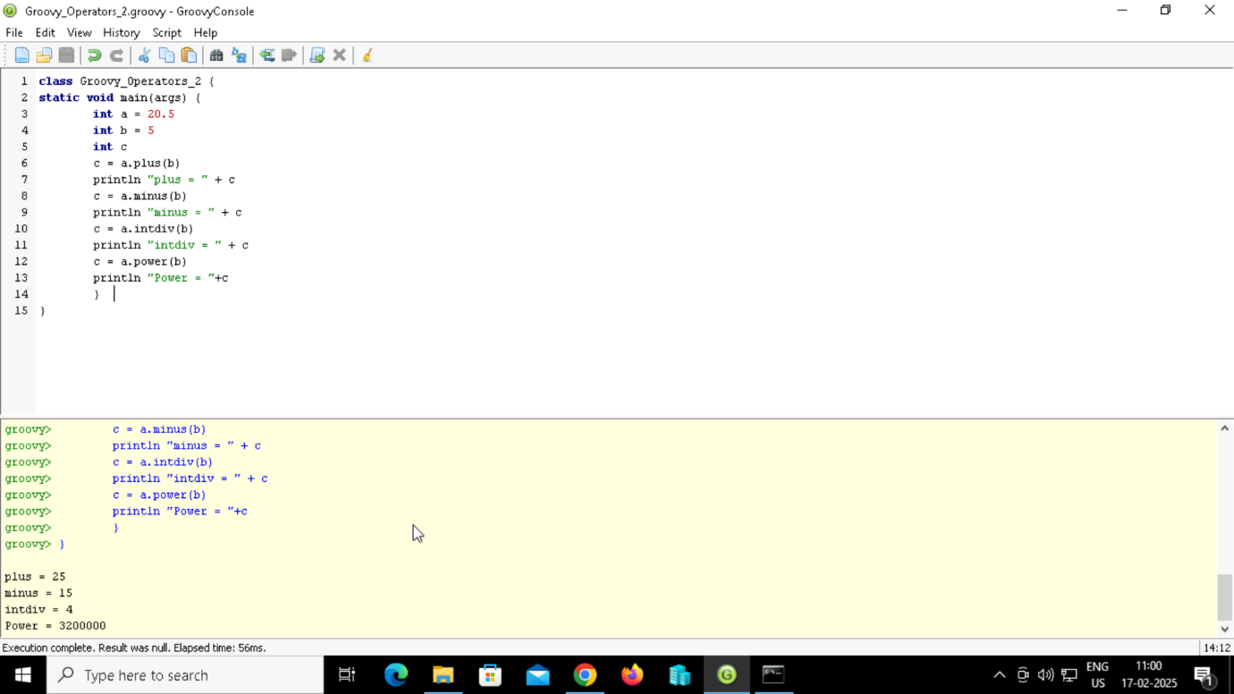

1. **Unary operators**

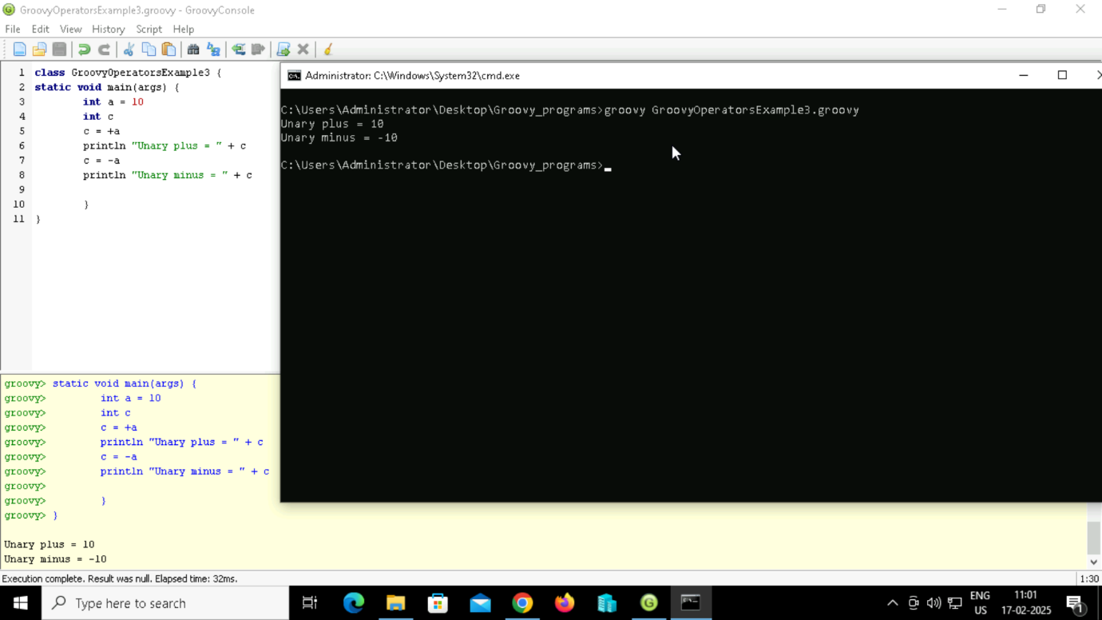

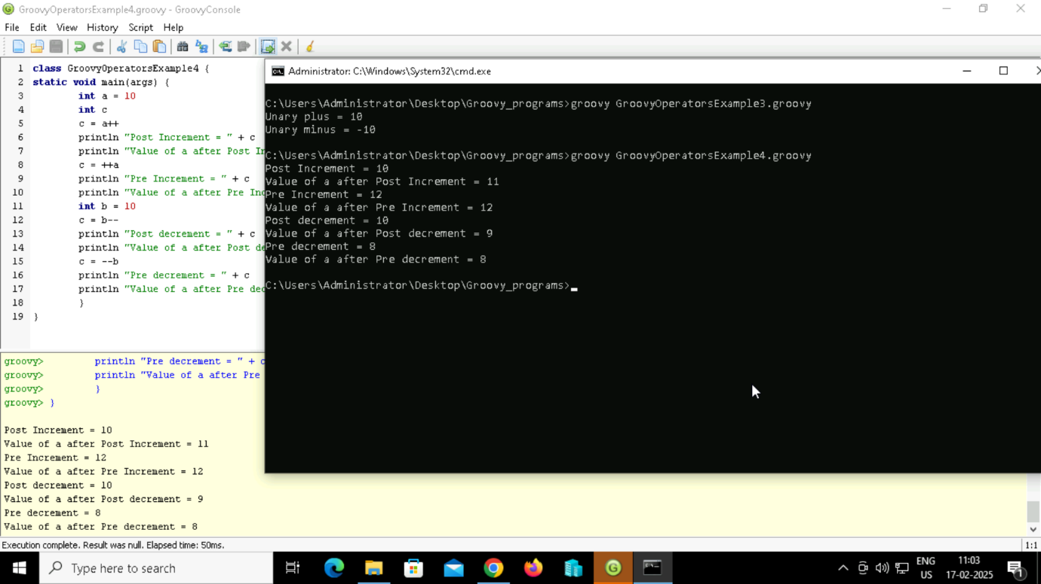

1. **Assignment arithmetic operators**

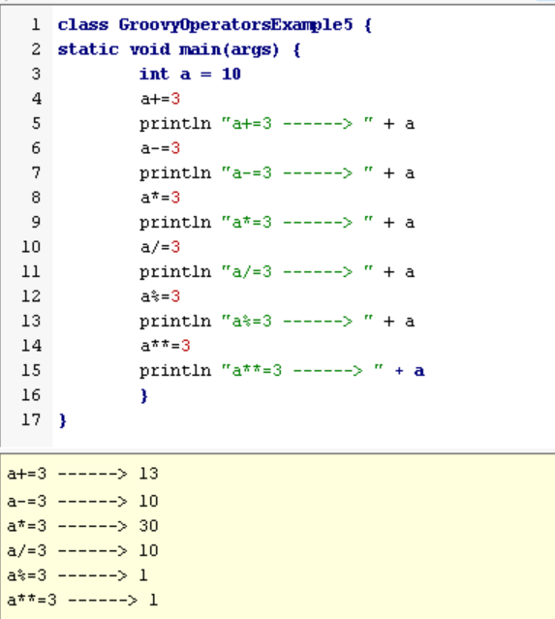

1. **Relational operators**

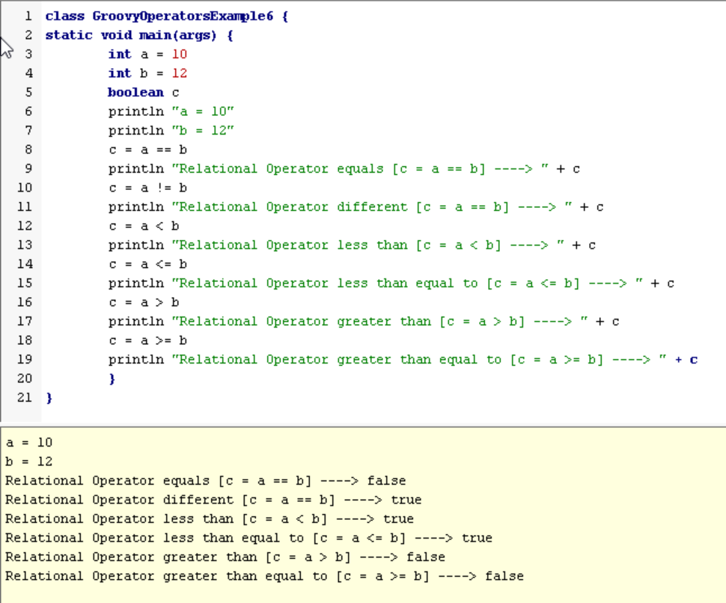

1. **Logical operators**

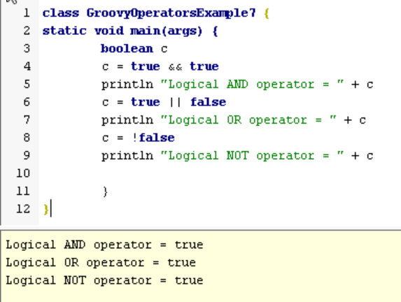

1. **Bitwise operators**

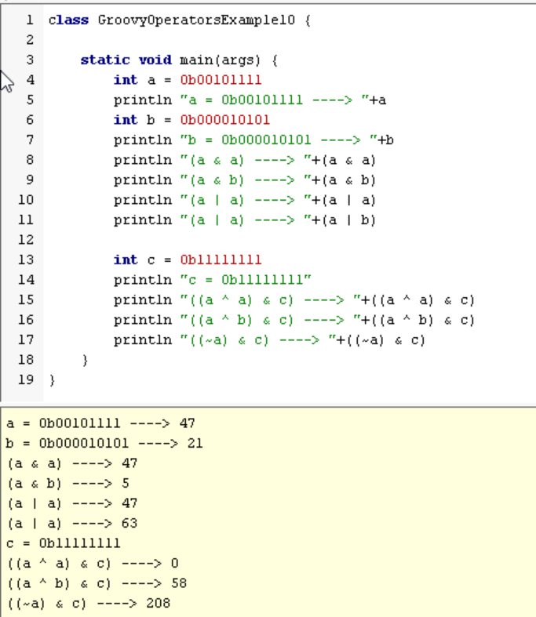

1. **Conditional operators**

