KARANAM YESWANTH TEJA

289224

**PYTHON CASE STUDY**

1. Log File Analysis & Monitoring with Groovy

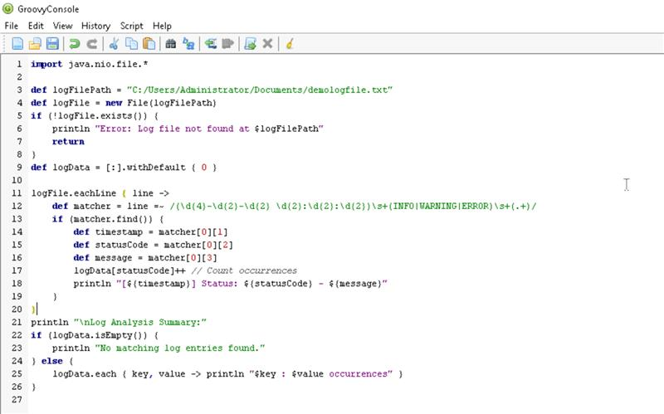

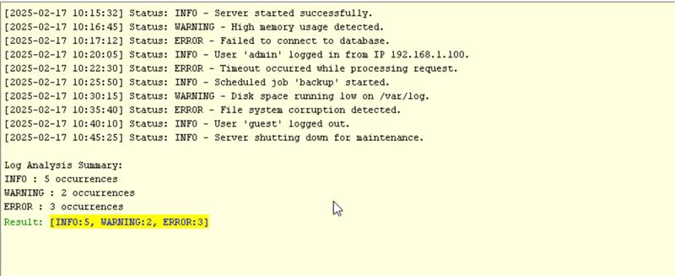

1. Web Scraping & Data Extraction with Groovy & Jsoup

