**KARANAM YESWANTH TEJA**

**289224**

**GROOVY PROJECT**

**DECISION MAKING:**

**1.  IF Statement:**

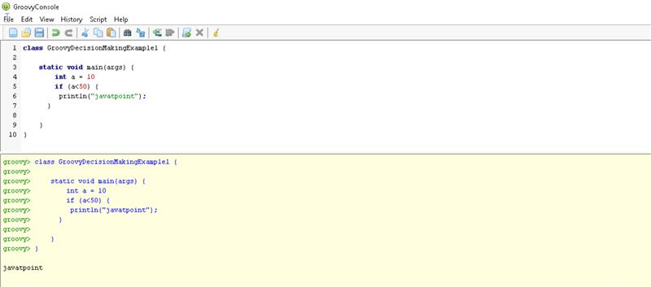

**2. IF- ELSE:**

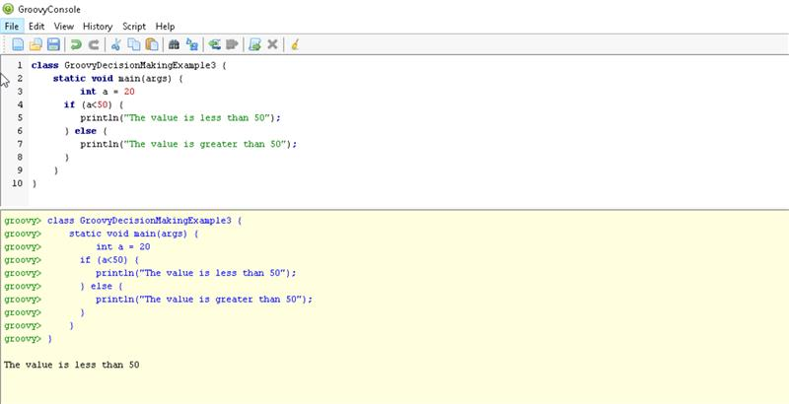

**3.NESTED – IF:**

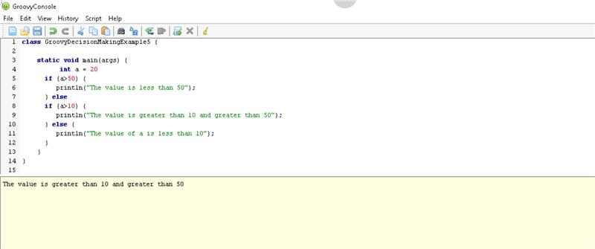

**4. SWITCH STATEMENTS:**

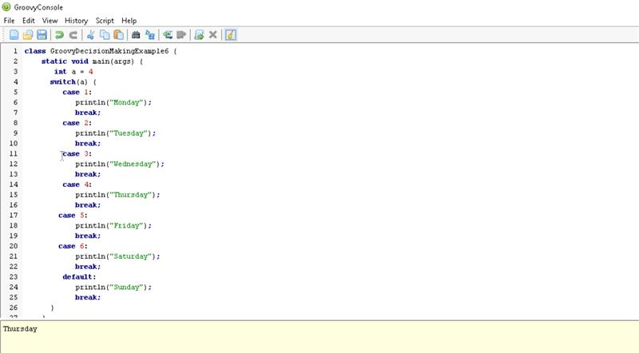

**STRINGS**

**Single quoted Strings**

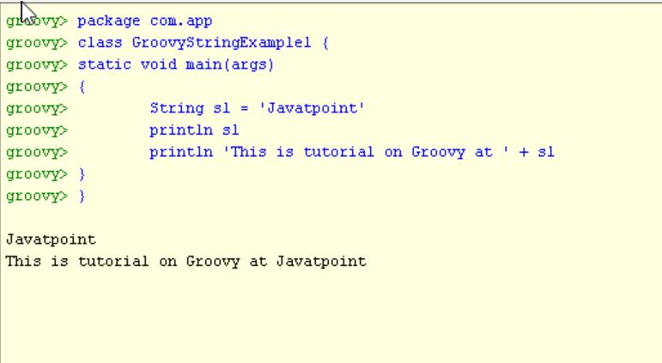

**Double quoted strings**

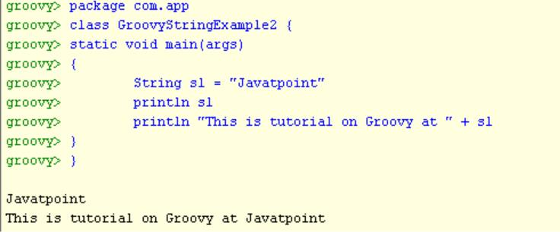

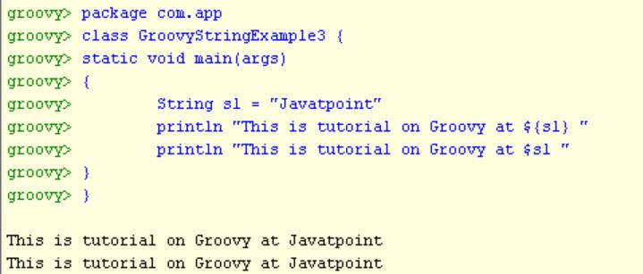

**Triple quoted Strings**

