

SCHOOL OF TECHNOLOGY AND SOCIAL SCIENCES
BIT402- IS PROJECT/RESEARCH

CropIQ: A Crop Reccomendation & Education System.
MUTUMWENU YETA
ID NO: BIT2221698
TABLE OF CONTENTS
CHAPTER 1 3
PROJECT TITLE 3
INTRODUCTION 3
BACKGROUND OF THE STUDY 4
PROBLEM OF THE STATEMENT 5
PROJECT OBJECTIVES 5
SIGNIFICANCE OF THE STUDY 6
SCOPE AND LIMITATIONS OF THE STUDY 7
PROJECT METHODOLOGY 8
DATA COLLECTION 9
EVALUATION AND TEST PLAN 11
CHAPTER 2 14
LITERATURE REVIEW 14
EXISTING SYSTEMS 14
PROPOSED SYSTEM VS EXISTING SYSTEMS 17
RELEVANCE OF CROPIQ 19
CHAPTER 3 20
SYSTEM SPECIFICATIONS REQUIREMENTS 20
FUNCTIONAL REQUIREMENTS 20
NON-FUNCTIONAL REQUIREMENTS 26
HARDWARE AND SOFTWARE REQUIREMENTS 28
CHAPTER 4 31
RESEARCH METHODOLOGY 31
DATA COLLECTION 31
DEVELOPMENT METHODOLOGY 34
CHAPTER 5 38
SYSTEM ARCHITECTURE 38
SYSTEM ARCHITECTURE DIAGRAMS 41
SYSTEM ARCHITECTURE SUMMARY 56

CHAPTER 1

PROJECT TITLE
CROPIQ
CropIQ is a mobile app that allows farmers and agricultural stakeholders to view historical weather data for their specific region and obtain data-driven crop suggestions. The system combines meteorological records with extensive crop knowledge bases to deliver thorough educational information on crop requirements, water demands, soil appropriateness, and common diseases, allowing for more educated agricultural decision-making.

INTRODUCTION
The convergence of information technology and communication technology has created an environment where agricultural stakeholders can access weather data, crop information, and agronomic knowledge online from anywhere, anytime. Hence, the demand for digital agricultural services has increased with the rapid advancements of information technologies, benefiting both farmers and agricultural extension services.
Agriculture continues to be a critical component of global food security and economic growth. Farmers continue to confront major hurdles in crop selection and management due to unpredictable weather patterns, limited access to historical climatic data, and a lack of agronomic understanding. Climate change has intensified these uncertainties, making conventional farming approaches more unreliable. Poor crop selection frequently results in lower yields, economic losses, and food poverty.
Many of these agricultural technological developments are great; they increase production, make vital information more accessible, and enhance overall farming results and lives. According to current research, digital agricultural technologies can enhance crop yields by 20-30% by improving decision-making and resource management (Zhang et al., 2022; Lowenberg-DeBoer et al., 2020).
A study by Kemp (2016) indicates that a total of 16.40 million cellular mobile connections were active in Zambia in early 2024, with this figure equivalent to 78.7 percent of the total population. This insight indicates that approximately 80% of Zambia's population has access to the internet and ICT services, creating a substantial opportunity for digital agricultural solutions.
As a result, various sectors have embraced technology to improve service delivery. For instance, communication and internet service providers such as Airtel, Zamtel, and MTN have embraced FinTech and developed efficient mobile money services. However, the absence of a comprehensive platform that provides farmers with accessible weather data and crop advisory services calls for the necessity of a mechanism to facilitate informed agricultural decision-making. Hence, a study on the context, purpose, significance, and scope will be discussed in this chapter.

BACKGROUND OF THE STUDY

Agriculture is an important driver of food security, economic growth, and rural life in Zambia. Despite its crucial relevance, the industry confronts various issues that jeopardize production and sustainability. Among these issues, Zambian farming communities continue to face unexpected weather patterns, climatic unpredictability, and a lack of accurate agricultural information (Muchapondwa & Ndhlovu, 2020). Farmers have traditionally made crop selection selections based on indigenous knowledge, seasonal cycles, and agricultural extension officials' guidance.

While these systems have served communities for centuries, they are becoming increasingly unreliable as climate change alters rainfall and temperature patterns throughout Zambia. Many farmers also lack access to historical weather data, which may help them make better crop decisions. This leads to mismatches between crop requirements and local climatic conditions, resulting in lower yields and financial losses (Mulungu et al., 2022).

Furthermore, many Zambian smallholder farmers lack a thorough understanding of crop-specific requirements such as water demands, soil preferences, pest and disease control, and ideal growth conditions. This information gap leads to inefficient resource usage, increased vulnerability to climate-related shocks, and lower production. Agricultural extension services are vital, but they frequently fail to reach all farmers owing to limited personnel, resource restrictions, and rural dispersion of towns.

The emergence of digital technologies, as well as rising internet and mobile adoption in Zambia, provide a chance to close the knowledge gap. Digital agricultural advising systems can improve access to essential farming information, allowing farmers to make more educated decisions based on scientific evidence rather than guesswork. By combining climatic data and agronomic expertise, these systems provide tailored suggestions that boost production and climate resistance.

As climate unpredictability continues to disrupt Zambia's agricultural systems, there is an urgent need to scale up new technological solutions that offer farmers with easily available, reliable, and actionable information. Such technologies have the ability to alter agricultural practices, increase food security, and enhance rural livelihoods by providing farmers with the knowledge they need to flourish in uncertain climate circumstances (GIZ & University of Reading, 2023).

PROBLEM OF THE STATEMENT
Farmers in Zambia struggle with crop selection owing to a lack of dependable meteorological data and agronomic understanding. Climate-induced consequences, such as late rains, droughts, and higher temperatures, cause 50-75% losses in crop output among smallholder farmers, who account for 80% of the country's food supply (Global Centre on Adaptation, 2024; AGRA, 2025). This knowledge gap leads to inferior crop selections, lower yields, and economic losses.
The current agricultural extension services cannot sufficiently serve all farmers, with a farmer-to-extension agent ratio of 1:1,000 to 1:1,200, leaving most smallholders underserved (Ministry of Agriculture Zambia, 2024). Farmers lack location-specific, data-driven suggestions and base their decisions on insufficient information, resulting in poor crop selection and resource management.
There is an obvious demand for technical solutions that combine meteorological information with agricultural knowledge to deliver accessible advice services. Digital platforms can close the extension service gap by providing farmers with credible information to make educated crop selection decisions, hence increasing agricultural production and climate resilience (UNDP Zambia, 2024).
.

PROJECT OBJECTIVES
The objectives of the study include the General Objective and Specific Objectives. These are:

GENERAL OBJECTIVE
To develop a mobile application that will provide farmers and agricultural stakeholders with a digital platform where they can access historical weather data for their location and receive data-driven crop recommendations along with comprehensive educational information on crop management.

SPECIFIC OBJECTIVES
- To design a mobile application that allows users to enter their location and retrieve historical weather data for that specific area.
- To implement a crop recommendation engine that suggests suitable crops based on the weather patterns and climate conditions of the user's location.
- To develop a comprehensive crop knowledge base that provides detailed information on crop requirements, water needs, soil suitability, and common diseases.
- To create an educational module that supports farmers in making informed crop choices, improving yields, and reducing agricultural risks.
- To integrate weather APIs and agricultural datasets to ensure the system provides accurate and up to date information.

SIGNIFICANCE OF THE STUDY
This initiative intends to significantly improve the way farmers and agricultural stakeholders acquire weather information and make crop selection decisions. The study's conclusion attempts to simplify crop planning by offering credible, data-driven suggestions that match crops to local climate conditions, saving time, lowering risks, and enhancing agricultural outcomes.
By bridging the gap between meteorological data, agronomic knowledge, and farming practice, the application will provide a more efficient and informed approach to agricultural decision-making. Integrating historical weather data with a comprehensive agricultural knowledge base increases suggestion quality by taking into account location-specific climatic trends and crop requirements.
Furthermore, the mobile application will provide farmers with thorough instructional information on specific crops, such as water needs, soil preferences, pest and disease control tactics, and ideal growth conditions. This instructional component provides farmers with knowledge that goes beyond basic suggestions, allowing them to grasp the reasoning behind crop selections and improve their farming methods over time.

The method has the potential to improve agricultural production, food security, resource management, crop failure rates, and farmer revenue. By democratizing access to agricultural information, the initiative promotes sustainable agricultural growth and assists farmers in developing resilience to climatic unpredictability and change.

SCOPE AND LIMITATIONS OF THE STUDY

Scope
- The system will be accessible as a mobile application, allowing users to access services through internet-enabled devices including tablets and smartphones.
- The scope of the system addresses coverage for farmers and agricultural stakeholders who need location-specific crop recommendations based on historical weather data and agronomic knowledge.
- The system will integrate weather APIs (such as open-meteo.com) to retrieve historical weather data for user-specified locations.
- The application will include a comprehensive crop knowledge base containing information on multiple crop varieties, including their requirements, characteristics, and management practices.
- The system will provide crop recommendations based on climate suitability, along with detailed educational information on water requirements, soil suitability, and common diseases.
- The application will utilize agricultural datasets from reliable sources such as FAO (Food and Agriculture Organization) and Ministry of Agriculture to ensure accuracy and comprehensiveness of crop information.

Limitations
- The system's recommendations are based on historical weather data, which may not account for unexpected climatic anomalies or extreme weather occurrences that depart dramatically from past patterns.
- The occuracy of weather data is dependent on the availability and quality of data from third-party weather APIs, which may have limited coverage or historical depth for certain geographical locations.
- The application may first focus on common crop types in the target region, omitting specialist or niche crops until the knowledge base is built.
- Farmers in places with inadequate internet infrastructure may face limited access to weather data and the application due to the system's internet connectivity requirements.
- The system's effectiveness relies on users' ability to accurately specify their location and understand the recommendations, which may require basic digital literacy. While the system provides advisory information and recommendations, crop success is not guaranteed due to factors such as farmer practices, input quality, and unforeseen environmental conditions.

PROJECT METHODOLOGY
Under this research study, the researcher opted to use the Agile model in the development of the Weather-Based Crop Advisory System. This model is a combination of iterative and incremental process models with focus on process adaptability and customer satisfaction by rapid delivery of working software product. Agile Methods segment the product into small incremental builds. These builds are provided in iterations.
The developer opted for this model due to the following reasons:
i. Instead of relying solely on documentation, demonstrating working software is said to be the greatest method of communicating with users (farmers and agricultural stakeholders) to understand their needs and gather feedback on system functionality.
ii. User collaboration – is the backbone of this methodology. Requirements cannot be gathered completely at the beginning of the project due to various factors. Continuous interaction with farmers, agricultural officers, and other stakeholders is very important to get proper product requirements and ensure the system meets actual user needs.
iii. Unlike the waterfall model which uses a predictive approach towards development, the Agile development methodology uses an adaptive approach which makes it ideal for the developer as they can quickly adapt to changing requirements because of constant user collaboration and communication. This is particularly important in agricultural systems where user needs may evolve as they interact with the system.
iv. Agile encourages early and regular delivery of working software, enabling quick release of functional increments of the application. This is beneficial for testing, validation, and early adoption by users, allowing farmers to start benefiting from the system even as additional features are being developed.
v. The iterative nature of Agile allows for continuous improvement based on user feedback, which is crucial for developing an effective agricultural advisory system that truly meets farmer needs.

Development Phases
The project will follow these phases in accordance with Agile methodology:
Phase 1: Requirements Gathering and System Design
- Conduct stakeholder interviews with farmers and agricultural officers
- Define system requirements and user stories
- Create initial system architecture and design mockups
- Establish success criteria and acceptance tests
Phase 2: Database Design
- Design and implement database schema for weather data storage
- Create crop knowledge base structure
- Integrate agricultural datasets from FAO and Ministry of Agriculture
- Set up Supabase database infrastructure
Phase 3: Frontend Development
- Develop user interface for location input
- Create visualization components for weather data display
- Design crop recommendation presentation interface
- Implement responsive design for multi-device accessibility
Phase 4: API Integration and Recommendation Engine
- Integrate open-meteo.com API for weather data retrieval
- Develop crop recommendation algorithm based on climate suitability
- Implement location-based data processing
- Create data validation and error handling mechanisms
Phase 5: Educational Module Development
- Develop detailed crop profile pages
- Create educational content on crop requirements, diseases, and management
- Implement search and filtering functionality for crop information
- Design user-friendly information presentation
Phase 6: Testing, Evaluation, and Improvements
- Conduct functional testing of all system components
- Perform usability testing with sample users (farmers and agronomists)
- Gather user feedback and implement improvements
- Conduct performance testing and optimization
- Prepare system documentation and user guides

DATA COLLECTION
Research methodology, according to Murthy & Bhojanna (2009, p. 32), is the systematic approach to solving a research problem through data collection using a variety of methodologies and procedures, offering an interpretation of the data acquired, and drawing inferences from the research findings.
In this study, we will utilize comprehensive approaches to acquire information from key stakeholders in the agricultural sector. The following data collection techniques will be used to gather data:

Literature Review

Purpose: Learn about existing research on agricultural advisory systems, crop-climate linkages, and digital agriculture solutions to help identify gaps in present systems and ways to increase efficiency and effectiveness.
Data sources: include Ministry of Agriculture, FAO, and Zamstats databases.
Data points: include agricultural decision-support systems, crop-climate suitability studies, weather data applications in agriculture, farmer information requirements, digital agriculture adoption patterns, and best practices in agricultural advisory services.

Questionnaires

The intended audience includes farmers, agricultural extension officials, and agronomists.
Purpose: Gather data on present practices, information needs, crop selection issues, and user expectations for digital agricultural advising tools.
Format: Multiple-choice questions, Likert scale ratings, and open-ended questions are used to collect both quantitative and qualitative data.
Data points: include demographics, agricultural experience, current information sources, crop selection issues, weather data requirements, levels of technology usage, desired information formats, satisfaction with present advisory services, and ideas for improvements.

Interviews
Target Audience: Experienced farmers, agricultural officers, agronomists, and crop specialists.
Purpose: Understand operational issues in agricultural decision making, collect expert information on crop requirements, and provide specific recommendations for system features and content.
Format: Semi structured interviews in confidential settings, allowing for in depth exploration of experiences and perspectives.
Data Points:Farmer viewpoints on crop selection issues, expert understanding of crop-climate linkages, present advisory service efficacy, information accessibility constraints, user interaction preferences, and proposals for improving agricultural decision-support tools.

Agricultural Dataset Analysis
Purpose: Analyze existing agricultural and weather datasets to understand data structures, availability, and quality for system integration.
Data Sources: FAO crop databases, Ministry of Agriculture Dataset, OpenMateo API historical data, agricultural research repositories.
Data Points: Crop characteristics, climatic conditions, soil preferences, water requirements, disease information, historical weather patterns, and data quality metrics.

EVALUATION AND TEST PLAN

Success Criteria
The system will be considered successful if it meets the following criteria:
- Weather Data Accuracy: The system accurately retrieves and displays historical weather data based on user-specified locations with at least 95% accuracy.
- Recommendation Relevance: The system correctly recommends crops that are climatically suitable for the location's weather patterns, validated by agricultural experts.
- Educational Content Quality: The system provides accurate, comprehensive, and accessible educational content on crop requirements, water needs, soil suitability, and common diseases.
- User Interface Effectiveness: Users can easily navigate the system, input their location, and understand the recommendations provided without requiring extensive technical knowledge.
- System Performance: The system responds to user queries within acceptable time frames (less than 5 seconds for most operations) and handles concurrent users without performance degradation.

Testing Strategy
Functional Testing:
- Test system features to verify they perform properly.
- Validate weather data retrieval via API.
- Validate crop recommendation algorithm logic.
- Test database operations for data integrity.
- Check user interface components for functionality.
Usability Testing:
- Conduct testing sessions with sample users including farmers and agronomists
- Evaluate ease of navigation and understanding of recommendations
- Assess clarity of educational content
- Gather feedback on user interface design and user experience
- Measure task completion rates and user satisfaction
Database Testing:
- Test with at least 100+ entries for weather records
- Validate crop knowledge base with comprehensive crop data
- Test data retrieval speed and accuracy
- Verify database integrity and consistency
- Test backup and recovery procedures
Integration Testing:
- Test integration between frontend and backend components
- Verify API integration with weather data providers
- Test database connectivity and data flow
- Validate recommendation engine integration with crop knowledge base
Performance Testing:
- Test system response times under various load conditions
- Evaluate database query performance
- Test with multiple concurrent users
- Identify and address performance bottlenecks
User Acceptance Testing:
- Deploy system to a test group of farmers and agricultural officers
- Gather feedback on system usefulness and practical applicability
- Validate that system meets user needs and expectations
- Document user suggestions for improvement

CHAPTER 2

LITERATURE REVIEW
In today's digital age, technology has expedited the procedures of service and product procurement in a variety of industries, including agricultural. Newly developed and deployed technologies are changing people's lives and consumption habits, drastically affecting the nature of interactions between service providers and end users (Zouari & Abdelhedi, 2021). The agriculture industry has profited significantly from digital advances that overcome information gaps and improve farmers' decision-making capacities. Thus, in this chapter, we will examine and evaluate three existing systems for agricultural advisory and weather-based decision assistance. This evaluation aims to give an examination of the existing systems' capabilities (features), limits, and why CropIQ is significant in comparison to other systems.

EXISTING SYSTEMS

FarmRise
FarmRise is a comprehensive digital agricultural platform that provides farmers with market linkages, agronomic advice, and input supply services. According to the platform's documentation, FarmRise connects smallholder farmers with buyers, agricultural experts, and suppliers through a mobile application (FarmRise, 2024). The system enables farmers to access real-time market prices, sell their produce directly to buyers, and receive agronomic guidance on crop production practices. FarmRise has expanded across several African countries, including Kenya, Tanzania, and Uganda, serving thousands of smallholder farmers.
Features:
- Market Linkages:Connects farmers and buyers directly, reducing middle men and increasing profit margins.
- Agronomic Advisory: Offers farmers specialized assistance on crop management, pest control, and best agricultural practices.
- Input Supply: Provides access to high-quality agricultural supplies such as seeds, fertilizers, and insecticides at cheap costs.
- Mobile Application: operates using a user friendly mobile platform accessible via smartphones.
- Real-time Information: Offers current market prices and demand information to help farmers make better selling decisions.
- Payment Integration: Includes mobile money integration for seamless transactions between farmers and consumers.

Limitations:
- Limited Weather Integration: While providing agronomic advice, the system lacks comprehensive historical weather data integration for location-specific crop recommendations.
- Internet Dependency: Requires reliable internet connectivity, which may be challenging in remote rural areas.
- Market Focus: Primarily emphasizes market linkages and input supply rather than climate-based crop selection guidance.
- Limited Educational Content: Does not provide detailed educational modules on crop requirements, soil suitability, and disease management.
- Geographic Coverage: Initially focused on specific regions, limiting accessibility for farmers in other areas.

Plantix
Plantix is a mobile crop advisory application developed by PEAT GmbH that uses artificial intelligence and image recognition technology to diagnose plant diseases, pests, and nutrient deficiencies. The developers state that Plantix has been downloaded by millions of farmers globally and provides instant diagnostic capabilities through smartphone cameras (PEAT GmbH, 2024). The application allows farmers to take photos of affected plants and receive immediate identification of problems along with treatment recommendations.
Features:
- AI-Powered Diagnostics: Uses image recognition and machine learning to identify plant diseases, pests, and deficiencies from photos.
- Instant Recommendations: Provides immediate treatment suggestions and management practices for identified problems.
- Community Forum: Enables farmers to connect with agricultural experts and other farmers to share experiences and solutions.
- Crop Library: Contains information on various crops and their common problems
- Multilingual Support: Offers content in multiple languages to serve diverse farming communities.
- Offline Functionality: Some features work offline, allowing access without constant internet connectivity.
Limitations:
- Limited Weather Focus: Does not integrate historical weather data or provide weather-based crop selection recommendations.
- Diagnostic Focus: Primarily concentrates on problem identification rather than preventive crop planning based on climate suitability.
- Requires Image Quality: Accurate diagnosis depends on clear, well-lit photos, which may be challenging for some users.
- Limited Location Specificity: Does not provide location-specific climate analysis for crop recommendations.
- Reactive Rather Than Proactive: Addresses problems after they occur rather than helping farmers make informed crop selection decisions beforehand.

Kurima Mari (Farm Well)
Kurima Mari is a digital agricultural extension platform developed in Zimbabwe that provides farmers with weather forecasts, agronomic advice, and market information through SMS and mobile application. According to project documentation, the platform aims to improve agricultural productivity by delivering timely and relevant information to smallholder farmers (Kurima Mari, 2024). Kurima Mari partners with meteorological services to provide weather forecasts and collaborates with agricultural extension services to deliver farming advice.
Features:
- Weather Forecasts: Provides short-term weather forecasts to help farmers plan agricultural activities.
- SMS Integration: Delivers information via SMS, making it accessible to farmers with basic mobile phones.
- Agronomic Advice: Offers farming tips and best practices for various crops and livestock.
- Market Information: Provides market prices and demand information for agricultural products.
- Local Language Support: Content is available in local languages to enhance accessibility.
- Extension Service Integration: Collaborates with government extension services to validate and deliver information.

Limitations:
- Short-term Focus: Primarily provides short-term weather forecasts rather than historical weather data analysis for long-term crop planning.
- Limited Crop Recommendation Engine: Does not offer automated crop recommendations based on comprehensive climate suitability analysis.
- Basic Educational Content: Lacks detailed educational modules on crop-specific requirements, water needs, and disease management.
- Limited Personalization: Provides general advice rather than location-specific, data-driven recommendations.
- SMS Limitations: SMS delivery can be constrained by character limits, reducing the depth of information shared.
- Dependency on Partnerships: Reliance on external partners for weather and extension services may affect service continuity.

PROPOSED SYSTEM VS EXISTING SYSTEMS

CropIQ vs FarmRise
Both CropIQ and FarmRise are digital platforms that link farmers to agricultural information, although they handle distinct parts of farming concerns. FarmRise specializes in market linkages and input supply, connecting farmers, buyers, and suppliers. However, the technology does not fully integrate past meteorological data to provide location-specific crop selection suggestions. This constraint, albeit considerable, points to an opportunity for CropIQ to thrive.
CropIQ fills a significant gap in agricultural decision-making by combining historical weather data analysis with climate-based crop recommendations. The technology extends beyond market connection to assist farmers in making educated crop selection selections prior to planting, lowering the chance of crop failures caused by climatic mismatches. CropIQ also offers rich instructional information on crop requirements, water demands, soil appropriateness, and disease management, providing farmers with a complete knowledge base and empowering them with agronomic intelligence.

While FarmRise focuses on post-production market access and input procurement, CropIQ on pre-season planning and climate-informed decision-making. This proactive method assists farmers in selecting appropriate crops based on their location's past weather trends, potentially increasing yields and avoiding economic losses. In summary, whereas FarmRise focuses on market efficiency, CropIQ tackles the basic difficulty of climate-appropriate crop selection by employing intelligent data analysis to improve farmers' crop intelligence levels.

CropIQ vs Plantix
Plantix and CropIQ both use digital technology to help farmers, but they play separate roles in the agricultural value chain. Plantix specializes in using AI-powered picture recognition to diagnose plant illnesses, pests, and nutritional deficits, and provides reactive remedies to issues as they arise. It emphasizes issue diagnosis and treatment suggestions, offering essential assistance throughout the growth season.
In contrast, CropIQ takes a proactive approach, assisting farmers in making educated crop selection selections prior to planting. By combining historical weather data with extensive agricultural information sources, farmers may select crops that are climatically appropriate for their unique areas. This proactive technique decreases the chance of crop failures while optimizing resource allocation from the start, displaying intelligent crop planning.
While Plantix focuses on diagnosing and treating existing problems, CropIQ emphasizes prevention through intelligent, data-driven decision-making. The system provides detailed educational content on crop requirements, water needs, and soil suitability, empowering farmers with knowledge that extends beyond problem-solving to comprehensive crop management understanding. Both platforms contribute to agricultural productivity but address different stages of the farming cycle—Plantix during cultivation and CropIQ during planning and crop selection, enhancing farmers' crop intelligence through smart, informed choices.

CropIQ vs Kurima Mari
Kurima Mari and CropIQ both leverage digital platforms to deliver agricultural information to farmers, but they differ in scope and analytical depth. Kurima Mari provides short-term weather forecasts, general agronomic advice, and market information through SMS and mobile applications. It focuses on immediate decision-making needs such as when to plant or harvest based on upcoming weather conditions.
CropIQ, however, takes a more comprehensive and analytical approach by integrating historical weather data to provide data-driven crop recommendations. Rather than focusing solely on short-term forecasts, the system analyzes long-term weather patterns to suggest crops that are climatically suitable for specific locations. This historical perspective enables farmers to make strategic crop selection decisions that account for typical climate conditions in their areas, demonstrating superior crop intelligence through advanced data analytics.
Furthermore, CropIQ offers a more extensive educational component, providing detailed information on crop-specific requirements, water needs, soil preferences, and common diseases. This depth of educational content surpasses the general farming tips provided by Kurima Mari, offering farmers a comprehensive knowledge resource for improving their agricultural practices. While Kurima Mari excels in delivering timely information for immediate decisions, CropIQ emphasizes long-term planning and climate-informed crop selection, filling a critical gap in agricultural advisory services by providing intelligent, evidence-based recommendations that elevate farmers' crop selection IQ.

RELEVANCE OF CROPIQ
The review of existing systems reveals that while several digital agricultural platforms provide valuable services to farmers, there remains a significant gap in comprehensive, location-specific, weather-based crop advisory services. CropIQ addresses this gap by integrating historical weather data with detailed crop knowledge bases to provide data-driven crop recommendations tailored to specific geographic locations.
Unlike platforms that focus on market linkages, disease diagnosis, or short-term weather forecasts, CropIQ takes a holistic approach to crop planning by combining climate analysis with agronomic knowledge. This integration enables farmers to make informed decisions about which crops are most likely to succeed in their specific locations based on historical weather patterns and crop-climate suitability. The name CropIQ itself reflects this mission—enhancing farmers' crop intelligence quotient through smart, data-driven agricultural insights.
The system's educational component further distinguishes it from existing platforms by providing comprehensive information on crop requirements, water needs, soil suitability, and disease management. This educational approach empowers farmers not just with recommendations but with the understanding necessary to make informed agricultural decisions independently over time, building their crop intelligence for long-term agricultural success.
Given the challenges faced by Zambian farmers—including climate variability, limited access to extension services, and information gaps—CropIQ offers a timely and relevant solution. By democratizing access to weather data and agronomic knowledge through a user-friendly mobile application, the system has the potential to significantly improve crop selection decisions, reduce crop failures, and enhance agricultural productivity in Zambia and similar contexts. CropIQ represents not just a technological solution, but an intelligent approach to agricultural decision-making that raises farmers' crop intelligence and empowers them to navigate increasingly uncertain climate conditions with confidence and data-driven insights.

CHAPTER 3

SYSTEM SPECIFICATIONS REQUIREMENTS
This chapter will focus on two main objectives: what our system will do (functional requirements) and how well it will work (non-functional requirements). Functional requirements are about specific tasks our system needs to handle, such as user authentication, location-based weather data retrieval, and crop recommendation generation. Non-functional requirements focus on the quality of our system, such as how reliable, accurate, and accessible it is to use.
In this chapter we will discuss what software and hardware we'll use to build CropIQ. This includes programming languages, development tools, and the laptop hardware specifications such as RAM and processor that will be used as we develop the system. This chapter is a roadmap that guides us through building a system that works smoothly and meets the needs of farmers and agricultural stakeholders.

FUNCTIONAL REQUIREMENTS

F1 - User Registration and Authentication
Input:
- The system will accept user-provided information during the registration process, including name, email address, phone number, password, and location (district/province).
- For logging in, users will input their registered email address or phone number and password.
Process:
- Upon receiving registration data, the system will validate the information provided by checking if the email address is in the correct format, ensuring the phone number follows Zambian mobile number standards, and verifying that the password meets security requirements.
- The system will then create a new user account and store the registration details securely in the database.
- When a user attempts to log in, the system will authenticate the provided credentials by comparing them against the data stored in the database. If the credentials are valid, the user will be granted access to their account. If the credentials are invalid, the system will restrict access and display an appropriate error message.

Output:
- Upon successful registration, the system will output a confirmation message indicating that registration was successful and provide instructions for email or phone number verification if required.
- If the login credentials are valid, the system will output a confirmation message and grant the user access to their personalized dashboard. Otherwise, it will display an error message indicating that the login attempt failed with suggestions for password recovery.
Storage:
- User registration data, including personal details and hashed passwords, will be securely stored in the database with appropriate encryption.
Security:
- The system will implement strong password policies requiring a minimum of 8 characters with a mix of uppercase, lowercase, numbers, and special characters.
- User passwords will be hashed using industry-standard encryption algorithms before storage.
- Multi-factor authentication options may be implemented for enhanced security.

F2 - Location-Based Weather Data Retrieval
Input:
- The system will accept user location data either through GPS coordinates from the user's device or manually selected location (province, district, or specific coordinates).
- Users can input their preferred time period for historical weather data analysis (e.g., past 1 year, 5 years, or 10 years).
Process:
- The system will process the location data to determine precise geographical coordinates.
- It will then query the weather API (Open-Meteo) to retrieve historical weather data including temperature, rainfall, humidity, and other relevant climate variables for the specified location and time period.
- The system will analyze and format the weather data for presentation and crop recommendation analysis.

Output:

- The system will display comprehensive weather information including:
- Historical temperature patterns (minimum, maximum, average)
- Rainfall distribution and patterns
- Growing degree days
- Humidity levels
- Visual representations (graphs and charts) of weather trends
Storage:
- Retrieved weather data will be cached in the database to improve system performance and reduce API calls.
- User location preferences will be stored for quick access in future sessions.
Security:
- Weather data transmission between the API and the system will be encrypted using HTTPS protocols.
- User location data will be anonymized and stored securely in compliance with data protection regulations.

F3 - Crop Recommendation Engine
Input:
- The system will receive processed weather data from the location-based weather retrieval module.
- User preferences or constraints (if any) such as available land size, farming experience, or specific crop interests.
Process:
- The system will analyze historical weather patterns against the crop knowledge base to determine climate suitability.
- It will apply recommendation algorithms that match crops to the location's climate characteristics including:
  - Temperature requirements vs. local temperature patterns
  - Water requirements vs. local rainfall patterns
  - Growing season duration vs. frost-free periods
  - Soil type suitability
- The system will rank crops based on suitability scores and generate a prioritized list of recommended crops.
Output:
- The system will display a list of recommended crops ranked by suitability for the user's location.
- Each recommendation will include:
  - Crop name and variety
  - Suitability score or rating
  - Brief explanation of why the crop is suitable
  - Link to detailed crop information
Storage:
- Recommendation results will be stored in the user's profile for future reference.
- Recommendation algorithms and crop-climate matching rules will be stored in the database.
Security:
- Recommendation data will be associated with user accounts through secure database relationships.
- Access to recommendation history will be restricted to authenticated users only.

F4 - Comprehensive Crop Knowledge Base
Input:
- Users can search for specific crops by name or browse through crop categories.
- System administrators can input new crop information or update existing crop data.
Process:
- The system will process search queries and retrieve relevant crop information from the database.
- For each crop, the system will compile comprehensive information from multiple data tables including requirements, characteristics, diseases, and management practices.
- Search results will be ranked by relevance and presented in an organized format
Output:
The system will display detailed crop profiles containing:
- Crop description and varieties
- Climate and temperature requirements
- Water and irrigation needs
- Soil type preferences and pH requirements
- Planting and harvesting timelines
- Common diseases and pests with symptoms
- Disease prevention and management strategies
- Nutritional information and uses
- Expected yields and economic viability
Storage:
- Comprehensive crop information will be stored in a relational database with tables for crops, requirements, diseases, and management practices.
- Images and educational content will be stored efficiently with appropriate indexing.

Security:
- Read access to the crop knowledge base will be available to all authenticated users.
- Write access for adding or modifying crop information will be restricted to authorized administrators only.

F5 - Educational Content Delivery
Input:
- Users can navigate through educational modules on topics such as:
  - Understanding weather patterns and climate
  - Soil preparation and management
  - Water conservation techniques
  - Integrated pest management
  - Sustainable farming practices
Process:
- The system will organize educational content into structured modules and lessons.
- It will track user progress through educational materials.
- Content will be presented in multiple formats including text, images, and downloadable PDFs where applicable.
Output:
- Educational content will be displayed in an easy-to-navigate, mobile-friendly format.
- Users will receive progress indicators showing completed and pending educational modules.
- Key takeaways and practical tips will be highlighted for easy reference.
Storage:
- Educational content, modules, and user progress will be stored in the database.
- Multimedia content will be optimized for mobile delivery and cached for offline access where possible.
Security:
- Educational content will be accessible only to authenticated users.
- User progress data will be securely associated with user accounts.

F6 - User Profile and Preferences Management
Input:
- Users can input and update their profile information including:
  - Personal details (name, contact information)
  - Farm location and size
  - Farming experience level
  - Preferred crops or farming interests
  - Notification preferences
Process:
- The system will validate and process profile updates.
- It will store user preferences and use them to personalize recommendations and content delivery.
- Notification settings will be applied to determine when and how users receive updates.
Output:
- Users will see their current profile information with options to edit.
- Confirmation messages will be displayed upon successful profile updates.
- Personalized dashboard content will reflect user preferences.

Storage:

- User profile data and preferences will be securely stored in the database.
- Historical interaction data may be stored for improving recommendation accuracy.
Security:
- Users can only access and modify their own profile information.
- Profile data will be encrypted and protected against unauthorized access.
- Users will have the option to delete their account and associated data

NON-FUNCTIONAL REQUIREMENTS

1. Reliability
The CropIQ application must ensure reliable performance at all times, minimizing downtime and system failures. Farmers rely on the system to make critical crop selection decisions, so it's crucial that it operates smoothly without disruptions. The system should maintain at least 99% uptime, with robust error handling and recovery mechanisms to manage unexpected failures gracefully.

2. Accuracy
The accuracy of weather data and crop recommendations is paramount for CropIQ's success. The system must integrate with reliable weather data sources and maintain an up-to-date crop knowledge base validated by agricultural experts. Recommendation algorithms should be tested and refined to ensure they provide suitable crop suggestions based on location-specific climate conditions. Regular validation against actual farming outcomes should be conducted to improve recommendation accuracy over time.

3. Performance
CropIQ should deliver fast response times and minimal latency, ensuring that users can access weather data and crop recommendations without delays. Key performance targets include:
- Weather data retrieval within 3-5 seconds
- Crop recommendations generated within 2-3 seconds
- Page load times under 3 seconds on 3G connections
- Smooth navigation and responsive user interface across different devices
Performance should be optimized for mobile devices and varying network conditions common in rural Zambian areas.

4. Scalability
As the user base grows and more farmers adopt the platform, CropIQ should be able to scale up its infrastructure seamlessly to accommodate increased demand. This includes:
- Ability to handle thousands of concurrent users without performance degradation
- Database architecture designed to manage growing volumes of weather data and user interactions
- Efficient caching strategies to minimize API calls and database queries
- Cloud-based infrastructure that can scale resources dynamically based on demand

5. Usability
The application should be intuitive and easy to use, catering to farmers with varying levels of technological proficiency and digital literacy. Key usability requirements include:
- Simple, clean user interface with clear navigation
- Minimal steps required to access core features (weather data and recommendations)
- Visual representations (charts, graphs, icons) to complement text
- Consistent design patterns throughout the application
- Help documentation and tooltips for guidance
- Support for local languages (English and potentially Bemba, Nyanja)

6. Accessibility
CropIQ should be accessible to users across different devices and platforms:
- Mobile-responsive design that works on smartphones and tablets
- Compatible with Android operating systems (primary platform)
- Optimized for devices with lower specifications (budget smartphones)
- Functional on limited internet bandwidth (2G/3G networks)
- Progressive web app capabilities for offline access to previously viewed content

7. Security
Protecting user data and maintaining the confidentiality of personal information is essential. CropIQ must implement robust security measures including:
- Secure user authentication with encrypted password storage
- HTTPS encryption for all data transmission
- Regular security audits and vulnerability assessments
- Compliance with data protection regulations
- Secure API integration with proper authentication tokens
- Protection against common web vulnerabilities (SQL injection, XSS, CSRF)

8. Maintainability
The system should be designed for easy maintenance and updates:
- Modular code architecture for easier debugging and updates
- Comprehensive documentation of code, APIs, and system architecture
- Version control for tracking changes and facilitating collaboration
- Automated testing frameworks for regression testing
- Clear separation between frontend and backend components

9. Data Integrity
The system must maintain data integrity across all operations:
- Accurate synchronization between the application and database
- Transaction management to prevent data corruption
- Regular database backups and disaster recovery procedures
- Validation checks to ensure data quality and consistency
- Audit trails for tracking changes to critical data

HARDWARE AND SOFTWARE REQUIREMENTS
The following are the hardware and software requirements used to build and access the CropIQ system.

HARDWARE REQUIREMENTS
Development Laptop
- Device name: DESKTOP-CROPIQ-DEV
- Processor: Intel(R) Core(TM) i5-8250U CPU @ 1.60GHz (or equivalent)
- Installed RAM: 8.00 GB (minimum) - 16.00 GB (recommended)
- System type: 64-bit operating system, x64-based processor
- Storage: 256GB SSD (minimum) for development environment
Testing Mobile Devices
Android Device :
  - Samsung Galaxy A Series or equivalent
  - Android version: 9.0 (Pie) or higher
  - RAM: 3GB minimum
  - Storage: 32GB minimum
Minimum User Device Requirements:
- Smartphone with Android 8.0 or higher
- 2GB RAM minimum
- 100MB available storage space
- Active internet connection (2G/3G/4G)

SOFTWARE REQUIREMENTS
Operating System
- Windows 10 Pro (64-bit) or Windows 11
- Alternative: Ubuntu 20.04 LTS or macOS for development
Integrated Development Environment (IDE)
- Visual Studio Code version 1.85 or later (primary)
- Android Studio Hedgehog | 2023.1.1 or later (for Android-specific development and emulation)
Version Control
- Git 2.40 or later
- GitHub Desktop (optional, for easier Git management)
Database Management
- Supabase (PostgreSQL-based cloud database)
- Supabase CLI for local development
API Integration
- Open-Meteo Weather API (free tier for development)
- Postman or Insomnia (for API testing)
Backend Services
- Supabase Authentication
- Supabase Database (PostgreSQL)
- Supabase Storage (for images and documents)
Frontend Framework and Tools
- React Native CLI or Expo CLI (for mobile app development)
- Node.js version 18.x LTS or later
- npm (Node Package Manager) version 9.x or later
Design and Documentation Tools
- Figma or Adobe XD (for UI/UX design)
- Microsoft Word or Google Docs (for documentation)
- Draw.io or Lucidchart (for system diagrams)

PROGRAMMING LANGUAGES AND FRAMEWORKS
Primary Languages
- JavaScript/TypeScript (for React Native development)
- SQL (for database queries)
- HTML/CSS (for web components if applicable)
Mobile App Framework
- React Native version 0.72 or later
- React version 18.2 or later
- React Navigation version 6.x (for navigation)
Key Libraries and Dependencies
- Axios or Fetch API (for HTTP requests)
- React Native Maps (for location services)
- Recharts or Victory Native (for data visualization)
- AsyncStorage (for local data persistence)
- React Native Paper or Native Base (for UI components)
Database
- PostgreSQL 14.0+ (via Supabase)
- Supabase JavaScript Client Library
API Documentation
- Swagger/OpenAPI (for documenting APIs if building custom backend endpoints)
This comprehensive setup ensures that the CropIQ system is developed on a robust technical foundation capable of delivering reliable, accurate, and user-friendly crop advisory services to Zambian farmers.

CHAPTER 4

RESEARCH METHODOLOGY
Research methodology, according to Murthy & Bhojanna (2009, p. 32), is the systematic approach to solving a research problem through data collection using a variety of methodologies and procedures, offering an interpretation of the data acquired, and drawing inferences from the research findings.

DATA COLLECTION
Taherboost, H (2021) provides that, Data collection as a main stage in research can overshadow the quality of achieving results by decreasing the possible errors which may occur during a research project. Therefore, alongside a good design for the study, plenty of quality time should be spent in the collection of data to gain appropriate results since insufficient and inaccurate data prevents assuring the accuracy of findings (Kabir, 2016).
Both primary and secondary research methodologies will be utilized to acquire the necessary information for project development. Primary research techniques will encompass interviews and questionnaires.

Secondary Research
Secondary research, According to Qualtrics (2023), often known as desk research, involves collecting data from various existing research studies, including both internal such as internal research and external such as the internet, organizational bodies, government data sources only to mention a few. We opt to utilize external research to gather data in that, With the aid of external research techniques, data can be gathered from a wide range of sources, including surveys, interviews, and secondary data sources like books, journals, and databases as Cresswell (2014) provides.

Implementation
By conducting secondary research for this project, we will involve gathering information of similar platforms as the CropIQ, through exploring research studies on digital agriculture platforms and articles on crop recommendation systems and their corresponding user behaviors, to gain insights on user preferences and system activities. We will also utilize literature reviews on agricultural decision-support systems utilizing weather data and geolocation technology for further analysis of the system architecture. Furthermore, we will analyze user experiences of similar systems, thus providing insights into satisfaction levels and preferences. By leveraging external research material on agricultural advisory platforms, we will gain insights from industry best practices.
We will also examine existing agricultural datasets from credible sources such as FAO (Food and Agriculture Organization),Ministry of Agriculture Dataset, and weather data repositories to understand data structures, quality, and availability. Additionally, we will review academic literature on crop-climate relationships, precision agriculture technologies, and the impact of weather patterns on crop productivity to inform our recommendation algorithm and educational content development.

Primary Research
According to Taherboost, H (2021), Data that is not published yet and is the first-hand information which is not changed by any individual is known as primary data. Primary research methods will be employed to collect first-hand information essential for the development of the CropIQ. This will involve conducting surveys through questionnaire forms and interviews.

Questionnaires
Questionnaires are commonly utilized in various fields such as social sciences, marketing, healthcare, and education to gather both quantitative and qualitative data from a large population. They serve purposes like surveys, evaluations, and assessments. Due to their time efficiency, cost-effectiveness, ability to ensure anonymity, and reduce interviewer bias, questionnaires will be employed to collect data crucial for system development. According to Dr. Abawi, K (2017), A questionnaire is a research instrument consisting of a series of questions and other prompts for the purpose of gathering information from respondents. We will include a combination of open-ended and closed-ended questions in our questionnaire, this will serve the research process with the flexibility of obtaining respondents' personal views and offer a standardized format of questions for easy comparison of the respondent responses.

Implementation
We will distribute online questionnaires to a broad audience of about 25-30 farmers, agricultural extension officers, and agronomists including males, females and others. The questionnaires will be designed to capture agricultural decision-making patterns, preferred functionalities of the desired system, and the overall system expectations. Questions will be asked to rank the importance of features like accessing historical weather data (e.g., viewing past rainfall and temperature patterns for their location), ability to personalize crop recommendations based on their specific farming conditions, and the types of agricultural information they frequently need.
Participants will be asked about their current methods of crop selection, challenges they face in accessing weather and agronomic information, their technology adoption levels, and their preferences for information presentation formats. We will also gather data on their familiarity with different crop varieties, their experiences with crop failures or reduced yields, and their willingness to adopt digital agricultural advisory tools. Analysis of questionnaire data will provide detailed understanding of farmers' preferences and information needs. We will be combining quantitative and qualitative data collection methods, which will help us gain a comprehensive understanding of the user requirements, that will provide broad understanding of the CropIQ's alignment to the user requirements.

Interviews
According to (Fox et al 2000) an interview is an important gathering tool of data that is used in research. She defines an interview as a technique involving verbal communication between the researcher and the respondent. Interviews can range from unstructured, where the respondent freely discusses topics of their choice, to highly structured, where responses are restricted to answering specific questions. Hence, for accurate information gathering, we will use both structured and unstructured questions for the interview.

Implementation
We will conduct semi-structured interviews with farmers, agricultural extension officers, and crop specialists including males, females and others. The interviews with farmers will explore the frequency of their crop selection decisions, the challenges faced with current information access methods (e.g., the difficulty of obtaining reliable weather data and the lack of detailed crop knowledge), and the functionalities that will help improve their agricultural decision-making (e.g., receiving location-specific recommendations and accessing educational content on crop management).
For agricultural extension officers and agronomists, interviews will focus on their experiences providing advisory services, the common questions and challenges farmers face, the types of information farmers most frequently need, and their perspectives on how digital tools can complement their extension work. We will also explore their insights on crop-climate relationships, regional crop preferences, and common agricultural mistakes that could be prevented with better information access.
Interviews with farmers will also focus on their preferred information delivery methods (e.g., user-friendly web interface with visual representations or mobile-responsive design), and capture data on the acceptance of the desired system features such as historical weather data visualization, crop recommendation based on climate suitability, and detailed crop profile pages with disease management information only to mention a few. By actively listening to user opinions and concerns, we will ensure that our platform addresses their needs and creates a positive social impact on agricultural productivity and farmer livelihoods.

DEVELOPMENT METHODOLOGY
According to Pressman (2014), development methodology is a process for organizing, developing, constructing, testing, deploying, and managing software system, it offers a collection of rules, procedures, and practices that aid developers in making sure their software satisfies the necessary standards for quality, functionality, and usability.
Several development methodologies have been created and implemented, each with its own advantages and disadvantages. However, all these methodologies share a common goal, which is assisting developers in reaching their objectives and creating software. Nonetheless, it's important for developers to pick the methodology that will best assist them in achieving the project's goals.
In this research study, we will utilize the Agile model in the development of CropIQ. This model is a combination of iterative and incremental process models with focus on process adaptability and customer satisfaction by rapid delivery of working software product. Agile Methods segments the product into small incremental builds which are provided in iterations.

Project Planning
During project planning for the web-based application development, we will focus on defining objectives, scope, and requirements, encompassing functionalities such as weather API integration, crop recommendation engine, educational content management, and user location input systems. Stakeholders will be identified, including farmers, agricultural extension officers, agronomists, and crop specialists, and communication channels are to be established for feedback collection. A product backlog will be created, containing user stories derived from specific objectives, like user interface design, database schema development, weather data retrieval, and crop knowledge base implementation. Prioritization of backlog items based on importance and dependencies ensures that we address critical features first.
Key planning activities will include:
- Defining the technology stack (JS React, Supabase database, Openmateo API)
- Establishing data collection requirements from FAO and Ministry of Agriculture datasets
- Planning the crop recommendation algorithm logic
- Designing the system architecture for frontend-backend integration
- Setting up development, testing, and production environments

Iteration Planning
In Iteration Planning, we will select a subset of user stories from the product backlog for the first sprint. These user stories will be broken down into smaller, actionable tasks that can be completed within the sprint duration. We will then estimate the effort required for each task and allocate them to individual team members based on their skills and capacity. Sprint goals will be set to provide guidance on focus areas and progress, and acceptance criteria will be defined for the selected user stories to ensure that the desired outcomes are achieved.
Each sprint will typically focus on delivering a specific increment of functionality, such as:
- Sprint 1: Database setup and basic user interface
- Sprint 2: Weather API integration and location input functionality
- Sprint 3: Crop recommendation engine development
- Sprint 4: Educational content module and crop profiles
- Sprint 5: Testing, refinement, and user feedback integration

Development and Design
During the Development and Design stage we will incrementally develop the web application, focusing on delivering small increments of functionality in each sprint. User interface design is prioritized for easy interaction and accessibility across different devices, while features such as location input, historical weather data retrieval, crop recommendation display, educational content pages, and search functionality are implemented iteratively. The continuous collaboration with stakeholders will ensure prompt addressing of any issues or changes.
Key development activities will include:
- Database Development: Implementing the Supabase database schema for storing weather data, crop information, and user queries
- Frontend Development: Creating responsive mobile application interfaces using React Native for location input, weather data visualization, crop recommendation display, and educational content presentation
- Backend Development: Developing server-side logic using react for processing weather data, executing recommendation algorithms, and managing database operations
- API Integration: Integrating OpenMateoAPI for retrieving historical weather data based on user location
- Recommendation Engine: Implementing algorithms that match crops to climate conditions based on historical weather patterns
- Educational Module: Developing comprehensive crop profile pages with information on requirements, diseases, water needs, and soil suitability
Throughout the development process, we will maintain close communication with farmers and agricultural experts to validate that the system provides accurate and useful information. Regular demonstrations of working features will be conducted to gather feedback and make necessary adjustments.

Testing and Deployment
During Testing and Deployment, we will conduct continuous testing to identify and resolve bugs and issues throughout the development process. Functional testing will be performed to ensure that implemented features meet specified requirements. The application will be tested across various devices (desktops, tablets, smartphones) to ensure compatibility and responsive design.
Specific testing activities will include:
- Unit Testing: Testing individual components such as weather data retrieval functions, recommendation algorithms, and database queries
- Integration Testing: Verifying that different system components work together seamlessly, including API integration, frontend-backend communication, and database operations
- Database Testing: Validating data integrity, query performance, and ensuring the crop knowledge base contains accurate information with at least 100+ weather records and 50+ crop profiles
- User Acceptance Testing: Conducting testing sessions with sample users (farmers and agronomists) to evaluate system usability, recommendation accuracy, and educational content quality
- Performance Testing: Assessing system response times, load handling capabilities, and optimization needs
Once testing is complete, the application is prepared for deployment for usage by farmers, agricultural extension officers, and other stakeholders. Upon deployment, we will monitor the application's performance and gather user feedback to make any necessary improvements post-deployment. This process ensures that we deliver a high-quality application that meets user expectations and provides valuable agricultural advisory services.
We will utilize the Agile methodology for development of this model due to the following reasons:
i. Instead of relying solely on documentation, demo working software is said to be the greatest method of communicating with users (farmers and agricultural stakeholders) to understand their needs and validate that the system provides useful recommendations.
ii. User collaboration – is the backbone of this methodology. Requirements cannot be gathered completely in the beginning of the project due to various factors. Continuous interaction with farmers, agricultural officers, and agronomists is very important to get proper product requirements and ensure the system addresses real agricultural challenges.
iii. Unlike the waterfall model which uses predictive approach towards development, the Agile development methodology uses adaptive approach which makes it ideal for the developer as they quickly adapt to changing requirements because of the constant user collaboration and communication. This flexibility is particularly important in agricultural systems where user needs may evolve as they interact with the technology.
iv. Agile encourages early and regular delivery of working software, enabling quick release of functional increments of the application. This is beneficial for testing, validation, and early adoption by users, allowing farmers to start benefiting from weather data access and crop recommendations even as additional features are being developed.
v. The iterative nature of Agile allows for continuous improvement of the recommendation algorithm and educational content based on user feedback and agricultural expert input, ensuring the system becomes increasingly accurate and valuable over time.

CHAPTER 5

SYSTEM ARCHITECTURE
We will use the client-server architecture due to its scalability, centralized control, security, consistency, offline support, flexibility, and resource optimization. By distributing workload between clients and servers, client-server architecture is effective in handling increasing demands. Centralized management will simplify administration and maintenance tasks, while also enabling better security enforcement. Consistency in data access and business logic execution will be ensured across different clients, reducing the chances of errors. Offline support allows clients to operate even without connectivity through cached data, while flexibility in development and deployment will enable the use of different technologies such as weather APIs and crop recommendation algorithms. Additionally, resource optimization will ensure efficient resource utilization with lightweight mobile clients and powerful backend servers. Overall, client-server architectures provide a robust framework for building distributed applications that meet modern users' demands while ensuring security, consistency, and centralized management.

5.1 Client (Mobile Application)
- The client represents the mobile application installed on users' devices (Android smartphones and tablets).
- It's responsible for user interactions, rendering the user interface, displaying weather data visualizations, and making requests to the server-side components via HTTPS.
- Handles user location input, displays crop recommendations, and presents educational content in a mobile-friendly format.

5.2 API Gateway
- Serves as the entry point for all client requests.
- Routes requests from the client to the appropriate backend services.
- Handles load balancing, authentication, and authorization.
- Manages API rate limiting to ensure fair usage and system stability.

5.3 Backend Services
Authentication Service:
- Manages user authentication and authorization.
- Handles user registration, login, password recovery, and session management.
- Implements secure password hashing and token-based authentication.
Location Service:
- Handles location-related functionalities such as fetching and processing user location data.
- Converts user-provided location information into precise geographical coordinates.
- Validates location data and determines regional boundaries (province, district).

Weather Service:
- Integrates with Open-Meteo API to retrieve historical weather data.
- Processes and formats weather data (temperature, rainfall, humidity, growing degree days).
- Caches frequently accessed weather data to improve performance and reduce API calls.
- Handles data validation and error recovery for API failures.
Recommendation Service:
- Implements the crop recommendation algorithm based on climate suitability.
- Analyzes historical weather patterns against the crop knowledge base.
- Calculates suitability scores for different crops based on location-specific climate data.
- Ranks and filters crop recommendations based on user preferences.
Crop Knowledge Service:
- Manages the comprehensive crop knowledge base.
- Handles queries for crop information, including requirements, diseases, and management practices.
- Provides search and filtering functionality for crop data.
- Updates and maintains crop profiles with information from agricultural datasets.
User Profile Service:
- Manages user profiles, preferences, and settings.
- Stores user location preferences, farming experience, and crop interests.
- Tracks user interaction history and recommendation feedback.
- Handles user preference updates and profile modifications.
Educational Content Service:
- Manages educational modules and learning materials.
- Tracks user progress through educational content.
- Delivers structured learning paths on agricultural topics.
- Provides multimedia content (text, images, diagrams) in mobile-optimized formats.

5.4 Database (Supabase - PostgreSQL)
- Stores persistent data such as user profiles, crop information, weather data cache, recommendation history, and educational content.
- Each backend service interacts with the database to perform data operations like storing, retrieving, updating, and deleting data.

- Database tables include:
  - Users (authentication and profile data)
  - Locations (geographic data and boundaries)
  - Weather_Data (cached historical weather records)
  - Crops (comprehensive crop information)
  - Crop_Requirements (climate, soil, water needs)
  - Crop_Diseases (disease information and management)
  - Recommendations (user recommendation history)
  - Educational_Content (modules, lessons, progress tracking)
  - User_Preferences (personalization settings)

5.5 Caching Layer
- Improves performance by caching frequently accessed data such as weather data and crop information.
- Reduces the load on the database and external APIs by serving cached data for read-heavy operations.
- Helps in achieving low latency and better scalability.
- Implements cache invalidation strategies to ensure data freshness.
- Prioritizes caching for:
  - Historical weather data for popular locations
  - Frequently accessed crop profiles
  - Recommendation results
  - Static educational content

5.6 External APIs
Open-Meteo Weather API:
- Provides historical weather data for specified locations.
- Returns temperature, rainfall, humidity, and other climate variables.
- Accessed via RESTful API calls with location coordinates.
Agricultural Data Sources:
- FAO databases for crop information
- Ministry of Agriculture datasets for local crop data
- Integrated during system setup and periodically updated

SYSTEM ARCHITECTURE DIAGRAMS

Figure 1: Physical Architecture Design
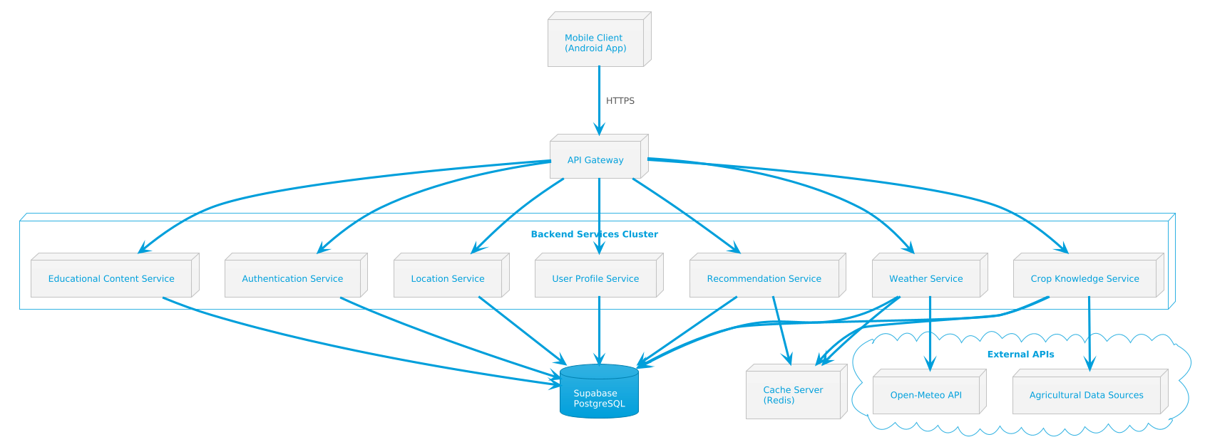
This diagram illustrates the physical design of the system architecture, showing the deployment of components across different tiers: the mobile client application, the API gateway, backend services layer, database server, and external API integrations. It demonstrates how these components are physically separated and communicate through network protocols.
Components:
- Mobile Client (Android devices)
- API Gateway Server
- Application Services Cluster (Authentication, Location, Weather, Recommendation, Crop Knowledge, User Profile, Educational Content)
- Database Server (Supabase/PostgreSQL)
- Cache Server (Redis/In-Memory)
- External APIs (Open-Meteo Weather API)
Communication:
- HTTPS connections between mobile client and API gateway
- Internal service-to-service communication via REST APIs
- Database connections using secure protocols
- External API calls via HTTPS

Figure 2: Logical Architecture and Component Interaction
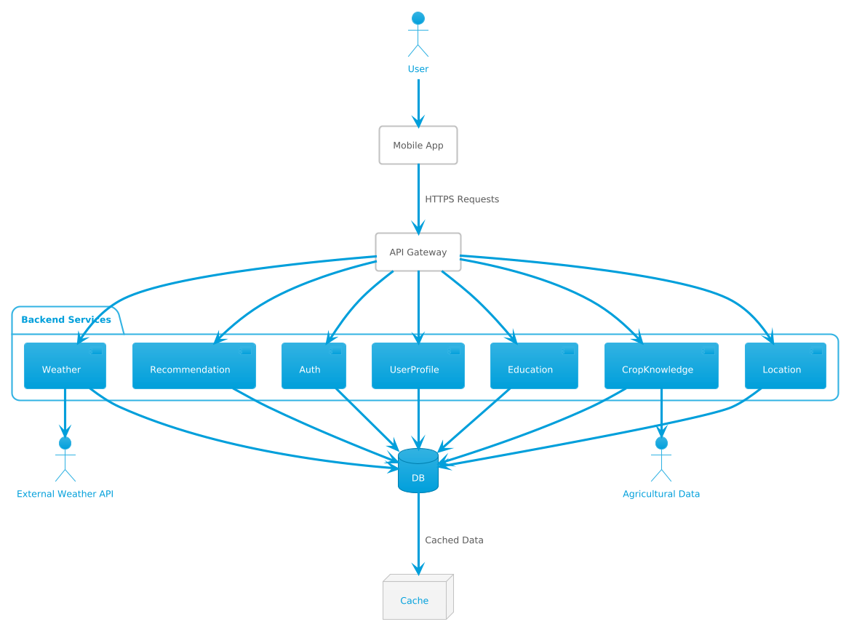
This diagram represents the client-side components (Mobile Application) and server-side components including API Gateway, Authentication Service, Location Service, Weather Service, Recommendation Service, Crop Knowledge Service, User Profile Service, Educational Content Service, Database, and Caching Layer. Arrows indicate communication flows between components, such as HTTPS requests from the client to the API Gateway, and RESTful API calls between the API Gateway and various backend services. Additionally, database queries are shown between services and the Database, and a dotted line indicates data caching between the Database and the Caching Layer for improved performance.
Key Interactions:
- Mobile App → API Gateway: HTTPS requests for all operations
- API Gateway → Authentication Service: User authentication and authorization
- API Gateway → Location Service: Location processing and validation
- Location Service → Weather Service: Weather data retrieval requests
- Weather Service → External API: Historical weather data fetching
- Weather Service → Recommendation Service: Processed weather data transfer
- Recommendation Service → Crop Knowledge Service: Crop data queries
- All Services → Database: CRUD operations
- Database → Cache Layer: Frequently accessed data storage
- Services → Cache Layer: Read operations for performance optimization

Figure 3: User Journey Flow - Farmer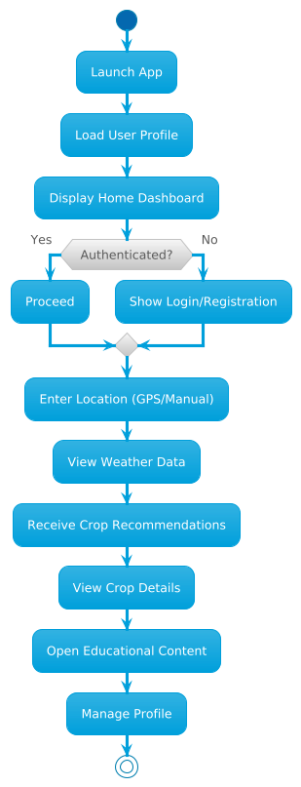

This diagram provides a visual representation of the farmer's user journey through the key steps of accessing the application, inputting location, viewing weather data, receiving crop recommendations, exploring crop details, accessing educational content, and managing their profile.
User Journey Steps:
- Launch Application
- User opens CropIQ mobile app
- System loads user profile (if authenticated)
- Displays home dashboard
- Authentication/Registration
- New users register with personal details
- Existing users log in with credentials
- System validates and authenticates user

- Location Input
- User provides location (GPS or manual entry)
- System validates and processes location data
- Location stored in user profile

- Weather Data Access
- User requests historical weather data
- System retrieves data from cache or external API
- Weather visualizations displayed (graphs, charts)

- Crop Recommendations
- System analyzes weather patterns
- Recommendation algorithm generates crop suggestions
- Ranked crop list displayed with suitability scores

- Crop Details Exploration
- User selects specific crop from recommendations
- System retrieves comprehensive crop information
- Displays requirements, diseases, management practices

- Educational Content
- User navigates to educational modules
- Accesses lessons on farming practices
- System tracks progress through modules

- Profile Management
- User updates preferences and settings
- Modifies location, crop interests, farming experience
- Views recommendation history

Figure 4: Data Flow Diagram Level 0 (Context Diagram)
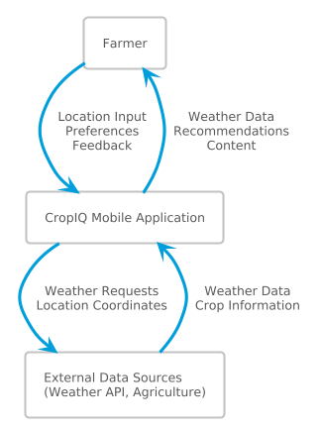
This diagram illustrates the highest-level view of data flow between Farmers, CropIQ Mobile Application, and External Data Sources. Farmers input location data and requests through the Mobile Application, which then communicates with External Data Sources (Weather APIs, Agricultural Databases). External Data Sources provide weather data and crop information back to the Mobile Application, which processes and displays recommendations to Farmers.

Entities:
- Farmers (External Entity): Provide location data, receive crop recommendations
- CropIQ Mobile Application (System): Central processing system
- External Data Sources (External Entity): Weather APIs, Agricultural databases
Data Flows:
- Farmers → Application: Location input, user preferences, feedback
- Application → Farmers: Weather data, crop recommendations, educational content
- Application → External Sources: Weather data requests, location coordinates
- External Sources → Application: Historical weather data, crop information

Figure 5: Data Flow Diagram Level 1 (Process Decomposition)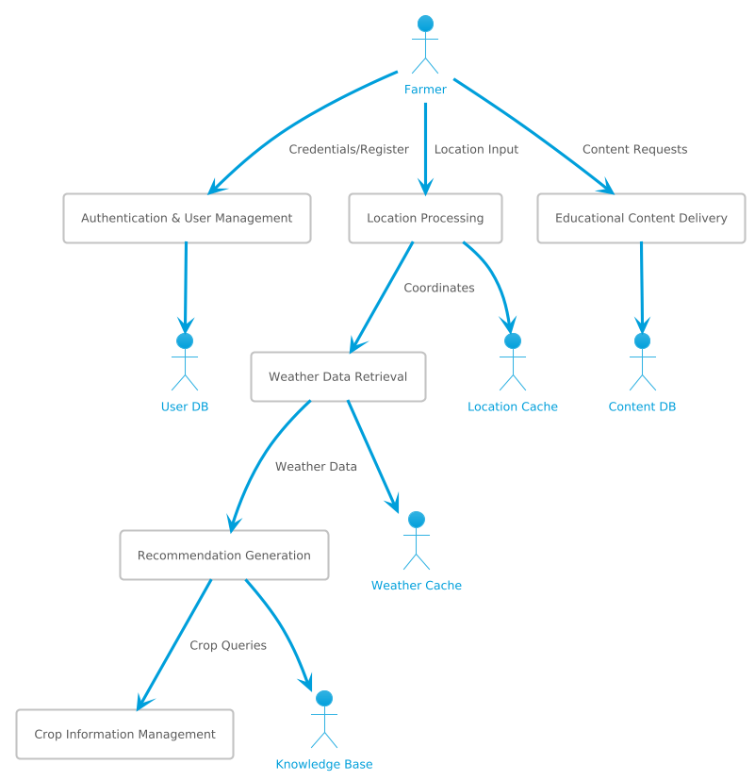
This diagram illustrates how the CropIQ Mobile Application interacts with internal processes: Authentication Process, Location Processing, Weather Data Retrieval, and Recommendation Generation. The Location Processing component receives location data from farmers and provides it to the Weather Data Retrieval component, which fetches historical weather data from External APIs. The Recommendation Generation component analyzes weather data and queries the Crop Knowledge Base to generate crop recommendations.
Processes:
- Authentication & User Management
  - Input: User credentials, registration data
  - Output: Authentication tokens, user profiles
  - Data Store: User Database
- Location Processing
  - Input: User location (GPS/manual)
  - Output: Validated coordinates, regional data
  - Data Store: Location Cache
- Weather Data Retrieval
  - Input: Location coordinates, time period
  - Output: Historical weather data
  - External: Weather API
  - Data Store: Weather Cache
- Recommendation Generation
  - Input: Weather data, user preferences
  - Output: Ranked crop recommendations
  - Data Store: Crop Knowledge Base, Recommendation Histor
- Crop Information Management
  - Input: Crop queries, search terms
  - Output: Detailed crop profiles
  - Data Store: Crop Database

- Educational Content Delivery
  - Input: Content requests, user progress
  - Output: Learning modules, progress reports
  - Data Store: Educational Content Database

Figure 6: Data Flow Diagram Level 2 (Detailed Process View)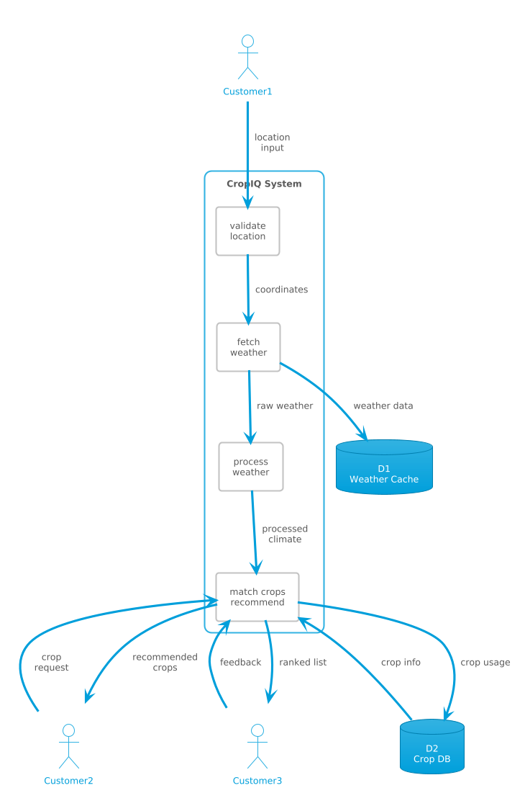
This diagram expands on Level 1 by showing sub-processes within major components. The Weather Data Retrieval process now includes sub-processes for API Request Handling, Data Validation, and Data Caching. The Recommendation Generation process includes sub-processes for Climate Analysis, Crop Matching, and Suitability Scoring.

Detailed Sub-processes:
Weather Data Retrieval:
- API Request Handler: Formats and sends requests to Open-Meteo
- Data Validator: Validates received weather data for completeness
- Data Processor: Formats data for analysis and visualization
- Cache Manager: Stores frequently accessed data
Recommendation Generation:
- Climate Analyzer: Analyzes historical weather patterns
- Crop Matcher: Queries crop database for climate requirements
- Suitability Calculator: Computes compatibility scores
- Ranking Engine: Orders crops by suitability
- Filter Applier: Applies user preferences and constraints
Crop Knowledge Management:
- Search Engine: Handles crop search queries
- Profile Compiler: Assembles comprehensive crop information
- Content Formatter: Prepares data for mobile display
- Update Manager: Maintains crop data currency

Figure 7: User Interface Navigation Flow

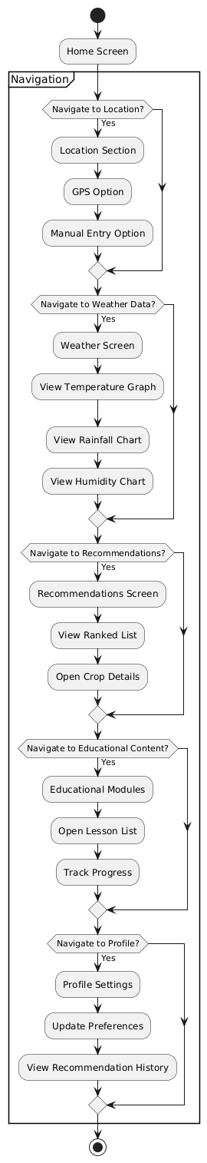
This diagram illustrates how users can navigate through different sections of the mobile application including Home, Location Input, Weather Data, Recommendations, Crop Details, Educational Content, and Profile. Users can input their location, view historical weather patterns, receive crop recommendations, explore detailed crop information, access educational modules, rate and bookmark crops, and manage their profile settings.
Navigation Structure:
Home Screen:
- Quick location input
- Recent recommendations
- Weather summary
- Educational highlights
- Navigation menu access
Location Section:
- GPS location fetch
- Manual location entry
- Saved locations list
- Location history
Weather Data Section:
- Temperature graphs
- Rainfall patterns
- Humidity charts
- Growing degree days
- Time period selection
Recommendations Section:
- Ranked crop list
- Suitability scores
- Brief crop descriptions
- Filter and sort options
- Detailed view access
Crop Details Section:
- Crop profile overview
- Climate requirements
- Water and soil needs
- Disease information
- Management practices
- Bookmark/save option

Educational Content Section:
- Module categories
- Lesson list
- Progress tracking
- Multimedia content
- Quiz/assessment (optional)
Profile Section:
- Personal information
- Farming details
- Preferences
- Recommendation history
- Settings

Figure 8: Authentication Flow Pseudocode
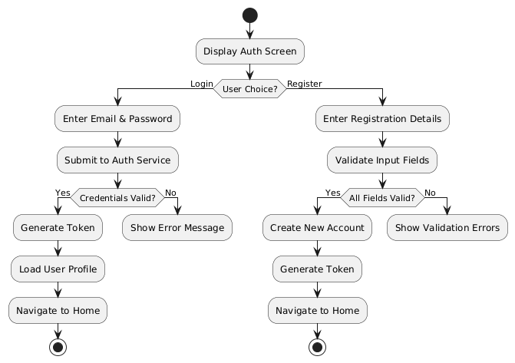
This pseudocode illustrates the login/register component flow of the mobile application. Users can either choose to login or register. If logging in, they input their email/phone and password, which are validated. If validation is successful, the user is authenticated and redirected to the home screen; otherwise, an error message is displayed, and they can retry. If registering, users input their registration details (name, email, phone, password, location), which are validated. If validation is successful, a new account is created, and the user is redirected to the home screen; otherwise, an error message is displayed.

Figure 9: Location and Weather Data Retrieval Flow Pseudocode
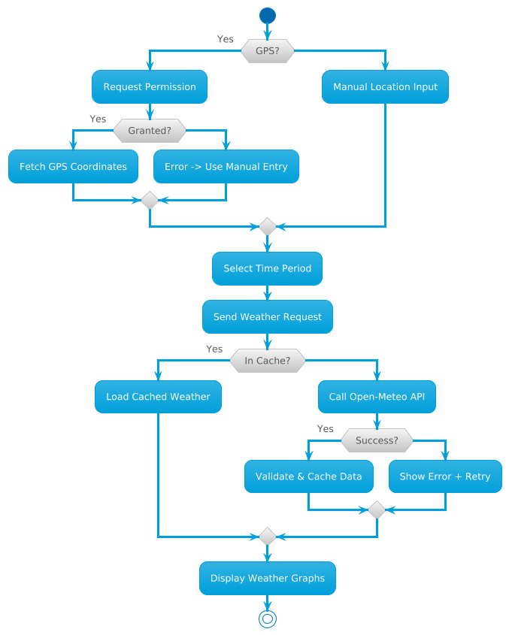
This pseudocode illustrates the location and weather component flow of the mobile application. When the user opens the app and navigates to the weather section, they can input their location either via GPS or manual entry. The app then requests weather data from the Weather Service. If the request is successful, it fetches and displays historical weather data with visualizations. If the user wishes to change the time period or location, they can update the parameters, triggering a new weather data request. If the request fails, an error message is displayed with retry options.

Figure 10: Crop Recommendation Generation Flow Pseudocode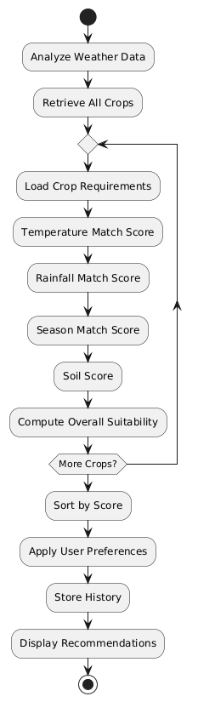
This pseudocode illustrates the recommendation engine flow. After weather data is retrieved, the system analyzes climate patterns and queries the crop knowledge base to match crops with suitable climate requirements. The recommendation algorithm calculates suitability scores based on temperature compatibility, rainfall adequacy, growing season alignment, and soil suitability. Crops are then ranked and filtered according to user preferences before being displayed.

Figure 11: Complete System Sequence Diagram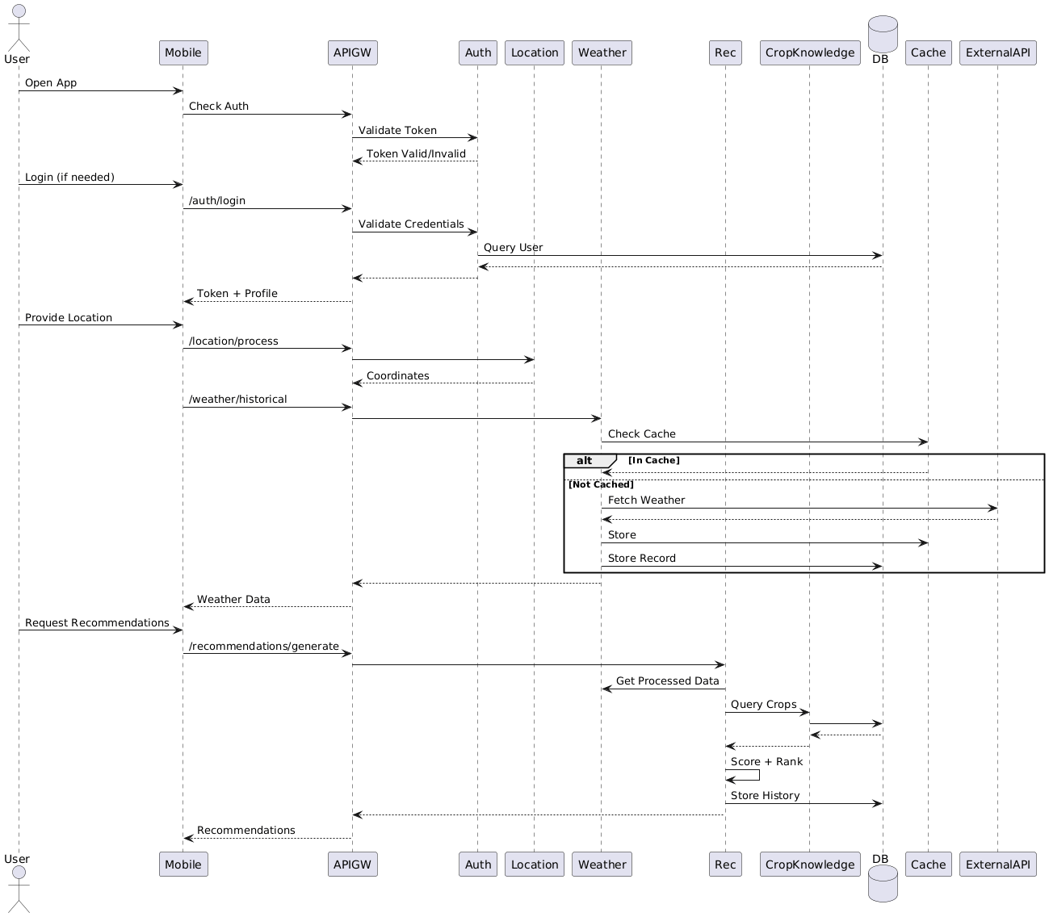
This sequence diagram illustrates the interaction between the mobile application and its backend components for the complete user journey from authentication to viewing crop recommendations. The user initiates actions such as logging in, fetching their current location, requesting weather data, generating crop recommendations, and viewing detailed crop information. These actions trigger corresponding processes within the system, including authenticating users, processing locations, querying weather APIs, calculating recommendations, and retrieving crop details. Throughout the sequence, communication occurs over HTTPS using RESTful APIs for data exchange, ensuring secure and reliable interaction between the client and server components. Overall, the sequence diagram provides a clear visualization of the system's flow and interactions, facilitating understanding and communication of its functionality.

SYSTEM ARCHITECTURE SUMMARY
The CropIQ system architecture implements a robust client-server model designed for scalability, security, and performance. The mobile application serves as a lightweight client that communicates with a comprehensive backend infrastructure through a secure API gateway. Backend services are modularized to handle specific functionalities—authentication, location processing, weather data retrieval, crop recommendation generation, crop knowledge management, user profile management, and educational content delivery.
The architecture leverages caching strategies to minimize external API calls and database queries, ensuring fast response times even in areas with limited connectivity. The Supabase PostgreSQL database provides reliable data persistence, while the caching layer optimizes read-heavy operations. External API integration with Open-Meteo enables access to comprehensive historical weather data, which is processed and analyzed by the recommendation service to generate intelligent crop suggestions.
Security is implemented at multiple layers, including HTTPS encryption for all communications, token-based authentication, secure password storage, and access control mechanisms. The system is designed to handle concurrent users efficiently while maintaining data integrity and consistency across all components.
This architecture provides a solid foundation for delivering reliable, accurate, and user-friendly crop advisory services to Zambian farmers, supporting the system's goals of improving agricultural decision-making and enhancing crop productivity through intelligent, data-driven recommendations.
REFRENCES

Kemp, S. (2016). Digital in 2016: We are social's compendium of global digital, social, and mobile data, trends, and statistics. We Are Social.
Alliance for a Green Revolution in Africa (AGRA). (2025, May 14). Multi-stakeholder approach to strengthening food security in Zambia. https://agra.org/news/multi-stakeholder-approach-to-strengthening-food-security-in-zambia/
Global Center on Adaptation. (2024, March 13). Scaling up climate adaptation solutions for Zambia's smallholder farmers. https://gca.org/scaling-up-climate-adaptation-solutions-for-zambias-smallholder-farmers/
Ministry of Agriculture, Zambia. (2024, January 25). Govt rolls out e-extension to boost agricultural productivity. https://www.agriculture.gov.zm/govt-rolls-out-e-extension-to-boost-agricultural-productivity/
GIZ & University of Reading (2023) Digital Climate Services for Smallholder Farmers in Zambia and Malawi (E-PICSA Project Report). Lusaka: GIZ.
Muchapondwa, E. and Ndhlovu, O. (2020) Smallholder farmers’ response to climate change in Zambia: Drivers and hindrances. Environment for Development (EfD) Discussion Paper 20-38.
Mulungu, K., Chirwa, G.C. and Kankwamba, H. (2022) ‘Climate variability, crop choice and smallholder welfare in Zambia’, African Review of Economics and Finance, 14(1), pp. 85–107.
United Nations Development Programme (UNDP) Zambia. (2024). Cultivating hope: How Zambian smallholder farmers are benefitting from climate-resilient farming. https://www.undp.org/zambia/stories/cultivating-hope-how-zambian-smallholder-farmers-are-benefitting-climate-resilient-farming
Lowenberg-DeBoer, J., Huang, I. Y., Grigoriadis, V., & Blackmore, S. (2020). Economics of robots and automation in field crop production. Precision Agriculture, 21(2), 278-299. https://doi.org/10.1007/s11119-019-09667-5
Murthy, S. N., & Bhojanna, U. (2009). Business research methods (2nd ed.). Excel Books.
Zhang, N., Wang, M., & Wang, N. (2022). Precision agriculture—a worldwide overview. Computers and Electronics in Agriculture, 36(2-3), 113-132. https://doi.org/10.1016/S0168-1699(02)00096-0

Zouari, G., & Abdelhedi, M. (2021). Customer satisfaction in the digital era: Evidence from Islamic banking. Journal of Innovation and Entrepreneurship, 10(1), 9. https://doi.org/10.1186/s13731-021-00151-x
FarmRise (2024) FarmRise Platform Documentation. Available at: https://www.farmrise.com \
Kurima Mari (2024) Kurima Mari Project Documentation. Available at: https://kurimamari.org
PEAT GmbH (2024) Plantix Application Information. Available at: https://plantix.net

Abawi, K. (2017). Data Collection Methods: Semi-Structured Interviews and Focus Groups. Training in Sexual and Reproductive Health Research. Geneva: Geneva Foundation for Medical Education and Research.
Bandaka, P., & D'Silva, H. (2016). Convergence of Information Technology and Communication Technology: A Study on the Impact of Mobile Applications. International Journal of Computer Applications, 143(8), 1-5.
Cresswell, J. W. (2014). Research Design: Qualitative, Quantitative, and Mixed Methods Approaches (4th ed.). Thousand Oaks, CA: SAGE Publications.
Fox, N., Hunn, A., & Mathers, N. (2000). Sampling and Sample Size Calculation. The NIHR RDS for the East Midlands / Yorkshire & the Humber.
Goroden, L. (2021). The Impact of Technology on Modern Life. Journal of Digital Transformation, 12(3), 45-58.
Kabir, S. M. S. (2016). Basic Guidelines for Research: An Introductory Approach for All Disciplines. Chittagong: Book Zone Publication.
Kemp, S. (2016). Digital 2024: Zambia. DataReportal – Global Digital Insights. Retrieved from https://datareportal.com
Lowenberg-DeBoer, J., Huang, I. Y., Grigoriadis, V., & Blackmore, S. (2020). Economics of robots and automation in field crop production. Precision Agriculture, 21(2), 278-299.
Murthy, S. N., & Bhojanna, U. (2009). Business Research Methods (2nd ed.). New Delhi: Excel Books.
Pressman, R. S. (2014). Software Engineering: A Practitioner's Approach (8th ed.). New York: McGraw-Hill Education.
Qualtrics. (2023). Secondary Research: Definition, Methods, and Examples. Qualtrics Experience Management. Retrieved from https://www.qualtrics.com
Taherdoost, H. (2021). Data Collection Methods and Tools for Research: A Step-by-Step Guide to Choose Data Collection Technique for Academic and Business Research Projects. International Journal of Academic Research in Management, 10(1), 10-38.
Zhang, N., Wang, M., & Wang, N. (2022). Precision agriculture—a worldwide overview. Computers and Electronics in Agriculture, 36(2-3), 113-132.
Zouari, G., & Abdelhedi, M. (2021). Customer satisfaction in the digital era: Evidence from Islamic banking. Journal of Innovation and Entrepreneurship, 10(1), 1-18.

