**1. Draw flowchart**

Start Morning:

if Saturday:

if time < 13:00:

going in fishing:

else if time = 18:00

watch football:

else if Sunday:

while time < 15:00:

read a book:

else:

watch TV:

else:

going work:

End:

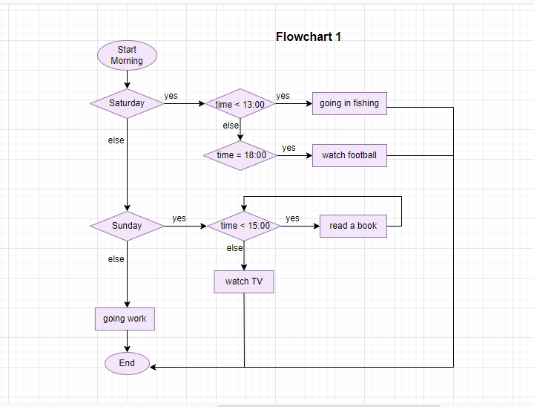

correct

**2. Draw flowchart**

Start:

if time = 13:00:

start lunch:

else if time = 14:00:

end lunch:

else:

while time < 18:00:

if time = 16:00:

meeting:

else:

work:

else:

home:

End:

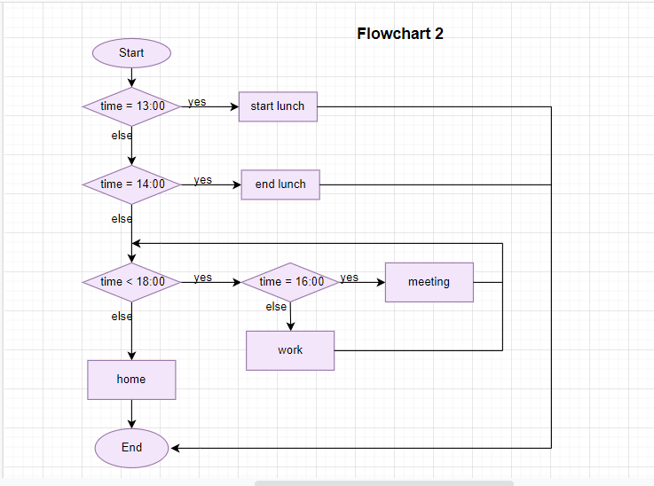

Correct

**3.** **Create pseudocode**

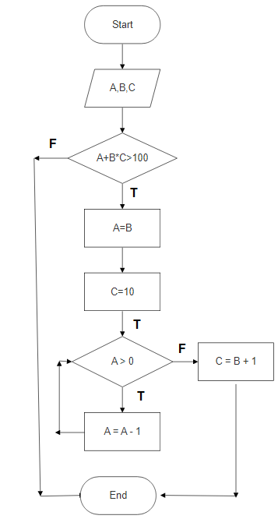

Start:

Input A, B, C:

If A + B * C > 100:

A = B and C = 10

While A > 0:

A = A – 1

Else:

C = B +1

End:

correct