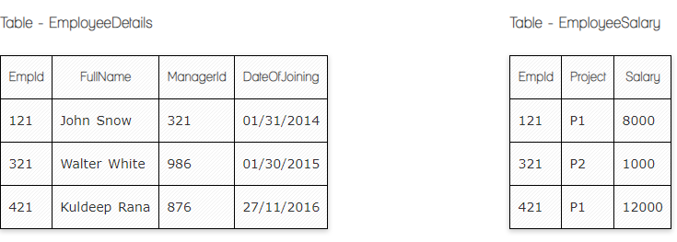

**Ques.1. Write a SQL query to fetch the count of employees working in project 'P1'.**

**My Answer:**

SELECT COUNT(Project)

FROM EmployeeSalary

WHERE Project=’P1’;

**Ques.2. Write a SQL query to fetch employee names having salary greater than or equal to 5000 and less than or equal 10000.**

**My Answer:**

SELECT FullName

FROM EmployeeDetails

INNER JOIN EmployeeSalary

ON EmployeeDetails.EmpId = EmployeeSalary.EmpId

WHERE Salary BETWEEN 5000 AND 10000;

**Ques.3. Write a SQL query to fetch count of employees sorted by project's count in descending order.**

**My Answer:**

SELECT COUNT(Project), COUNT(EmpId)

FROM EmployeeSalary

GROUP BY Project

ORDER BY COUNT(Project) DESC;

**Ques.4. Write a query to fetch employee names and salary records. Return employee details even if the salary record is not present for the employee.**

**My Answer:**

SELECT EmployeeDetails.FullName, EmployeeSalary.Salary

FROM EmployeeDetails

LEFT JOIN EmployeeSalary

ON EmployeeDetails.EmpId = EmployeeSalary.EmpId;

**Ques.5. Write a SQL query to create an empty table with ‘Test’ name.**

**My Answer:**

CREATE TABLE Test (

ID *int ,*

LastName *varchar(125)* ,

FirstName *varchar(125)*

);

**Ques.6. Write a SQL query to delete an empty table with ‘Test’ name.**

**My Answer:**

DROP TABLE Test

**Ques.7. Write a SQL query to update EmployeeSalery table with setting Salary to 2000 for Project P2.**

**My Answer:**

UPDATE EmployeeSalary

SET Salary = '2000'

WHERE EmpId = '321';

**Ques.8. Write a SQL query to right join both tables and draw the results.**

**My Answer:**

SELECT *

FROM EmployeeDetails

RIGHT JOIN EmployeeSalary

ON EmployeeDetails.EmpId = EmployeeSalary.EmpId;

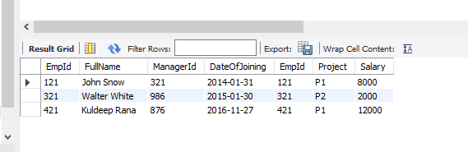

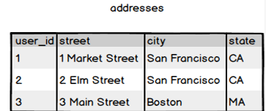

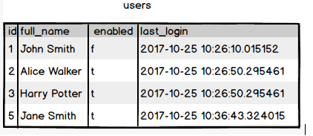

**Ques.9. Write a SQL query to fetch all users full_name from San Francisco.**

**My Answer:**

SELECT full_name

FROM users

INNER JOIN addresses

ON users.id = addresses.user_id

WHERE city = 'San Francisko';

**Ques.10. Write a SQL query to fetch all users full_name, last_login who are enabled**

**My Answer:**

SELECT full_name, last_login

FROM users

WHERE enabled = 't';

**Ques.11. Write a SQL query to fetch all users full_name who are not from Main street**

**My Answer:**

SELECT full_name

FROM users

INNER JOIN addresses

ON users.id = addresses.user_id

WHERE NOT street = '3 Main Street';

**Ques.12. Write a SQL query to fetch all users full_name who are from Main street or San Francisco**

**My Answer:**

SELECT full_name

FROM users

INNER JOIN addresses

ON addresses.user_id = users.id

WHERE street = '3 Main Street' OR city = 'San Francisko';

**Ques.13. Write a SQL query to fetch user full_name who is equal to user_id from Boston (find user_id value in sub_query)**

**My Answer:**

SELECT full_name

FROM users

WHERE id =

(SELECT user_id

FROM addresses

WHERE city = 'Boston');