MINISTRY OF EDUCATION AND SCIENCE OF UKRAINE

Work title:

ROBOTIC REMOTE CONTROL ASSISTANT BASED ON A BIOMECHANICAL MANIPULATOR

Area: Mechatronics-MT
Author: Yevgenii Chernozub
Contacts: +38-099-472-66-84
Email: evgeniy.chernozub@gmail.com

Research Supervisor: Pashko Ivan
Contacts: +38-050-963-01-21

- Abstract:
A human mechanical assistant in the form of a manipulator based on a human biomechanical prosthesis is a device created by us to improve the quality of life of older people or people with physical disabilities who are unable to move for long periods.
Everyone knows that in the world there are many people with disabilities who, one way or another, need help from another person.
This paper presents a prototype of a future mechanical assistant to humans, in the form of a manipulator based on a human biomechanical prosthesis. This device is able to accurately copy the movements of a person’s hand remotely using a voice UART extension cord or a voice recognition sensor.
During the study, many variations of various robots and prostheses were analyzed, and design flaws were identified in some models. An analysis was also made of existing platforms for programming the manipulator. Based on the acquired knowledge, using engineering skills, a new multifunctional device was created that can make life easier for many people not only in everyday life, but also in industrial enterprises, laboratories, hospitals.
- Introduction:

- In the modern world, robotics and automation is developing rapidly. Robots and various manipulators are used in many areas of human activity, including in everyday life, in industrial enterprises, scientific developments and so on.
Modern developments in this area can be useful for people who, due to injuries or illnesses, have limited physical abilities. Especially they can be useful to single elderly people and those who are in a lying position for a long time. These people need constant help from other people. I believe that creating mechanical assistants is a good solution to this problem. They will take on some functions that will ensure more human independence.
- The goal of our work was to check whether it is possible to create a multifunctional mechanical assistant in the form of a manipulator based on a biomechanical prosthesis of a human hand, which could reproduce an exact copy of a person’s hand movement remotely using a wireless UART extension or voice control sensor.

- Scientific novelty:

The scientific novelty of the project is that, unlike the existing fixed manipulators with disabilities and a small number of areas of use, a remote controlled manipulator was created, the main part of which is a biomechanical prosthesis, which due to its small size and versatility, not only in everyday life but also in factories and factories (while increasing its technical characteristics).

- Essence of the work:
- The operation of this device is based on the operation of two elements: Bend Sensor and Servo Motor:
- Servomotor:
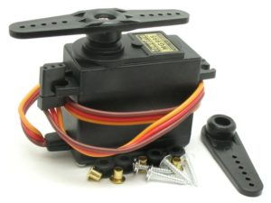
A servomotor is a type of motor that can precisely control motion parameters. In other words, it is an engine that can rotate its shaft by a certain angle or maintain continuous rotation with an accurate period.(Fig.1)[2],[3]
Fig.1
Servomotor
Source: https://numl.org/.790201
The servo motor can be any type of mechanical motor. The servomotor consists of a motor, a position sensor and a control system (Fig.2). The main objective of such devices is the exact rotation of the shaft, and with it the structure, at a certain angle.
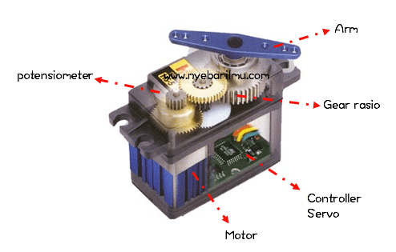
Fig.2. Servomotor construction. Source: https://numl.org/.890201

The entire control circuit of the servomotor is located inside the housing, control signals and power are supplied, as a rule, go through three wires: ground, power voltage and control signal.
Controlling the servomotor directly for changes in the pulse width code is a rather complicated task, but in order to save time, the developers created a special library Servo.h, which is built into the Arduino IDE development environment. [4],[8]
- Bend sensor:
In some cases, the electronic system needs data on the degree of bending of one or another mechanical part of the device. For example, it may be the leg or arm of a robot. To obtain information about mechanical bending, special sensors are used (Fig.3) in the form of a thin long resistive strip. Such a sensor changes its resistance depending on the magnitude of the bend.[5]
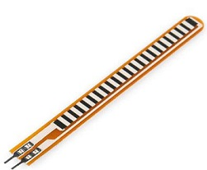
Fig.3. Bend Sensor. Source: https://numl.org/.990201

That is, it turns a change in the mechanical structure into electrical resistance, while the more bending, the greater the resistance value. Bend sensors or Flex sensors are quite cheap and easy to use, so they can be used without problems in Arduino projects.
The patented Flex sensor technology is based on resistive carbon elements. Due to the fact that it is a variable printing resistor, it can be made long enough on a thin flexible substrate. When the substrate is bent, some resistance is present at the output of the sensor, corresponding to the bending radius. In other words, flexible sensors are analog resistors that operate as part of variable analog voltage dividers.
To read data from the sensor, the usual analogRead () function is suitable.

- To simplify the creation of a prototype of a biomechanical manipulator with remote control, the project was created in two stages: the development of a control panel with a glove and the creation of the manipulator itself.
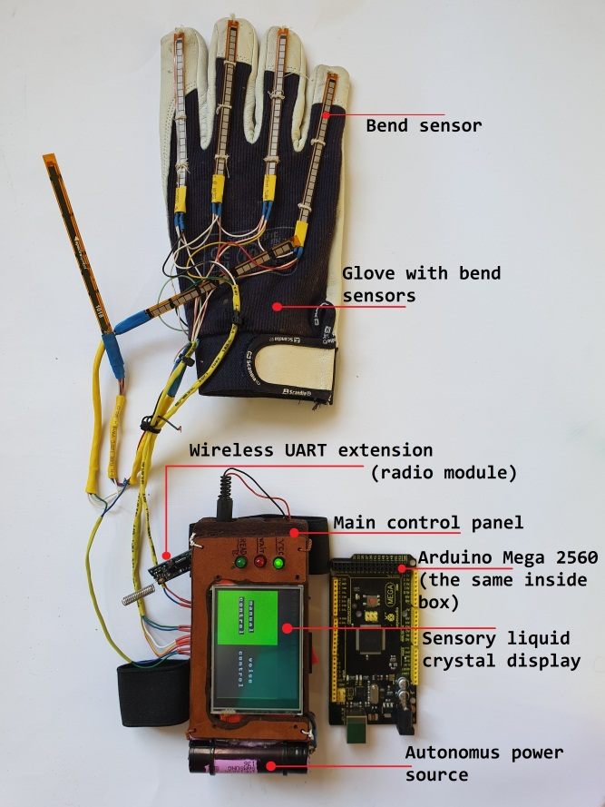
- To create a system control device, we used such details as 7 bend sensors, a UART wireless extension cable, an LCD display with a touch screen, and an autonomous power supply system including 2 batteries and a voltage regulator. The Arduino Mega hardware platform was used to process signals from the glove (Fig.4).
Fig.4. Control system. Source: Original development
The concept of work is simple: when you turn on the control panel, the user is given a choice of the operating mode - manual control or the use of voice commands. If manual control is selected, the system for reading analog signals from bend sensors starts and the platform control menu is displayed on the LCD. After that, every second a data packet is sent to the receiver, which is located on the platform, about the deformation of the hand and user interaction with the display. Data transmission is carried out using a wireless UART extension cable(gadget similar to the radio transmitter), which transmits data through the serial interface of Arduino boards.
If the user selects a control mode using voice commands, the control panel sends this command and enters standby mode until the mode changes. At the same time, a sound analysis system is launched directly on the platform, which assumes the role of a control panel until the mode changes. The sound analysis sensor works continuously, waiting for a signal, when a voice command is recognized, the module informs the board to which it is connected (Arduino Uno). When a signal is received, the board sends commands via a wireless channel to a controller that controls the entire manipulator. In this combination, each voice command is responsible for a certain set of actions (from one – “raise” / “lower” the hand to the sequence of commands).
- To create the manipulator, 11 servos were used, which are connected in parallel, the chassis, the motor driver, various power supplies, as well as 2 Arduino Uno, Arduino Mega and a voice recognition sensor. The manipulator is a biomechanical prosthesis that drives the servos.
To carry heavy loads, you can use a mechanical grip with 2-3 fingers, but to create subtle movements and work, nature created a 5-finger hand, so we decided to take the prosthesis of the human hand as the basis of the project.[7]
The initial version of the prosthesis was cumbersome due to the presence of excess parts and assemblies (Fig.5). The total mass of the prosthesis under the influence of the force moment during the first experiments exceeded the maximum load-carrying capacity of the servos, which made their rotation impossible. For this reason, we decided to simplify the design by removing the extra protection and 2 nodes. At the same time, the functionality of the manipulator has only increased.[1]
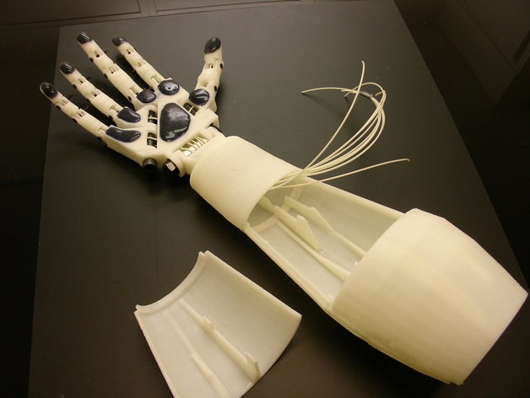
Fig.5. Biomechanical prosthesis from plastic. Source: Original development

The arm of the manipulator was made of plastic on a 3D printer, and the forearm, elbow and shoulder were made of wood. It should be noted that at the time of assembly of the device, we did not find servos with a sufficiently high torque, so we added an auxiliary design with a counterweight, which can be easily removed when using more powerful servos (Fig.6).[6]
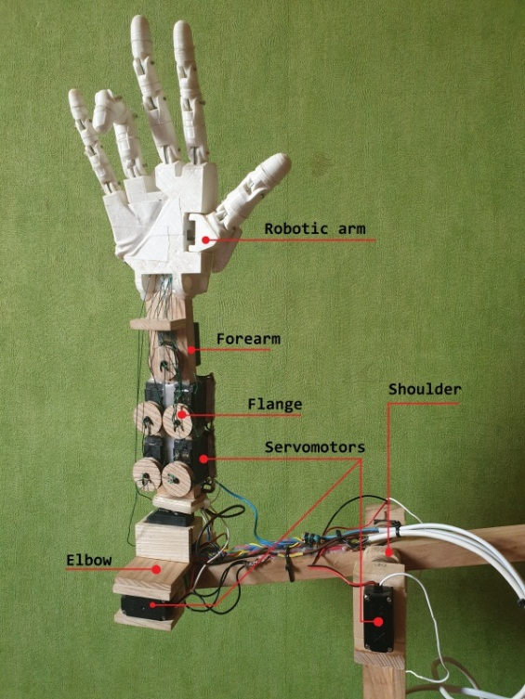
Fig.6. Improved Biomechanical prosthesis. Source: Original development

When receiving a signal from the control panel, the Arduino Mega board turns on all the servos and sets them to their initial position. As mentioned earlier, depending on the user's choice, either the console or the voice analysis sensor controls the subsequent movements of the manipulator. The rotation of the servos is carried out by the method of supplying an analog signal of a certain frequency from the board to the “channel” of the servo data.
- The mobile platform (chassis) includes 4 electric motors, which are controlled by the Arduino Uno board using the ln298n motor driver. This driver greatly simplifies the work with electric motors, prevents their short circuit, and reduces the amount of expended resources needed for control (cables, board contacts).(Fig.7)

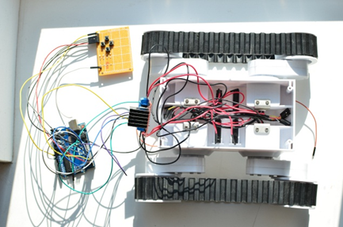
Fig.7. Chassis. Source: Original development

- As you might have guessed, the hardware component of our project consists of Arduino boards, namely 2 Arduino Uno (Fig.8) and 1 Arduino Mega2560 (Fig.9). Both boards are programmed in the Wiring language, in the environment of Arduino IDE. These boards have processors with low performance, but they are very resistant to interference and can "forgive" many errors such as incorrect code, power surges, etc. At the initial stages of assembling the project layout, this was necessary, but now that the final version has already been determined, there is a need to expand the functions of our device. To accomplish this task, the Arduino processor is pretty weak. Because of this, errors occur in the operation of the device. For example: delays in signal transmission, sometimes there are arbitrary manipulator movements during signal transmission. To solve these problems in the near future we are going to make the transition to a new platform based on the stm32 processor(Fig.10). This will speed up the manipulator as a whole, remove most of the errors, and also add new functions.
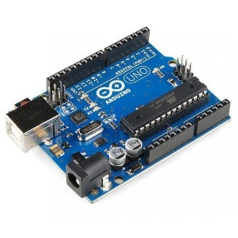
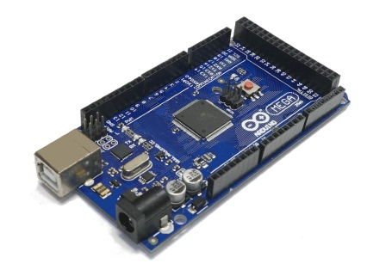
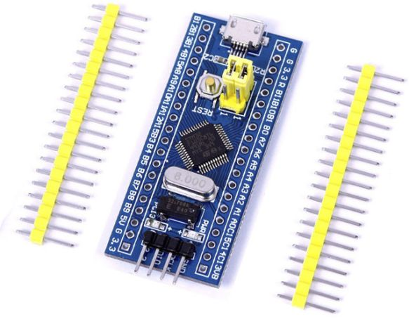

Fig.10. STM32. Source: https://numl.org/.401201
Fig.9. Arduino Mega2560. Source: https://numl.org/.301201
Fig.8. Arduino Uno. Source: https://numl.org/.201201
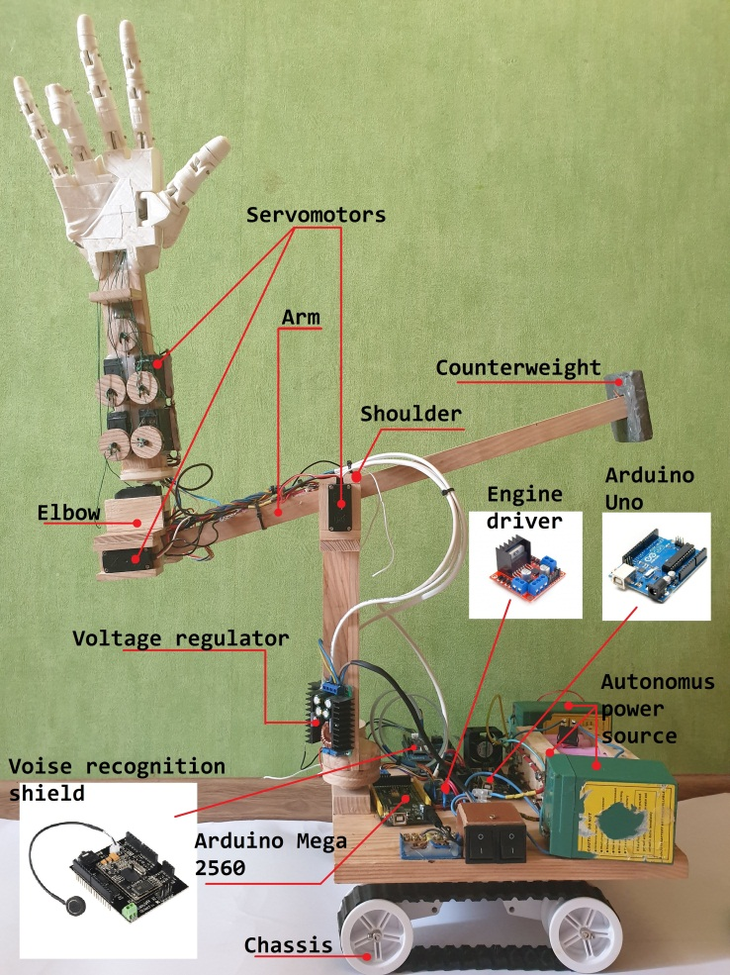
- Results:

As a result of the work, we got a manipulator based on a biomechanical prosthesis. The maximum height of the device is 97 cm (when the arm fully raised), the width is 26 cm and the length is 83 cm (Fig.11). Such specifications provide the device with high maneuverability and, as a result, more comfortable use. The device is powered by two 12V / 6A & 8V / 18A battery packs. Using the formula for calculating electric power, we calculated that the approximate battery life of the entire device is 6 hours (at maximum load). Also, after a series of experiments, we calculated that the manipulator can lift up to 300 g, and transport up to 1 kg of additional weight on the platform . This is good performance, as for the layout, and with an increase in technical characteristics, you can achieve better results.
Fig.10. Result of work. Source: Original development

- Conclusions:

It was possible to create a prototype of a future assistant in everyday life, the basis of which is a biomechanical prosthesis, controlled by bend sensors.

The result of the work showed that with the help of the programmed controllers of the Arduino system, it is possible to achieve accurate reproduction of the movements of the “mechanical arm” without the high costs of components and electricity, which confirm our hypothesis.

I believe that this device can make life easier not only for Ukrainians, but also for many people around the world, because the manipulator is compact and multifunctional, and the wide availability of components, when any element fails, will save a lot of time and money to the user.

The created project can be used in many areas of human life: using only low-powered engines, the installation can be used as a good helper in everyday life, which is able to perform simple functions: bring water, open a cabinet, etc. upper limb. With increasing power, this installation can be used in the industry to perform rough and dangerous work.

- References:
- Robot arm with remote control from gloves and Arduino [Electronic resource] / Arduino-DIY // - access mode to the site: http: //arduino-diy.com/arduino-robo-ruka-s-distantsionnym-upravleniyem-ot- perchatki
- Arduino for beginners. Lesson 4. Servo control [Electronic resource] / Entertaining robotics // - access mode to the site: http: //edurobots.ru/2014/04/arduino-servoprivod/
- Servos Arduino SG90, MG995: connection diagram and control [Electronic resource] / Arduino Master // - access mode to the site: https: //arduinomaster.ru/motor-dvigatel-privod/servoprivody-arduino-sg90-mg995-shema -podklyuchenie-upravlenie /
- What is the Arduino IDE? [Electronic resource] / zelectro community // - access mode to the site: http: //zelectro.cc/what_is_arduino_ide
- Arduino and bending sensor [Electronic resource] / digitrode // - access mode to the site: http: //digitrode.ru/computing-devices/mcu_cpu/716-arduino-i-datchik-izgiba.html
- How bionic limbs work [Electronic resource] / Popular mechanics // - access mode to the site: https: //www.popmech.ru/technologies/12782-kak-rabotayut-bionicheskie-konechnosti/
- How bionic prostheses work [Electronic resource] / Popular mechanics // - access mode to the site: https: //www.popmech.ru/science/235633-kak-rabotayut-bionicheskie-protezy/
- Arduino development environment [Electronic resource] / arduino.ru // - access mode to the site: http: //arduino.ru/Arduino_environment

