Eugene Borts

Applied Database 2

Assignment 1

**Airline Flight Tracking**

Custom Data Dictionary

**Airline**: Airline information consisting of Airline ID and airline name.



**Flight**: Flight information consisting of Flight ID, flight number, departure airport, arrival airport, and foreign keys AirlineID and TrackerID.

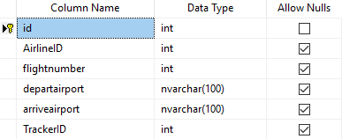

**Tracker**: Flight tracking information consisting of Tracker ID, flight date, departure time, arrival time, flight duration, flight status, terminal, and foreign key FlightID.

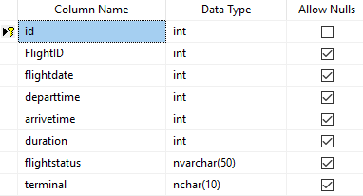

**Customer**: Customer information consisting of customer ID and customer name.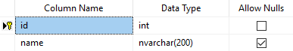

**Passenger**: Passenger information consisting of Passenger ID, seat, ticket, and foreign keys CustomerID and FlightID.

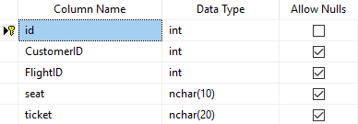

**Note:**   
I realized I made some mistakes in selecting the data types, especially regarding things like the flightdate field in the Tracker table. I did attempt to change the flightdate data type from int to date, but this is my first time using Microsoft SQL Server and I encountered some issues when it came to changing the data types.

When I attempted to change the data type, I was given an error and told that I must drop the table and recreate it to change the data type. When I attempted to delete the table, I received another error stating that it could not be deleted. I assume this happened due to dependency issues with the keys, so I decided against deleting and recreating all my tables over this mistake.

**Relationships**

Airline 1:n Flight – An airline can have many flights, but each flight must be assigned to a single airline.

Flight 1:1 Tracker – Once a row is entered into the flight table, there can only be one Tracker table created for it using the FlightID, and the TrackerID is then assigned as a foreign key in the Flight table. This is a one-to-one relationship since each flight can have only one Tracker and each Tracker can have only one Flight.

Customer 1:n Passenger - Flight 1:n Passenger – A customer does not become a passenger and is not assigned to any flight until his or her unique CustomerID is entered into the Passenger table along with the FlightID for that specific flight. One customer can be a passenger on multiple flights, and a customer can purchase multiple seats on a single flight.

Customer n:n Flight – A customer can have multiple Passenger entries for a flight and is assigned multiple Passenger ID’s for the same flight if the customer buys multiple seats/tickets for that flight. By using a unique Passenger ID for every ticket purchased, Customer and Flight have a many-to-many relationship with the capacity to have multiple flights per customer and multiple seats purchased by one customer for the same flight. An example of this is shown in the screenshot at the bottom of the document, in which Passenger ID’s 1 and 22 both belong to Customer ID 1 for the same flight, while Customer ID’s 17 and 15 have purchased seats on multiple different flights.

|  |  |  |
| --- | --- | --- |
| **Entity 1** | **Relationship** | **Entity 2** |
| Airline | 1:n | Flight |
| Flight | 1:1 | Tracker |
| Customer | 1:n | Passenger |
| Flight | 1:n | Passenger |
| Customer | n:n | Flight |

**Database Diagram**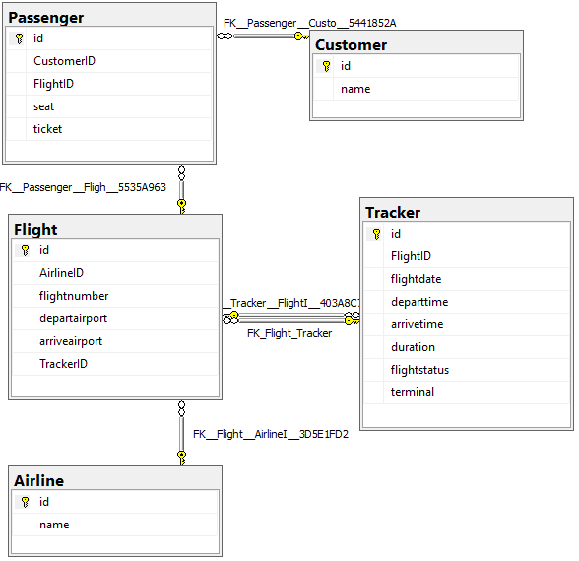

**SQL Code**

This assignment was completed using a combination of SQL code and the SQL Server Management GUI.

**Table Creation**

CREATE TABLE Airline (

id int primary key identity(1,1),

name nvarchar(100)

)

CREATE TABLE Flight (

id int primary key identity(1,1),

AirlineID int foreign key references Airline(id)

flightnumber int,

departairport nvarchar(100),

arriveairport nvarchar(100),

)

CREATE TABLE Tracker (

id int primary key identity(1,1),

FlightID int foreign key references Flight(id)

Flightdate int,

Departtime int,

Arrivetime int,

Duration int,

Flightstatus nvarchar(50)

)

**Once the Tracker table was created, I then went back to the Flight table and added a relationship using the GUI to insert the second foreign key, TrackerID from Tracker(id).**

CREATE TABLE Customer (

id int primary key identity(1,1),

name nvarchar(200)

)

CREATE TABLE Passenger (

id int primary key identity(1,1),

CustomerID int foreign key references Customer(id),

FlightID int foreign key references Flight(id),

seat nchar(10),

ticket nchar(20),

)

CREATE TABLE Seat (

id int primary key identity(1,1),

PassengerID int foreign key references Passenger(id),

name nvarchar(200)

)

**Row Insertion**

INSERT INTO Airline (id, name) VALUES ('American Airlines'), ('Delta'), ('Jet Blue')

INSERT INTO Flight (AirlineID, flightnumber, departairport, arriveairport) VALUES

(3, 2351, 'DAB - Daytona Beach Intl, Daytona Beach, FL', 'JFK - John F. Kennedy Intl, NYC, NY'),

(1, 7223, 'JAX - Jacksonville Intl, Jacksonville, FL', 'JFK - John F. Kennedy Intl, NYC, NY'),

(2, 5110, 'MCO - Orlando Intl, Orlando, FL', 'LGA - LaGuardia Airport, NYC, NY')

INSERT INTO Tracker (FlightID, flightdate, departtime, arrivetime, duration, flightstatus, terminal) VALUES

(2, 012119, 1500, 1800, 300, 'Delayed', ‘C5’),

(1, 012719, 0800, 1040, 240, 'On-time', ‘A3’),

(3, 020319, 1200, 1450, 250, 'On-time', ‘B7’)

INSERT INTO Customer VALUES ('Robert Jordan'), ('Henry Kissinger'), ('John Rico'),

('Robert Heinlein'), ('Isaac Asimov'), ('Isaac Arthur'), ('Stephen King'), ('Stephen Hawking'),

('William Golding'), ('Thomas Cromwell'), ('George Patton'), ('Mike Patton'), ('Betty Page'),

('Norma Jean'), ('Alice Walker'), ('Bettany Hughes'), ('Mary Beard'), ('Sam Harris'), ('Mary Shelley')

INSERT INTO Passenger VALUES (1, 2, '1A', '1st Class - 29351A'), (2, 2, '14C', 'Coach - 35132C'),

(3, 2, '3D', 'Business - 23155B'), (4, 2, '4F', 'Business - 41433B'), (5, 2, '11B', 'Coach - 51233C'),

(6, 1, '1A', '1st Class - 12351A'), (7, 1, '1B', '1st Class - 12455A'), (8, 1, '17A', 'Coach - 35134C'),

(9, 1, '9B', 'Business - 35143B'), (9, 3, '6A', 'Business - 35564B'), (10, 1, '20C', 'Coach - 42443C'),

(11, 3, '4E', '1st Class - 31344A'), (12, 3, '9D', 'Business - 13441B'), (13, 3, '16A', 'Coach - 45143C'),

(14, 3, '16B', 'Coach - 42331C'), (15, 3, '2B', '1st Class - 13415A'), (15, 2, '2B', '1st Class - 13234A'),

(16, 1, '3D', '1st Class - 32123A'), (17, 1, '2A', '1st Class - 34412A'), (17, 2, '7C', 'Business - 23314B'),

(18, 2, '11A', 'Coach - 54342C')

**Screenshots of Individual Tables**

**Airline**

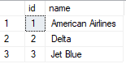

**Customer**

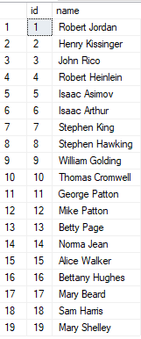

**Flight**

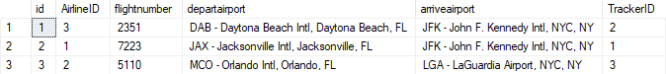

**Tracker**

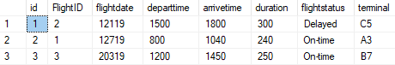

**Passenger**

