Eugene Borts

Applied Database 2

Dr. Ron Eaglin

Assignment 10B

The purpose of this report is to determine the disparity between the performance of the students in CTS2321 and CIS4360. The data set displayed below has been analyzed to provide the necessary statistics to undertake this determination.

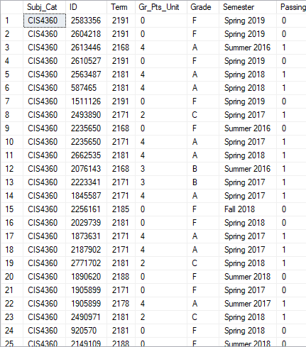

The following properties have been analyzed to determine the performance disparity between these classes:

Grades By Class

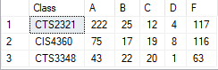

Average Grade % By Class



Average Grade % For Each Class By Semester

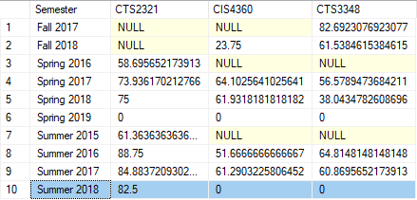

Rounded Passing Rate % by Class



Passing Count By Class

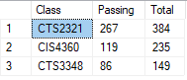

Conclusion

The above results demonstrate that