Eugene Borts

Applied Database II

Dr. Ron Eaglin

Assignment 11

Introduction

The purpose of this report is to demonstrate the use of Full Text Indexing to perform a full text search within a database in SQL Server. This report is comprised of three parts. The first part lists the database and tables used for this demonstration, the second part lists the queries used to perform the operations, and the third part shows the results achieved using Full Text Indexing. The database used for this report is a menu database which contains menu’s, menu groups, and menu items with text descriptions. There are two queries used to complete this demonstration, one query for the creation of a Full Text Catalog and Index, and a second query for the full text index search procedure. The search results consist of multiple snapshots, which display the results of the search query for all rows in the Menu Item Description field that contain both the words “spicy” and “delicious”.

Part I: Menu Database & Tables Used

MenuID

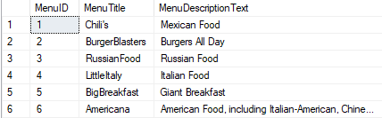

Menugroup

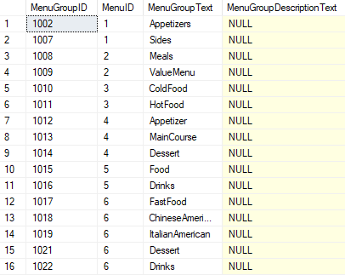

MenuItem

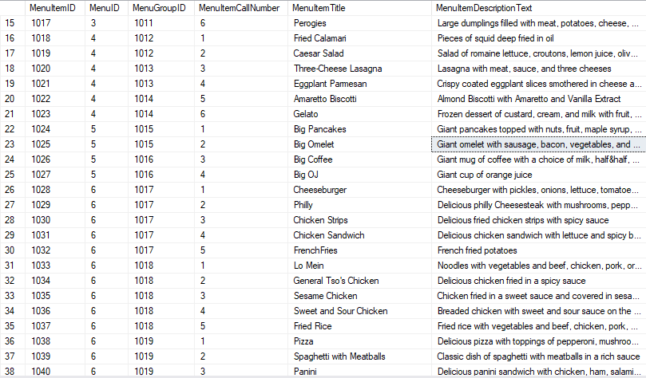

Part II: Queries for Full Text Indexing

Query I: Create Full Text Catalog and Index

|  |
| --- |
| USE MenuDB  GO  SELECT MenuItemTitle, MenuItemDescriptionText  FROM MenuItem  WHERE MenuItemDescriptionText LIKE '%spicy%'  AND MenuItemDescriptionText LIKE '%delicious%'    CREATE FULLTEXT CATALOG MenuFT  CREATE FULLTEXT INDEX ON dbo.MenuItem(MenuItemTitle, MenuItemDescriptionText)  KEY INDEX PK__MenuItem__8943F702885A0BC7 ON MenuFT  WITH CHANGE_TRACKING AUTO  GO |

Query II: Full Text Index Search Using CONTAINS

|  |
| --- |
| USE MenuDB  GO  SELECT MenuItemID,  MenuGroupText,  MI.MenuGroupID,  MI.MenuID,  MenuItemCallNumber,  MenuItemTitle,  MenuItemDescriptionText  FROM MenuItem AS MI, MenuGroup as MG  WHERE MI.MenuGroupID = MG.MenuGroupID AND  CONTAINS(MI.*, 'Spicy') AND  CONTAINS (MI.*, 'Delicious')  ORDER BY MG.MenuGroupID |

Part III: Search Results

All entrées containing both the words ‘delicious’ and ‘spicy’ in their description are displayed when the query is run.

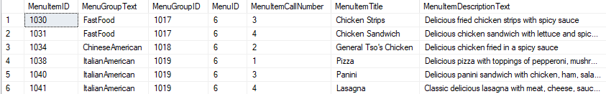

All records are ordered by MenuGroupID.

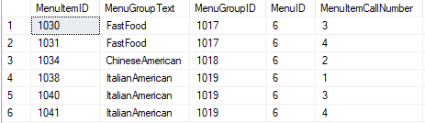

Only records with the words ‘spicy’ and ‘delicious’ appearing in the description are displayed.

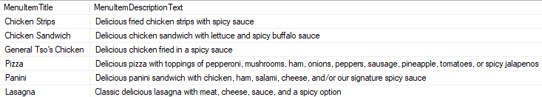

Conclusion

Full Text Indexing has been shown to be an effective method of searching for records in a SQL Server database based on the text contained in the specified field. The creation of a Full Text Catalog and Full Text Index allowed for the CONTAINS predicate to be utilized, which is used to search for keywords that are contained within a table. The CONTAINS predicate may be used in conjunction with the AND/OR operators to control the precision of a full text search. The above results demonstrate the efficacy of Full Text Indexing when searching for and locating any specific text within a database. Full text searches may be used in a variety of ways to list many records containing a common keyword, or to provide a more concentrated list of records across a shorter scope of uncommon keywords or multiple keywords. This allows for a broad range of search functionality, allowing for quick and easy retrieval of records in a database.