Eugene Borts

Applied Database II

Dr. Ron Eaglin

Assignment 12

Introduction

This report details the performance analysis and optimization of an SQL query using a specified optimization technique. The report is divided into three parts: the first part is an analysis of the test query prior to the introduction of an optimization technique, the second part is a summary of the optimization technique used, and the third part is the post-optimization performance analysis.

The database used to perform the optimization analysis is the Florida Housing Database, which includes the primary table FLHousing, which is a set of raw data, and the supplemental tables ACR, Categories, Codes, FS, Region, and Type. The test query used to perform both the pre-optimization and post-optimization analysis is shown below.

Test Query

|  |
| --- |
| SELECT [Codes].[Description], COUNT(*) As 'Number Units'  FROM FLHousing, Codes, Categories  WHERE FLHousing.ACR = Codes.Name  AND Codes.CategoryName = 'ACR'  AND Categories.Name = Codes.CategoryName  GROUP BY [Codes].[Description] |

Part I: Pre-Optimization Performance

An analysis of query performance by finding the amount of time it takes for the query to run. As shown below, the test query took 7 seconds to run.



Execution Plan - Full

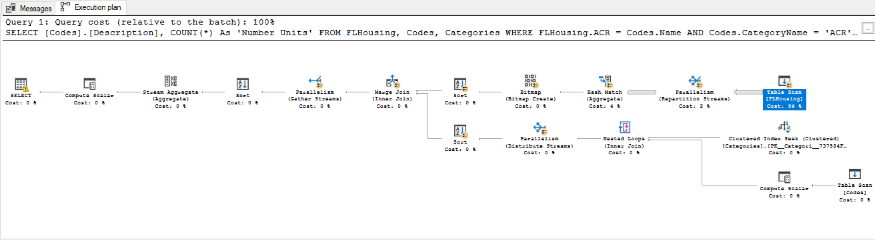

Execution Plan – Left Side

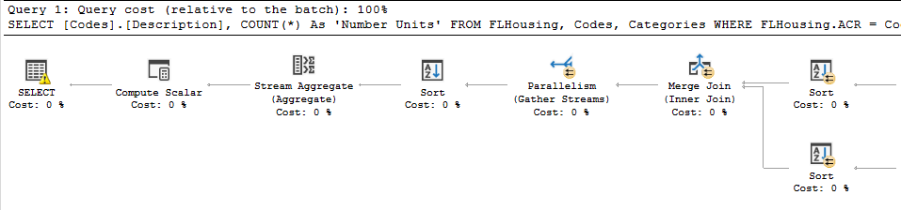

Execution Plan – Right Side

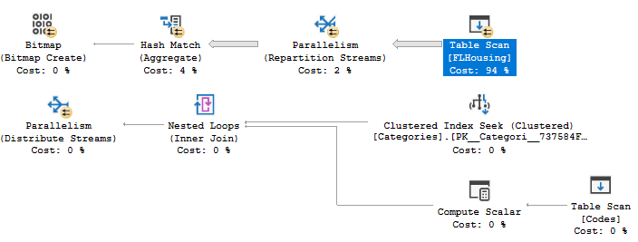

Table Scan

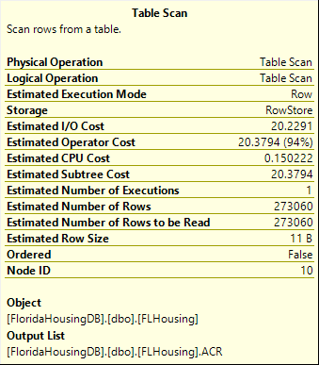

SQL Server Profile Trace



Part II: Optimization Used

The method of optimization used to increase the performance of this query is indexing. Indexing is an optimization technique in which indexes are created for each table to quickly retrieve data from the database. These indexes work to speed up searches and queries while staying invisible to users.

There are two types of indexes that can be used for a table or view, clustered and non-clustered. Clustered indexes sort and store data rows based on their key values, while non-clustered indexes have a structure that is separate from the data rows. Non-clustered indexes contain non-clustered index key values, and each key value has a pointer to the data row that contains the key value, called a row locator.

The query used to create the indexes is shown below.

Query for Indexes

|  |
| --- |
| USE FloridaHousingDB  CREATE INDEX HousingIndex  ON FLHousing (ACR, FS, REGION, TYPE)  CREATE INDEX ACRIndex  ON ACR (Code, Description1)  CREATE INDEX CodesIndex  ON Codes (Name, CategoryName, Description)  CREATE INDEX FSIndex  ON FS (Code, Description1)  CREATE INDEX TypeIndex  ON Type (Code, Description1)  CREATE INDEX CategoriesIndex  ON Categories (Name, Description)  CREATE INDEX RegionIndex  ON REGION (Code, Description1) |

Part III: Post-Optimization Performance

Shown below is the total time taken to execute the primary query after creating the indexes.



With the indexes in place, the test query now runs in 0 seconds as opposed to the 7 seconds it took to run prior to creating the indexes.

Execution Plan With Indexes - Full

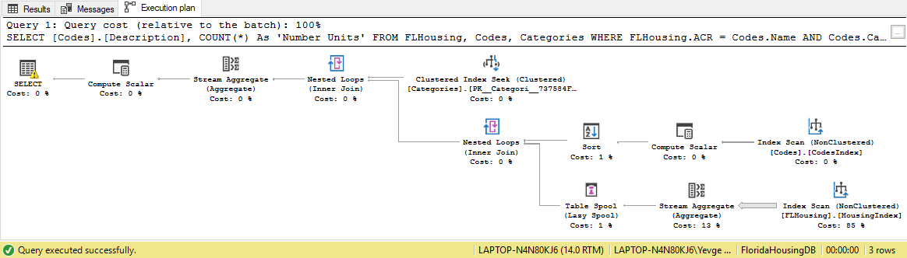

Execution Plan – Left Side

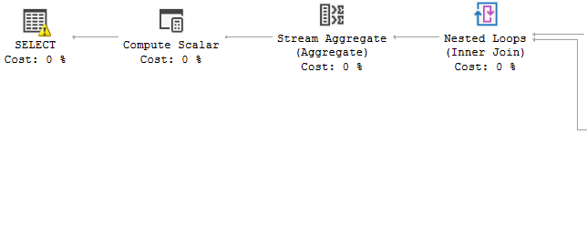

Execution Plan – Right Side

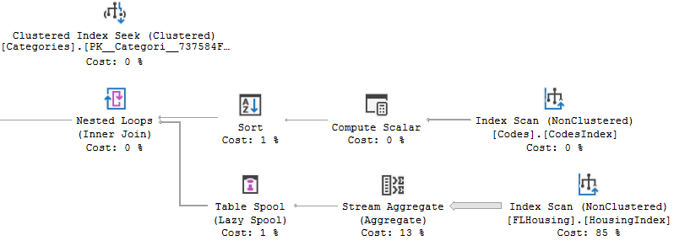

Index Scan

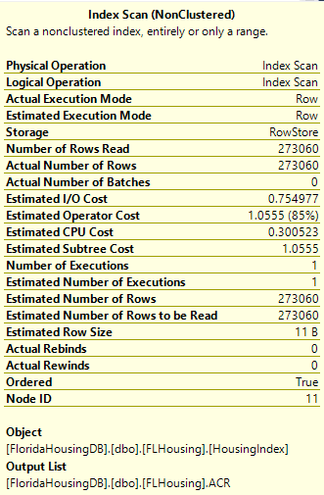

SQL Server Profiler Trace

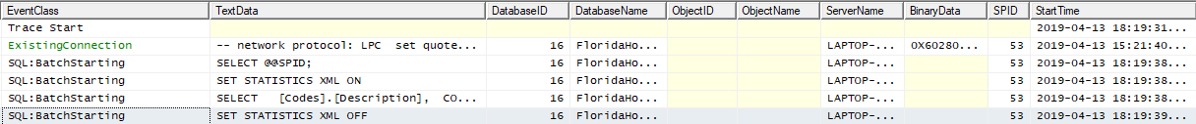

Conclusion

The results gathered from this test demonstrate that the use of indexes in a database offers a significant reduction in the time it takes to run queries for that database. The test query took seven full seconds to run prior to the implementation of indexes, while it took less than one second to run once the indexes were created. The indexes also caused a dramatic shift in the execution plan for the query.

The execution plan for the test query with indexes is comprised of 12 elements, whereas the execution plan for the test query without the indexes is comprised of 17 elements. There is also a change in the cost associated with these computations, as the cost of the index scan is 85% compared to the 94% cost of the table scan.

These demonstrable differences between the table scan and index scan are indicative of a drastic increase in performance when using indexes to optimize database queries.