Eugene Borts

Applied Database II

Dr. Ron Eaglin

Assignment 14B

**Introduction**

The purpose of this report is to demonstrate the most basic uses of MongoDB, a powerful NoSQL database program which uses JSON-like documents with schemata. This objective is accomplished by creating a database, a collection within that database, and adding multiple documents into that collection. Three queries are then used to retrieve data from the collection. The first query uses the in operator, the second query uses the and operator, and the third query uses the or operator.

**Part One: MenuDB.RussianFood**

The RussianFood collection in the MenuDB database consists of five fields: ID, Name, Description, MenuGroup, and Price.

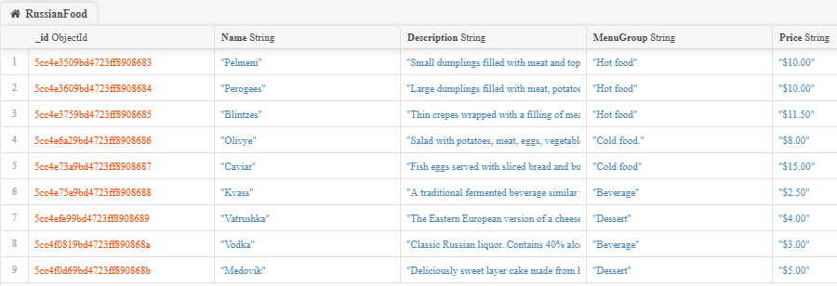

**Part Two: Queries**

**In Operator**

{"MenuGroup" : {$in : ["Dessert"]}}

Display rows that contain dessert.

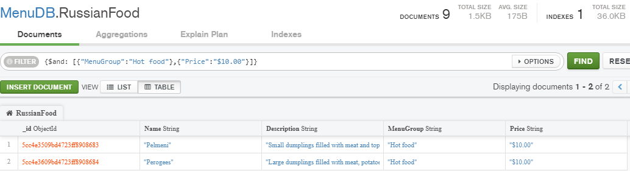

**And Operator**

{$and: [{"MenuGroup":"Hot food"},{"Price":"$10.00"}]}

Display rows with hot food for the price of $10.00.

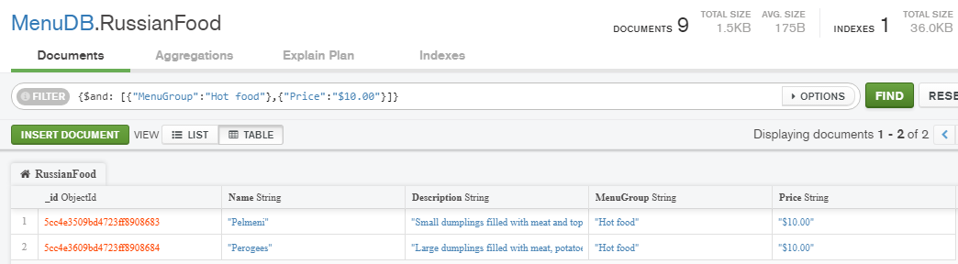

**Or Operator**

{$or: [{"MenuGroup":"Cold food"},{"Price":"$10.00"}]}

Display rows that have either cold food or a $10.00 item.

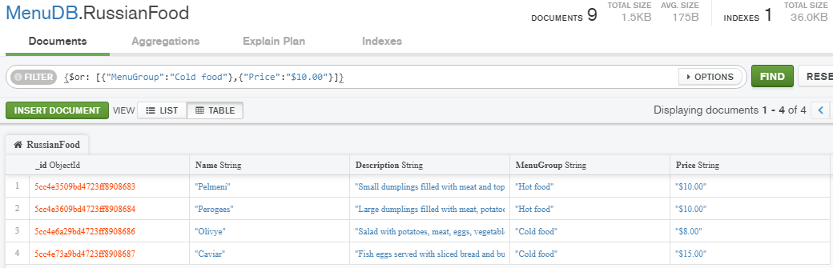

**Conclusion**

NoSQL is shown to be quite different from SQL, though similar at its core. MongoDB is faster and more scalable than SQL Server, but it does not support JOIN and Global transactions whereas SQL Server does. MongoDB also supports larger amounts of data and Agile practices, while SQL Server does not. In conclusion, NoSQL can be a powerful and effective database structure with numerous differences from database management systems that use SQL database structure, such as SQL Server.