Eugene Borts

Applied Database 2

Dr. Eaglin

Assignment 3

**Contents**

1. Create Tables

2. Create Foreign Key Constraints

3. Create Stored Procedure

4. Execute Stored Procedure

5. Stored Procedure Results

6. Database Diagram

**Create Tables**

USE MenuDB

GO

CREATE TABLE Menu

(

MenuID int primary key identity (1,1),

MenuTitle varchar(200) null,

MenuDescriptionText varchar(255) null,

)

CREATE TABLE MenuGroup

(

MenuGroupID int primary key identity (1,1),

MenuID int,

MenuGroupText varchar(200) null,

MenuGroupDescriptionText varchar(255) null,

)

CREATE TABLE MenuItem

(

MenuItemID int primary key identity (1,1),

MenuID int,

MenuGroupID int null,

MenuItemCallNumber varchar(50) null,

MenuItemTitle varchar(200) null,

MenuItemDescriptionText varchar(255) null,

MenuItemNutritionText varchar(255) null,

MenuItemIngredientsText varchar(255) null,

MenuItemQuantity varchar(50) null,

MenuItemPreparationTime varchar(50) null,

MenuItmeCost varchar(50) null,

MenuItemTypeCode varchar(50) null,

MenuItemEthnicTypeCode varchar(50) null,

MenuItemAvailabilityBit varchar(50) null,

)

**Add Constraints**

ALTER TABLE [dbo].[MenuGroup] WITH CHECK ADD CONSTRAINT [FK_MenuGroup_Menu] FOREIGN KEY([MenuID])

REFERENCES [dbo].[Menu] ([MenuID])

GO

ALTER TABLE [dbo].[MenuGroup] CHECK CONSTRAINT [FK_MenuGroup_Menu]

GO

ALTER TABLE [dbo].[MenuItem] WITH CHECK ADD CONSTRAINT [FK_MenuItem_Menu] FOREIGN KEY([MenuID])

REFERENCES [dbo].[Menu] ([MenuID])

GO

ALTER TABLE [dbo].[MenuItem] CHECK CONSTRAINT [FK_MenuItem_Menu]

GO

ALTER TABLE [dbo].[MenuItem] WITH CHECK ADD CONSTRAINT [FK_MenuItem_MenuGroup] FOREIGN KEY([MenuGroupID])

REFERENCES [dbo].[MenuGroup] ([MenuGroupID])

GO

ALTER TABLE [dbo].[MenuItem] CHECK CONSTRAINT [FK_MenuItem_MenuGroup]

GO

**Create Stored Procedure**

USE MenuDB

GO

CREATE PROCEDURE [dbo].[stp_InsertNewMenuItem]

(

@MenuItemTitle VARCHAR(200),

@MenuGroupText VARCHAR(200),

@MenuTitle VARCHAR(200)

)

AS

BEGIN

BEGIN TRANSACTION

BEGIN TRY

DECLARE @MenuID INT

SELECT @MenuID = MenuID

FROM Menu

WHERE MenuTitle = @MenuTitle

IF @MenuID IS NULL

BEGIN

INSERT INTO Menu(MenuTitle)

VALUES (@MenuTitle)

SET @MenuID = SCOPE_IDENTITY()

END

DECLARE @MenuGroupID INT

SELECT @MenuGroupID = MenuGroupID

FROM MenuGroup

WHERE MenuGroupText = @MenuGroupText

IF @MenuGroupID IS NULL

BEGIN

INSERT INTO MenuGroup(MenuID, MenuGroupText)

VALUES (@MenuID, @MenuGroupText)

SET @MenuGroupID = SCOPE_IDENTITY()

END

INSERT INTO MenuItem (MenuID, MenuGroupID, MenuItemTitle)

VALUES (@MenuID, @MenuGroupID, @MenuItemTitle)

COMMIT TRANSACTION

END TRY

BEGIN CATCH

IF @@TRANCOUNT > 0

ROLLBACK TRANSACTION

END CATCH

END

GO

**Execute Stored Procedure**

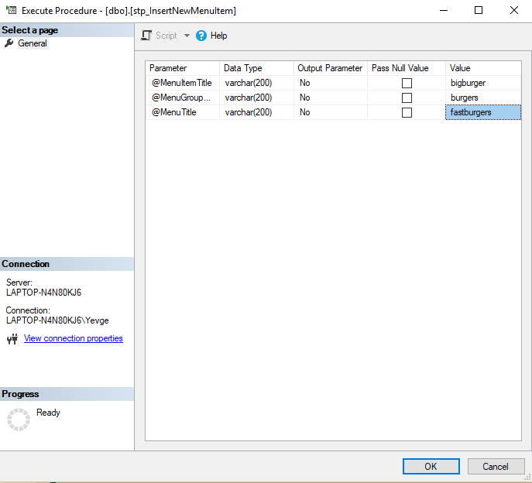

**Stored Procedure - MenuID**

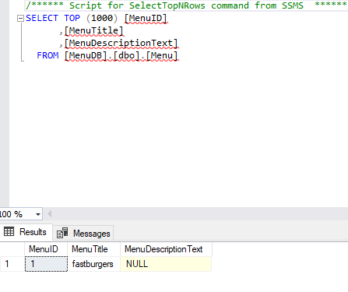

**Stored Procedure - MenuGroup**

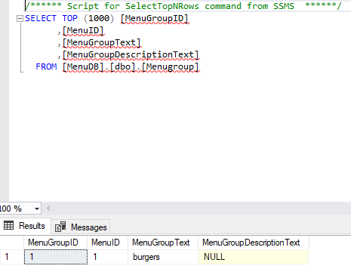

**Stored Procedure - MenuItem**

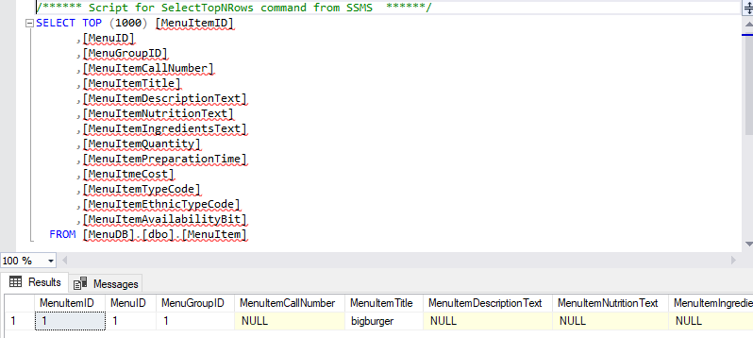

**Database Diagram**

