Eugene Borts

Applied Database II

Dr. Ron Eaglin

Assignment 4

**Table Function - func_GetMenuItemsForMenu**

|  |
| --- |
| CREATE FUNCTION dbo.func_GetMenuItemsForMenu  (@MenuItemID NVARCHAR(200)  )  RETURNS TABLE  AS RETURN (  SELECT  Menu.MenuID,  MenuItem.MenuItemTitle  FROM Menu  INNER JOIN  MenuItem ON  MenuItem.MenuID = Menu.MenuID  WHERE  MenuItem.MenuID LIKE @MenuItemID + '%')  GO |

**Scalar Function – func_GetMenuItemDescriptionForMenuItemID**

|  |
| --- |
| CREATE FUNCTION dbo.func_GetMenuItemDescriptionForMenuItemID  (  @MenuItemID nvarchar (200)  )  RETURNS nvarchar (200)  AS  BEGIN  RETURN  (SELECT MenuItemDescriptionText  FROM MenuItem  WHERE MenuItemID = @MenuItemID)  END |

**Select Statement for func_GetMenuItemsForMenu**

|  |
| --- |
| USE MenuDB  SELECT * FROM dbo.func_GetMenuItemsForMenu('1') |

**Table Function - Screenshot of Query and Results**

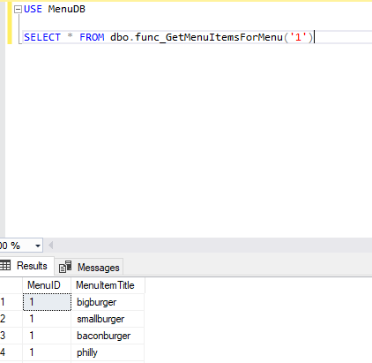

**Select Statements for func_GetMenuItemDescriptionForMenuItemID**

Note: Each SELECT statement displays one item description specified by ItemID.

|  |
| --- |
| USE MenuDB  SELECT dbo.func_GetMenuItemDescriptionForMenuItemID('1') as "Item Description"  SELECT dbo.func_GetMenuItemDescriptionForMenuItemID('2') as "Item Description"  SELECT dbo.func_GetMenuItemDescriptionForMenuItemID('3') as "Item Description"  SELECT dbo.func_GetMenuItemDescriptionForMenuItemID('4') as "Item Description"  SELECT dbo.func_GetMenuItemDescriptionForMenuItemID('5') as "Item Description" |

**Scalar Function - Screenshot of Query and Results**

