Eugene Borts

Applied Database II

Dr. Ron Eaglin

Assignment 7

**Part I**

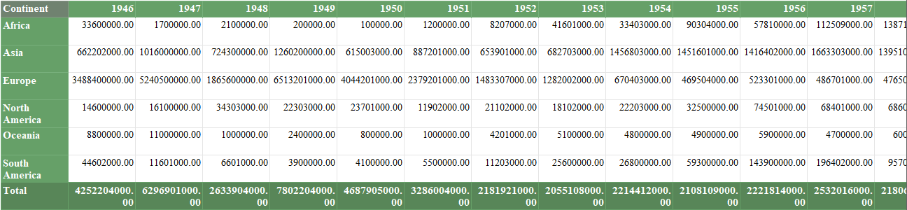

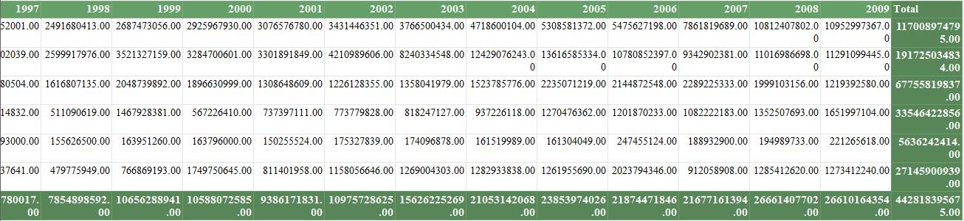

**Part II**

