Eugene Borts

Applied Database II

Dr. Ron Eaglin

Assignment 8

This assignment has been divided into two parts. The first part contains SQL code that has been used in this assignment, and the second part contains screenshots of the results, including query results, stored procedure results, and tables.

**Part I: SQL Code**

Lookup Tables

|  |
| --- |
| USE FloridaHousingDB  CREATE TABLE [dbo].[ACR](  [Code] [varchar](5) NULL,  [Description1] [varchar](50) NULL  ) ON [PRIMARY]  GO  CREATE TABLE [dbo].[FS](  [Code] [varchar](5) NULL,  [Description1] [varchar](50) NULL  ) ON [PRIMARY]  GO  CREATE TABLE [dbo].[REGION](  [Code] [varchar](5) NULL,  [Description1] [varchar](50) NULL  ) ON [PRIMARY]  CREATE TABLE [dbo].[Type](  [Code] [varchar](5) NULL,  [Description1] [varchar](50) NULL  ) ON [PRIMARY]  GO |

Categories and Codes Tables

|  |
| --- |
| USE FloridaHousingDB  DROP TABLE Codes  DROP TABLE Categories  CREATE TABLE Categories (  [Name] NVARCHAR(50) PRIMARY KEY NOT NULL,  [Description] NVARCHAR(200)  )  CREATE TABLE Codes (  [Name] NVARCHAR(50) NOT NULL,  [CategoryName] NVARCHAR(50) FOREIGN KEY REFERENCES Categories(Name) NOT NULL,  [Description] NVARCHAR(200)) |

Insert Category Stored Procedure

|  |
| --- |
| USE FloridaHousingDB  DROP PROCEDURE sp_InsertCategory  GO  CREATE PROCEDURE sp_InsertCategory  @CategoryName nvarchar(50),  @Description nvarchar(200)    AS  BEGIN  INSERT INTO Categories(Name, Description)  VALUES(@CategoryName, @Description)  END  GO |

Insert Code Stored Procedure

|  |
| --- |
| USE FloridaHousingDB  DROP PROCEDURE sp_InsertCode  GO  CREATE PROCEDURE sp_InsertCode  @Name nvarchar(50),  @CategoryName nvarchar(50),  @Description nvarchar(200)  AS  IF EXISTS (SELECT * FROM Categories WHERE Name = @CategoryName)  BEGIN  INSERT INTO Codes(Name, CategoryName, Description)  VALUES(@Name, @CategoryName, @Description)  END  ELSE  BEGIN  INSERT INTO Categories(Name, Description)  VALUES(@CategoryName, @Description)  INSERT INTO Codes(CategoryName)  VALUES(@CategoryName)  END |

ACR Query

|  |
| --- |
| USE FloridaHousingDB  SELECT [Codes].[Description], COUNT(*) As 'Number Units'  FROM FLHousing, Codes, Categories  WHERE FLHousing.ACR = Codes.Name  AND Codes.CategoryName = 'ACR'  AND Categories.Name = Codes.CategoryName  GROUP BY [Codes].[Description] |

FS Query

|  |
| --- |
| USE FloridaHousingDB  SELECT [Codes].[Description], COUNT(*) As 'Number Units'  FROM FLHousing, Codes, Categories  WHERE FLHousing.FS = Codes.Name  AND Codes.CategoryName = 'FS'  AND Categories.Name = Codes.CategoryName  GROUP BY [Codes].[Description] |

Type Query

|  |
| --- |
| USE FloridaHousingDB  SELECT [Codes].[Description], COUNT(*) As 'Number Units'  FROM FLHousing, Codes, Categories  WHERE FLHousing.Type = Codes.Name  AND Codes.CategoryName = 'Type'  AND Categories.Name = Codes.CategoryName  GROUP BY [Codes].[Description] |

**Part II: Results**

**Query Results**

FS Query



ACR Query

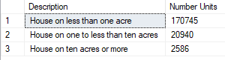

Type Query

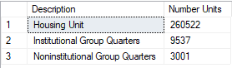

**Stored Procedure Results**

Codes Table

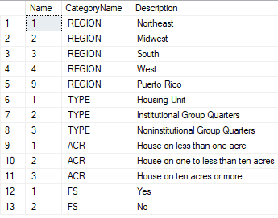

Categories Table

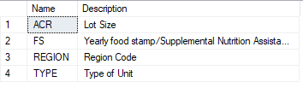

**Lookup Tables**

ACR

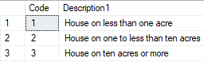

FS



Region

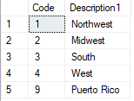

Type

