Eugene Borts

Applied Database II

Dr. Ron Eaglin

Assignment 9B

Introduction

The purpose of this report is to demonstrate the use of Pivot Tables in SQL using the US Financial Aid database from the Getting Started With Report Builder 3 lecture, which lists the total financial aid received from the US for each country by fiscal year. This report is divided into two parts. Part one uses a standard pivot table, while the second part uses a dynamic pivot table. The standard pivot table is quick and easy to use, but the dynamic pivot table allows for a greater level of control and customization.

Part I: US Financial Aid Pivot Table

The total financial aid is displayed for each country per fiscal year, ordered by fiscal year.

Query

|  |
| --- |
| USE USAidDatabase  SELECT * FROM  (SELECT  CountryName,  FiscalYear,  Amount  FROM  FinancialAid) AS BaseData    PIVOT (  SUM(Amount)  FOR CountryName  IN ([Brazil], [Canada], [India], [Mexico], [Paraguay], [Peru], [Portugal], [Spain])  ) AS PivotTable ORDER BY FiscalYear |

Result

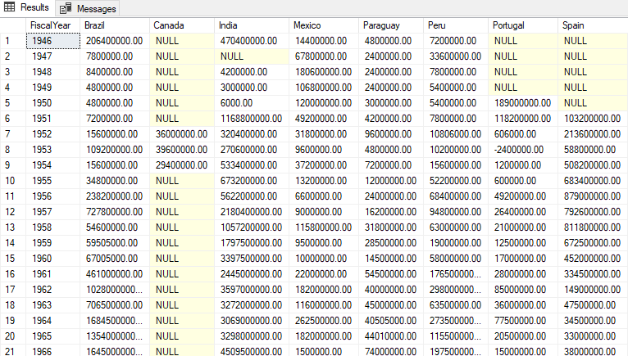

Part II: US Financial Aid Dynamic Pivot Table

In the dynamic pivot table, all countries are now included and listed in alphabetical order rather than being manually selected, and all null values have been replaced with a value of zero.

Query

|  |
| --- |
| USE USAidDatabase  GO  DECLARE @DynamicPivotQuery AS NVARCHAR(MAX),  @PivotColumnNames AS NVARCHAR(MAX),  @PivotSelectColumnNames AS NVARCHAR(MAX)  SELECT @PivotColumnNames= ISNULL(@PivotColumnNames + ',','')  + QUOTENAME(CountryName)  FROM (SELECT DISTINCT CountryName FROM FinancialAid) AS CountryName  SELECT @PivotSelectColumnNames  = ISNULL(@PivotSelectColumnNames + ',','')  + 'ISNULL(' + QUOTENAME(CountryName) + ', 0) AS '  + QUOTENAME(CountryName)  FROM (SELECT DISTINCT CountryName FROM FinancialAid) AS CountryName ORDER BY CountryName  SET @DynamicPivotQuery =  N'SELECT FiscalYear, ' + @PivotSelectColumnNames + '  FROM FinancialAid  PIVOT(SUM(Amount)  FOR CountryName IN (' + @PivotColumnNames + ')) AS PVTTable  ORDER BY FiscalYear'  EXEC sp_executesql @DynamicPivotQuery |

Result

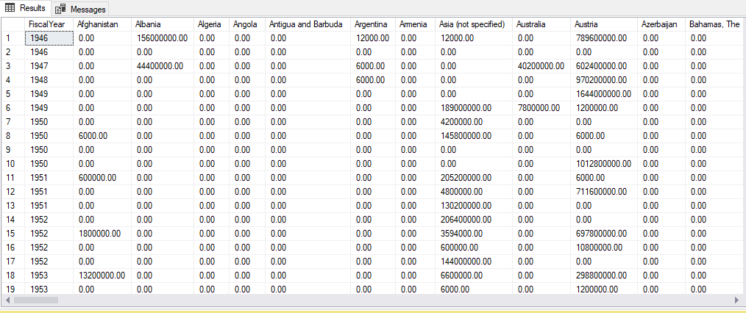

Conclusion

In conclusion, pivot tables are a quick, easy, and powerful tool to sort and organize data in a way that allows the user to compare results by specific fields and values, in this case comparing the yearly financial aid amount by country for each fiscal year. This allows for quick comparison of yearly financial aid among different countries, as well as sorting the financial aid of each country by fiscal year, allowing the user to see how the financial aid for a target country compares from one year to the next. Dynamic pivot tables are even more powerful and effective than pivot tables, allowing for greater control over the contents of the pivot table and how those contents are displayed.