Neogames C# test – Infrastructure team

1. You realize that your web application is very slow, what actions you should take to make it faster?

First of all, I will check couple of things:

* Architecture of the application
* Sql Server – store procedures/views/indexes and etc
* Application code
* Hardware
* Run windbg with memory dump

2. You need to design a web application that receives PDF document as input and convert it to plain text which is displayed back to the user. The system needs to support a load of 100 requests per sec. Please draw an architecture of such a system and send a picture

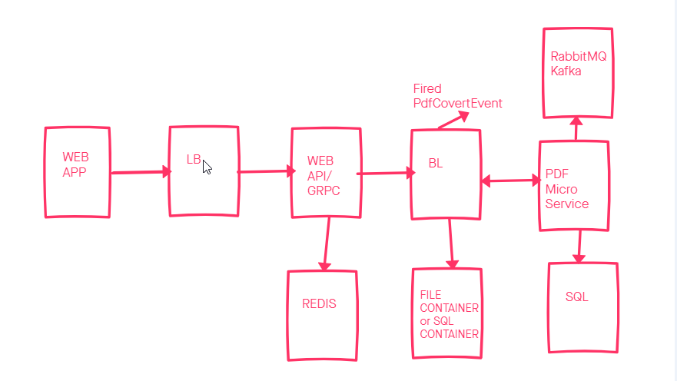

Or we can use Cloud – Azure or Aws

Aws Gateway, SNQ/SNS, Lambda, Dynamo DB

3. What are the characteristics of well-designed API?

* Documentation
* Stability and Consistency
* Flexibility
* Security
* Ease of Adoption

4. Implementation - (Taken from: https://www.codingame.com/ide/puzzle/dice-probabilitycalculator)