Instructions:

1. Сlient side
   1. Run npm install in the weather-client-app directory
   2. Run npm start
   3. Please pay attention that  API URL  [http://api.openweathermap.org/data/2.5](https://cors-anywhere.herokuapp.com/http:/api.openweathermap.org/data/2.5)  was replaced with <https://cors-anywhere.herokuapp.com/http://api.openweathermap.org/data/2.5>  because we have cors problem when we call <http://api.openweathermap.org/data/2.5> from the localhost (base-http.service.ts) , so before you run this app, please open in the chrome browser <https://cors-anywhere.herokuapp.com/http://api.openweathermap.org/data/2.5/weather?q=Kyiv&appid=0d7303c17ee3d3482cd82a2ad273a90d&units=metric> and click on Request button

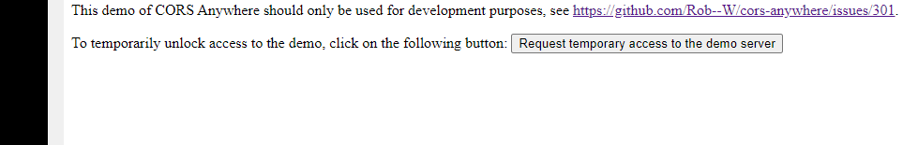

1. Print Screen:

