Yevhenii Bocharov
20.04.2026 | Computer tools
Performance Optimization in Modern Web Applications
Techniques, Tools, and Best Practices

Contents
Introduction 0
Literature Review 1
Key performance metrics 2
Optimization Techniques 3
Comparison of Optimization Techniques 4
Technique 4
Benefit 4
Drawback 4
Code Splitting 4
Faster initial load 4
More complex setup 4
Lazy Loading 4
Reduced data usage 4
Delayed content loading 4
Caching 4
Faster repeat visits 4
Cache invalidation issues 4
Performance Metrics Comparison 4
Image Optimization 5
Performance Tools 6
Discussion 7
Conclusion 8
Bibliography 9

Introduction
Performance optimization in modern web applications is a critical aspect of web development. As users increasingly expect fast, responsive, and seamless digital experiences, developers must ensure that applications load quickly and perform efficiently across various devices and network conditions.
Modern web applications are often complex, incorporating dynamic content, APIs, and client-side rendering frameworks. While these features enhance functionality, they can also introduce performance challenges such as slow load times, excessive resource usage, and poor responsiveness.
This report explores the importance of performance optimization, reviews existing research and best practices, and analyzes key techniques used to improve web application performance. The goal is to provide a structured understanding of how developers can build faster and more efficient applications.

Literature Review
Numerous studies and industry resources emphasize the importance of performance optimization in web development. According to research by Google, even a one-second delay in page load time can significantly reduce user satisfaction and conversion rates.
Web performance experts highlight several key factors affecting application performance, including network latency, inefficient code, and large asset sizes. Frameworks such as React and Angular have introduced optimization techniques like lazy loading and code splitting to address these challenges.
Additionally, organizations like Mozilla and Web.dev provide guidelines and tools for measuring and improving performance. Metrics such as First Contentful Paint (FCP) and Time to Interactive (TTI) are commonly used to evaluate user experience.
Overall, the literature consistently shows that performance optimization is essential for both user engagement and business success.

Key performance metrics
Performance metrics are essential for evaluating the efficiency of a web application. These metrics provide measurable insights into how users experience a website.
Some of the most important metrics include:
- First Contentful Paint (FCP): Measures the time it takes for the first visible content to appear.
- Largest Contentful Paint (LCP): Indicates when the main content has loaded.
- Time to Interactive (TTI): Represents when the page becomes fully interactive.
- Total Blocking Time (TBT): Measures delays caused by heavy scripts.
Developers use these metrics to identify bottlenecks and prioritize optimization efforts.

Optimization Techniques
There are several techniques used to optimize web application performance. These techniques focus on reducing load times, minimizing resource usage, and improving responsiveness.
One common approach is code splitting, which involves breaking down large JavaScript bundles into smaller chunks that load only when needed. This reduces initial load time and improves performance.
Another important technique is lazy loading, where images and components are loaded only when they appear in the user’s viewport. This significantly reduces unnecessary data transfer.
Caching is also widely used to store frequently accessed data locally, reducing the need for repeated server requests. Additionally, compression techniques such as Gzip and Brotli help reduce file sizes during transmission.

Comparison of Optimization Techniques

Technique | Benefit | Drawback
Code Splitting | Faster initial load | More complex setup
Lazy Loading | Reduced data usage | Delayed content loading
Caching | Faster repeat visits | Cache invalidation issues
Figure 1: Optimization Techniques Comparison

Performance Metrics Comparison
Understanding different performance metrics allows developers to better evaluate the effectiveness of optimization techniques. Each metric focuses on a specific aspect of user experience and helps identify performance bottlenecks.
Metric | What It Measures | Ideal Value
First Contentful Paint | Time until first content appears | < 1.8 seconds
Largest Contentful Paint | Time until main content is visible | < 2.5 seconds
Time to Interactive | When page becomes fully usable | < 3.8 seconds
Total Blocking Time | Delay caused by scripts | < 200 ms
Figure 2: Web Performance Metrics and Ideal Values

Image Optimization
Images are often the largest assets in web applications and can significantly impact performance. Optimizing images involves reducing file sizes without compromising quality.
Common strategies include using modern formats such as WebP, compressing images, and serving responsive images based on device resolution. Content Delivery Networks (CDNs) are also used to deliver images from servers closer to the user, reducing latency.
Proper image optimization can drastically improve loading times and overall user experience.

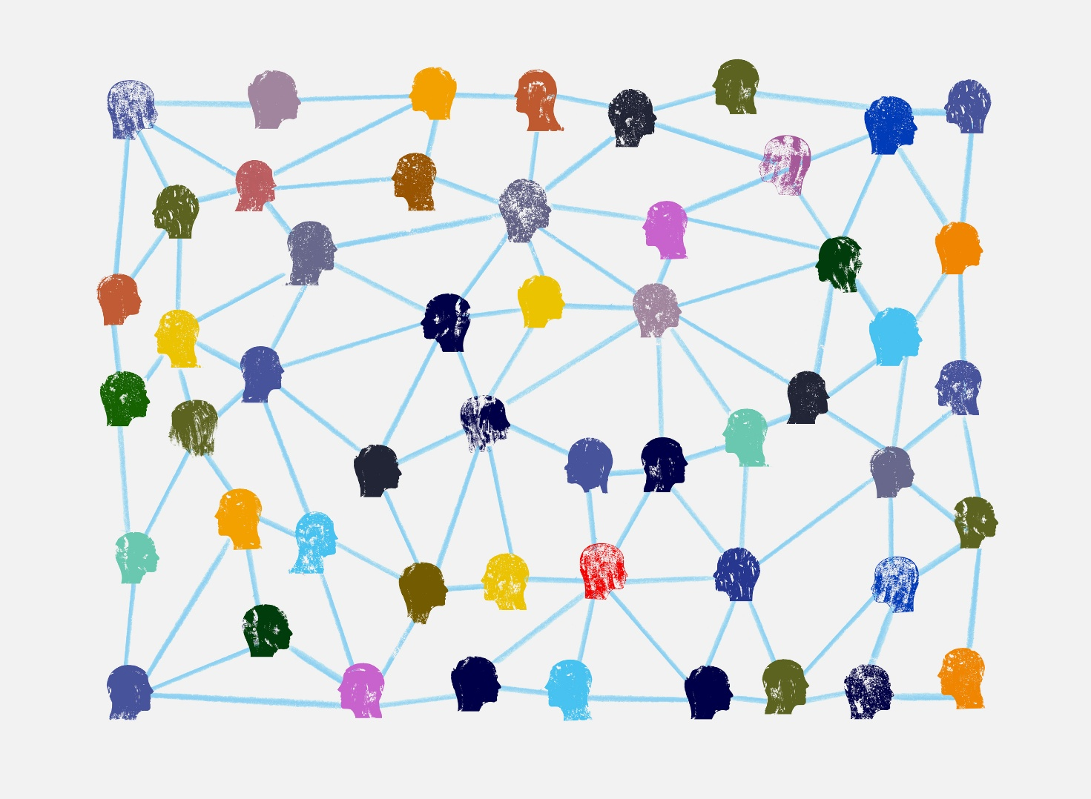
Figure 3: Web representation

Performance Tools
Developers rely on various tools to measure and improve performance. Tools such as Google Lighthouse, GTmetrix, and Chrome DevTools provide detailed reports on performance metrics.
These tools identify issues such as unused JavaScript, large images, and render-blocking resources. By analyzing these reports, developers can make targeted improvements to their applications.

Figure 4: Chart image

Discussion
Performance optimization requires a balance between functionality and efficiency. While adding features can enhance user experience, it can also introduce performance overhead if not managed properly.
Developers must continuously monitor and optimize applications as technologies evolve. The adoption of modern frameworks and tools has made optimization more accessible, but it still requires careful planning and execution.

Conclusion
In conclusion, performance optimization is a fundamental aspect of modern web development. By applying techniques such as code splitting, lazy loading, caching, and image optimization, developers can significantly improve application performance.
The use of performance metrics and analysis tools allows developers to identify issues and make data-driven decisions. As user expectations continue to rise, optimizing performance will remain a critical priority in web development.

Bibliography
https://developer.mozilla.org/en-US/
https://web.dev/articles/promises.
https://wpvip.com/website-performance-test/?utm_device=c&utm_term=&utm_source=google&utm_medium=ppc&utm_campaign=WPVIP-Brand&hsa_cam=20013986353&hsa_grp=193542047705&hsa_mt=&hsa_src=g&hsa_ad=800266081613&hsa_acc=2789592023&hsa_net=adwords&hsa_kw=&hsa_tgt=
https://www.debugbear.com/blog/improve-website-performance
https://www.semrush.com/blog/website-health/?g_network=g&g_keyword=&g_keywordid=dsa-2185834088336&g_adtype=search&g_acctid=231-119-4540&g_adid=767053390734&g_campaign=CA_SRCH_DSA_Blog_EN_Voyantis_V2&g_campaignid=21956373051&g_adgroupid=170515151719&kw=&cm
Wagner, J. Web Performance in Action: Building Fast Web Pages.

