***Windows Notepad.exe***

**Test Plan**

**Version 1.0**

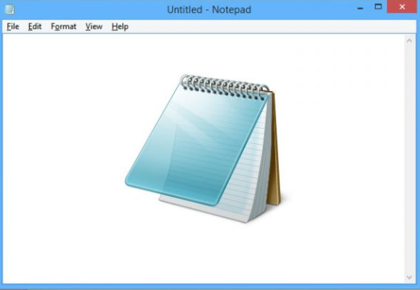

**Revision History**

|  |  |  |  |
| --- | --- | --- | --- |
| **Date** | **Version** | **Description** | **Author** |
| 24/03/2020 | 1.0 | Creation | Suprunova |
|  |  | Edition |  |
|  |  |  |  |

**Table of Contents**

1. Introduction 4
   1. Purpose 4
   2. Background 4
   3. Scope 5
2. Requirements for Testing 5
3. Test Strategy 5
   1. Testing Types 6
      1. Functional Testing 6
      2. Usability Testing 7
4. Scheduled Work 7
5. Risks and restrictions 7
6. Final Results 7
   1. Conclusion 8

**Test Plan**

1. **Introduction**
   1. **Purpose**

The purpose of this Test Plan is to describe the testing process of Notepad.exe, which is one of the components of Microsoft Windows software. The document helps to receive a better understanding about the scheduled work of a testing program.

The object of testing is Notepad.exe – version 1903.

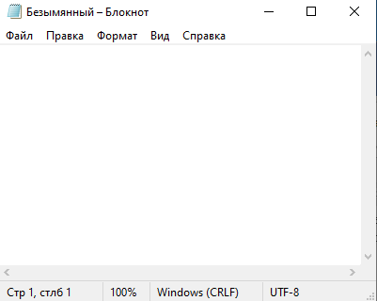

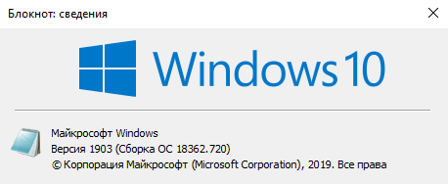

* 1. **Background**

Notepad is a simple text editor for Microsoft Windows and a basic text-editing program which enables computer users to create documents. It also gives the opportunity to view the contents of text files and perform various actions on them - inserting, deleting and copying text, contextual searching and replacing, sorting strings, viewing character codes and encoding conversion, printing, etc.

* 1. **Scope**

The goal of testing the Notepad is the thorough verification of all the features of the program with the typical scripts of its usage. Some time (about 20%) will be spent on testing the negative scenarios which are also able to uncover some bugs.

The final results of the testing process will be the following documents:

* the report about the testing results;
* documented bugs.

The testing will be manual with the help of the ad-hoc method testing.

1. **Requirements for testing**

* Notepad is a basic text-editing program which enables computer users to create documents. Notepad is a type of computer program that edits plain text. This text editor is provided with operating systems and software development packages, and can be used to change files such as configuration files, documentation files and programming language source code (high priority).
* The resulting files typically saved with the [.txt](https://en.wikipedia.org/wiki/Text_file) extension (high priority).
* Notepad supports both left-to-right and right-to-left based languages (high priority).
* Notepad offers only the most basic text manipulation functions, such as finding text (high priority).
* The maximum file size that Notepad can open is 64 KB (high priority).
* Pictures won't be viewable in Notepad (middle priority).
* Notepad also has a simple built-in logging function (middle priority).
* Notepad can print files, but doesn't print correctly if Word Wrap is turned on (high priority).

1. **Test Strategy**

As a result of the first testing cycle, where the functional tests take place, there will be some corrections and additions made and put into the Test Plan. The first cycle will give the definite understanding about the system stability and will help to define the necessary test suite which will be executed shortly. Such method will give the opportunity to get a detailed report about the program and will attract the attention towards weak spots.

The client will be given all daily reports about the testing process, bugs found, propositions about the improvements should be made. All the bugs found will be added to the bug tracker for further corrections and fixes.

Stages of testing that are planned:

* + 1. analysis, Test Plan creation, partial fulfillment of some functional tests;
    2. detailed fulfillment of functional tests uncovering and describing the bugs;
    3. fixed bugs check and Regression testing fulfillment;
    4. User Interface testing with uncovering and description the bugs.

Such kind of testing system allows fulfilling detailed testing and preventing, fixing bugs on early stages.

Configuration – Personal Computer Dell Vostro 14 Series 500, OS Windows 10 Pro.

* 1. **Testing Types**
     1. **Functional Testing**

Target - Functional errors detection via functional tests fulfillment.

Process Description

During testing, attention will be paid to the following:

***Notepad Tools***

* File (New, Open, Save, Save As, Page Setup, Print and Exit)
* Edit (Cut, Copy, Paste, Delete, Find, Find Next, Replace, Go To, Select All, and Time/Date)
* Format (Word Wrap and Font)
* View (Scale and Status Bar)
* Help

***Popular Shortcuts for Notepad***

* Ctrl+W Close Window
* Ctrl+Shift+T Copy Line
* Alt+Enter Show Document Properties
* Ctrl+/ Quick Find
* Ctrl+A Select All
* Ctrl+C Copy
* Ctrl+L Cut Line
* Ctrl+N New File
* Ctrl+O Open File
* Ctrl+V Paste
* Ctrl+P Print
* Ctrl+S Save
* Ctrl+Shift+S Save All

It is supposed to carry out positive application testing (correct steps, correct data) and negative testing (implies the introduction of incorrect data).

**3.1.2. Usability Testing**

Target - To check Notepad for compliance with the requirements in terms of ease of use of the program.

Process Description:

Check the tools of Notepad (File, Edit, Format, View and Help) as user.

**Criteria for the start and end of testing:**

Testing can be started if the following conditions are met:

1. The necessary documentation is ready and approved;

2. The tested functionality is finished and ready for transfer to testing.

Testing is completed if all defects, which are found, are documented.

1. **Scheduled Work**

One person will be involved in testing the program.

|  |  |  |  |
| --- | --- | --- | --- |
| **Task** | **Volume of work** | **Starting date** | **Expiry date** |
| Test Plan Creation | 6 hours | 24/03/2020 | 25/03/2020 |
| Test Execution | 4 hours | 25/03/2020 | 26/03/2020 |
| Analysis of testing | 2 hours | 25/03/2020 | 26/03/2020 |
| Summing-up | 2 hours | 25/03/2020 | 26/03/2020 |

1. **Risks and restrictions:**

Taking into account limited resources, testing of the program will be provided only on devices that are listed in the "Configuration" table.

1. **Final Results**

After testing it is planned to have the following documents:

* Test Plan
* Check list
* Bug report
  1. **Conclusion**

The final result is a documented final result of testing process with the bug descriptions and also with some recommendations and suggestions for further improvement of the given program from the user’s point of view.