Full Void/Refunds

Full Void/Refunds

Partial refunds

Reply to questions via email or FB Messenger/Comments

Order Confirmation

Track orders

Listen to voicemails and cross reference them to their order/email

Delete negative posts (visitor posts on our fb page)

Reply to Facebook messages

Reply to Facebook comments. Delete negative comments

Monitor Facebook Comments (negative comments should not sit there for more than 5 minutes, must delete it ASAP) Hide, Ban, Delete <<<--------- Do it in this order.

File a ticket in Shipbob

Edit shipping addresses

Combine Orders/Split orders

**WEBSITE:**

[**www.MiracleScraper.com**](http://www.miraclescraper.com)

**Email Support:**  
 [info@miraclescraper.com](mailto:info@miraclescraper.com)

**ORDER FORM:**

[**https://www.miraclescraper.com/order-yours-today-1**](https://www.miraclescraper.com/order-yours-today-1)

**TERMS:**[**https://www.miraclescraper.com/terms117702731**](https://www.miraclescraper.com/terms117702731)

**PRIVACY TERMS:**[**https://www.miraclescraper.com/terms117540934**](https://www.miraclescraper.com/terms117540934)

**RETURN AND REFUND POLICY:**[**https://www.miraclescraper.com/terms117974636**](https://www.miraclescraper.com/terms117974636)

**SHIPPING POLICY:**

[**https://www.miraclescraper.com/terms117996983**](https://www.miraclescraper.com/terms117996983)

***FOR GMAIL***

***USERNAME: info@miraclescraper.com***

***PW: Damon808***

***FOR NMI***

***USERNAME: MIRACLEVA***

***PW: Damon888***

RETURNS/REFUNDS:

I am sorry to hear that the product you received did not meet your needs. We have a process for Return and Refund. You have within 30 calendar days to return the item/s from the date you received it and as soon as we have it, we will process the refund accordingly. The credit of the refund may take up to 10 business days to reflect on your account, depending on your card issuer's policies.

Click direct link to have the details of the complete process:<https://www.miraclescraper.com/terms117974636> or you may visit our website [www.MiracleScraper.com](http://www.miraclescraper.com) and click on Return and Refund Policy at the bottom part of the website.

Please see the attached file and print for a Return Label. Once printed, affix it to the outside of the box and drop off at your nearest UPS Customer Service Center.

Let us know if there is anything else that we can help you with.

Happy Holidays!

**Return and Refund for outside of US**  
I am sorry to hear that the product you received did not meet your needs. We have a process for Return and Refund. You have within 30 calendar days to return the item/s from the date you received it and as soon as we have it, we will process the refund accordingly. You will receive the credit within a certain amount of days, depending on your card issuer's policies.  
  
Click direct link to have the details of Returns and Refunds process: <https://www.miraclescraper.com/terms117974636> or you may visit our website [www.MiracleScraper.com](http://www.miraclescraper.com) and click on Return and Refund Policy at the bottom part of the website.   
  
Please ship back items to Miracle Scraper C/O ShipBob, Inc  
68 33RD ST BLDG 8, 6TH FLOOR Brooklyn, NY 11232 USA. If you have any questions on how to return your item to us, contact us at [info@miraclescraper.com](mailto:info@miraclescraper.com)

DEFECTIVE PRODUCTS:

***Kindly send back the defective product together with the return label.***

***Kindly follow all the instructions in order to process the refund accordingly. The credit of the refund may take up to 10 business days to reflect on your account which also depends on your bank.***

***Let us know if there is anything else that we can help you with.***

**Ship bob cannot just send the cap. They have to send entirely new scrapers. Hopefully the ones they send have the cap. so when making a ticket in ship bob, include the order ID and the item number (#1111477 is scraper) and tell them to send either 1 new, 6 new, whatever it is when you send ticket to shipbob, include all customer info, order number, item number. Put in the fault spreadsheet and copy and paste the info**

**When filing a ticket in Shipbob Link:https://support.shipbob.com/hc/en-us/requests/new**

**1. Go in ship bob and go to “support” in upper right**

**2. Click “submit a request"**

**3. Choose issue- create a ticket**

**4. Put info@miraclescraper.com as email**

**5. Paste whole line from the excel doc into the description and write a sentence in front of that saying exactly what you want them to do. Like “send 1 new scraper” or “send 4 caps"**

RETURN LABEL ONLY

[**https://web.shipbob.com/Returns/miraclescraper**](https://web.shipbob.com/Returns/miraclescraper)

**Please see the attached file and print for a Return Label.**

**Kindly follow all the instructions in order to process the refund accordingly.**

**The credit of the refund may take up to 10 business days to reflect on your account which also depends on your bank on how long they post the credit.**

**Let us know if there is anything else that we can help you with.**

**SS ADDRESS ERROR**

**1. ORDERS > STORES> CLICKFUNNELS**

**2. OTHERS> ADDRESS VERIFIED> ERROR**

**FOR EMAIL MESSAGES FROM:**

**1) UPC**

**2) BBB**

**3) INTUIT QUICKBOOKS ONLINE**

**4) AMAZON SERVICES**

**5) SHIPBOB WITH SUBJECT: “Your Outstanding Invoice….”**

**7) SENDGRID**

**8) HELCIM**

**9) ANY MARKETING OR BUSINESS RELATED OFFERS/CONCERNS**

**FORWARD THE FOLLOWING EMAIL TO: italiatradingllc@gmail.com;**

**Thank you for calling miracle scraper. You have reached our unmonitored voicemail inbox. The quickest and best way to reach us is by email at info@miraclescraper.com and we will be happy to help you as soon as possible. Thank you for your business.**

SHIPBOB

**\*Thus, we are pleased to announce that every shipment shipped through ShipBob is covered up to $100, regardless of carrier used! We will be providing instant refunds for these shipments as well.\***

**\*Please note: claims can only be filed for orders shipped in the last 90 days**

To get an instant refund a lost or damaged shipmefor nt, please fill out [this form](https://support.shipbob.com/hc/en-us/requests/new?ticket_form_id=360000339014) to provide the following required information (see example below):

|  |  |
| --- | --- |
| Account Email | email@yourbusiness.com |
| ShipBob Order ID | 12345 |
| Tracking Number | 9400000000000000 |
| Carrier | USPS |
| Ship Date | 12/9/2016 |
| Nature of Loss | Damaged Item |
| Merchandise Description | ShipBob Coffee Mug |
| Merchandise Cost | $25 |
| Reshipment Required? | Yes/No* |
| Invoice/proof of Value of Merchandise | Attached** |
| Screenshot of the email or message from customer notifying you of the Loss or Damage | Attached** |

* You can create a reshipment in the system and ship out the item to the recipient again by [copying the order](https://support.shipbob.com/hc/en-us/articles/218456127-How-do-I-copy-an-order-) and [modifying anything as needed](https://support.shipbob.com/hc/en-us/articles/115011053108-How-to-edit-order-details-recipient-information-order-items-ship-method). We do not cover the shipping or reshipment costs for the lost/damaged items.

** We need to receive the invoice or proof of value of the item to provide to our insurance company.

Once we receive this information, please allow 3-5 business days for the claim to be processed, then we will be able to submit an immediate credit of up to $100.

**PRODUCT INFO**

> Our products are advertised in US Dollars. We can ship out orders to US and Canada address.

> Our products are proudly made in Colorado, USA and be shipped out of NY,USA. We offer FREE shipping and we have an option for PRIORITY Shipping with minimal cost. We can shipped out orders to US and Canada address. Purchase now and get one FREE at www.MiracleScraper.com ❄️

**\*\*priority shipping $4.97  
**regular shipping FREE**

**Currency Conversion:**

[**https://www.xe.com/currencyconverter/convert/?Amount=1&From=USD&To=CAD**](https://www.xe.com/currencyconverter/convert/?Amount=1&From=USD&To=CAD)

**MATERIAL OVERVIEW**

* Miracle Scraper Makes It Easy! Tired of wasting time & money on ice and snow scrapers that just don't work?
* The Miracle Scraper is the clever tool that does it in just seconds! The special two-sided design makes it incredible easy to remove tough ice and snow from your car, without damaging your glass or paint.
* Easily switch between the two sides when needed (large opening for thin layers of snow/ice or the small spiked end for breaking thicker layers).
* You can even remove the smaller end and use the Miracle Scraper as a funnel for your car fluids. Talk about handy!
* Miracle Scraper is made in the USA with quality materials so you can enjoy the peace of mind that this scraper will be the best that you ever own. Get yours today!

**FEATURES**

* 2" & 5.5" scraping surface
* Double scraping action for efficient scraping
* Comfortable and stable grasp
* Scrapes snow, ice and frozen frost
* Detaches to become a car funnel

**OTHER DETAILS**

* Directions: Two-sided winter ice scraper can be used on both sides. For thin ice use the wider side of this scraper. For thicker ice you will use the smaller spiked end.
* Dimensions: This windshield ice scraper measures 6” in height with an 18” scraping surface.
* Material: This ice scraper is made of heavy duty durable plastic made to last.
* Additional: This ice scraper for trucks can also be used as an automobile fluid tunnel.
* Availability: Currently available in blue.

**- The Miracle Scraper - is a two-sided winter ice scraper made of heavy duty durable plastic and manufactured in USA. It is tested, designed and engineered to remove thick frost, ice and snow in all types of vehicles without damaging your glass or paint in just seconds.**

**- The Miracle Smart Texting Gloves - that allow you to use smartphones WHILE keeping your hands warm!**

**- The Miracle Bluetooth Beanie - So you can keep nice and snug while the music plays, and without any need for pesky wires!**

**- The Miracle Emergency Blanket - The Space Grade Blanket with specialised reflective coating to keep you warm and dry if all else fails! An absolute MUST to have in the car for emergencies!**

EXTENDED HANDLES   
Thanks for your inquiry. The extended handles are not yet available. We'll share this to our Product Team, so we can look into it. Your idea is among our considerations. Keep posted, we have other products available as well at [www.MiracleScraper.com](http://www.miraclescraper.com) ❄️

TO ASK FOR CX INFO

Thanks for reaching out. We want to have this resolved for you. Can you confirm your email address, date of purchase, and full name so we can look into it?

Looking forward to your response.

WEBSITE NOT WORKING

Thanks for reaching out. We are sorry for any difficulty you have experienced. You can purchase using this link [https://www.MiracleScraper.com](https://www.miraclescraper.com/) and you may use a Debit card or Credit card Visa, Mastercard, Discover and Amex for payment.

We are looking forward to earning your business. Keep yourself safe and warm!

Confirm Your Shipping Address

Thanks for your recent purchase. It looks like we have an invalid shipping address.

Please confirm immediately so we can deliver it as promised. Kindly include any Unit, Apt or Suite #.

*4112 41ST ST*

*LONG ISLAND CITY, NY 11104-3256 US*

Looking forward to hearing from you.

********************************************************************************************************

Thank you for the prompt response. I have already updated your address and forwarded it to our Shipping Department.

You will receive an email with the tracking information, once it gets shipped out.

***SHIPSTATION (On Hold, Awaiting)***

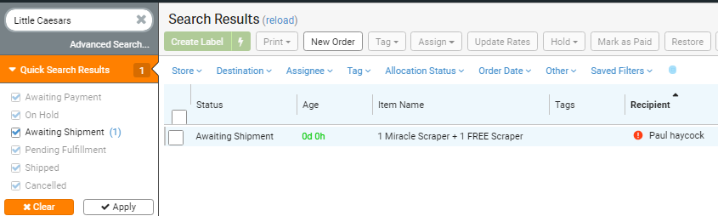

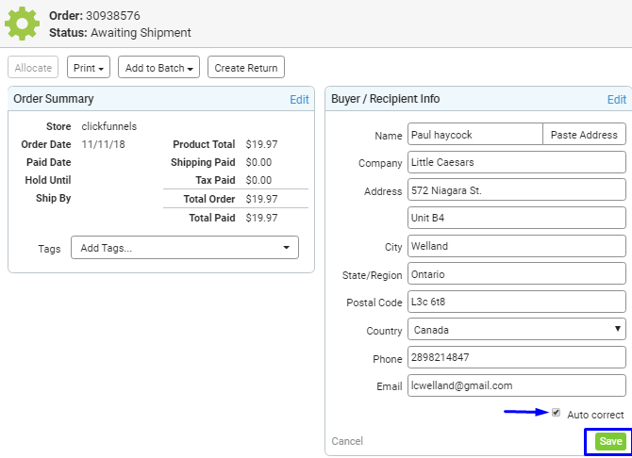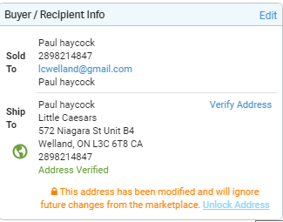

***SHIPBOB (Processing, On Hold and Exception)***

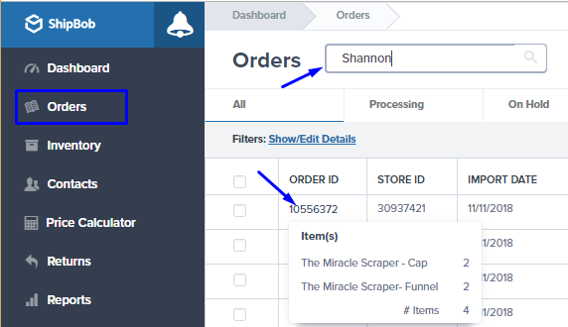 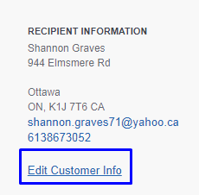

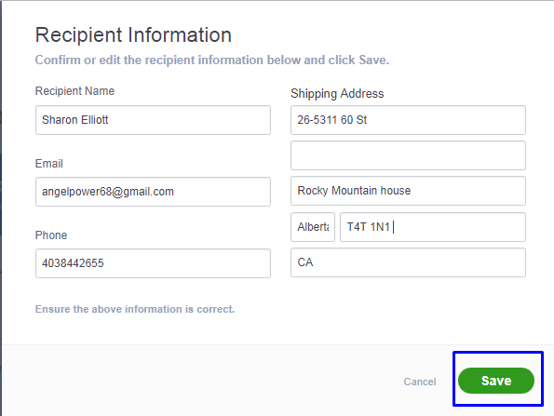 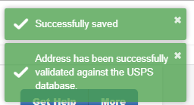

PAYPAL

Your details are kept 100% safe and secure through fully protected SSL Security Order form for your safety. Our payment system is with Network Merchant LLC, (NMI) that currently accept active major debit cards and credit cards like Visa, MasterCard, Discover and American Express.

To process your order, please visit our website www.MiracleScraper.com ❄️

TO CONFIRM PURCHASE/ORDER

Thanks for placing an order through the Miracle Scraper Online store!

I checked your order and shows 1 Miracle Scraper + 1 FREE Scraper with a shipping address 8355 BEACH LAMAR DR BLAINE, WA 98230-9341 US. You will receive an email with the tracking information, once it gets shipped out.

From here, FREE shipping transit time normally takes between 10-14 business days (not including weekends and holidays).

From here, PRIORITY shipping transit time normally takes between 7-10 business days (not including weekends and holidays).

*\*\*We have sent a copy of your purchase receipt. Let us know if there is anything else that we can help you with.*

*\*\*See the screenshot/image for your reference. Let us know if there is anything else that we can help you with.*

*Let us know if there is anything else that we can help you with. Keep safe and warm 😉*

See the screenshot/photo for your reference.

Let us know if there is anything else that we can help you with.

************************************************************************************************************

***(IF MENTIONED THEY DIDN’T RECEIVE A CONFIRMATION AFTER PURCHASE)***

Thanks for placing an order through the Miracle Scraper Online store!

We are sorry to hear that you did not receive a confirmation email right after your order. This is to confirm that we have received your purchase for 1 Miracle Scraper + 1 FREE Scraper . You will receive an email with the tracking information,once it gets shipped out.

From here, FREE shipping transit time normally takes between 10-14 business days (not including weekends and holidays).

From here, PRIORITY shipping transit time normally takes between 7-10 business days (not including weekends and holidays).

*\*\*We have sent a copy of your purchase receipt. Let us know if there is anything else that we can help you with.*

*\*\*See the screenshot/image for your reference. Let us know if there is anything else that we can help you with.*

*Let us know if there is anything else that we can help you with. Keep safe and warm 😉*

FOR ORDERS on AWAITING SHIPMENT on SS and PROCESSING on SB

(DON'T CANCEL ORDERS, JUST HAVE THEM RETURN IT)

(CANCEL ONLY IF On Hold on SS - usually within 12-24 hrs of purchase)

Your order(s) were forwarded already to our Warehouse Team. You will need to refer to our 'Returns & Refunds' policy - <https://www.miraclescraper.com/terms11797463>

You will receive a tracking number via email within 3 days of ordering. Let us know if you have further questions. Thank You!

DELIVERY TIMEFRAME

Please allow 10-14 business days for your order to arrive with free shipping.

Please allow 7-10 business days for your order to arrive with priority shipping.

You will receive a tracking number via email within 3 business days of ordering.

SANCTIONED

Balkans, Belarus, Burundi, Central African Republic, Cuba, Democratic Republic of Congo, Iran, Iraq, Lebanon, Libya, Magnitsky, North Korea, Somalia, Sudan & Darfur, South Sudan, Syria, Ukraine, Russia, Venezuela, Yemen, Zimbabwe, Burma (Myanmar) and Cote d'Ivoir (Ivory Coast

Please check this website <https://www.treasury.gov/resource-center/sanctions/Programs/Pages/Programs.aspx> to know more details.

TRACKING ORDERS

Thanks for purchasing Miracle products!

I checked your order, it has been shipped out with estimated delivery timeframe within 10-14 business days. Here's the Tracking Number 9374869903503266092537 of your order with *AsendiaOne*

You may use this link to track your order:[*http://apps.asendiausa.com/tracking/packagetracking.html?uid=MTc0ODMzMjM1NDA5NjUyMzMyODY3&pid=000000000317718*](http://apps.asendiausa.com/tracking/packagetracking.html?uid=MTc0ODMzMjM1NDA5NjUyMzMyODY3&pid=000000000317718)

Or you can also use this link with their contact number:

[https://track.aftership.com/asendia-usa/000000000317718?](https://track.aftership.com/asendia-usa/000000000317718)

Please allow 7-10 business days for your order to arrive with priority shipping.

We appreciate your patience and please let us know if there is anything else that we can help you with.

ORDER IS IN TRANSIT (within 14 business days)

Hi,

Sorry for the inconvenience. Please know that the item is still in-transit. The tracking number is :

Click on the link to track your package at anytime:

We ask that you give up to 14 business days from shipment for your package to arrive, as there are a number of reasons your package could be slightly delayed.

We wish we could get your package there faster, but unfortunately, some factors are beyond our control. Please note that we work regularly with our shipping carriers to ensure we are providing the fastest and most efficient services for our customers.

If you have not received your package after 14 business days please reach back to us.

If you have not received your package after 10 business days please reach back to us.

Let me know if you need further help.

ORDER SHIPPED

We no longer have the package for y provided our order, since it has already been handed over to the carrier and on its way to your address when you placed the order. Shipped items cannot be cancelled by the carrier and will be delivered as normal. As soon as we see received back the package, we'll process the refund you're requesting. This may take some time, so you can send a follow up email to check on the status of the returned package after 7 business days from the time of RTS/refusal.

CANCELLATION RESPONSE

Thanks for your interest in buying our Miracle Scrapers product.

As per your request, we already canceled the order and < priority shipping (if any)>. A refund will be issued and can take up to several days to show on your statement, unfortunately we have no control over the time it takes to process- it is up to your bank. You will receive the credit within a certain amount of days, depending on your card issuer's policies.

You may place your new order at any time <https://www.miraclescraper.com/order-yours-today-2>

***We’ll send a copy of your refund receipt. Let us know if there is anything else that we can help you with****.*

***We have sent a copy of your voided transaction. Let us know if there is anything else that we can help you wi****th.*

CANCEL AND VOIDED TRANSACTION (WITHIN THE DAY/FEW HRS CANCELLATION)

This is to confirm we have canceled the order for 2 Miracle Scraper + 2 FREE Scraper with Miracle Tarp and voided $63.89. We have sent a copy of the voided transaction to your email address.

You may place your new order at any time <https://www.miraclescraper.com/order-yours-today-2>

PARTIAL REFUND/CHANGE ORDER

Thanks for reaching out. As per your request, we have canceled the order 3 Miracle Scraper + 3 FREE Scraper at $54.91 and reprocessed a new order for 1 Miracle Scraper + 1 FREE Scraper at $19.97

You will receive an email with the tracking information, once it gets shipped out. *From here, FREE shipping transit time normally takes between 10-14 business days (not including weekends and holidays).*

*From here, PRIORITY shipping transit time normally takes between 7-10 business days (not including weekends and holidays).*

A refund is issued for $34.94 (difference), it can take up to several days to show on your statement, unfortunately, we have no control over the time it takes to process- it is up to your bank. Your refund should not take more than 10 business days. If that time has passed, please follow up with your bank before contacting us, as they are usually the reason behind any delays.

See the screenshot/image below for your reference. Let us know if there’s anything else we can help you with.

RESPONSE AFTER CANCEL/VOID AND REFUNDED BY MANAGER

Good day!

This is to let you know that refund for **price in USD** was processed **as per your request to cancel the order.**  It can take up to several days to show on your statement, unfortunately we have no control over the time it takes to process- it is up to your bank. Your refund should not take more than 10 business days. If that time has passed, please follow up with your bank before contacting us, as they are usually the reason behind any delays.

You are welcome to place your order at anytime at [www.MiracleScraper.com](http://www.miraclescraper.com)

***We have sent a copy of your refund receipt. Let us know if there is anything else that we can help you with****.*

*\*\*See the screenshot/image for your reference. Let us know if there is anything else that we can help you with.*

*Let us know if there is anything else that we can help you with. Keep safe and warm 😉*

Thanks for your interest in buying our Miracle Scrapers product.

As per your request, we already canceled the order and priority shipping (if any). You may place your new order at <https://www.miraclescraper.com/order-yours-today-1>

*We have sent a copy of your voided transaction. Let us know if there is anything else that we can help you with.*

*We have sent a copy of your refund receipt. Let us know if there is anything else that we can help you with.*

*See the screenshot/image for your reference. Let us know if there is anything else that we can help you with.*

*Let us know if there is anything else that we can help you with. Keep safe and warm 😉*

**TO CREATE A NEW ORDER OR MANUAL ORDER IN SHIPSTATION**

> Go to ***“New Order”***

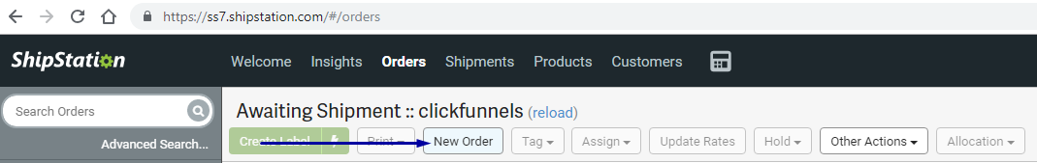

> Fill out this part for customer’s information (make sure STORE is **clickfunnels** and Order# is at **AUTO** )

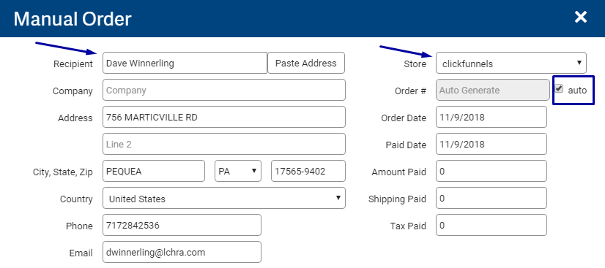

> Type the **Name of Order** then the **SKU** will appear and put the number of items on Qty

(base the name under on this link <https://ss7.shipstation.com/#/products> can be found under Products in SS) Choose only SAVE ORDER

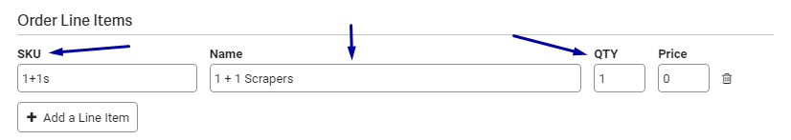

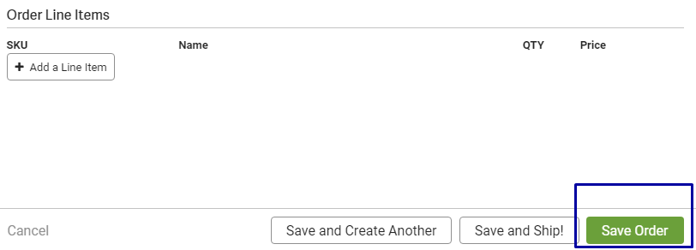

> Make sure to TAG new order as MANUAL ORDER (yellow tag) and placed a note for reason for adding a new order and if it’s via Email or FB.

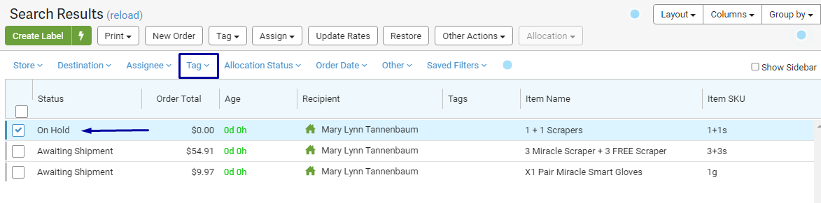

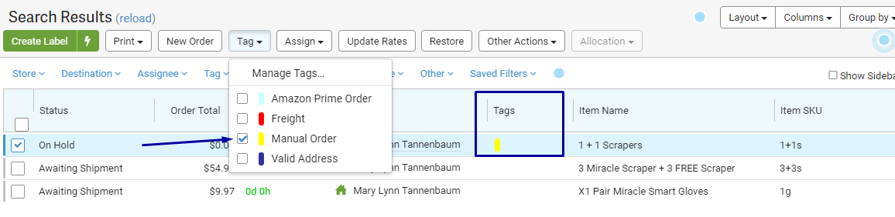

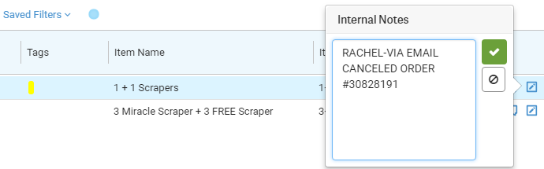

**TO CANCEL ORDER IN SHIPSTATION:**

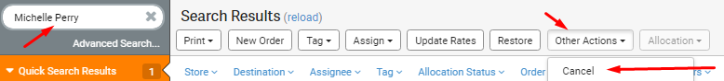



**TO CANCEL ORDER IN SHIPBOB:**

<https://support.shipbob.com/hc/en-us/articles/115003339027-How-do-I-cancel-orders->

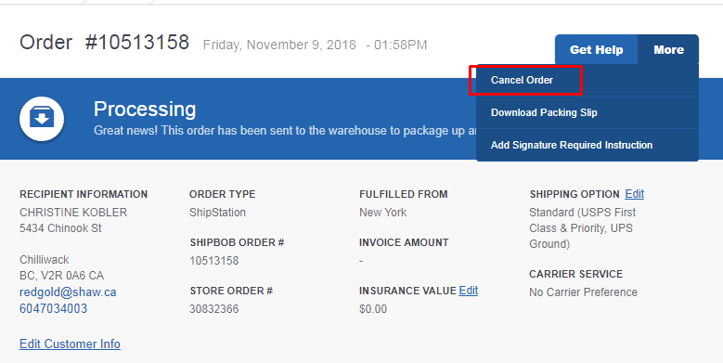

**TO SPLIT AN ORDER IN SHIPBOB:**

<https://support.shipbob.com/hc/en-us/articles/115015595687-How-do-I-split-an-order-that-is-in-exceptions->

>>>Reasons why orders are in Exception <https://support.shipbob.com/hc/en-us/articles/115003244828-Why-is-my-order-in-Exceptions->

*\*\*See the screenshot/image for your reference. Let us know if there is anything else that we can help you with.*

*Let us know if there is anything else that we can help you with. Keep safe and warm 😉*

See the screenshot/photo for your reference.

Let us know if there is anything else that we can help you with.

************************************************************************************************************

***(IF MENTIONED THEY DIDN’T RECEIVE A CONFIRMATION AFTER PURCHASE)***

Thanks for placing an order through the Miracle Scraper Online store!

We are sorry to hear that you did not receive a confirmation email right after your order. This is to confirm that we have received your purchase for 1 Miracle Scraper + 1 FREE Scraper . You will receive an email with the tracking information,once it gets shipped out.

From here, FREE shipping transit time normally takes between 10-14 business days (not including weekends and holidays).

From here, PRIORITY shipping transit time normally takes between 7-10 business days (not including weekends and holidays).

*\*\*We have sent a copy of your purchase receipt. Let us know if there is anything else that we can help you with.*

*\*\*See the screenshot/image for your reference. Let us know if there is anything else that we can help you with.*

*Let us know if there is anything else that we can help you with. Keep safe and warm 😉*

FOR ORDERS on AWAITING SHIPMENT on SS and PROCESSING on SB

(DON'T CANCEL ORDERS, JUST HAVE THEM RETURN IT)

(CANCEL ONLY IF On Hold on SS - usually within 12-24 hrs of purchase)

Your order(s) were forwarded already to our Warehouse Team. You will need to refer to our 'Returns & Refunds' policy - <https://www.miraclescraper.com/terms11797463>

You will receive a tracking number via email within 3 days of ordering. Let us know if you have further questions. Thank You!

DELIVERY TIMEFRAME

Please allow 10-14 business days for your order to arrive with free shipping.

Please allow 7-10 business days for your order to arrive with priority shipping.

You will receive a tracking number via email within 3 business days of ordering.

SANCTIONED

Balkans, Belarus, Burundi, Central African Republic, Cuba, Democratic Republic of Congo, Iran, Iraq, Lebanon, Libya, Magnitsky, North Korea, Somalia, Sudan & Darfur, South Sudan, Syria, Ukraine, Russia, Venezuela, Yemen, Zimbabwe, Burma (Myanmar) and Cote d'Ivoir (Ivory Coast

Please check this website <https://www.treasury.gov/resource-center/sanctions/Programs/Pages/Programs.aspx> to know more details.

TRACKING ORDERS

Thanks for purchasing Miracle products!

I checked your order, it has been shipped out with estimated delivery within 10-14 business days. Here's the Tracking Number 9374869903503266092537 of your order with *AsendiaOne*

You may use this link to track your order:[*http://apps.asendiausa.com/tracking/packagetracking.html?uid=MTc0ODMzMjM1NDA5NjUyMzMyODY3&pid=000000000317718*](http://apps.asendiausa.com/tracking/packagetracking.html?uid=MTc0ODMzMjM1NDA5NjUyMzMyODY3&pid=000000000317718)

Or you can also use this link with their contact number:

[https://track.aftership.com/asendia-usa/000000000317718?](https://track.aftership.com/asendia-usa/000000000317718)

Please allow 7-10 business days for your order to arrive with priority shipping.

We appreciate your patience and please let us know if there is anything else that we can help you with.

ORDER IS IN TRANSIT (within 14 business days)

Hi,

Sorry for the inconvenience. Please know that the item is still in-transit. The tracking number is 92748902118759543400162654

Click on the link to track your package at anytime:

<https://www.ups.com/track?loc=en_US&tracknum=92748902118759543400162654&requester=WT/trackdetails>

We ask that you give up to 14 business days from shipment for your package to arrive, as there are a number of reasons your package could be slightly delayed.

We wish we could get your package there faster, but unfortunately, some factors are beyond our control. Please note that we work regularly with our shipping carriers to ensure we are providing the fastest and most efficient services for our customers.

If you have not received your package after 14 business days please reach back to us.

If you have not received your package after 10 business days please reach back to us.

Let me know if you need further help.

ORDER SHIPPED

We no longer have the package for your order, since it has already been handed over to the carrier and on its way to your address provided when you placed the order. Shipped items cannot be cancelled by the carrier and will be delivered as normal. As soon as we see received back the package, we'll process the refund you're requesting. This may take some time, so you can send a follow up email to check on the status of the returned package after 7 business days from the time of Return To Sender or refusal of package.

CANCELLATION RESPONSE

Thanks for your interest in buying our Miracle Scrapers product.

As per your request, we already canceled the order and < priority shipping (if any)>. A refund will be issued and can take up to several days to show on your statement, unfortunately we have no control over the time it takes to process- it is up to your bank. You will receive the credit within a certain amount of days, depending on your card issuer's policies.

You may place your new order at any time <https://www.miraclescraper.com/order-yours-today-1>

***We’ll send a copy of your refund receipt. Let us know if there is anything else that we can help you with****.*

***We have sent a copy of your voided transaction. Let us know if there is anything else that we can help you wi****th.*

CANCEL AND VOIDED TRANSACTION (WITHIN THE DAY/FEW HRS CANCELLATION)

This is to confirm we have canceled the order for 2 Miracle Scraper + 2 FREE Scraper with Miracle Tarp and voided $63.89. We have sent a copy of the voided transaction to your email address.

You may place your new order at any time <https://www.miraclescraper.com/order-yours-today-1>

PARTIAL REFUND/CHANGE ORDER

Thanks for reaching out. As per your request, we have canceled the order 3 Miracle Scraper + 3 FREE Scraper at $54.91 and reprocessed a new order for 1 Miracle Scraper + 1 FREE Scraper at $19.97

You will receive an email with the tracking information, once it gets shipped out. *From here, FREE shipping transit time normally takes between 10-14 business days (not including weekends and holidays).*

*From here, PRIORITY shipping transit time normally takes between 7-10 business days (not including weekends and holidays).*

A refund is issued for $34.94 (difference), it can take up to several days to show on your statement, unfortunately, we have no control over the time it takes to process- it is up to your bank. Your refund should not take more than 10 business days. If that time has passed, please follow up with your bank before contacting us, as they are usually the reason behind any delays.

See the screenshot/image below for your reference. Let us know if there’s anything else we can help you with.

Good day!

This is to let you know that refund for **price in USD** was processed **as per your request to cancel the order.**  It can take up to several days to show on your statement, unfortunately we have no control over the time it takes to process- it is up to your bank. Your refund should not take more than 10 business days. If that time has passed, please follow up with your bank before contacting us, as they are usually the reason behind any delays.

You are welcome to place your order at anytime at [www.MiracleScraper.com](http://www.miraclescraper.com)

***We have sent a copy of your refund receipt. Let us know if there is anything else that we can help you with****.*

*\*\*See the screenshot/image for your reference. Let us know if there is anything else that we can help you with.*

*Let us know if there is anything else that we can help you with. Keep safe and warm 😉*

Thanks for your interest in buying our Miracle Scrapers product.

As per your request, we already canceled the order and priority shipping (if any). You may place your new order at <https://www.miraclescraper.com/order-yours-today-1>

*We have sent a copy of your voided transaction. Let us know if there is anything else that we can help you with.*

*We have sent a copy of your refund receipt. Let us know if there is anything else that we can help you with.*

*See the screenshot/image for your reference. bn Let us know if there is anything else that we can help you with.*

*Let us know if there is anything else that we can help you with. Keep safe and warm 😉*

**TO CREATE A NEW ORDER OR MANUAL ORDER IN SHIPSTATION**

> Go to ***“New Order”***



> Fill out this part for customer’s information (make sure STORE is **clickfunnels** and Order# is at **AUTO** )



> Type the **Name of Order** then the **SKU** will appear and put the number of items on Qty

(base the name under on this link <https://ss7.shipstation.com/#/products> can be found under Products in SS) Choose only SAVE ORDER





> Make sure to TAG new order as MANUAL ORDER (yellow tag) and placed a note for reason for adding a new order and if it’s via Email or FB.







**TO CANCEL ORDER IN SHIPSTATION:**





**TO CANCEL ORDER IN SHIPBOB:**

<https://support.shipbob.com/hc/en-us/articles/115003339027-How-do-I-cancel-orders->



**TO SPLIT AN ORDER IN SHIPBOB:**

<https://support.shipbob.com/hc/en-us/articles/115015595687-How-do-I-split-an-order-that-is-in-exceptions->

>>>Reasons why orders are in Exception <https://support.shipbob.com/hc/en-us/articles/115003244828-Why-is-my-order-in-Exceptions->