You are an **Online Analytics Consultant Company** that helps organizations manage customer relations in Asia Pacific.

* Company name
* Company logo
* Company structure (roles and responsibilities per member)
* As a potential customer, not from Asia Region, who wants to explore selling my product in the Asia Pacific Region, **why should I hire your company to help me manage my customer relations?**

→ at this stage, we don’t know who our customer is and what asia pacific region they want to sell yet

**Fun Video Format Video:**

Boston Consulting Group <https://www.youtube.com/watch?v=aGRlEjpQwLk>

IM Consulting: <https://www.youtube.com/watch?v=YUUO5lTqwrg>

From seniors- <https://www.youtube.com/watch?v=rDlwMfqSBZ0>

**Project Example:** <https://web.microsoftstream.com/video/ed2ac925-8c71-467c-aeb9-5409937687fd>

**Possible Company Names:**

<https://www.squadhelp.com/premium-domains-for-sale/all/categories/Agency%20%26%20Consulting/page/2>

Intelscale → AC

Intelcademy

Intel Alliance -> ch

Data Scout -yw ra AC

The insight factory ra

Juicy insights.co -yw

Datahouse

The data people

LifeLytics

**Company Logo**

**Data Scout (blue)**

**Company Structure**

Director:

*Initiate and center team efforts to gather, analyze and interpret data and formulate recommendations and conclusions to target new and current clients.*

Engagement Manager:

*Working directly with clients and taking ownership of the overall project and its end products.In addition lead the day to day execution of a client project while guiding and developing a team of consultant members.*

Business Consultant:

*Gathering and analyzing information, presenting results to client management and implementing recommendations in collaboration with client team members.*

Sales Company structure

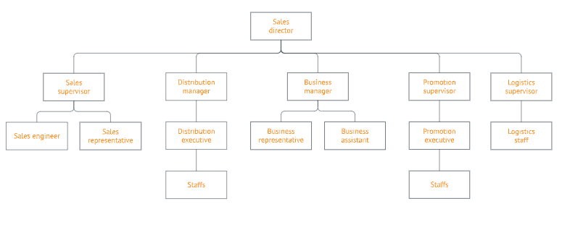

Customer relations

Creating dashboard

CEO/Founder (leader of project team)

Regional Head / SME Manager / Enterprise Manager

Sales Manager

Business analyst

Data analyst

Marketing Manager

Project Manager

4th point:

Strengths/Why Choose Us: [Persuasion - Logos]

* **Importance of customer relations (touch and go, 1-2 sentences?)**
* ***benefit/success of crm (with stats)***
* ***Many companies still fail to be data driven (with stats)***

CRM software is now the biggest software market in the world and the growth isn't slowing down. In fact, CRM is now expected to reach more than $80 billion in revenues by 2025. Yet, 69% of companies still have not created a data-driven organisation.

Frame: Bustling city, skyscrapers, moving clouds (fast-forwarded)

* Strengths of the company (what we are good at doing?) → long standing history with using certain crm tools like salesforce
* Credibility/accolades
* Business cases (especially APAC), helping key clients from outside of apac penetrate the market successfully, maybe even provide certain figures/numbers/growth i.e number of successful solutions delivered

Company Fundamentals/Our Philosophy/Value Proposition:

1. Customer Centric Decision Making
2. Data driven decisions
3. Staying on top of the latest trends in CRM

| * Experience the Evolution of your Business. |
| --- |
| * Experience you can trust, service you can count on * Growing Businesses, Changing Lives. * Your vision…our process   **Slogan**  Scouting insights for customer relations  https://thinkisthan.com/150-best-consulting-slogans-and-popular-taglines/ |

Industry / Vertical Org Chart

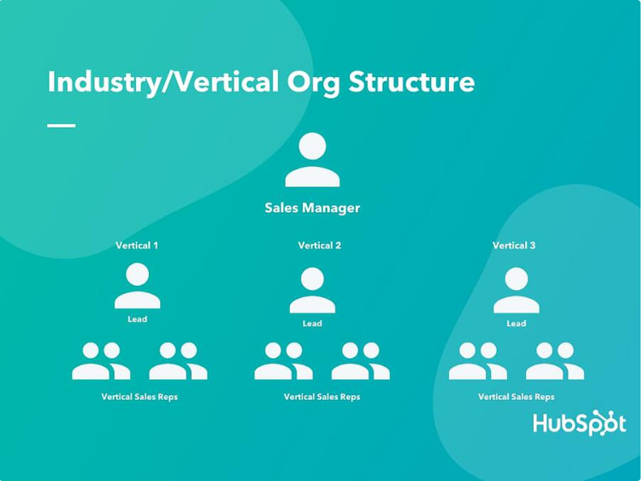

Customer / Account size org structure

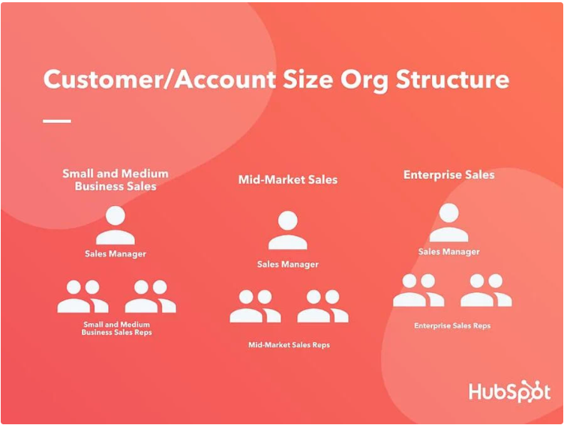

Product / Service Line org structure

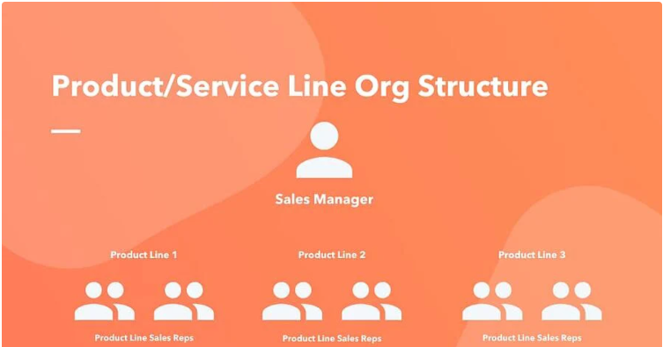

Geography / Territory Org Structure

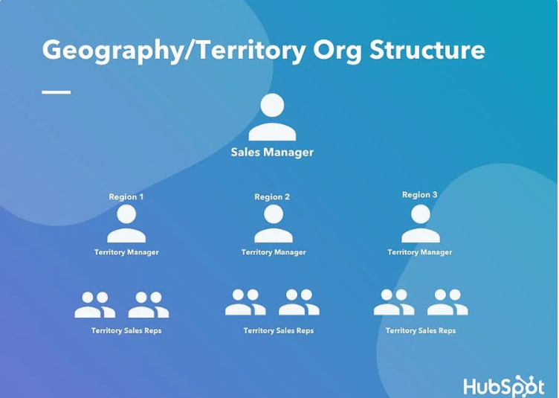

**Why should I hire your company to help me manage my customer relations?**

* Business today powered by data for insights, analytics help to stay competitive
* The company has proven results, clients use case, experiences, awards etc
* The company provide in depth touchpoint analysis, customer lifecycle management (alongside with customer journey mapping)
* Very good deployment methods and strategies methods > how the client can benefit from it
* Tailor the strategies and recommendations to your own business

5w1h

Who → Data Scout

Where → Asia pacific

when → real time data update? -

What → company motto/obj ( i think it's good to have it to make us sound convincing)

Some slogan:

| * Experience the Evolution of your Business. |
| --- |
| * Experience you can trust, service you can count on * Growing Businesses, Changing Lives. * Your vision…our process   https://thinkisthan.com/150-best-consulting-slogans-and-popular-taglines/ |

Why → why choose us ?

* Cultural ?
* [http://blog.coinpip.com/east-meets-west-15-cultural-differences-that-affect-business](http://blog.coinpip.com/east-meets-west-15-cultural-differences-that-affect-business/)

How → How can clients benefit from choosing us? How are we able to help them ?

* The different industry data we can provide ?
* Different kind of data insights ( descriptive, analytical , statistical, etc)
* How can they gain competitive advantage by hiring us (<https://www.softwebsolutions.com/resources/leverage-data-analytics-for-business.html#:~:text=Competitive%20advantage%20of%20data%20analytics,potential%20gaps%20in%20the%20market>.)

**Pumpfree energy**

Company description

PumpFree Energy is devoted to developing the best solutions to help busy restaurant owners and managers take care of liquid waste in the cleanest, most efficient way possible.

We have worked in and run liquid waste businesses in Australia and the USA over the last 25 years and have a very knowledgeable team devoted to making our customers lives easier. We started PumpFree to offer a better solution to the industry. We have spent thousands of hours testing the best way to collect and treat liquid waste from grease traps.

**Script (90s- 1 min 30s)**

| **Timing** | **Frame** | **Script** |
| --- | --- | --- |
| [About our company in relation to the background story] | | |
|  | City backdrop:  <https://www.pexels.com/video/time-lapse-video-of-cityscape-during-nighttime-5625316/>  (Maybe can add on the many businesses just opened alert, to show like many businesses just started).  Idea:    Business Connection Backdrop:  <https://www.videezy.com/backgrounds/37482-world-map-line-business-connection> | About 137,000 businesses are launched daily in the world. As the world becomes increasingly complex and customers become more demanding, it is ever so important to do customer journey mapping and analytics. |
|  | Bustling city, skyscrapers, moving clouds (fast-forwarded)  Colour: bright  People analyzing:  <https://www.pexels.com/video/light-marketing-businessman-man-5716230/> | ~~Trends have shown that businesses are strategizing with techniques such as customer journey mapping and analytics in the data rich environment.~~  ~~It is ever so important to do customer journey mapping and analytics with data being important to businesses.~~ |
|  | Video backdrop: <https://www.pexels.com/video/woman-discussing-to-her-colleagues-3114574/>  (We can film ourself doing this)  Company Logo | Introducing Data Scout, an online analytics consulting firm that simplifies matters with data, to bridge the gap between clients and to empower everyday decision making processes for business. |
|  | Video handshake  <https://www.pexels.com/video/people-in-business-ending-a-meeting-with-a-shake-hand-3209211/> | ~~We inspire powerful minds by embracing a global mindset and our passion for problem solving drives creativity, helping us to create bold solutions for our clients.~~  ~~We walk our clients through every step of execution till they see the results we promised to deliver.~~ |
| [What our company can offer] → strengths | | |
|  | Video: <https://www.pexels.com/video/computer-coding-programming-2516162/>  (Can add on TIBCO, Salesforce logo)  Tibco image link: <https://www.google.com/url?sa=i&url=https%3A%2F%2Fen.wikipedia.org%2Fwiki%2FFile%3ATibco_logo-_Palo_Alto%2C_CA_company-_(PNG)_2013-11-24_16-00.png&psig=AOvVaw0Smt1H2GLaO-tpZTrvGJMw&ust=1613478667948000&source=images&cd=vfe&ved=0CAIQjRxqFwoTCLCF2Mny6-4CFQAAAAAdAAAAABAD>  SalesForce: <https://www.google.com/url?sa=i&url=https%3A%2F%2Fwww.stickpng.com%2Fimg%2Ficons-logos-emojis%2Ftech-companies%2Fsalesforce-logo&psig=AOvVaw1nBmThmD333O2TZe5wEa8U&ust=1613478704193000&source=images&cd=vfe&ved=0CAIQjRxqFwoTCKju8try6-4CFQAAAAAdAAAAABAD> | ~~Using state of the art CRM softwares like TIBCO and Salesforce, Data Scout helps you to maximise the full potential of your data, delivering a deeper layer of insights to help you make better informed decisions.~~  ~~As a global data consulting firm, we have a rich history of working across global markets through a diverse portfolio of clients. Our strong understanding of the global and regional markets help us to enable effective solutions for our clients.~~ |
|  |  | ~~Our diverse portfolio of clients broadened expertise in (something about better understanding the apac market in terms of culture, customer behaviour, geographical landscape) labelling us as the one of the global leading data consulting firms.~~ |
|  | Show award logos if want | ~~Since 2000, we were awarded with top xxxx (input achievements and accolades)~~ |
|  | Video backdrop: <https://www.pexels.com/video/digital-projection-of-geometrical-distance-of-earth-s-land-mass-end-points-3125427/>  (Put company logo examples) | On top of that, Data Scout has strong ties to some of the top 10 companies within the APAC region, to manage their customer relations. |
| [Team Introduction- Can be standalone or infused into the respective parts] | | |
|  | Singapore Backdrop:<https://www.pexels.com/video/view-of-cityscape-3910599/> | We have a diverse team of highly experienced consultants headquartered in Singapore. |
|  | Collage of each of us waving  (combine with: we have a diverse team of highly experienced consultanta headquartered in singapore) | Our experienced team consists ~~of the following members~~:   * Regional Head / SME Manager / Enterprise Manager * Sales Manager * Business analyst * Data analyst * Marketing Manager * Project Manager |
| [What the client can benefit] | | |
|  | Customer lifecycle diagram  Keyboard typing:<https://www.pexels.com/video/close-up-video-of-a-person-typing-on-keyboard-853989/>  Possible Customer Support Video: <https://www.pexels.com/video/man-people-office-girl-5452807/> | Data Scout tackles each stage of the customer life cycle through attracting and maintaining relationships with customers.  ~~Through innovative solutions that enable your company to stay ahead of competition, infusing the relationships at the tip of your fingers.~~ |
|  |  | We curate innovative solutions that enable your company to stay ahead of competition, infusing the relationships at the tip of your fingers. |
|  | Aerial View Backdrop: <https://www.pexels.com/video/aeerial-view-of-city-with-tall-buildings-2818546/>  Counting Money:  <https://www.pexels.com/video/a-man-counting-cash-money-and-put-it-into-record-3196002/>  Video of people giving hi-5  <https://www.pexels.com/video/a-group-of-people-giving-high-fives-for-their-success-6774777/> | ~~We drive these changes for you to stay on top of the competitive arena and manage these relationships through Customer Centric Decision Making, Data driven decisions and Staying on top of the latest trends in CRM.~~  We enable you to manage these relationships through Customer Centric Decision Making, data-driven decisions and Staying on top of the latest trends in CRM. |
| [Call to action] / Slogan : | | |
|  | <https://www.pexels.com/video/people-having-a-team-building-3246359/> (Maybe our logo can appear after the team fistbump)- also possible to film ourself    <https://www.videezy.com/people/35565-business-partners-handshaking-after-signing-contract-at-office>  (Here got handshake then can throw the logo and end?)  <https://www.videezy.com/people/35601-happy-and-enthusiastic-business-team-in-a-business-meeting>  (Happy people :”) )  Text with white background ? | Scout Insights today! Experience the revolution of your Business. |
|  |  | Compassion, Innovation, Trust  Experience and Innovation in a single touch for your customers |
| [Closing with company logo] | | |
| Time Take  (__Min__s) | Script | About 137,000 businesses are launched daily in the world. As the world becomes increasingly complex and customers become more demanding, it is ever so important to do customer journey mapping and analytics.  Introducing Data Scout, an online analytics consulting firm that simplifies matters with data, to bridge the gap between clients and empower everyday decision making processes for business.  Utilising state of the art CRM softwares like TIBCO and Salesforce, Data Scout helps you to realise the full potential of your data. ~~delivering a deeper layer of insights to help you make better informed decisions.~~  On top of that, Data Scout has strong ties to some of the top 10 companies within the APAC region, to manage their customer relations.  We have a diverse team of highly experienced consultants headquartered in Singapore.  Our team consists ~~of the following members~~:   * Regional Head / SME Manager / Enterprise Manager * Sales Manager * Business Analyst * Data Analyst * Marketing Manager * Project Manager   Data Scout tackles each stage of the customer life cycle through attracting and maintaining relationships with customers.  We curate innovative solutions that enable your company to stay ahead of competition, infusing the relationships at the tip of your fingers.  We enable you to manage these relationships through Customer Centric Decision Making, data-driven decisions and Staying on top of the latest trends in CRM.  Scout Insights today! Experience the revolution of your Business. |
| [Entire Script | | |

# Sales Pitch Video - 10%

**Context**

You got a qualified lead from [**PumpFree Energy**](https://pumpfree.com.au/)

## Deadline

Submit **one day before** your class starts on Week 9 (After recess week)

## Spoken Expectations

From the main stakeholders:

* Which Demand Generation strategy/tactics do you recommend to us in your Asian Market?
* Is there competition and price expectations for waste management?
* Any advice regarding legal issues and taxes?
* Should we enter your market?

From the teaching team:

* Showcase **all that you learned** on the six first lessons! Attract and Convert

## Submission Guidelines

| **Format** | mp4 |
| --- | --- |
| **Name Convention** | M8-GxTy-Sales   * Change GxTy for your Team code: G2T4 * Example: M8-G2T4-Sales.mp4 |
| **Location** | Submit your video at your folder in **“Sales Pitch Video”** channel in Microsoft Teams |
| **Duration** | 5 minutes (Plus/minus 30 seconds) |