Kafka Example:  
Create  
  


Update  
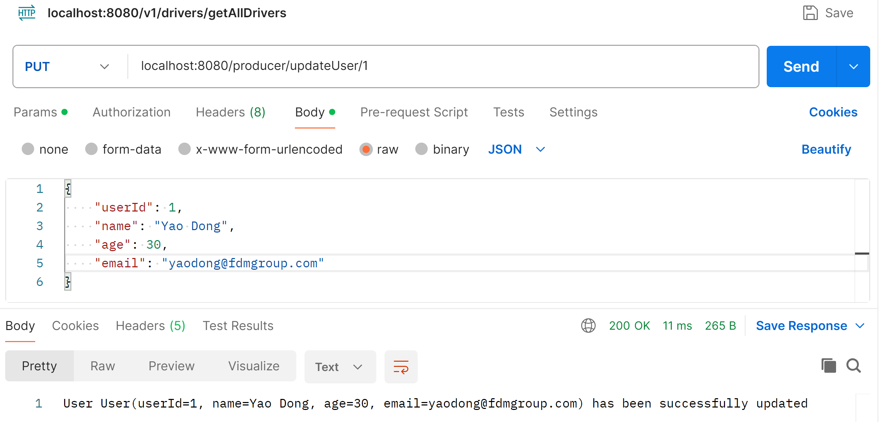  
  
Delete  
