SUPERSTORE PERFORMANCE DASHBOARD
Executive Summary Report
Prepared by Yewande Mosaku | Junior Business Intelligence Analyst
AnalystLab Africa Data Analytics Internship Programme — Week 2 Business Analytics Case Study

Purpose
This report summarizes the findings of the Superstore Performance Dashboard, built in Microsoft Power BI to help senior management monitor sales performance, profitability, customer behavior, and regional performance for the retail business. It draws on the full Sample Superstore dataset (9,994 order line items, 2014–2017) and translates the dashboard's visuals into business insights and actionable recommendations.

Key Performance Indicators
$2.30M  Total Sales | $286.41K  Total Profit | 5,009  Total Orders | $458.56  Average Sales | 12.5%  Profit Margin

Dashboard Overview
Page 1 — Performance Overview: KPI cards, Total Sales & Profit by Region, Total Sales by Segment, Category Performance by Sales & Profit, and the Top 10 Best Performing Products by profit.
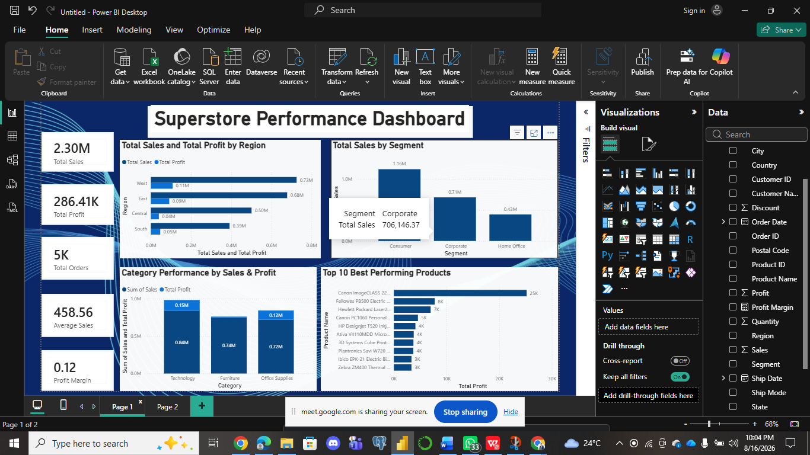
Page 2 — Trend Analysis: Monthly Sales and Profit trend, highlighting seasonal demand patterns across the year.


Performance Breakdown
Regional Performance
Region | Total Sales | Total Profit
West | $725,458 | $108,418
East | $678,781 | $91,523
Central | $501,240 | $39,706
South | $391,722 | $46,749

Customer Segment Performance
Segment | Total Sales | Total Profit
Consumer | $1,161,401 | $134,119
Corporate | $706,146 | $91,979
Home Office | $429,653 | $60,299

Category Performance
Category | Total Sales | Total Profit
Technology | $836,154 | $145,455
Office Supplies | $719,047 | $122,491
Furniture | $741,999 | $18,451

Key Business Insights
- The West region drives disproportionate profit. Sales generate ~$725K with ~$108K profit — the strongest sales-to-profit conversion of any region. Central posts similar sales scale to South but converts far less of it to profit, pointing to a regional efficiency gap.
- Furniture is a sales-heavy, profit-light category. Furniture brings in nearly as much revenue as Technology (~$742K vs ~$836K) but converts only a fraction to profit (~$18K vs ~$145K) — roughly a 2.5% margin versus Technology's ~17%.
- Consumer segment is the revenue backbone. At ~$1.16M in sales, the Consumer segment alone accounts for more than half of total company revenue — more than Corporate and Home Office combined.
- A small number of products carry most of the profit. The Canon imageCLASS 2200 Advanced Copier alone contributes roughly $25K in profit, multiples ahead of the next-best product — profit is concentrated rather than evenly spread across the catalog.
- Sales and profit are strongly seasonal. Monthly trends show a clear ramp into Q4, peaking in November and December after a comparatively flat first half of the year — a predictable seasonal pattern rather than steady demand.

Business Risks
- Margin erosion in Furniture. Furniture sales nearly match Technology but profit trails far behind; continued investment without addressing pricing or discounting ties up capital for minimal return.
- Regional inefficiency in Central. Weak profit conversion relative to sales volume suggests higher costs, deeper discounting, or logistics inefficiencies that could compound as the business scales.
- Revenue concentration risk. Heavy reliance on the Consumer segment and a handful of top products leaves limited cushioning if demand shifts in either.

Business Opportunities
- Scale what's working in the West. The West region's high sales-to-profit conversion suggests a pricing, product mix, or operational playbook that could be studied and replicated in Central and South.
- Grow underrepresented segments. Corporate and especially Home Office have far more sales headroom than Consumer — targeted campaigns could diversify revenue without cannibalizing the core segment.
- Plan around the Q4 seasonal peak. Since demand reliably surges in November and December, there is a clear opportunity to optimize inventory, staffing, and promotions ahead of that window.

Recommendations
- 1. Review Furniture pricing and discount policy. Audit discount depth on Furniture sub-categories — especially Tables and Bookcases, which post outright losses — and consider renegotiating supplier costs or repositioning pricing.
- 2. Investigate Central region's cost structure. Compare Central's discounting, shipping mode, and supplier terms against West's to identify what is compressing margin, then apply corrective pricing or logistics changes.
- 3. Double down on Technology. Increase marketing spend and catalog prominence for Technology products to grow an already high-margin line.
- 4. Launch targeted campaigns for Corporate and Home Office. Use targeted CRM or email marketing aimed at Corporate and Home Office to close the revenue gap with Consumer and reduce reliance on a single customer type.
- 5. Build a Q4 readiness plan. Increase inventory and staffing ahead of the November–December surge, and shift some marketing budget earlier in the year to smooth out the flatter January–August period.

Conclusion
The Superstore dashboard shows a business with healthy overall growth (sales up roughly 50% from 2014 to 2017) but uneven profitability across regions, categories, and products. Addressing the Furniture margin gap and Central's cost inefficiency, while scaling what already works in the West and in Technology, offers the clearest path to improving overall business performance without requiring new revenue streams.

