Name: Yeyu Chi Date: 2/20/25

NYU ID: yc7720

Course section: CSCI-GA 2262 001

Lab #2 - Application Layer
Total in points(100 points total):
Professor’s Comments:

Affirmation of my Independent Effort: 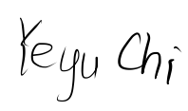

T1
(a)
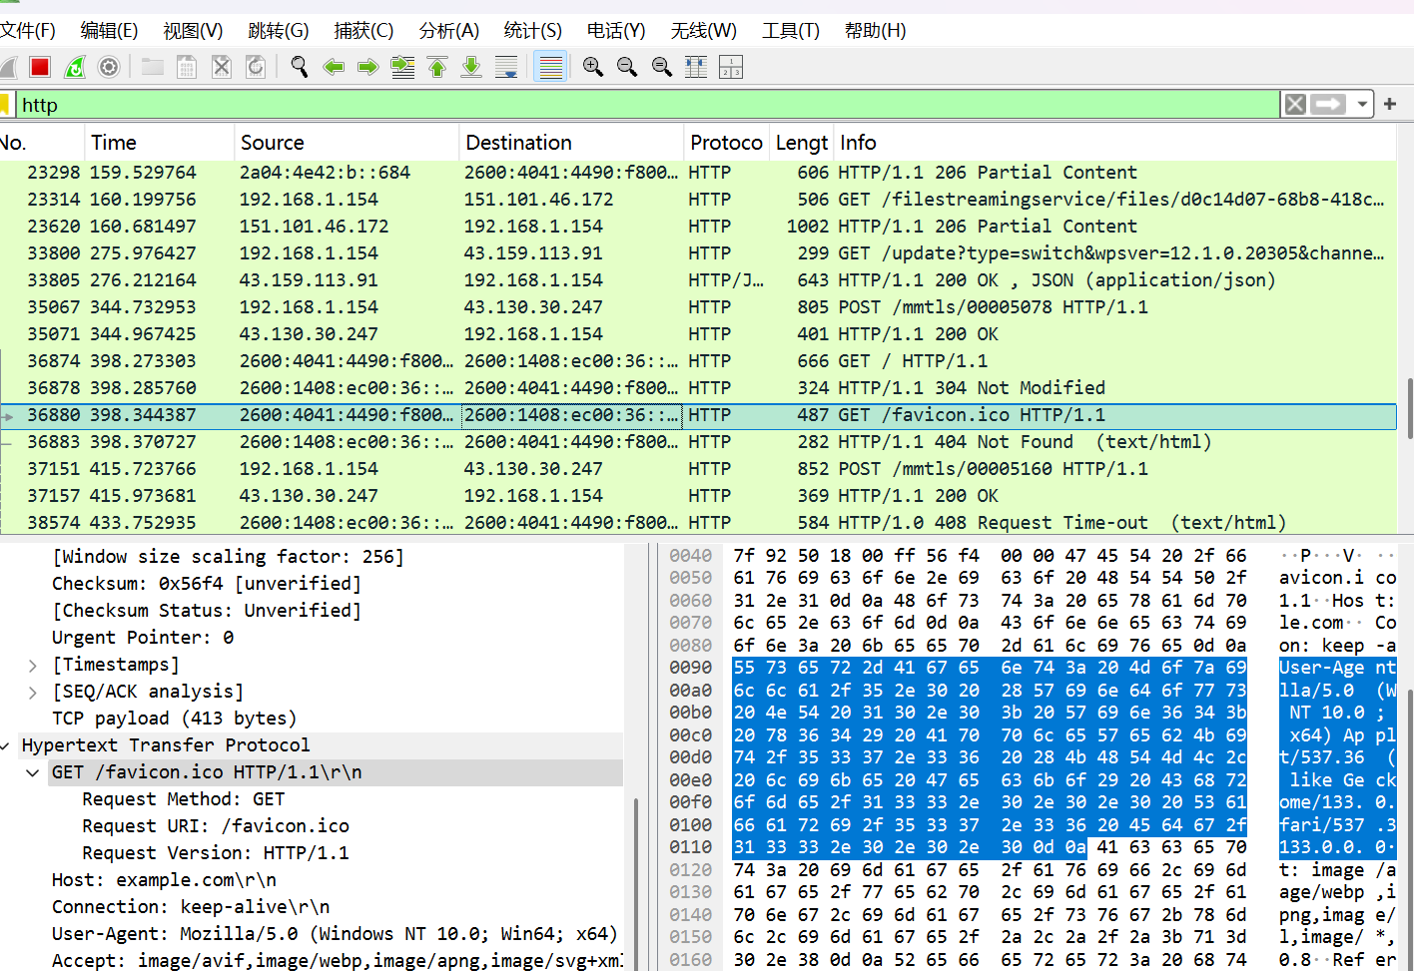
(b)
example.com HTTP/1.1 (Windows NT 10.0; Win64; x64)
(c)Yes, because we can see here Connection: keep-alive\r\n
(d)Edg/133.0.0.0 The server needs to know the browser information to provide compatible content (e.g., HTML, CSS, JavaScript).
(e)200 OK indicates success. Content-Type: application/octet-stream\r\n
(f)
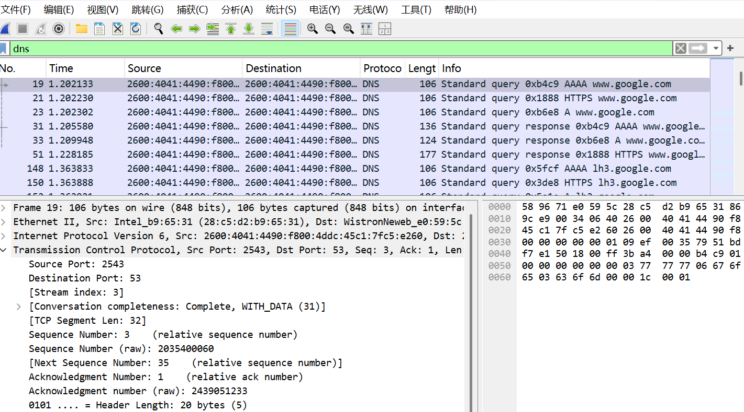

T2

