Optimizing Fire Station Locations: Balancing Service Coverage and Accessibility in the London Borough of Hillingdon

Introduction

Fires can pose significant threats to human life and both the built and natural environments (Kodur, Kumar and Rafi, 2019). Minimizing the adverse impacts of fires depends heavily on timely firefighting and rescue responses. As the location of fire stations directly influences how quickly emergency services can reach incident sites, fire station location planning is a critical component of fire protection.

Fire station planning typically considers two critical factors: accessibility and service coverage. Accessibility reflects the ease of reaching incident sites, while service coverage refers to the area that can be reached from a fire station within a maximum allowable response distance or time (Yao, Zhang and Murray, 2019). Existing studies seldom consider both factors simultaneously, and relatively few incorporate existing fire stations into the optimization process (Yao, Zhang and Murray, 2019), limiting their applicability to real-world fire station planning.

Building on these insights, this study aims to answer the question: How can the current fire station network be optimized to balance service coverage and accessibility? The London Borough of Hillingdon is selected as the case study due to its unsatisfactory fire service performance.

Literature Review

Many studies have been dedicated to optimizing fire station locations, and their approaches can be broadly categorized into accessibility-based and service coverage-based models. For accessibility, the p-median problem (PMP; Hakimi, 1964) is a widely used approach that determines the locations of a predefined number of facilities to minimize the total weighted travel distance or time between demand areas and their assigned facilities. The PMP has also undergone various extensions, such as the incorporation of time-related constraints to better reflect the time-sensitive nature of fire rescue operations (Xi et al., 2013). On the other hand, service coverage is commonly addressed through the location set covering problem (LSCP; Toregas et al., 1971) and maximal covering location problem (MCLP; Church and Velle, 1974). The LSCP seeks to minimize the number of facilities required to cover all demand areas within a predefined service distance or time. For example, Church and Li (2016) applied the LSCP to Los Angeles County, finding that existing fire stations are only 74% efficient: 254 stations could provide full coverage compared to the 341 stations currently in operation. The MCLP is generally applied when full coverage is infeasible or not required, and instead aims to maximize service coverage with a specified number of facilities. A recent study applied the MCLP to optimize fire station locations in Shanghai by incorporating factors such as land use, population, building density, and fire incidents, showing that 100 stations could cover 90% of demand and 150 could achieve full coverage (He et al., 2024).

However, no model is without limitations. Accessibility-based models do not directly account for service coverage, meaning that some demand areas may fall outside the specified service threshold. In contrast, coverage-based models typically treat all covered locations as equally desirable, thereby overlooking variations in spatial accessibility within the service area. Both objectives are critical to fire station planning, but few studies consider them simultaneously (Church, Current and Storbeck, 1991; Yao, Zhang and Murray, 2019). Moreover, many models ignore existing fire stations and optimize new locations without considering the current network (Schilling et al., 1980). To address these limitations, this study adopts an integrated model that considers both objectives and existing fire stations.

Data

In this study, the centroids of Output Areas (OAs) were used as demand points, with population data obtained for each OA. OAs represent the finest spatial scale at which population data are available, typically containing 40–250 households. The centroids of Middle layer Super Output Areas (MSOAs), which typically contain 2000–6000 households, were used as candidate sites for new fire stations. Historical fire incident data for the last ten years (2015-2024) were also used. These datasets were obtained from London Datastore (https://data.london.gov.uk/). In addition, the locations of existing fire stations were sourced from UK Fire Stations (https://www.ukfirestations.co.uk/stations/london/).

After obtaining the datasets, fire risk was estimated by calculating the number of fire incidents per thousand residents in each OA. Based on the guideline that the first fire engine should arrive within six minutes (London Fire Brigade, 2008), a 3 km radius was adopted as the service standard in this study. The spatial distributions of fire risk and service coverage are shown in Figure 1.

The London Borough of Hillingdon was chosen as the study area due to its high fire risk and obvious coverage gaps, as shown in Figure 1. The area contains 789 demand units and four existing fire stations. Currently, 75% of demand units are covered, leaving 195 uncovered. The candidate location set consists of 36 sites, including four existing fire stations and 32 MSOA centroids.

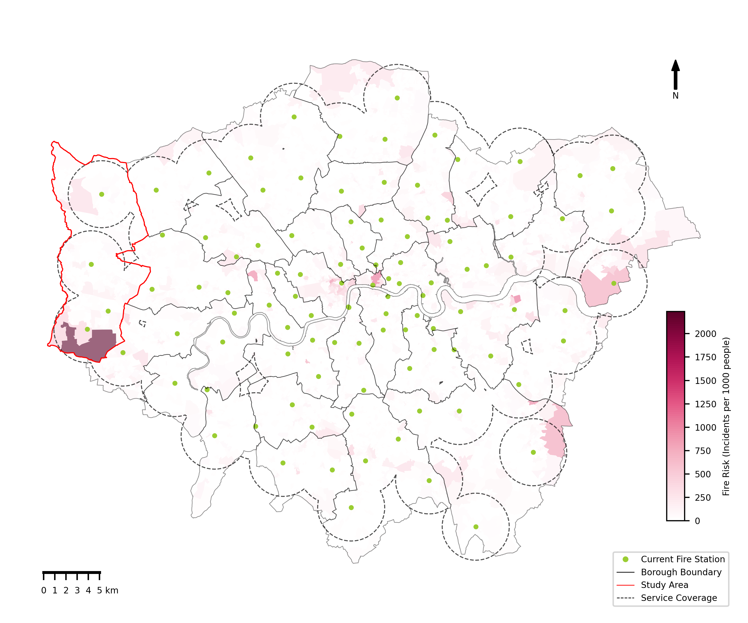
Figure 1 Study area

Methodology

To optimize both accessibility and service coverage, this study employs a method that integrates LSCP and PMP, as proposed by Yao, Zhang and Murray (2019). The model was chosen because it uses the LSCP rather than the MCLP to address service coverage. This feature is particularly important for this study because we consider fire rescue a fundamental life-saving service, making full coverage within the specified service range essential. The model is defined as follows:

$$\begin{aligned}\text{Minimize }\sum_{\text{j}\text{∈}\text{J}}{{\text{Y}}_{\text{j}}}\#\left(\text{1}\right)\end{aligned}$$

$$\begin{aligned}\text{Minimize }\sum_{\text{i}\text{∈}\text{I}}{\sum_{\text{j}\text{∈}{\text{Ω}}_{\text{i}}}{{\text{w}}_{\text{i}}{\text{d}}_{\text{ij}}{\text{X}}_{\text{ij}}}}\#\left(\text{2}\right)\end{aligned}$$
subject to
$$\begin{aligned}\sum_{\text{j}\text{∈}{\text{Ω}}_{\text{i}}}{{\text{X}}_{\text{ij}}} \text{=} \text{1,} \text{∀}\text{i}\text{∈}\text{I}\#\text{(3)}\#\#\#\end{aligned}$$

$$\begin{aligned}{\text{X}}_{\text{ij}} \text{≤} {\text{Y}}_{\text{j}}\text{,} \text{∀}\text{i}\text{,} \text{j}\text{∈}{\text{Ω}}_{\text{i}} \#\left(\text{4}\right)\end{aligned}$$

$$\begin{aligned}\sum_{\text{j}\text{∈}\text{Φ}}{{\text{Y}}_{\text{j}}} \text{=} \text{q} \#\left(\text{5}\right)\end{aligned}$$

$$\begin{aligned}{\text{Y}}_{\text{j}} \text{=} \left\{\text{0,1}\right\}\text{,} \text{∀}\text{j}\text{∈}\text{J}\#\left(\text{6}\right)\end{aligned}$$

$$\begin{aligned}{\text{X}}_{\text{ij}} \text{≥} \text{0,} \text{∀}\text{i}\text{,} \text{j}\text{∈}{\text{Ω}}_{\text{i}}\#\left(\text{7}\right)\end{aligned}$$

$$\begin{aligned}\sum_{\text{j}\text{∈}\text{J}}{{\text{Y}}_{\text{j}}} \text{≤} \text{p}\#\left(\text{8}\right)\end{aligned}$$
where
I is the set of demand areas;
J is the set of potential fire stations;
Φ is the set of existing fire stations;
i is the index of demand areas;
j is the index of potential fire stations;
q is the number of existing fire stations remaining in the system;
p is the number of sited fire stations in the system;
w_{i} is the estimated fire risk of demand i;
d_{ij} is the distance between demand i and station j;
S is the service standard;
Ω_{i} is the set of fire stations capable of serving demand i, {j| d_{ij} ≤ S};
Y_{j} equals 1 if a fire station is located at site j, and 0 otherwise;
X_{ij} is the proportion of demand at i that is provided by station j.

Objective 1 minimizes the number of fire stations in the system, while Objective 2 minimizes the total fire-risk-weighted distance between demand units and fire stations. Constraint 3 ensures that all demand units are fully served and Constraint 4 ensures that each demand unit can only be served by stations that are chosen. Constraint 5 specifies the number of existing stations to stay in the system. Constraint 6 requires each candidate station to be either selected or not selected, and Constraint 7 ensures that the proportion of demand assigned to a station is non-negative. It should be noted that, although Constraint 7 allows continuous allocation, Objective 2 drives the allocation to 0 or 1, so each demand area is fully served by its nearest selected fire station. Constraint 8 limits the total number of fire stations sited in the system.

The solution procedure involves two steps. First, the minimum number of fire stations (p_{min}) required to achieve full coverage is determined by optimizing Objective 1 subject to Constraints 3–7. Second, the obtained p_{min} is substituted into Constraint 8, and Objective 2 is optimized subject to Constraints 3–8. Given the bi-objective nature of the model, a single solution cannot generally optimize both objectives simultaneously; therefore, Pareto-optimal solutions are sought. A Pareto-optimal solution is one in which one objective cannot be improved without worsening the other (Coello et al., 2023). The value of p is increased gradually from p_{min}, and Objective 2 is repeatedly solved to generate a set of Pareto-optimal solutions. The model was solved using the CBC solver in Python.

Results

Using the methods described above, we examined five scenarios, ranging from retaining none of the existing fire stations (q = 0), through retaining some (q = 1, 2, 3), to retaining all four (q = 4). The Pareto fronts in Figure 2 show the Pareto-optimal solutions for each scenario. All fronts exhibit a monotonically decreasing trend, reflecting a trade-off between the number of stations and accessibility, as more stations reduce the total fire-risk-weighted distance. The gradual flattening of these curves further indicates diminishing returns, with each additional station yielding progressively smaller accessibility improvements.

In addition, the minimum number of stations required for full coverage increases as more existing stations are retained. Eight stations are sufficient when zero, one, or two existing stations are retained, rising to nine for three retained stations and ten for all four. This suggests that the current station configuration is not spatially optimal for achieving full coverage with the smallest network. Moreover, for a given number of stations, scenarios retaining more existing stations generally exhibit higher total fire-risk-weighted distances, indicating lower accessibility; however, these differences become less pronounced as the network expands, as reflected by the gradual convergence of the Pareto fronts. This indicates that the accessibility difference associated with retaining existing stations is most important when the network is relatively sparse and becomes less significant as more stations are added.

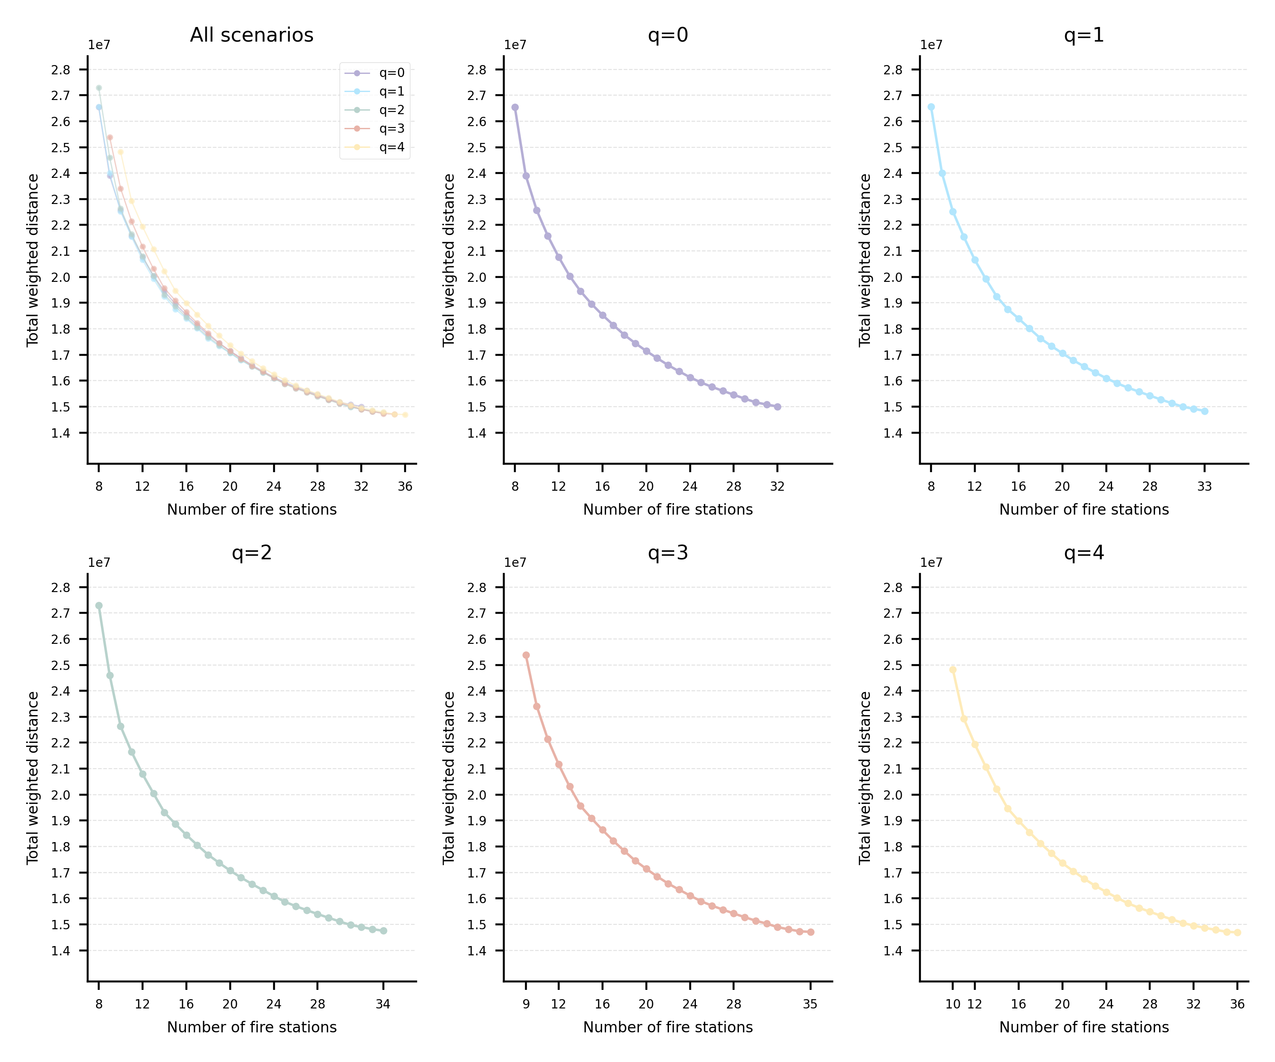
Figure 2 Pareto fronts for fire station number and weighted distance under different existing-station-retention scenarios

Given the 3-km service radius adopted in the model, all solutions achieve relatively good accessibility levels. Therefore, the selection was primarily guided by practical considerations of network size. The scenario retaining all four existing fire stations with a total of 10 stations was selected as the preferred solution, as it maximizes the retention of existing stations while minimizing the number of newly required stations. The spatial configuration of the selected solution is shown in Figure 3. The four existing fire stations are located mainly along the central axis of the study area, covering the northern, central, and southern parts of the area. Two stations are located in the south, which also exhibits relatively higher fire risk. This spatial pattern suggests that the existing configuration has a certain planning rationale, with the original layout potentially aiming to achieve broad area coverage along the main spatial axis while providing additional protection for higher-risk areas. The six newly added stations identified by the optimization model are distributed on both sides of the central axis, with three located to the east and three to the west. The three newly added stations in the west are recommended for construction, as they address coverage gaps in the peripheral areas of London. In contrast, the three eastern stations may require further assessment and potential adjustment, as the model excludes stations in neighboring boroughs that may already provide some coverage to the eastern part of the study area (Figure 1).

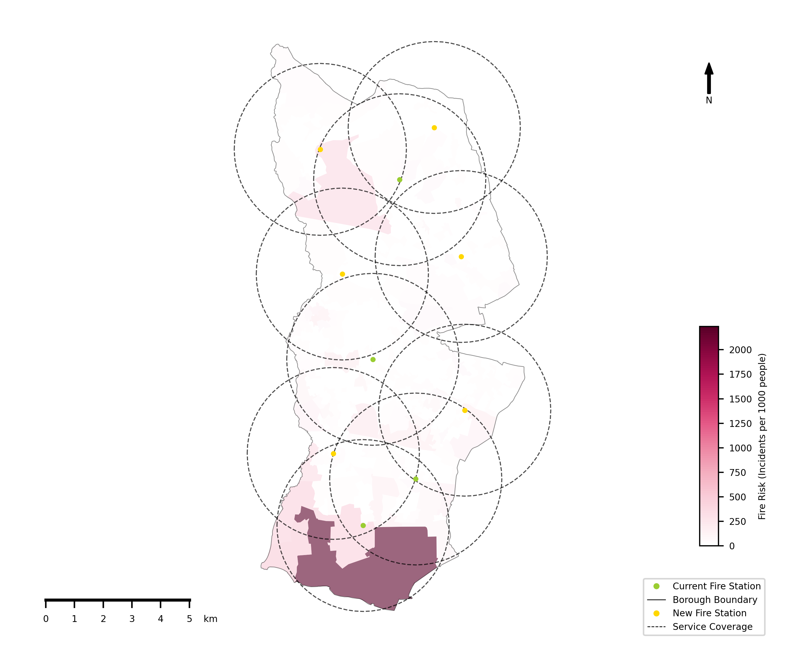
Figure 3 Spatial configuration of the selected solution

Discussion and Conclusion

This study applies a bi-objective optimization model that balances service coverage and accessibility to identify the optimal locations for fire stations in the London Borough of Hillingdon, while accounting for existing stations. After evaluating all scenarios with different numbers of existing stations retained, we recommend retaining all four existing stations and adding three new stations in the west, while further reviewing the number and locations of the three proposed eastern stations in light of fire station coverage in neighboring boroughs. This recommendation addresses existing coverage gaps, strengthens emergency response capacity in high-risk areas, and improves resource efficiency by avoiding redundant station construction.

In terms of policy implications, these results highlight the need to address coverage gaps in peripheral areas, which remain underserved by the existing fire station network across London. Fire station planning should also consider the wider urban network rather than individual administrative boundaries to avoid redundant construction and maximize the use of existing infrastructure. This also represents a limitation of the current study, which only considers fire stations within the London Borough of Hillingdon.

Several other limitations should also be acknowledged. First, the optimization model considers only service coverage and accessibility, while other factors, such as station workload, could be incorporated to ensure a more balanced allocation of service demand. Second, candidate locations are represented by MSOA centroids, without considering practical site suitability, water availability, or construction costs. Finally, road network distance or travel time could be used instead of Euclidean distance to provide more realistic measurements.

References

Church, R., Current, J. and Storbeck, J. (1991) “A Bicriterion Maximal Covering Location Formulation Which Considers the Satisfaction of Uncovered Demand,” Decision Sciences, 22(1), pp. 38–52. Available at: https://doi.org/10.1111/j.1540-5915.1991.tb01260.x.
Church, R. and Velle, C.R. (1974) “The Maximal Covering Location Problem,” Papers in Regional Science, 32(1), pp. 101–118. Available at: https://doi.org/10.1111/j.1435-5597.1974.tb00902.x.
Church, R.L. and Li, W. (2016) “Estimating spatial efficiency using cyber search, GIS, and spatial optimization: a case study of fire service deployment in Los Angeles County,” International Journal of Geographical Information Science, 30(3), pp. 535–553. Available at: https://doi.org/10.1080/13658816.2015.1083572.
Coello, C. et al. (eds.) (2023) Evolutionary Multi-objective Optimization: An Honorary Issue Dedicated to Professor Kalyanmoy Deb. MDPI. Available at: https://doi.org/10.3390/books978-3-0365-6981-9.
Hakimi, S.L. (1964) “Optimum Locations of Switching Centers and the Absolute Centers and Medians of a Graph,” Operations Research, 12(3), pp. 450–459. Available at: https://doi.org/10.1287/opre.12.3.450.
He, Q. et al. (2024) “Research on Chinese Fire Station Optimal Location Model Based on Fire Risk Statistics: Case Study in Shanghai,” Applied Sciences, 14(5), p. 2052. Available at: https://doi.org/10.3390/app14052052.
Kodur, V., Kumar, P. and Rafi, M.M. (2019) “Fire hazard in buildings: review, assessment and strategies for improving fire safety,” PSU Research Review, 4(1), pp. 1–23. Available at: https://doi.org/10.1108/PRR-12-2018-0033.
London Fire Brigade (2008) Third London Safety Plan. Available at: https://www.london-fire.gov.uk/media/4847/third_london_safety_plan_2008-2011-1.pdf.
Schilling, D.A. et al. (1980) “Some models for fire protection locational decisions,” European Journal of Operational Research, 5(1), pp. 1–7. Available at: https://doi.org/10.1016/0377-2217(80)90067-3.
Toregas, C. et al. (1971) “The Location of Emergency Service Facilities,” Operations Research, 19(6), pp. 1363–1373. Available at: https://doi.org/10.1287/opre.19.6.1363.
Xi, M. et al. (2013) “A Modified p-Median Model for the Emergency Facilities Location Problem and Its Variable Neighbourhood Search-Based Algorithm,” Journal of Applied Mathematics, 2013(none), pp. 1–10. Available at: https://doi.org/10.1155/2013/375657.
Yao, J., Zhang, X. and Murray, A.T. (2019) “Location optimization of urban fire stations: Access and service coverage,” Computers, Environment and Urban Systems, 73, pp. 184–190. Available at: https://doi.org/10.1016/j.compenvurbsys.2018.10.006.

