Problem1
{
"case_id": "ss_mujoco_002",
"layer": "single_source",
"category": "sim_config",
"source": ["mujoco"],
"target": "Find a MuJoCo simulation scene for robotic grasping with Panda arm.",
"lang": "EN",
"expected": {
"req_types": ["SIM_CONFIG"],
"quality": ["real", "fallback"],
"format": ["xml", "mjcf", "json"],
"min_files": 1
},
"priority": "P1"
},
发现问题1：前端同步调用 graph.stream，但 retrieve_data 节点为异步节点，导致真实流程在数据检索阶段中断。
解决：将前端改为异步，统一了
问题2：目标输入和进度展示显示的时间不一样，比如在目标输入页停留5s后才进入进度展示页，此时进度展示页刚开始计时
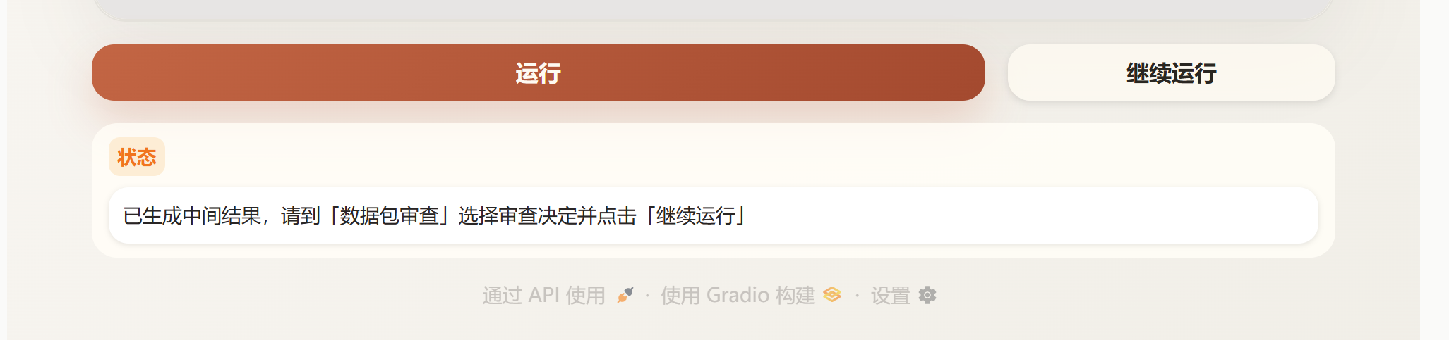
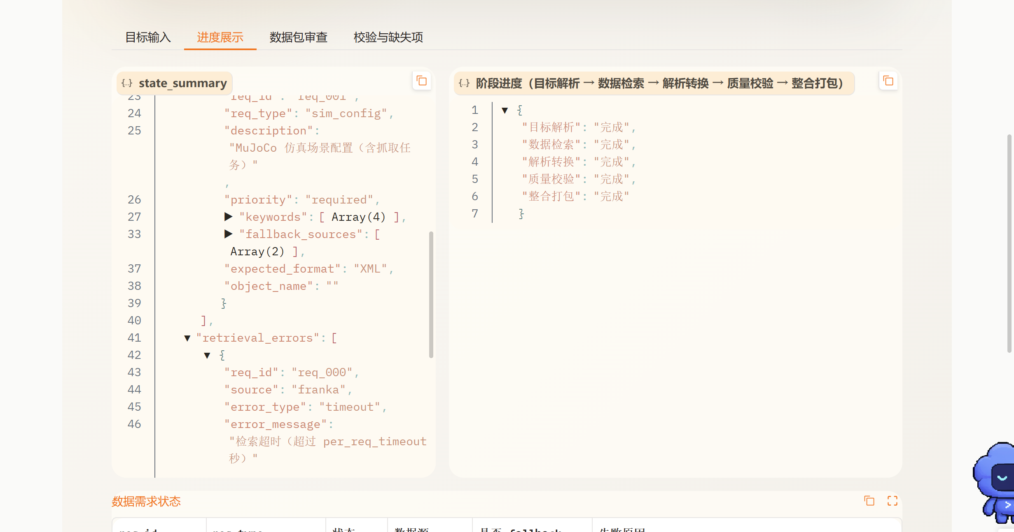
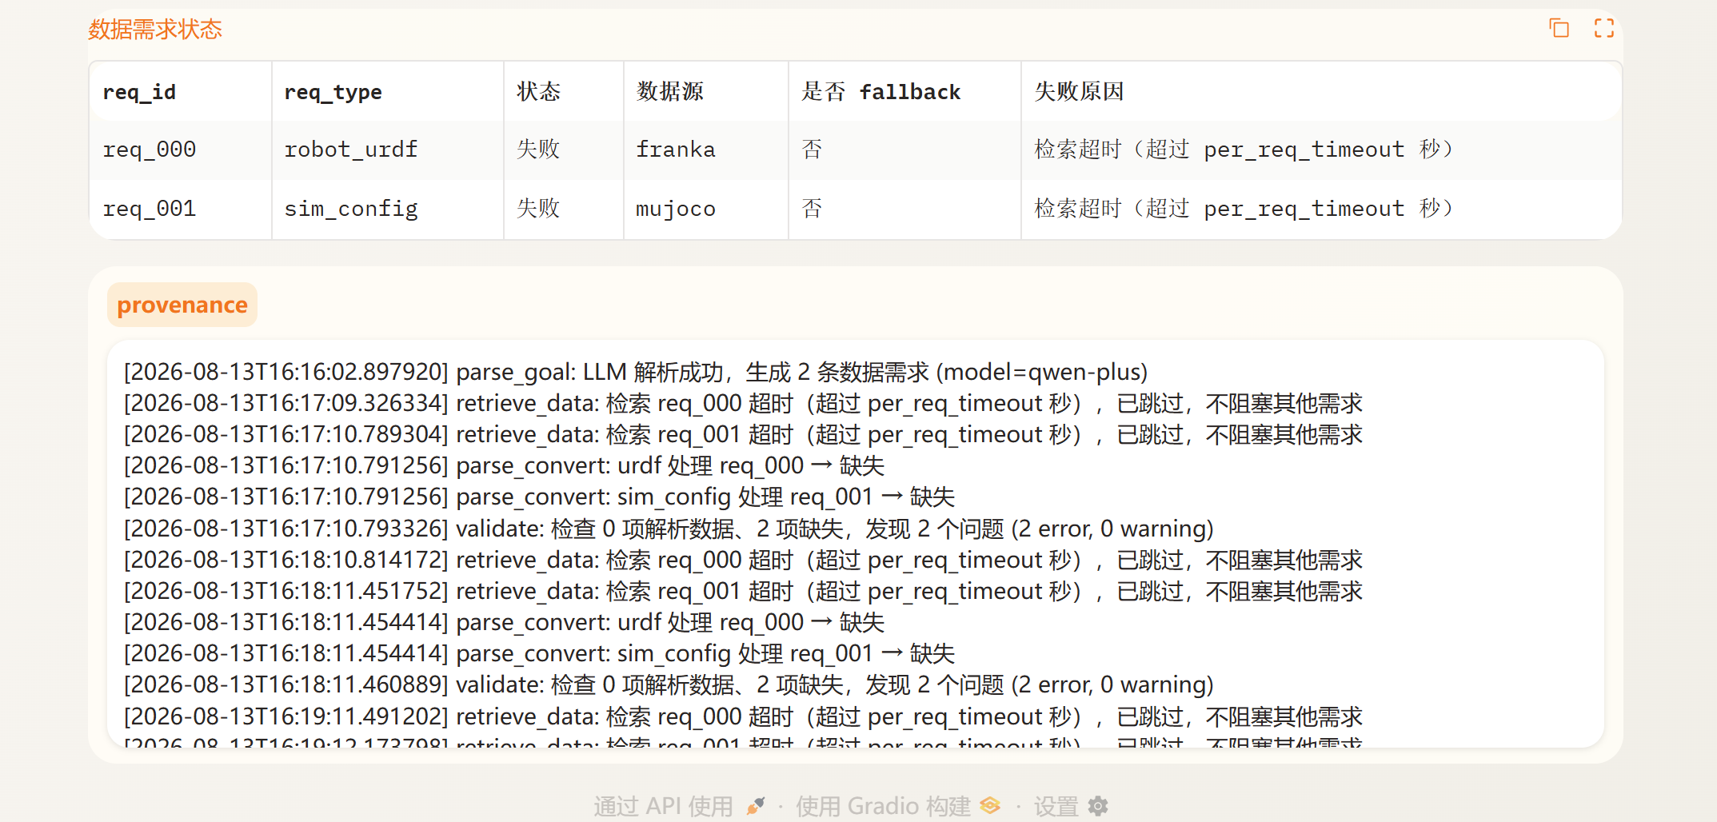
Provenance不能翻页
问题3：检索超时，此时数据包审查栏为空
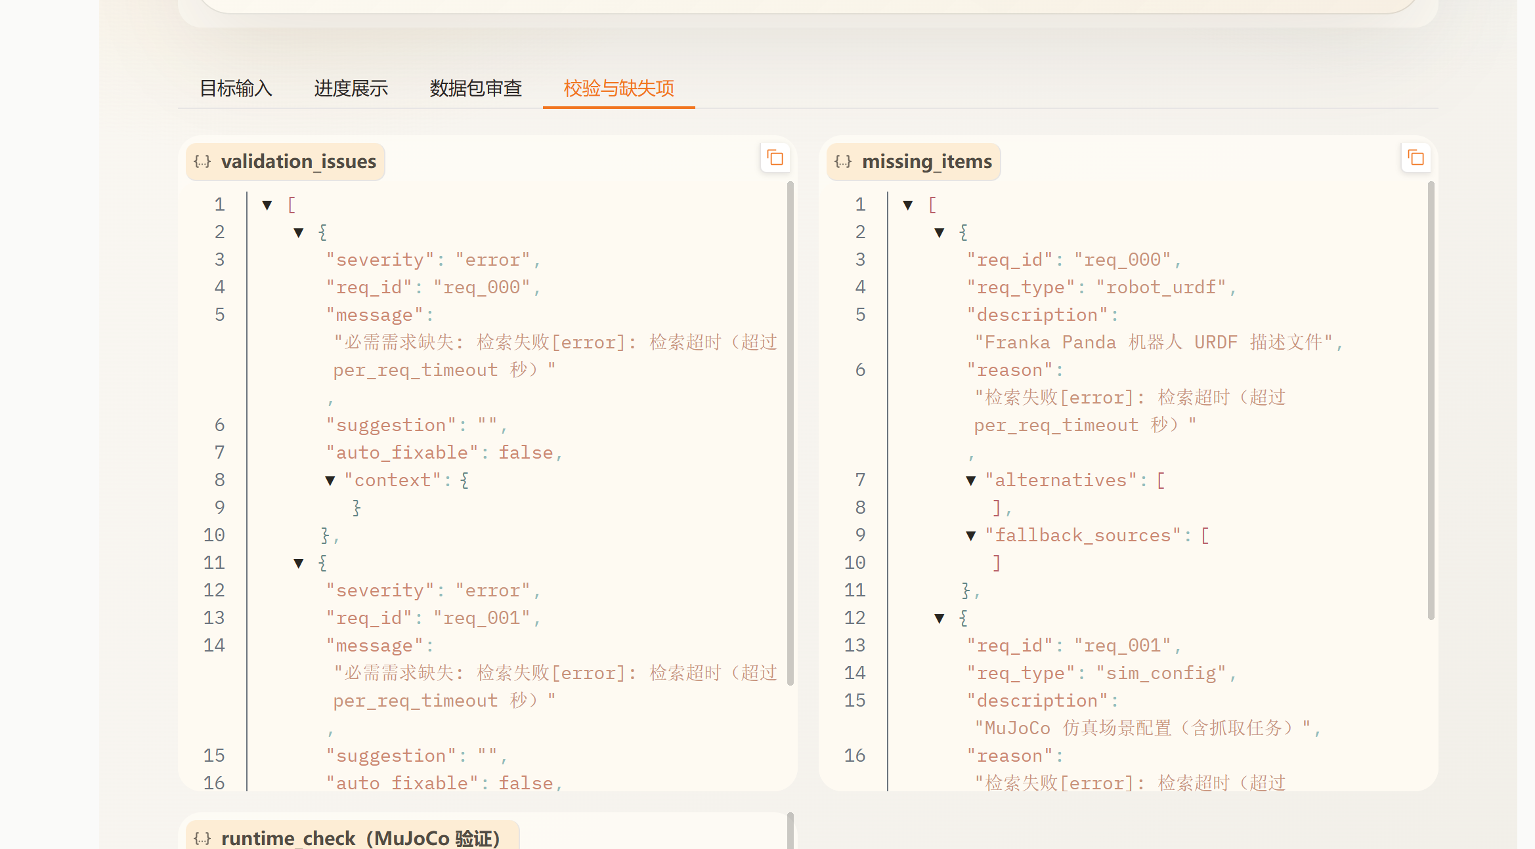
点击继续运行后
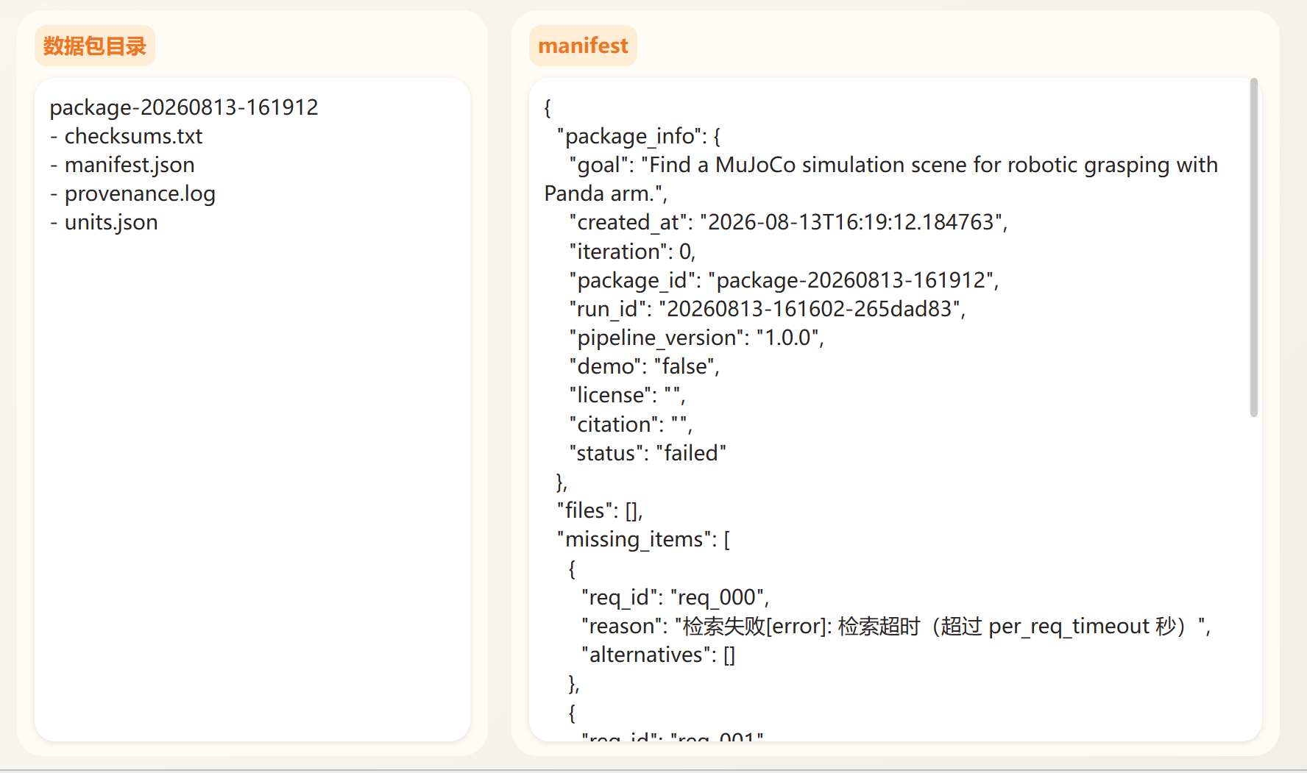
{
"package_info": {
"goal": "Find a MuJoCo simulation scene for robotic grasping with Panda arm.",
"created_at": "2026-08-13T16:19:12.184763",
"iteration": 0,
"package_id": "package-20260813-161912",
"run_id": "20260813-161602-265dad83",
"pipeline_version": "1.0.0",
"demo": "false",
"license": "",
"citation": "",
"status": "failed"
},
"files": [],
"missing_items": [
{
"req_id": "req_000",
"reason": "检索失败[error]: 检索超时（超过 per_req_timeout 秒）",
"alternatives": []
},
{
"req_id": "req_001",
"reason": "检索失败[error]: 检索超时（超过 per_req_timeout 秒）",
"alternatives": []
}
],
"quality_report": {
"total_requirements": 2,
"fulfilled": 0,
"missing": 2,
"validation_issues": 2,
"avg_confidence": 0.0,
"avg_completeness": 0.0
},
"provenance_log": [
"[2026-08-13T16:19:12.184763] assemble_package: 生成数据包 package-20260813-161912，落盘 0 个文件，缺失 2 项"
],
"runtime_check": {},
"revision_history": [],
"output_dir": "D:\\glass\\trae\\robot-data-integrator-feat-integration-v3\\data\\output_packages\\package-20260813-161912"
}

Problem2
{
"case_id": "ss_mujoco_001",
"layer": "single_source",
"category": "sim_config",
"source": ["mujoco"],
"target": "检索 MuJoCo 中 Franka Panda 抓取场景配置。",
"lang": "ZH",
"expected": {
"req_types": ["SIM_CONFIG"],
"quality": ["real", "fallback"],
"format": ["xml", "mjcf", "json"],
"min_files": 1
},
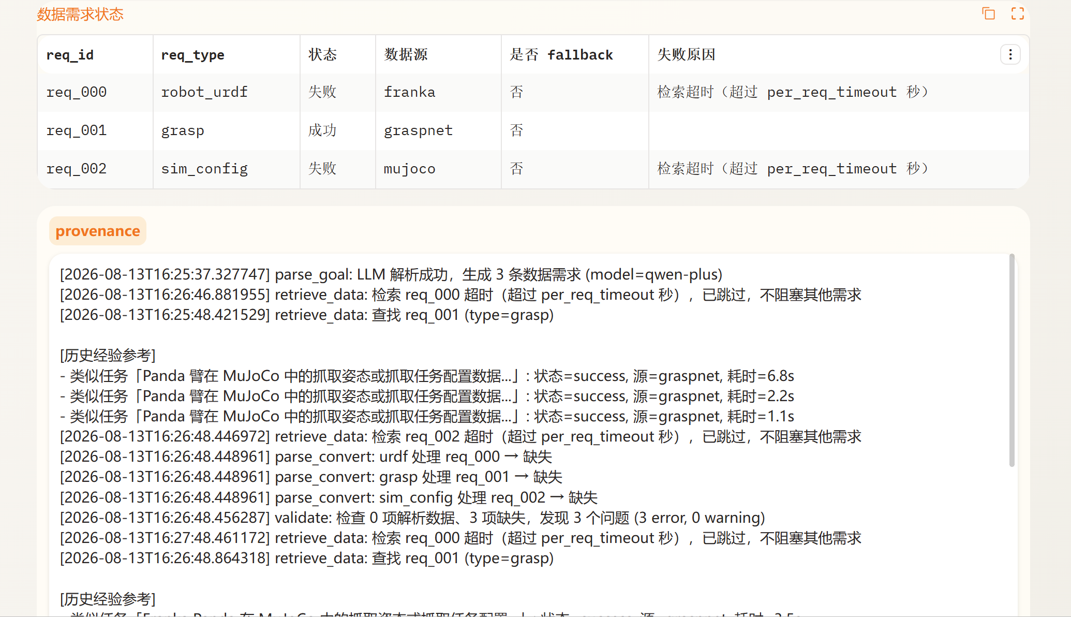
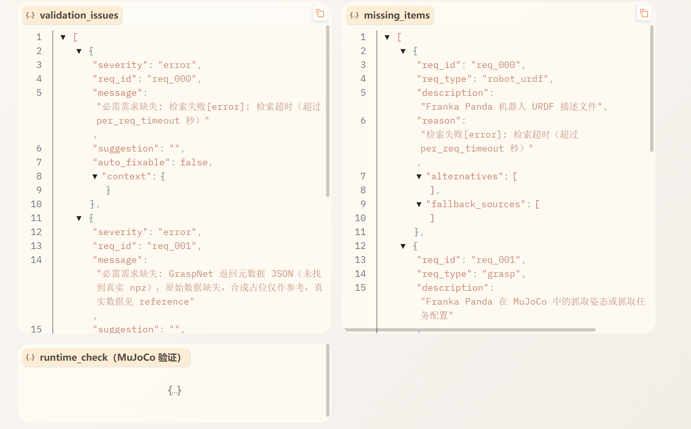
Missing_items:
[
{
"req_id": "req_000",
"req_type": "robot_urdf",
"description": "Franka Panda 机器人 URDF 描述文件",
"reason": "检索失败[error]: 检索超时（超过 per_req_timeout 秒）",
"alternatives": [],
"fallback_sources": []
},
{
"req_id": "req_001",
"req_type": "grasp",
"description": "Franka Panda 在 MuJoCo 中的抓取姿态或抓取任务配置",
"reason": "GraspNet 返回元数据 JSON（未找到真实 npz）；原始数据缺失，合成占位仅作参考，真实数据见 reference",
"alternatives": [
"参考数据源（未自动下载，供手动获取）: https://huggingface.co/datasets/DravenALG/GraspNet-1Billion"
],
"fallback_sources": []
},
{
"req_id": "req_002",
"req_type": "sim_config",
"description": "MuJoCo 仿真场景配置（含 Franka Panda 和被抓物体）",
"reason": "检索失败[error]: 检索超时（超过 per_req_timeout 秒）",
"alternatives": [],
"fallback_sources": []
}
]
Validation_issue:
[
{
"severity": "error",
"req_id": "req_000",
"message": "必需需求缺失: 检索失败[error]: 检索超时（超过 per_req_timeout 秒）",
"suggestion": "",
"auto_fixable": false,
"context": {}
},
{
"severity": "error",
"req_id": "req_001",
"message": "必需需求缺失: GraspNet 返回元数据 JSON（未找到真实 npz）；原始数据缺失，合成占位仅作参考，真实数据见 reference",
"suggestion": "",
"auto_fixable": false,
"context": {}
},
{
"severity": "error",
"req_id": "req_002",
"message": "必需需求缺失: 检索失败[error]: 检索超时（超过 per_req_timeout 秒）",
"suggestion": "",
"auto_fixable": false,
"context": {}
}
]
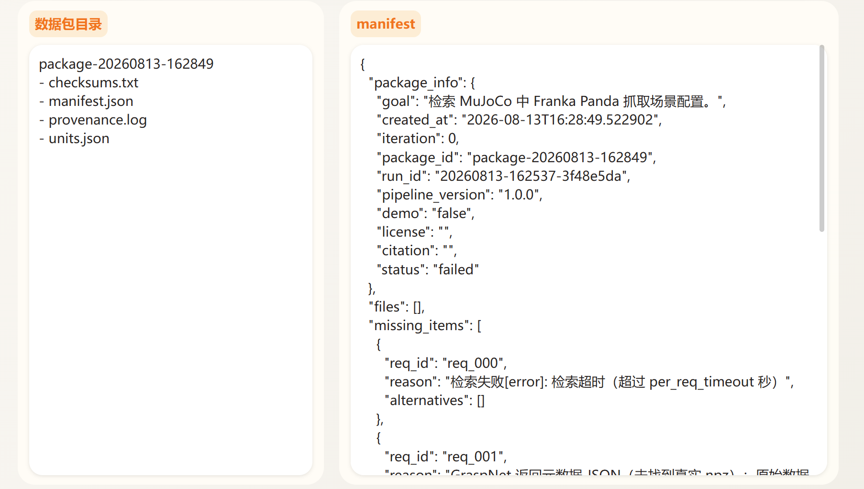
Manifest:
{
"package_info": {
"goal": "检索 MuJoCo 中 Franka Panda 抓取场景配置。",
"created_at": "2026-08-13T16:28:49.522902",
"iteration": 0,
"package_id": "package-20260813-162849",
"run_id": "20260813-162537-3f48e5da",
"pipeline_version": "1.0.0",
"demo": "false",
"license": "",
"citation": "",
"status": "failed"
},
"files": [],
"missing_items": [
{
"req_id": "req_000",
"reason": "检索失败[error]: 检索超时（超过 per_req_timeout 秒）",
"alternatives": []
},
{
"req_id": "req_001",
"reason": "GraspNet 返回元数据 JSON（未找到真实 npz）；原始数据缺失，合成占位仅作参考，真实数据见 reference",
"alternatives": [
"参考数据源（未自动下载，供手动获取）: https://huggingface.co/datasets/DravenALG/GraspNet-1Billion"
]
},
{
"req_id": "req_002",
"reason": "检索失败[error]: 检索超时（超过 per_req_timeout 秒）",
"alternatives": []
}
],
"quality_report": {
"total_requirements": 3,
"fulfilled": 0,
"missing": 3,
"validation_issues": 3,
"avg_confidence": 0.0,
"avg_completeness": 0.0
},
"provenance_log": [
"[2026-08-13T16:28:49.522902] assemble_package: 生成数据包 package-20260813-162849，落盘 0 个文件，缺失 3 项"
],
"runtime_check": {},
"revision_history": [],
"output_dir": "D:\\glass\\trae\\robot-data-integrator-feat-integration-v3\\data\\output_packages\\package-20260813-162849"
}

{
"case_id": "ss_isaac_001",
"layer": "single_source",
"category": "sim_config",
"source": ["isaac"],
"target": "检索 Isaac Sim 中机械臂抓取物体的示例场景配置。",
"lang": "ZH",
"expected": {
"req_types": ["SIM_CONFIG"],
"quality": ["real", "fallback"],
"format": ["json", "usd", "py", "html"],
"min_files": 1
},
"priority": "P1"
},
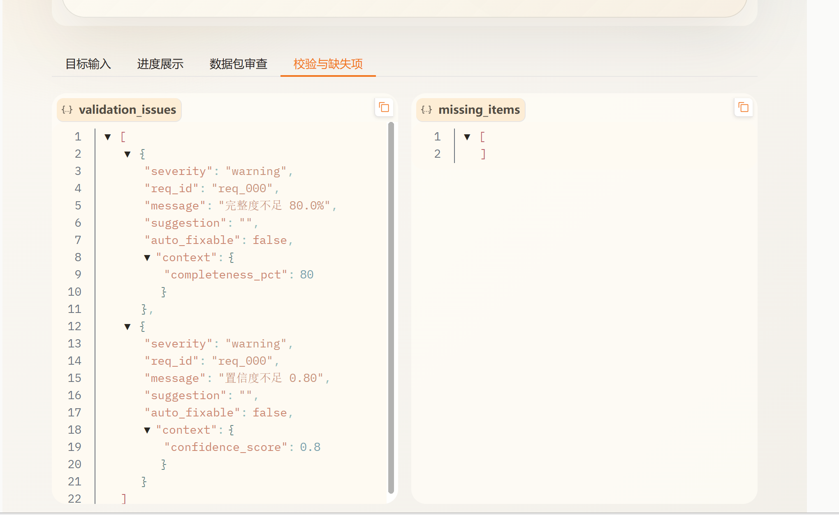
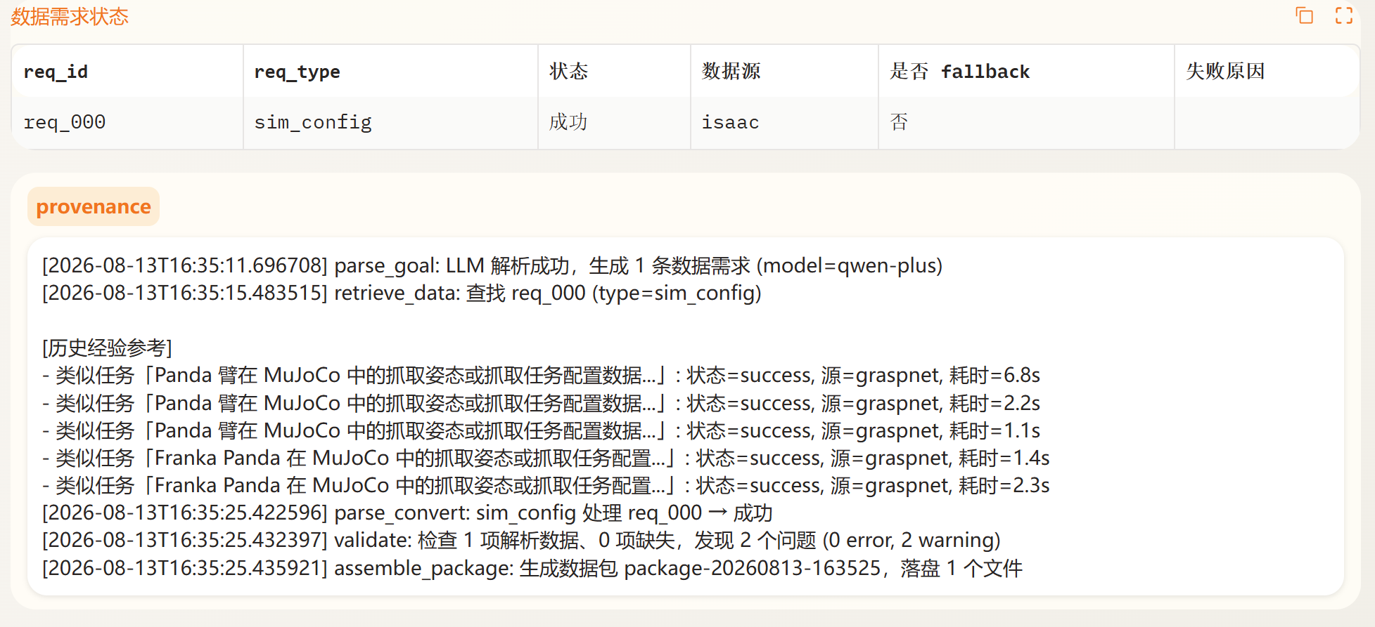
{
"case_id": "ss_franka_001",
"layer": "single_source",
"category": "robot_urdf",
"source": ["franka"],
"target": "获取 Franka Panda 机械臂的 URDF 或机器人模型资源。",
"lang": "ZH",
"expected": {
"req_types": ["ROBOT_URDF"],
"quality": ["real", "fallback"],
"format": ["urdf", "xacro", "xml", "json"],
"min_files": 1
},
"priority": "P0"
},

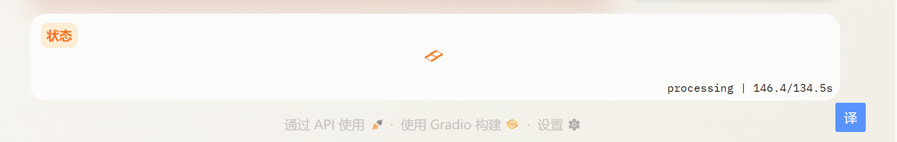
问题1：这个134.5s是上一轮执行所用的时间，这一轮就会把这个作为基准时间，bug可以修复一下，没有这种逻辑
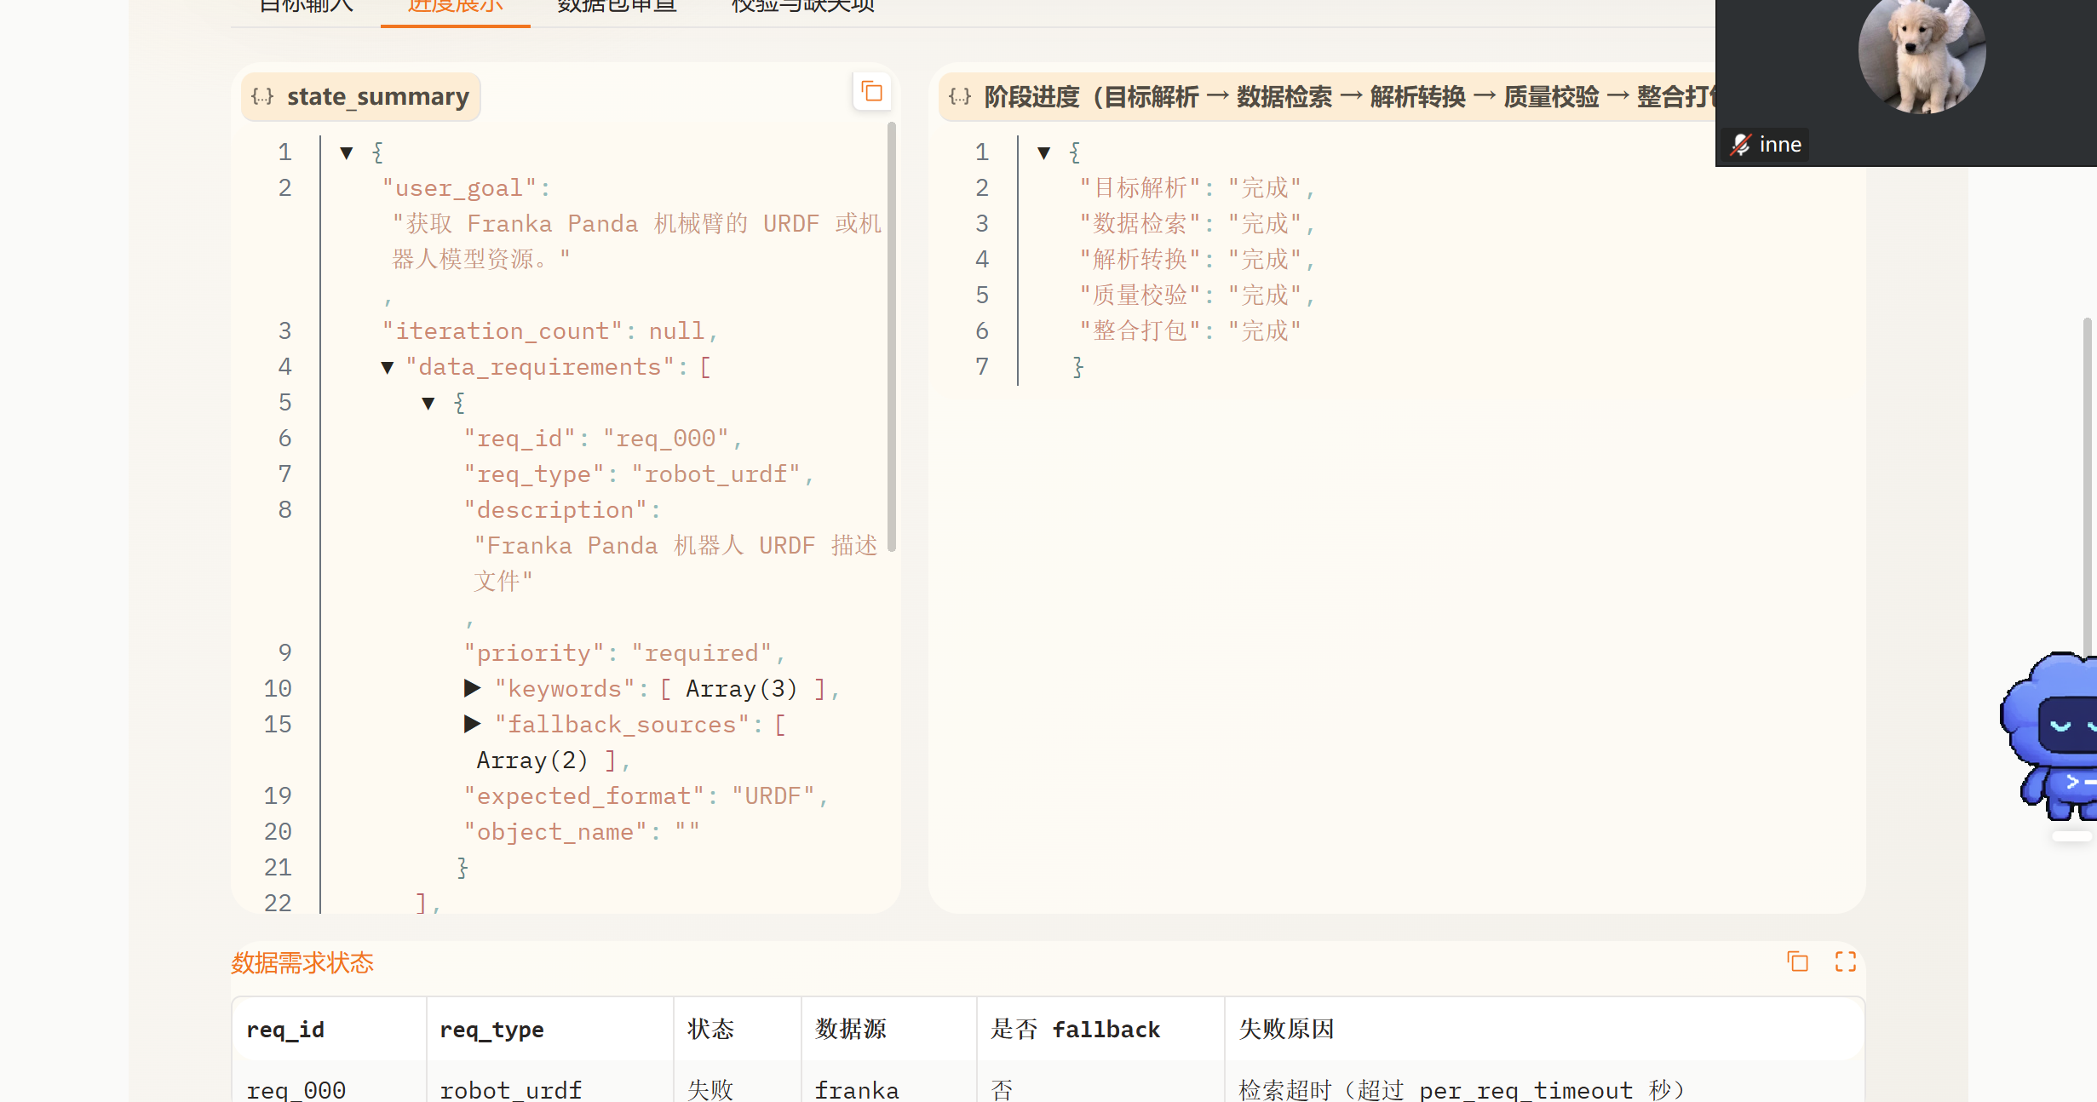
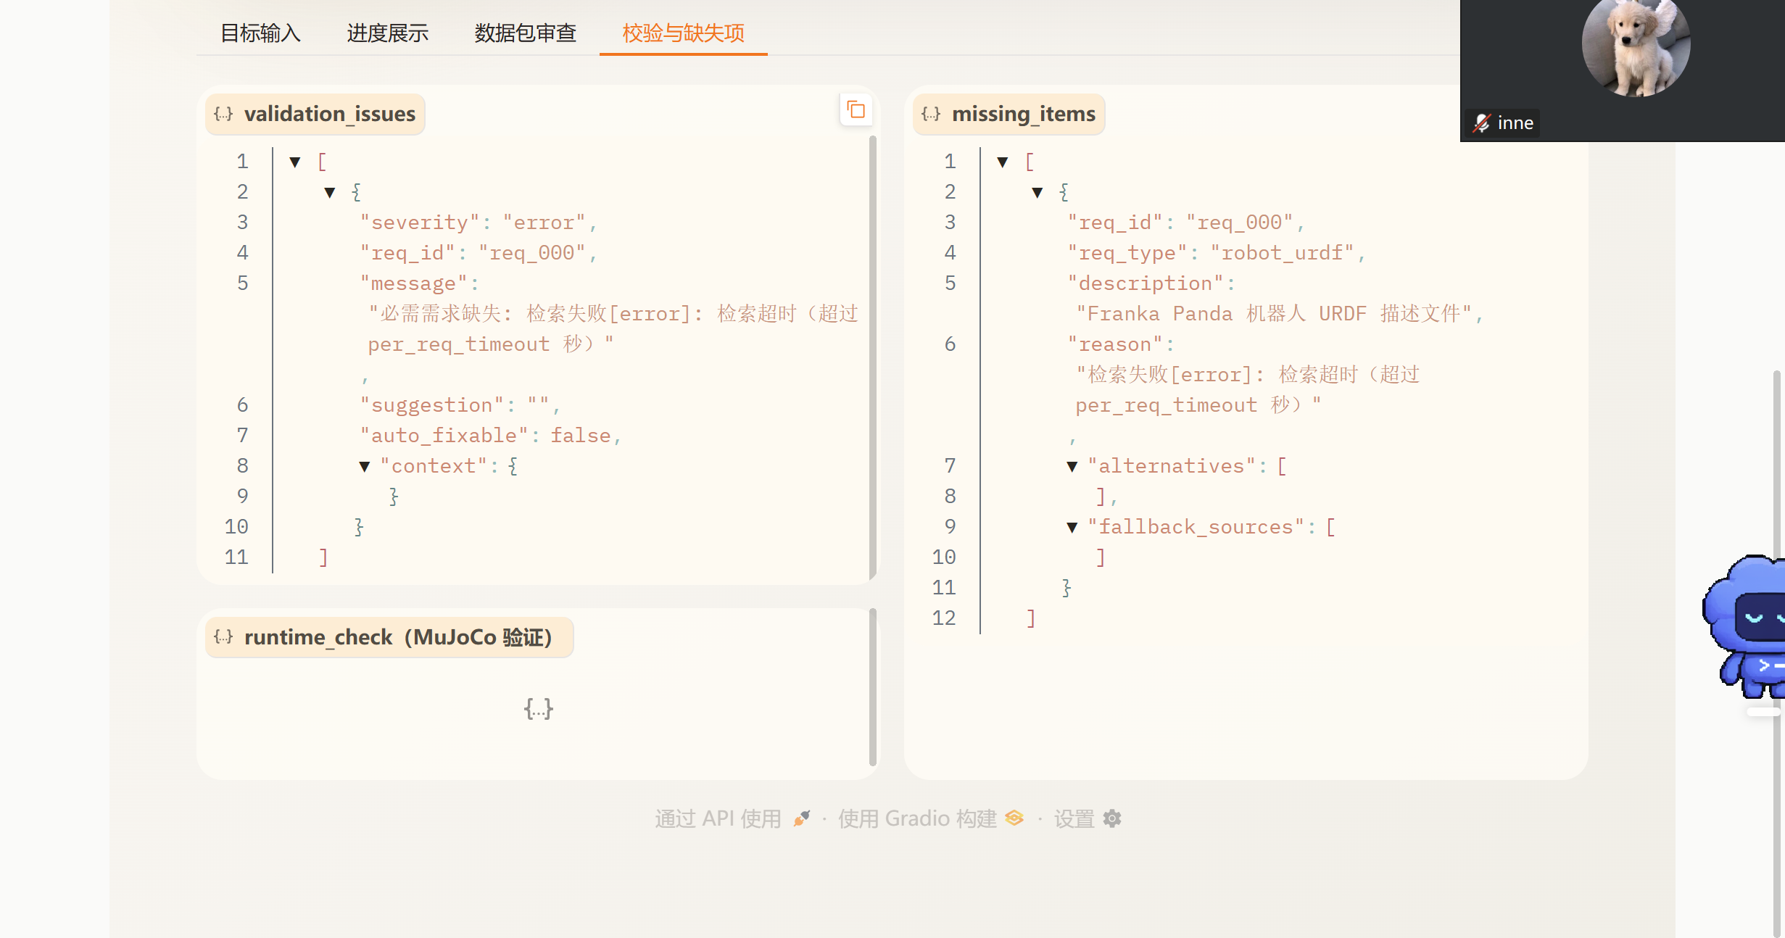
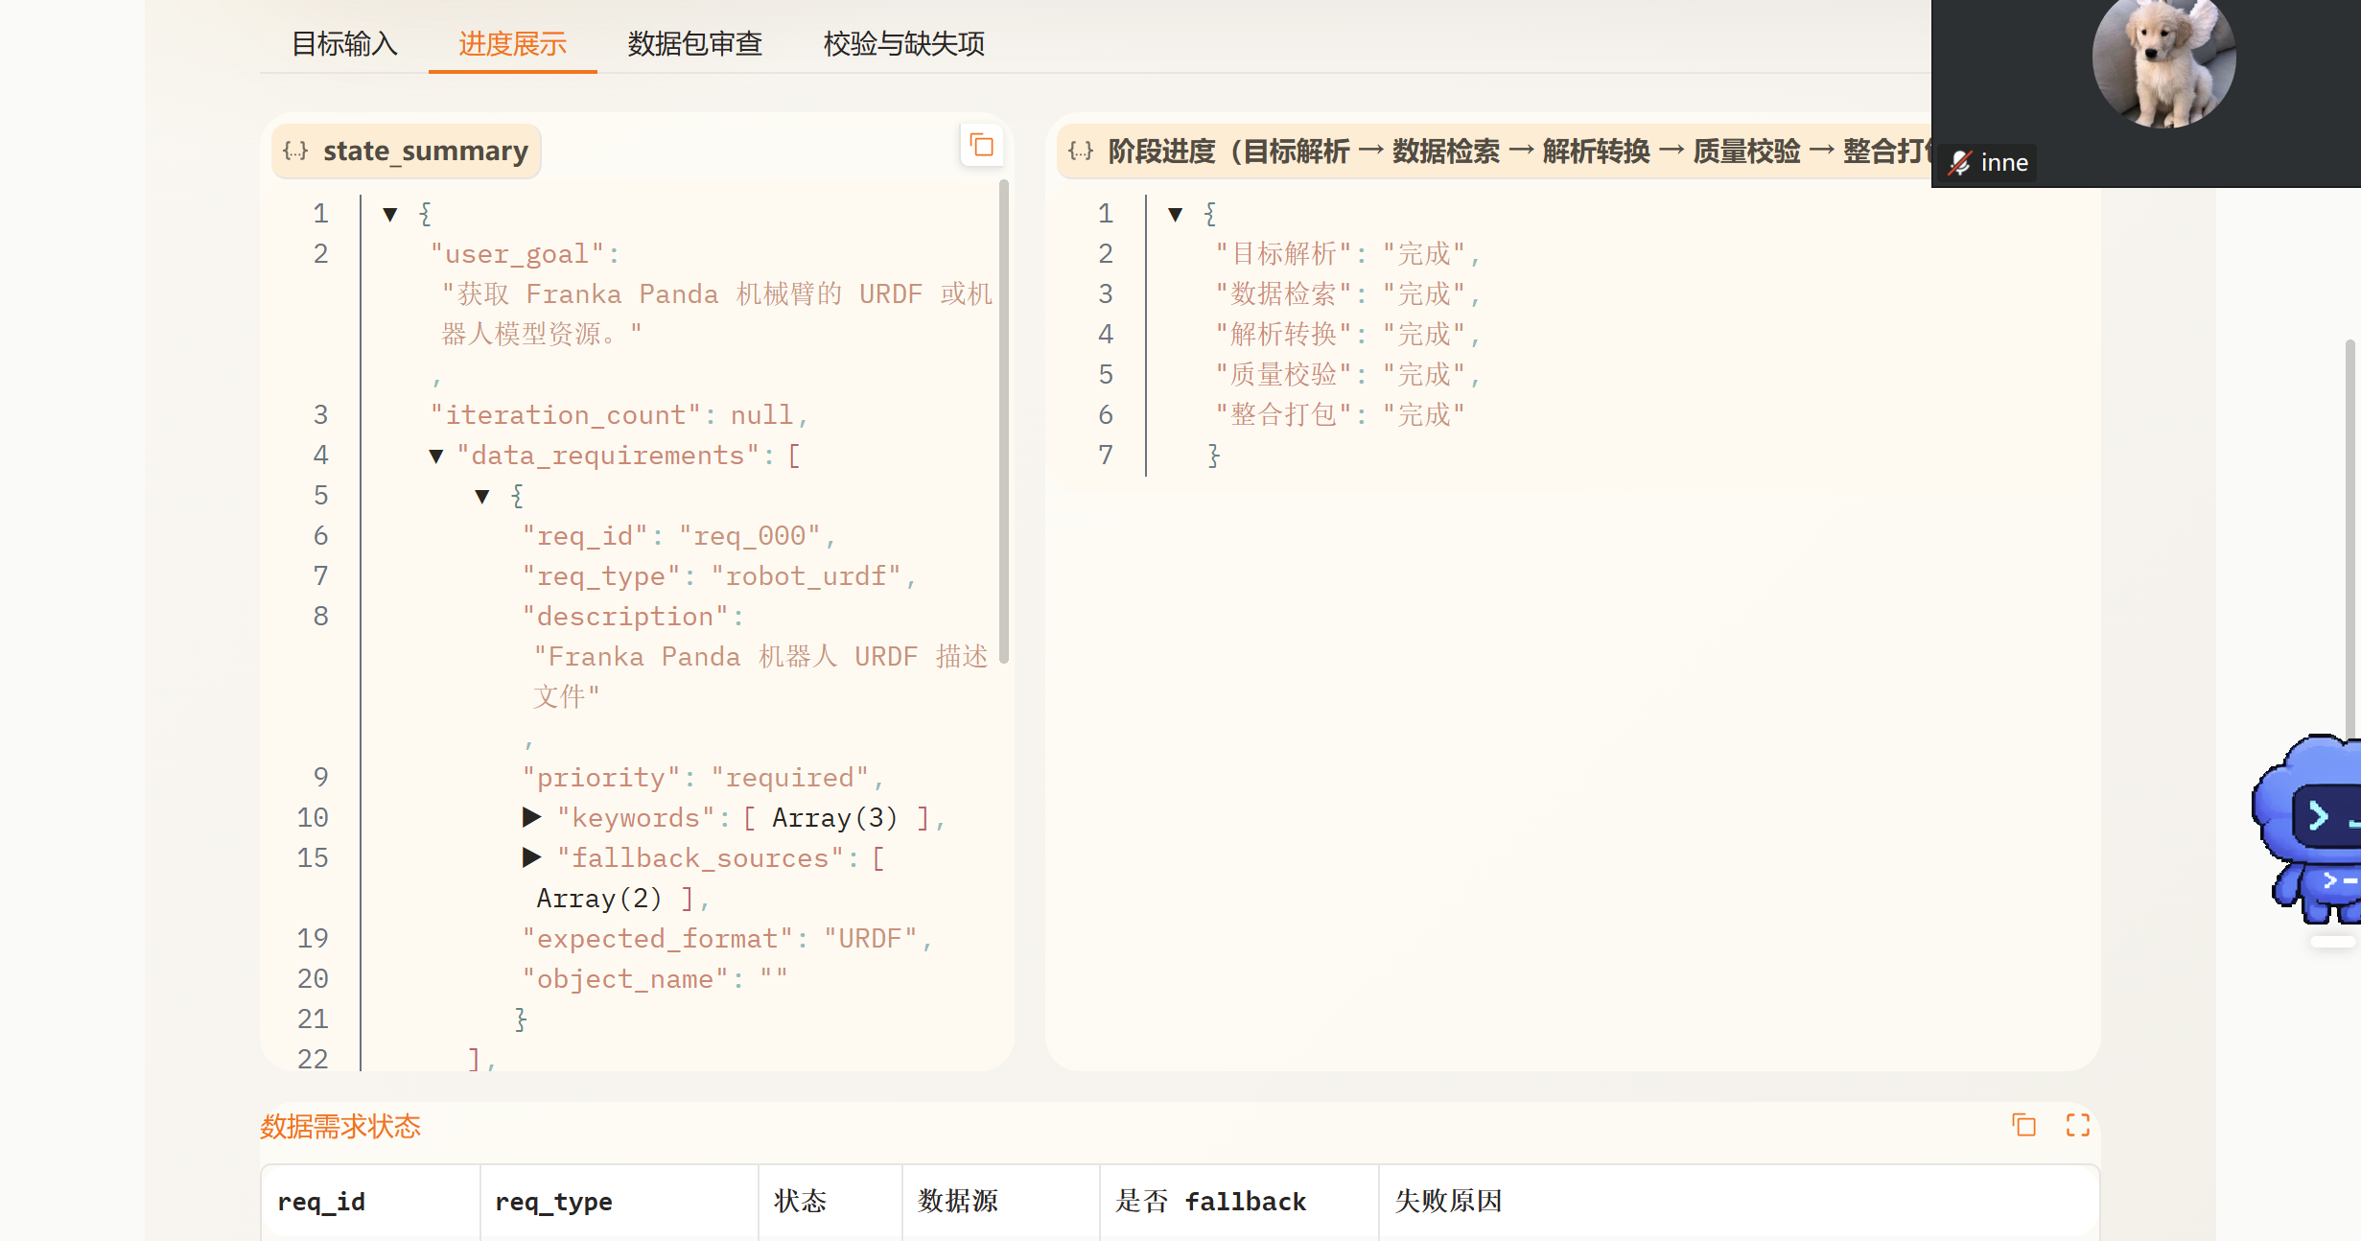
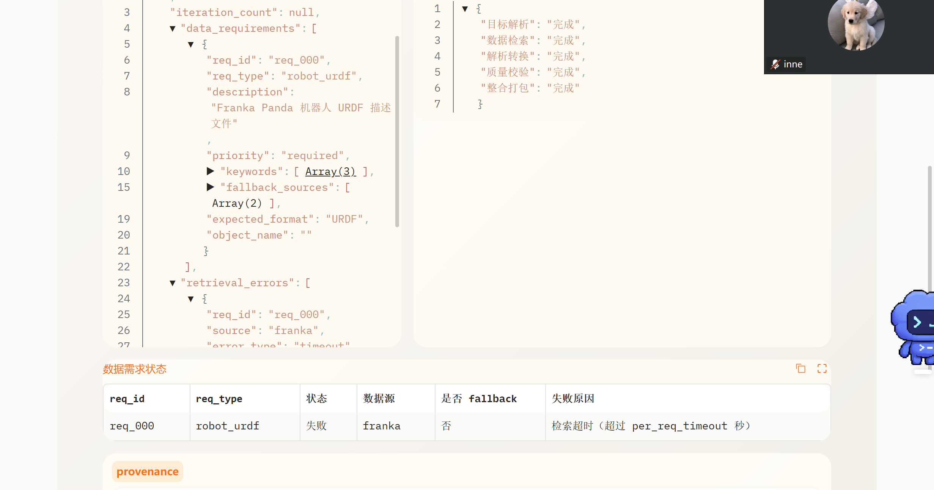
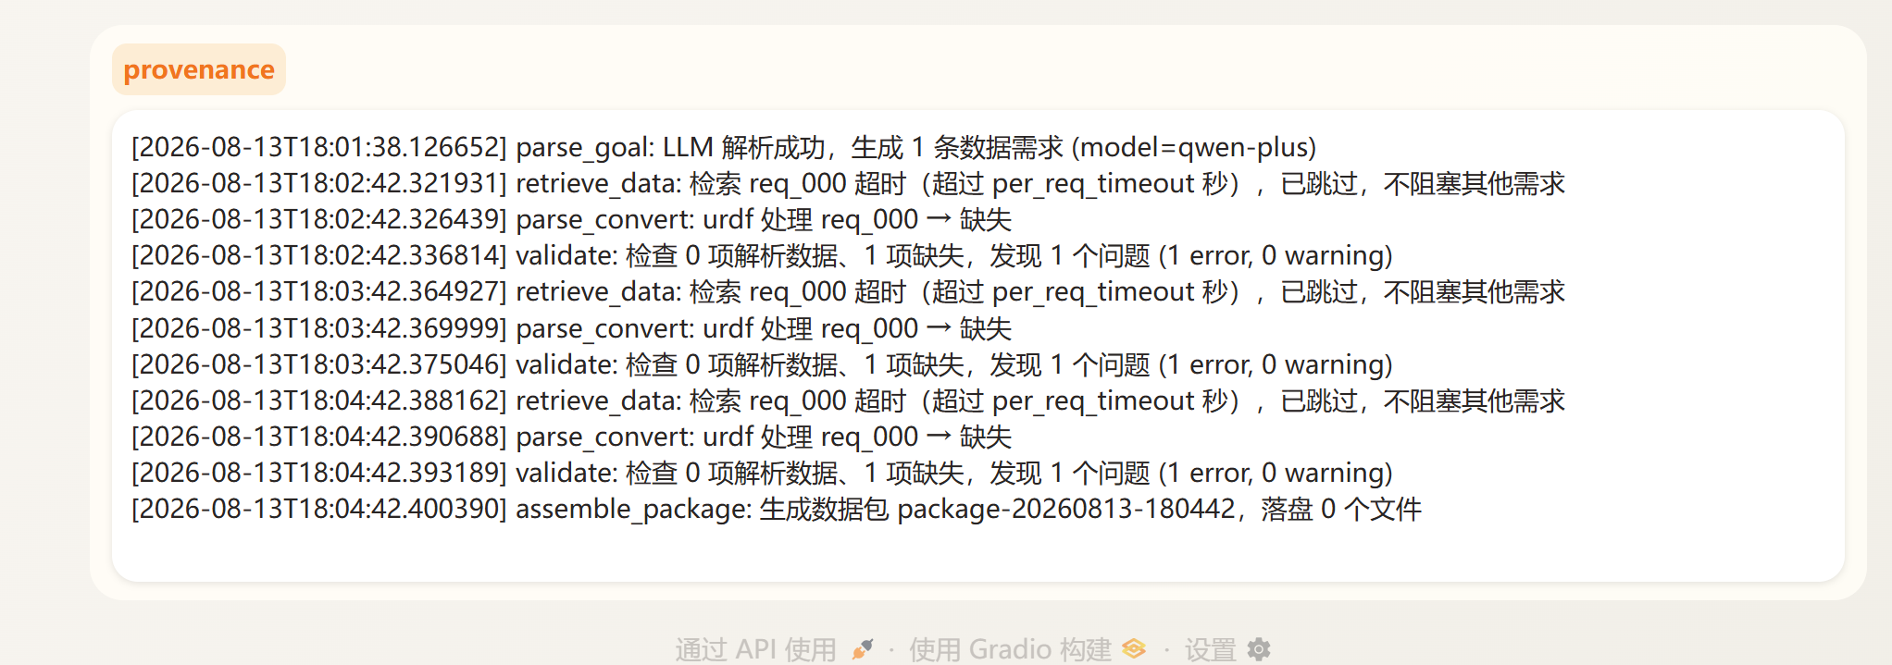
问题2：pre_req_time，超过这个时间好像就会显示超时，但是这个预计需要时间不是一个固定的时间，不知道确定它的逻辑是什么。

