
UECS2094 / UECS2194 / EECS2194
Web Application Development

Assignment

Project Title: Food Blind Box Web Application Development

Prepared by:

No | Student Name | Student No.
1 | Lee Zhen Yong
2 | Liew Yu Heng
3 | Sim Yie Vern
4 | Tho Sweet Ning

.Marking Rubrics:

PART |  | Criteria | Marks Allocated | Comprehensive solutions and accurate with no errors | Complete with room for improvement | Mostly complete with missing minor solutions | Partially complete with errors or missing significant solutions | Demonstrated attempts to solve | No attempts | Marks Awarded
 |  |  |  | 1 | 0.8 | 0.6 | 0.4 | 0.2 | 0
CO1 | 1 | Required page structure and content | 5
 | 2 | Navigation structure and usability | 10
 | 3 | CSS design, layout and visual consistency | 10
 | 4 | Responsive design using CSS media | 5
 | TOTAL |  | 30
 | 1 | Event-driven JavaScript functionality | 10
CO2 | 2 | DOM manipulation and dynamic page behavior | 10
 | 3 | Client-side input validation and Client-side usability and user interactions | 10
 | TOTAL |  | 30
CO3 | 1 | Database design and SQL file | 10
 | 2 | PHP and MySQL integration, and CRUD operations | 10
 | 3 | User registration and authentication, Sessions, authorization and access control, Relational queries and user-specific data | 10
 | TOTAL |  | 30
 | Video demonstration |  | 10
GRAND TOTAL |  |  | 100

Table of Contents
1. Project Description
2. Website Structure and Design
3. CSS Design and Responsive Layout
4. Client-Side JavaScript Implementation
5. Database Design and SQL Implementation
6. PHP and MySQL Integration
7. User Registration and Authentication System
8. Session Management and Authorization
9. Relational Queries and Search Functions
10. Project Deployment, README and Setup
11. Conclusion
12. Workload Summary
References
Appendices
1 Project Description
1.1 Project Overview
Blind Bite is a responsive food blind-box website. It connects customers with local restaurants that sell surprise meals from edible surplus food. Customers choose a restaurant and quantity, but the meal contents remain a surprise. The website gives customers lower-cost meal choices. It also helps restaurants reduce food waste and recover part of their food cost.
The front end uses HTML5, CSS3 and vanilla JavaScript. CSS Grid, Flexbox and media queries support desktop, tablet and mobile screens. PHP 8 handles forms, validation, sessions, access control and order rules. MySQL or MariaDB stores users, restaurants, promotions, carts, orders and reviews. PHP uses mysqli prepared statements to access the database. The project runs on Apache through WampServer or XAMPP. It does not need Composer, Node.js or a front-end framework.
1.2 Problem Statement
Restaurants may have safe food left after a sales period. Throwing it away causes food waste and lost income. Customers also need an easy way to find affordable food nearby. Blind Bite solves both problems in one system. It supports restaurant discovery, ordering, discounts, feedback and administration.
1.3 Project Objectives
• Reduce food waste in Malaysia by selling edible surplus food as affordable surprise meals.
• Let customers compare restaurants by price, category, rating, review count and live opening status.
• Support registration, login, profile updates, wishlist, cart, vouchers, checkout, orders, reviews and enquiries.
• Let administrators manage restaurant records, promotion records and customer enquiries.
• Protect data with validation, prepared SQL, password hashing, sessions, CSRF checks and checkout transactions.
1.4 Target Users and Scope
The main users are customers who want low-cost surprise meals. Registered customers can save restaurants, claim vouchers, place orders and submit reviews. Administrators maintain restaurants, promotions and enquiries. Restaurants are project stakeholders, but they do not have their own login accounts in the current version.
1.5 Technology and File Structure
Layer | Technology | Main project files
Interface | HTML5 and PHP templates | index.php, pages/*.php, authentication/*.php, admin/*.php
Design | CSS3, Grid, Flexbox, media queries | css/style.css and 14 page or feature stylesheets
Interaction | Vanilla JavaScript | js/menu-search.js, status.js, cart-order.js, payment.js and other page scripts
Server | PHP 8+ and mysqli | config/db_connect.php, includes/*.php and form handlers in PHP pages
Data | MySQL or MariaDB | database/create_table.sql and database/insert_data.sql

2 Website Structure and Design
2.1 Home Page
index.php is the public landing page. It reads current promotions from the promotions table. A promotion appears only when is_active is 1 and the current time is between starts_at and ends_at. Logged-in customers can claim a voucher. The page also shows the five highest-rated restaurants. Its SQL groups reviews by restaurant name and sorts by average rating and review count.
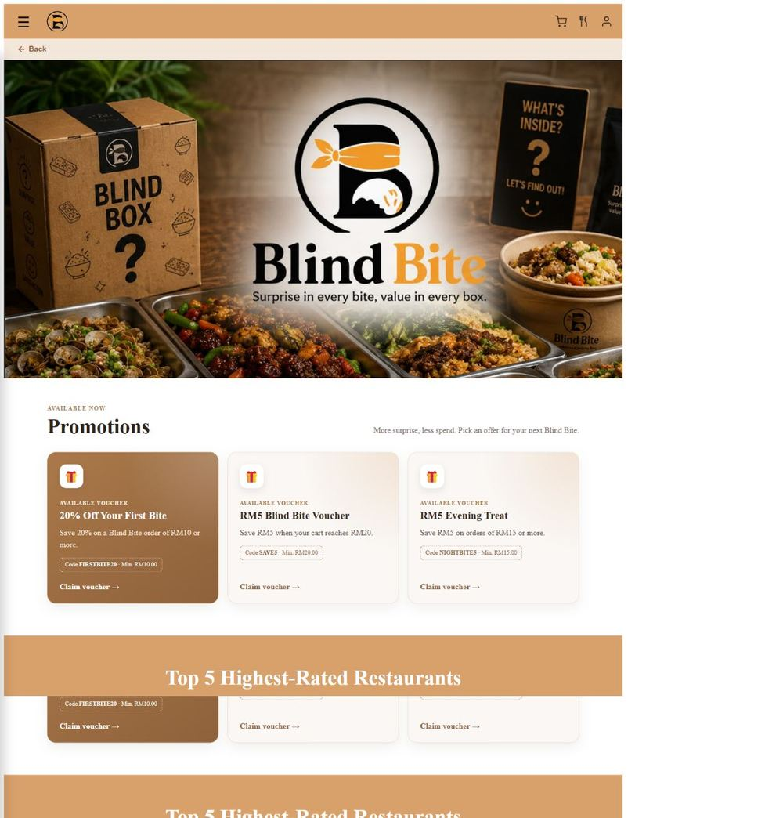
Figure 2.1: Home page with live promotions and top-rated restaurants.
2.2 Navigation Menu
includes/navigation.php provides the customer menu. includes/adminNavigation.php provides the admin menu. js/script.js and js/admin-navigation.js open and close the sidebars. Both menus also include a Back button that uses browser history.
User menu | Administrator menu
Home | Dashboard
Menu | Manage Restaurants
Cart | Manage Promotions
Wishlist | Enquiries
Order History | Log Out
Profile
About Us
Contact Us
Log In or Log Out

2.3 Restaurant Listing Page
pages/menu.php lists each restaurant with its image, category, price, address, rating and review count. js/menu-search.js filters cards by restaurant name or category. The rating button changes the order from random to high-to-low, then low-to-high. js/status.js compares the current day and time with each restaurant's opening hours. It supports overnight hours and updates the Open or Closed badge every minute.
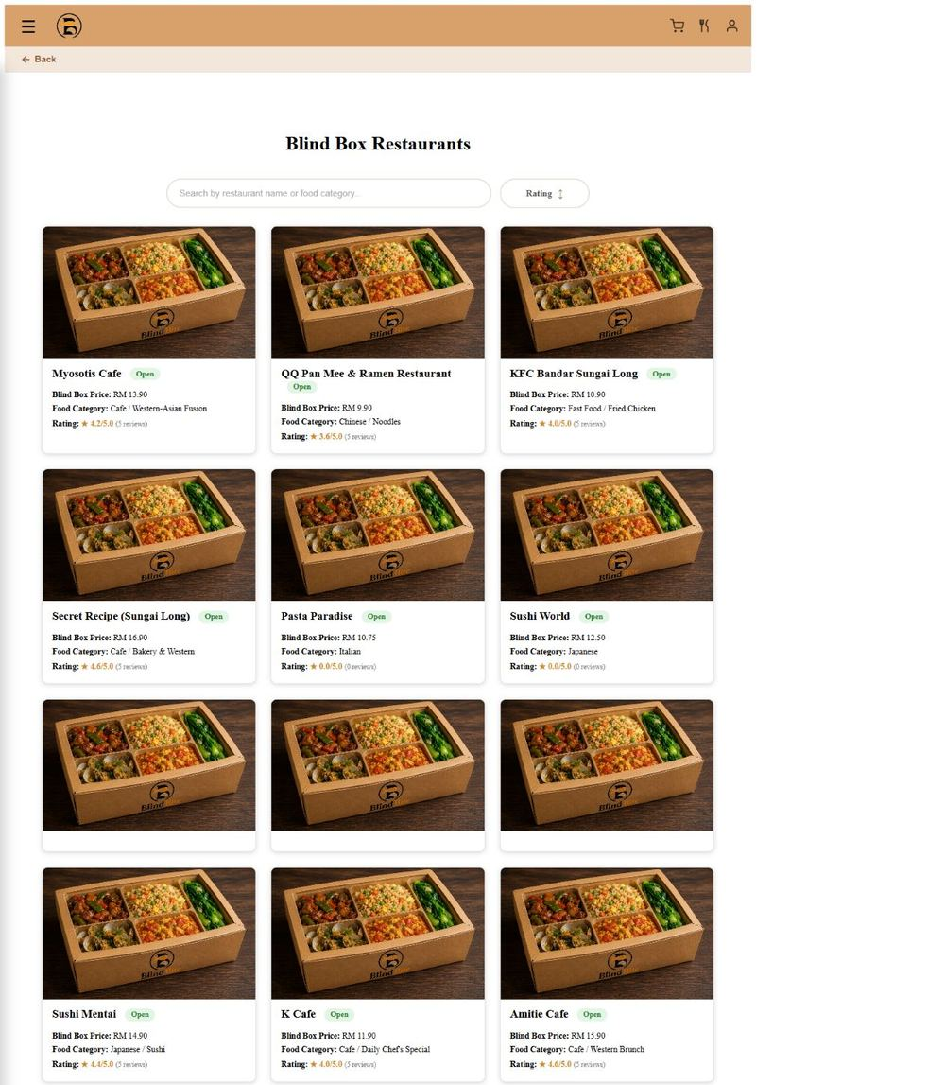
Figure 2.2: Restaurant menu with search, rating sort and status badges.
2.4 Restaurant Details Page
pages/details.php shows one restaurant. The page includes the blind-box image, description, category, address, phone, price and opening hours. Customers can choose a quantity from 1 to 99. They can add the item to the cart or wishlist. The desktop layout uses three areas for the image, restaurant details and reviews. Smaller screens stack these areas.
The review section shows the average rating and review count. js/reviews-carousel.js moves the review cards at 22 pixels per second. The script stops this motion when the user has enabled reduced-motion settings.
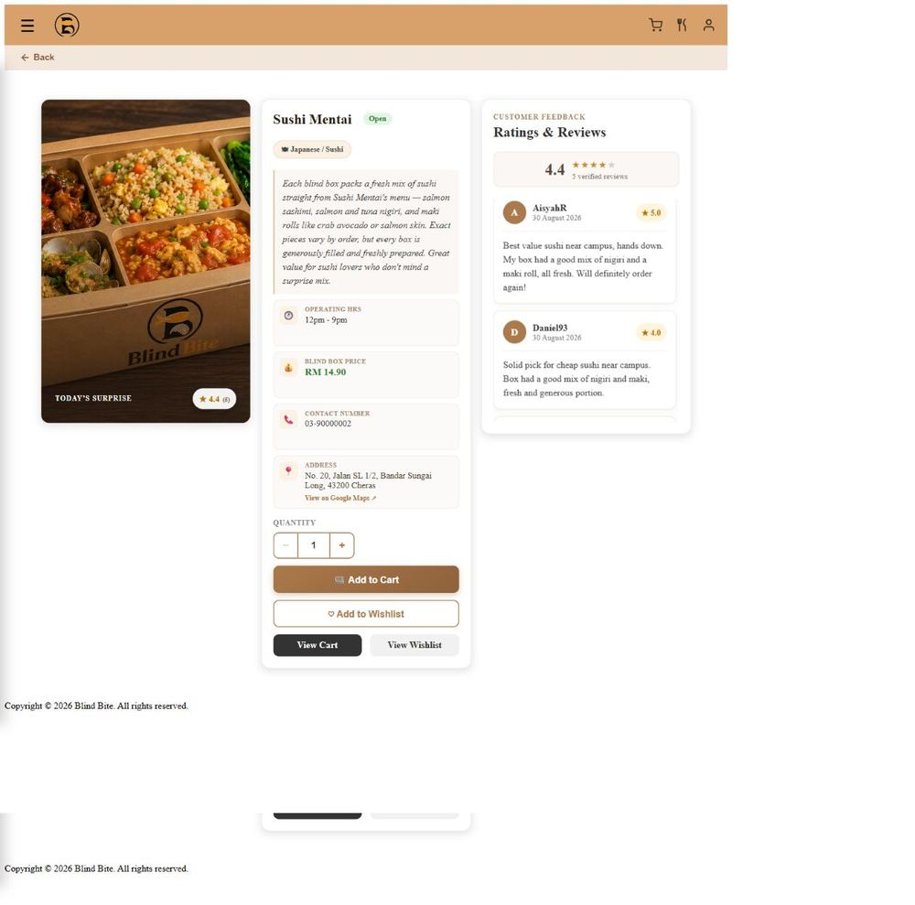
Figure 2.3: Sushi Mentai details, order controls and customer reviews.
2.5 About Us Page
pages/aboutus.php explains the Blind Bite mission and the food-waste problem. Its WhatsApp button is a normal styled link with a pre-filled message. It does not need JavaScript.
2.6 Contact Us Page
pages/contact.php collects a name, email, subject, enquiry type and message. PHP checks the CSRF token and validates each field. Valid enquiries are inserted into the enquiries table. admin/enquiries.php lists them and builds a pre-filled Gmail reply link for the administrator.
2.7 Wishlist Page
pages/wishlist.php shows restaurants saved by the current customer. Each action includes the username in the SQL condition. A customer can remove an item or move it to the cart. If the same restaurant already exists in the cart, the code updates that cart row instead of creating a duplicate.
2.8 Cart Page
pages/cart.php joins cart rows with restaurant records to obtain the current price and details. Customers can change quantity, remove an item, choose pickup or delivery and select a claimed voucher. Delivery adds RM5. js/cart-order.js updates the subtotal, discount, delivery fee and final total on screen.
The voucher rules come from includes/vouchers.php. The code checks the owner, active dates, minimum spend and whether the voucher was used. js/payment.js opens the payment popup. Cash and Card complete the local form. The Touch ’n Go choice opens its login website for demonstration only. The project does not process a real online payment.
2.9 Order History and Order Complete Pages
pages/order_complete.php shows the order total after checkout. pages/orderhistory.php shows up to three compact order cards per row on wide screens. Each card includes status, quantity, voucher, discount, delivery fee and payment method. Order Again copies the restaurant and quantity into the cart. Completed orders allow one rating and review per history_id. The saved review later affects the restaurant average rating.
2.10 Profile Page
authentication/profile.php shows the customer's account, address, phone number, saved card and voucher wallet. js/profile.js switches between view and edit panels. It also changes the Active Vouchers and Past Vouchers tabs and their ARIA state. Active vouchers are unused and within their dates. Past vouchers are used or expired.
2.11 Admin Dashboard and Management Pages
admin/dashboard.php shows searchable restaurant cards with rating summaries. admin/restaurants.php lists all restaurants and provides Add, Edit and Delete actions. Its summary cards show Total Restaurants and Total Orders. admin/promotions.php supports create, read, update and delete actions. It can also enable or disable a promotion. The page shows Total Promotions and Live on Homepage counts. admin/enquiries.php lets the administrator read customer messages. Every page calls require_admin_login() from admin/admin_auth.php.
3 CSS Design and Responsive Layout
3.1 Stylesheet Organisation
File | Pages used | Purpose
css/style.css | All customer pages | Shared header, sidebar, footer and basic controls
css/index.css | Home | Promotion cards and top restaurant carousel
css/menu.css | Menu | Search controls and restaurant card grid
css/details.css | Details | Three-area details layout and review cards
css/cart.css | Cart | Cart rows, summary and payment popup
css/orderhistory.css, order_complete.css | Orders | Order cards, review form and confirmation
css/profile.css | Profile | Profile panels, payment card and voucher tabs
css/contact.css, aboutus.css | Contact, About | Content sections and enquiry form
css/login.css, signup.css | Authentication | Branded forms and responsive fields
css/wishlist.css | Wishlist | Saved restaurant grid and actions
css/admin.css | All admin pages | Dashboard, tables, forms and summary cards
css/status.css | Menu and details | Shared Open and Closed badges

3.2 Visual Identity
The main brown colours are #AB794B and #8F623C. They match the food and café theme. Cream and white backgrounds keep the pages light. Green marks positive actions and open status. Red marks errors, closed status and delete actions. Rounded cards, soft shadows, badges and consistent spacing appear on both customer and admin pages. css/login.css places the login card over a food image and keeps strong text contrast.
3.3 Layout Structure
CSS Grid controls the menu cards, details layout, order-history cards, profile panels and admin sections. Flexbox aligns navigation items, buttons, card content and form actions. The project reuses card shapes, button styles and spacing instead of designing each page from zero. The home and review carousels use long horizontal rows that loop through cloned content.
3.4 Responsive Design
Breakpoint | Visible change | Files
1000 px | Menu, order and profile grids use fewer columns. | menu.css, orderhistory.css, profile.css
900 px | Cart, wishlist and About layouts stack or reduce columns. | cart.css, wishlist.css, aboutus.css
800 px | Details and Contact change from columns to stacked content. | details.css, contact.css
720 px | Menu search and rating controls stack vertically. | menu.css
600 px | Cart, order and confirmation controls use smaller spacing and type. | cart.css, orderhistory.css, order_complete.css
480 to 560 px | Header, forms and details controls fit narrow phones. | style.css, login.css, details.css

css/details.css
@media (max-width: 800px) {
.details-card { grid-template-columns: 1fr; }
}
@media (prefers-reduced-motion: reduce) {
.review-list { animation: none; }
}
Media queries prevent wide grids from overflowing on small screens. The prefers-reduced-motion rules in css/index.css and css/details.css also disable the two carousel animations when a user requests less motion.
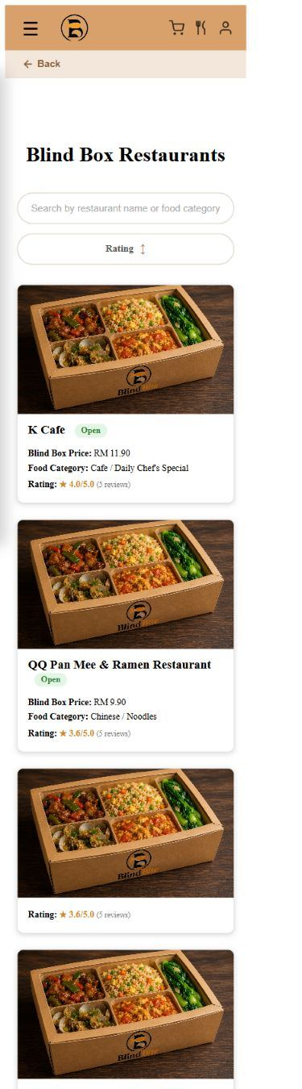
Figure 3.1: The same menu at a 390-pixel mobile viewport.
4 Client-Side JavaScript Implementation
4.1 Event-Driven Functions and DOM Updates
JavaScript files are stored in js/. PHP pages load only the scripts they need. The project does not place JavaScript functions or inline click handlers inside the page markup.
File | Event | Result on the page
menu-search.js | input, click | Filters restaurant cards and changes rating order
status.js | load, timer | Updates Open or Closed text, class and cart access
quantity.js | click | Changes the details-page quantity from 1 to 99
reviews-carousel.js | animation frame | Moves review cards and resets the loop
home-restaurants-carousel.js | animation frame | Moves the Top 5 restaurant row at 40 pixels per second
cart-order.js | click, change, input | Updates order type, voucher code, RM5 fee and total
payment.js | click | Opens the payment popup and submits the chosen method
script.js | click | Opens or closes the customer sidebar and handles Back
admin-navigation.js | click | Controls the separate admin sidebar
profile.js | click | Switches profile panels and voucher tabs
admin-promotions.js | click, submit | Switches promotion tabs and confirms deletion
admin-restaurants.js | input, submit | Filters rows and confirms deletion

js/menu-search.js
searchInput.addEventListener('input', applyFiltersAndSort);
ratingSortButton.addEventListener('click', () => {
ratingSortState = ratingSortState === 'random' ? 'desc'
: ratingSortState === 'desc' ? 'asc' : 'random';
applyFiltersAndSort();
});
The menu script reads the search text and the data stored on each restaurant card. It hides cards that do not match. It then reorders the matching cards inside the grid. This gives fast feedback without another server request.
4.2 Client and Server Validation
HTML attributes improve form use. Examples include required, minlength, maxlength, pattern, min and max. PHP repeats the checks because browser rules can be bypassed. PHP is the final source of truth.
Area | Rules enforced
Signup | Username 3 to 20 letters, numbers or underscore; valid email up to 50 characters; password 8 to 72 characters with a letter and number; address 5 to 255 characters; Malaysian mobile number 01 plus 8 or 9 digits; no duplicate username, email or phone.
Profile | Valid phone and address; duplicate phone check; card fields checked before save.
Contact | CSRF token plus valid name, email, subject, enquiry type and message.
Cart and review | Quantity and rating limits; owned completed order; active unused voucher; minimum spend; pickup or delivery choice.
Admin restaurant | Required text, Malaysian phone format, positive price, duplicate name/address/phone check, and image type/size check.
Admin promotion | Unique code, valid discount type/value, percentage at most 100, valid dates and non-negative minimum spend.

5 Database Design and SQL Implementation
5.1 Database Tables
Table | Key and relationship | Purpose
restaurants | PK restaurant_name | Stores restaurant details, image, price and hours
users | PK username; unique email and phone | Stores customer account and contact data
promotions | PK promotion_id; unique code | Stores fixed or percentage voucher rules and dates
user_vouchers | PK user_voucher_id; FK username and promotion_id; unique pair | Tracks voucher claims and used_at
paymentmethod | PK payment_id; FK username | Stores one customer's saved card record
cart | PK cart_id; FK username and restaurant_name | Stores current item and quantity
wishlist | PK wishlist_id; FK username and restaurant_name | Stores saved restaurants
history | PK history_id; FK username | Stores completed order totals, voucher, fee and payment
reviews | PK review_id; FK history_id and username; unique history_id | Stores rating and review for a completed order
admin | PK admin_id; unique admin_username | Stores administrator login data
enquiries | PK enquiry_id; optional FK username | Stores customer messages and reply details

Relationship map
Parent | Relationship | Child records
users | one customer to many records | cart, wishlist, history, reviews, user_vouchers and enquiries
restaurants | one restaurant to many records | cart, wishlist and review/history references by restaurant name
promotions | one promotion to many claims | user_vouchers
history | one completed order to zero or one review | reviews through unique history_id

5.2 Database Creation and Sample Data
database/create_table.sql creates the blindbite database and its 11 tables in relationship order. It defines primary keys, foreign keys, unique values, checks and delete rules. database/insert_data.sql adds restaurant, review, promotion and admin test data. Examples include Sushi Mentai, Secret Recipe (Sungai Long), Domino's Pizza (Sungai Long), FIRSTBITE20, SAVE5 and NIGHTBITE5. database/promotions and vouchers.sql is an update script for the promotion and voucher feature. It is not the main schema file.
The supplied admin/admin123 login is only for local testing. A real deployment should replace it and store every administrator password as a hash.
6 PHP and MySQL Integration
6.1 Database Connection
config/db_connect.php creates one mysqli connection to the blindbite database. The current code uses localhost on port 3306. The README explains that this value can be changed when a local WampServer setup uses another MySQL port. The file stops the request and shows a connection error when the database is unavailable.
6.2 CRUD Operations
Operation | Project examples
Create | signup.php creates users; contact.php creates enquiries; index.php claims vouchers; cart and wishlist pages add items; cart.php creates history rows; orderhistory.php creates reviews; admin pages add restaurants and promotions.
Read | index.php and menu.php read restaurants and rating summaries; details.php reads one restaurant and reviews; profile.php reads account, card and vouchers; admin pages read counts, tables and enquiries.
Update | profile.php updates phone, address and card; cart.php updates quantity and voucher use; edit_restaurant.php updates and synchronises a renamed restaurant; promotions.php edits or toggles promotions.
Delete | cart.php and wishlist.php remove user-owned items; checkout clears the cart; admin pages delete restaurants or promotions after confirmation.

6.3 Prepared Statements and Transactions
User values are passed through prepare() and bind_param() instead of being joined into SQL text. This reduces SQL injection risk. The username is also included in customer update and delete conditions, so one customer cannot change another customer's cart or wishlist row.
pages/cart.php
$conn->begin_transaction();
try {
// Insert history rows and mark a voucher as used.
// Clear this user's cart only after all steps succeed.
$conn->commit();
} catch (Throwable $error) {
$conn->rollback();
}
Checkout uses one transaction. It creates history rows, marks the claimed voucher as used and clears the cart. A failure rolls back every step. The restaurant rename process also uses a transaction because several related tables may need the new name.
7 User Registration and Authentication System
7.1 Registration
authentication/signup.php trims each value and checks all required fields. The username must contain 3 to 20 letters, numbers or underscores. The email must be valid and no longer than 50 characters. The password must contain 8 to 72 characters, at least one letter and at least one number. The date of birth cannot be in the future. The address must contain 5 to 255 characters. The phone must start with 01 and contain 8 or 9 more digits. A prepared query blocks duplicate usernames, emails and phone numbers.
7.2 Password Security and Login
authentication/signup.php
$password = password_hash($plain_password, PASSWORD_DEFAULT);
authentication/login.php
$password_ok = password_verify($password, $stored_password);
Customer passwords are never saved as plain text. signup.php creates a one-way hash. login.php verifies the entered password against this hash. The login form accepts a username or email for customers. The same file also checks administrator accounts and redirects them to admin/dashboard.php.
The current admin login still accepts the supplied legacy plain-text admin record for compatibility. This is not the recommended design. All administrator passwords should use password_hash() and password_verify() before production use.
8 Session Management and Authorization
session_start() creates or resumes the PHP session. A successful customer login stores the username. A successful admin login also sets is_admin to true. Customer-only pages check the username before loading private data. Admin pages call require_admin_login() before any page output or query.
admin/admin_auth.php
function require_admin_login() {
if (empty($_SESSION['is_admin']) || $_SESSION['is_admin'] !== true) {
header('Location: ../authentication/login.php');
exit();
}
}
User state | Allowed area | Blocked result
Guest | Home, Menu, Details, About, Contact and login pages | Private customer and admin actions redirect to login
Customer | Customer pages and records linked to that username | Admin pages reject access
Administrator | Dashboard, restaurant, promotion and enquiry tools | Normal customer login flow is not used

authentication/logout.php removes session data and destroys the session. It then starts a clean session for the logout message and returns the user to the login page.
9 Relational Queries and Search Functions
9.1 Query Implementation
Files | Relationship or query | UI result
index.php, menu.php, admin/dashboard.php | restaurants LEFT JOIN a review AVG and COUNT subquery | Rating and review count remain visible even when a restaurant has no reviews
pages/cart.php | cart INNER JOIN restaurants | Current price, image and restaurant details appear beside each cart row
authentication/profile.php, pages/cart.php | user_vouchers INNER JOIN promotions | Voucher rules and active, used or expired state appear for the current customer
admin/promotions.php | promotions LEFT JOIN claim counts | Administrator sees how many customers claimed each promotion
pages/orderhistory.php | history LEFT JOIN restaurants and reviews | Each order shows restaurant details and its submitted review
pages/wishlist.php | wishlist INNER JOIN restaurants | Saved restaurant cards use current details and price
admin/enquiries.php | enquiries ordered by submitted_at | Newest customer messages appear first

index.php
LEFT JOIN (
SELECT restaurant_name, AVG(rating) AS average_rating,
COUNT(*) AS review_count
FROM reviews
GROUP BY restaurant_name
) AS review_summary
ON restaurants.restaurant_name = review_summary.restaurant_name
SQL searches the stored relationships. JavaScript filtering is separate. js/menu-search.js filters cards already loaded on the Menu page. js/admin-restaurants.js filters table rows already loaded on the admin Restaurants page. These scripts improve speed, but they do not replace database queries.
10 Project Deployment, README and Setup
1. Install WampServer or XAMPP with PHP 8 or newer and MySQL 5.7 or MariaDB 10.4 or newer.
2. Copy the WAD-Food-Blind-Box folder into the web server document root. For WampServer, the usual location is C:\wamp64\www.
3. Start Apache and MySQL or MariaDB.
4. Import database/create_table.sql. Then import database/insert_data.sql into the blindbite database.
5. Check config/db_connect.php. Set the host, username, password, database name and port for the local server. The submitted file uses port 3306.
6. Open http://localhost/WAD-Food-Blind-Box/ in a browser.
7. Use the README local admin account only for testing. Replace its password before any real deployment.
README.md also explains the main folders, customer workflow and admin functions. The project has no Composer or npm installation step.
11 Conclusion
Blind Bite meets the main goal of a food blind-box ordering website. Customers can discover restaurants, claim vouchers, place pickup or delivery orders and review completed orders. Administrators can maintain restaurants, promotions and enquiries. The design adapts to desktop and mobile screens. Prepared statements, password hashing, access checks, CSRF protection and transactions improve data safety.
The current version is suitable for local demonstration. A production version should connect to a real payment gateway, hash every admin password and use payment tokenisation. It should never store a card CVV. Future work could add restaurant accounts, stock limits, email notices and delivery tracking.
12 Workload Summary
The team should complete this table with the final student IDs and agreed contribution percentages before submission. The names below come from the report cover. No percentage has been assumed.
Student | Student ID | Main contribution | Percentage
Lee Zhen Yong | To be completed | To be completed by team | To be completed
Liew Yu Heng | To be completed | To be completed by team | To be completed
Sim Yie Vern | To be completed | To be completed by team | To be completed
Tho Sweet Ning | To be completed | To be completed by team | To be completed

References
Blind Bite project source files, WAD-Food-Blind-Box, inspected on 1 September 2026.
• README.md. Local setup, project structure and feature summary.
• database/create_table.sql. Database schema, keys and relationships.
• database/insert_data.sql. Sample restaurants, reviews, promotions and administrator data.
• PHP files in index.php, pages/, authentication/, admin/, config/ and includes/.
• CSS files in css/ and JavaScript files in js/.
Appendices
Appendix A: Main Project Folder Map
Folder | Contents
admin/ | Protected dashboard and restaurant, promotion and enquiry management
authentication/ | Signup, login, logout and profile pages
config/ | mysqli database connection
database/ | Schema, sample data and promotion migration SQL
includes/ | Navigation, footer, status, image and voucher helpers
pages/ | Menu, details, cart, wishlist, orders, About and Contact pages
css/ | Shared and page-specific responsive styles
js/ | Page interaction, filtering, status, modal, tabs and carousels
images/ | Logo, restaurant images and page graphics

Appendix B: Verification Performed
• All 72 submitted project files were inspected.
• All 27 PHP files passed PHP syntax checking.
• The local home page returned HTTP 200 and loaded the Blind Bite title.
• The Home, Menu, Details and About pages were checked in the local browser.
• The Menu page was checked at a 390-pixel mobile viewport.
• The SQL schema, sample data, CSS breakpoints and JavaScript event files were reviewed against this report.
Appendix C: Current Demonstration Limits
• Touch ’n Go opens an external login page. No real payment is processed.
• The saved-card feature stores card fields directly. Production use needs payment tokenisation and must not store CVV data.
• The supplied admin record supports a legacy plain-text password. Production administrators must use password hashes.
• Restaurant owners do not have self-service accounts in this version.

