PROJECT: LITERATURE REVIEW CLASSIFIER

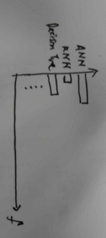

.pdf

ml_glossary.txt

sort_from_highest()

**pdf_glossary_analyzer.py**

**word_counter_utils.py**

**stop_words.py**

**web_glossary_crawler.py**

INTERNET

SOURCE