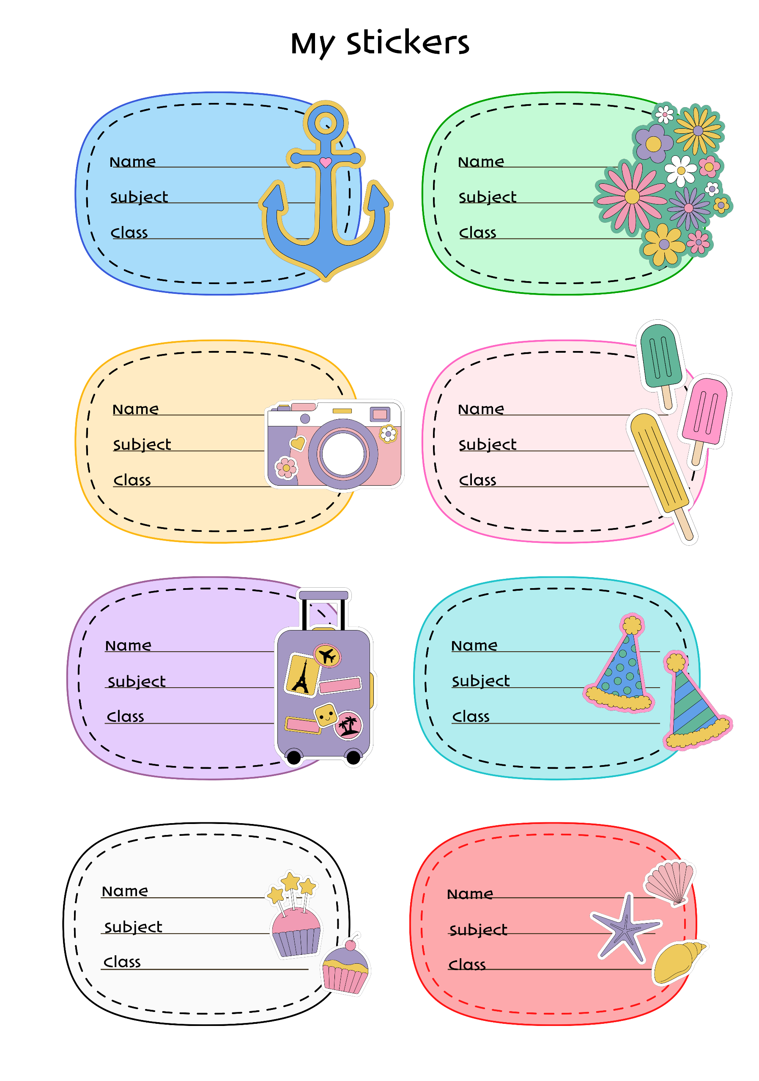

**: GRADE IV - ST. AGUSTINE**

**: GRADE IV - ST. AGUSTINE**

**: ARALING PANLIPUNAN**

**: MAPEH**

**: Colleen Princess Phel B. Lanto**

**: Colleen Princess Phel B. Lanto**

**: ESP**

**: EPP**

**: GRADE IV - ST. AGUSTINE**

**: GRADE IV - ST. AGUSTINE**

**: Colleen Princess Phel B. Lanto**

**: Colleen Princess Phel B. Lanto**

**: FILIPINO**

**: MATHEMATICS**

**: ENGLISH**

**: Colleen Princess Phel B. Lanto**

**: Colleen Princess Phel B. Lanto**

**: Colleen Princess Phel B. Lanto**

**: GRADE IV - ST. AGUSTINE**

**: GRADE IV - ST. AGUSTINE**

**: GRADE IV - ST. AGUSTINE**

**: GRADE IV - ST. AGUSTINE**

**: SCIENCE**

**: Colleen Princess Phel B. Lanto**