Carpel Sweet Dreams B. Lanto

BSIT 2-F4

1. Answer following questions based on the two relations, Branch and Staff below.  Write your answer on the space provided. (10 pts.)  
   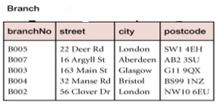  
   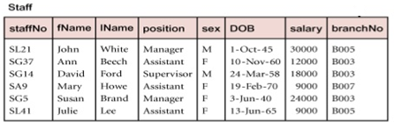
   1. Primary Key: __staffNo___ ___ brancNo___
   2. Foreign Key: __brancNo__
   3. Attributes of the Branch relation: __branchNo__ __street__

   __city__ __postcode__

* 1. Number of instances of the relation Staff: ___48___
  2. Relationship between the relations Branch and Staff: __ branchNo __
  3. Number of Fields of the Staff relation: __8__

2. Convert the given ERD to relational schema (5 pts).

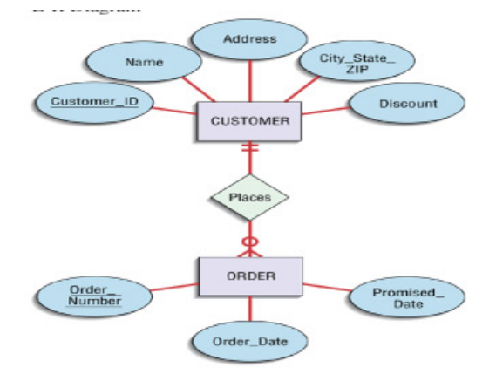

Relational Schema

Customer (Customer_id, Name, Address, City_State_Zip, Discount)

Order (Order_id, Order_Number, Order_Date, Promised_Date)

 3. Produce the relational schema for the following ER diagram (5 pts.).

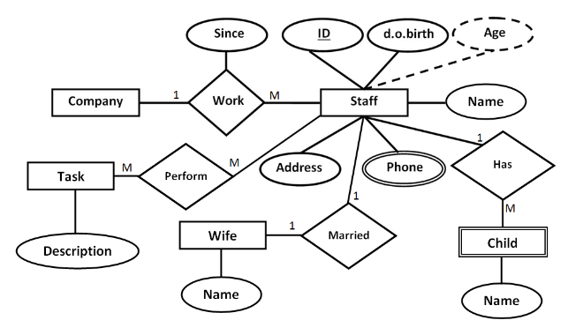

Company (CompanyID, name, address)

Staff (StaffID, dob, address, WifeID)

Child (ChildID, name, StaffID)

Wife (WifeID, name)

Phone (PhoneID, phoneNumber, StaffID)

Task (TaskID, description)

Work (WorkID, CompanyID, StaffID, since)

Perform (PerformID, StaffID, TaskID)