**HELPMETRACKER: OR MIN FINANCIAL ASSISTANCE –AIDE**

**MANAGEMENT SYSTEM WITH TRACKER**

**AND FILE TAGGING SYSTEM**

IT Research Methods Project

Presented to the Faculty of

College of Computer Studies

**MINDORO STATE UNIVERSITY**

Calapan City Campus

Masipit, Calapan City, Oriental Mindoro

In Partial Fulfillment of the Requirements for the Degree of

**BACHELOR OF SCIENCE IN INFORMATION TECHNOLOGY**

Lanto, Carpel Sweetdreams B.

De Torres, Ju Romar M.

Reig, Princes M.

BSIT IIIF1

FEBRUARY 17, 2022

**TABLE OF CONTENTS**

**TITLE PAGE i**

**TABLE OF CONTENTS ii**

**LIST OF FIGURES v**

**LIST OF TABLES vi**

**LIST OF APPENDICES vii**

**CHAPTER**

**l. INTRODUCTION**

Project Context 1

Objectives of the Study 2

Scope and Limitation of the Study 3

Significance of the Study 4

Conceptual Framework 5

Definition of Terms 6

**II. REVIEW OF RELATED LITERATURE AND SYSTEM**

Local Literature / System 7

Foreign Literature / System 8

Synthesis 9

**III. METHODOLOGY**

Developmental Method 10

Gantt Chart 11

Requirements Specifications 12

Functional Requirements 13

User Interface 14

Hardware Interface 15

Software Interface 16

Security Requirements 17

Technical Background 18

Hardware Specifications 19

Software Specifications 20

System Analysis and Design 21

System Overview 22

System Architecture 23

Use Case Diagram 24

Activity Diagram 25

Data Flow Diagram (DFD) 26

Context Diagram 27

Diagram 0 28

Database Schema 29

Testing and Evaluation 30

Participants of the Study 31

Data Gathering Instrument 32

Implementation Plan 33

**BIBLIOGRAPHY**

**APPENDICES**

Appendix A - Project Team Assignment Form

Appendix B – Capstone/Research Project Topic Proposal Form

Appendix C – Chapter II Matrix

Appendix D - Notice of Title Acceptance

Appendix E - Curriculum Vitae

Appendix F - CD/User’s Manual

**LIST OF FIGURES**

**Figure Page**

1 Concept of the Study 3

2 Developmental Method 12

**LIST OF TABLES**

**Table Page**

1 Gantt Chart 17

2 Functional Requirements 19

3

**LIST OF APPENDICES**

**Appendix Page**

A Project Team Assignment Form 50

B Capstone/Research Project Topic Proposal Form 67

C Chapter II Matrix 70

D Notice of Title Acceptance  72

E Curriculum Vitae 74

**CHAPTER I**

**INTRODUCTION**

**Project Context**

The Financial Aide Management System here in Oriental Mindoro with Tracker and File tagging system is a web-based system for managing files in the office of Batasang Panlalawigan here in Oriental Mindoro. Sickness and hospitalization are a huge problem when it comes to the financial aspect of having an illness. Especially if you and your family do not have health insurance or money is not enough for hospitalization bills on necessary surgeries as well as medications. Many people are suffering from serious illness so they will ask for help. Before the client receive financial assistance, they need to complete the documents in order to receive help from the government. Though we have access financial medical assistance from government office of financial assistance and Department of Social Welfare and Development. Managing files are not easy to handle manually using hard copies of document, it may cause mistake.

Issues pertaining to the efficient storage, management, and retrieval of files, documents, and other content stored on PCs reflect new demands on human-computer interface design. Using declarative keywords is a common method for organizing content for navigation, filtering, or searches(Chen et al., 2008).

This study aims to arrange the files and folders by category, manage individual or group files such as special office documents and record and, administering a system that handles a data and records with similar information. Through the use of Help Me Tracker: or Min Financial Assistance –Aide Management System with Tracker and File Tagging System it will provide a more accessible and convenient means for client here in Oriental Mindoro.

**Objectives of the Study**

The main objective of the study is to develop a file managing system provider for more accessible and convenient that will use for managing files. It is entitled “___” . This study aims to achieve the following objectives:

1. To integrate a File Tagging System that arranges the files and folders by category, manage individual or group files such as special office documents and record and, administering a system that handles a data and records with similar information.
2. To implement a Data Analytic Process where demographics of a client/patient, database illustration of patient illness, request assistance, location and condition.(MALI ITO) ANG DATA ANALYTICS AY HINDI LANG SA DATA. SEARCH KAYO ONLINE.
3. To apply a Recommendation System that will predict the classification or the preference of a client and the system automatically conclude the clients’ preferences by monitoring the clients record and letter request.
4. To track the beneficiaries of the assistance which easily notifies if they actually used it or not through the involvement of the hospitals and funeral homes in the system.

**Scope and Limitation of the Study**

The study will focus on the development of file managing system for the office of Batasang Panlalawigan in Oriental Mindoro where the system includes file tagging that arranges the files and folder by category, manage individual or group files such as special office documents and record and, administering a system that handles a data and records with similar information. Demonstrate data analytics where demographics of a client/patient, database illustration of patient illness, request assistance, location and condition. This study refers to qualitative data that can be used to determine the specific frequencies of traits or characteristics. The researchers can form parameters through which larger data sets can be observed with it. Qualitative data is collected through questionnaires, interviews, or observation. Analyzing data allows us to explore ideas. Predict recommendation system that seeks to predict the classification or the preference of a client and the system automatically conclude the clients’ preferences by monitoring the clients record and letter request. Identify through tracking/monitoring which is use to know if the client is already use their asked assistance, the hospital will send a confirmation to the system if it the client is back to the hospital with their asked assistance. This study will be conducted for 6 months (October 2021-April 2022).

**Significance of the Study**

This study will be beneficial for future researchers, officers or staff and, residence of Oriental Mindoro that seeks for help in assistance and file managing specially for the client of Batasang Panlalawigan Office. The system includes file tagging that arranges the files and folder by category, manage individual or group files such as special office documents and record and, administering a system that handles a data and records with similar information. Predict recommendation system that seeks to predict the classification or the preference of a client and the system automatically conclude the clients’ preferences by monitoring the clients record and letter request. Identify through tracking/monitoring which is use to know if the client is already use their asked assistance, the hospital will send a confirmation to the system if it the client is back to the hospital with their asked assistance. ISA-ISA ANG LAGAY!

E.G.

**RESEARCHER**. THIS WILL HELP THEM IN TERMS OF…

**ORMIN HELP SEEKER**. THIS WILL HELP THEM IN TERMS OF…

**Conceptual Framework**

INPUT

OUTPUT

PROCESS

Web-Based File Managing System

* Planning
* Analyzing
* System Design
* Observation
* Research
* Review of related Literature and system
* Development

tools and Technique

* On-site testing and observation

**CHAPTER II**

**REVIEW OF RELATED LITERATURE AND SYSTEM**

**Local Literature / System (at least 10 citations here)**

**File tagging**

As stated by (Marchetti et al., 2007) all the tagging systems listed above are usually adopted by particular communities of users; del.icio.us by Computer Science experts, Flickr mainly by amateur photographers and Technocrati by bloggers. As we can infer, also by reading this short description of significant examples, tagging represents a collaborative social effort of a community of users constituted around a tagging service; with his tagging action, every user, mainly on the basis of its interests, directly contributes to the creation of a shared metadata collection, progressively increasing its relevance and its richness of useful and shared data. The three main components of collaborative tagging systems are: users, resources and tags.

However (Lee & Han, 2007) stated that a number of previous works provide evidence that users of tagging system use tags for ratings and opinion-expression. Marlow et al. provided a comprehensible taxonomy of tagging incentives, assigning six different incentives. [3] He noted incentives such as Self Presentation and Opinion Expression. One of the most cited study pertaining to tagging is Golder and Huberman’s research concerning del.icio.us. They classified tags from del.icio.us into seven different classes according to their functions. One of the classes was Identifying Qualities or Characteristics.[1] Sen et al. meanwhile classified tags from the MovieLens Community into three classes based upon a study by Golder and Huberman. They classified Subjective Tags, which represent users’ opinions and ratings.

**Tracking/Monitoring system**

According to (B. Caluza, 2017) information systems have shown its significant impact and importance in the digital age. A study reveals the benefits of having a digital process were fast and increased productivity, better monitoring, high level of accuracy, and high level of consistency of information. Many organizations are developing information systems designed specifically to facilitate the sharing and integration of knowledge.

On the other hand, (Rodriguez et al., 2017) highly urbanized LGUs in the Philippines have their own system in monitoring system for both relief and casualty. This system is only available on the city/municipal level. The system has no connection to the barangay level, provincial level or even regional level. The need to cascade information both to provincial, regional and national level is very important for the decision makers. Given all these reviews, we were motivated to propose a system that is related to the existing system. However, we focus not only on one aspect of disaster, but several aspects like early warning using 2G technology, information management such as monitoring of inventories both donations and casualty.

**Funeral Assistance**

Asstated by (Derogongan et al., 2019) Funeral home industry affects the political scenario of Iligan city. The local funeral homes, Capin and Mary Venus have become a privileged market for political ascension and platforms of local politicians. Danilo Capin’s Funeraria implements former Congressman Vicente ‘Varf’ Belmonte‘s Priority Development Assistance Funds (PDAF)-funded projects, “MagtamVarfyayong sa Kasubo” (Together at Sorrow) and “MagtamVarfyayong sa Transportasyon” (Transportation Services Assistance). It aims to help indigent Iliganon for funeral assistance, free coffins, flowers, and services for funeral procession, tents for wakes and other discounted funeral facilities like lights. In 2016, the then Mayor Celso G. Regencia also launched a funeral assistance program to the indigent Iliganon especially in embalming, transportation and coffin.

While(Kiang et al., 2020) notes that the attribution of indirect deaths from the COVID-19 pandemic, which could last for years, will not be straight- forward because economic and social disruptions will intersect in complex ways to affect morbidity and mortality. There is also no global consensus on the timescale over which post disaster deaths should be measured. The CDC recommends applying the “but for” principle when ascertaining disaster-related deaths: “But for the [pan- demic], would the person have died when he/she did?”. This inclusive definition of indirect deaths is similar to that proposed by the Emergency Events Database maintained by the Centre for Research on the Epidemiology of Disasters, but it is far more expansive than that espoused in the Sendai Framework for Disaster Risk Reduction, which recommends counting only persons who died “during or directly after the disaster, as a direct result of the hazardous event”. Such attribution is not without consequence. For example, some insurance policies may not cover expenses related to indirect deaths because the deaths were attributed to a “disaster,” for which payouts may be exempt. Conversely, a life insurance policy that would not otherwise cover suicides may be compelled to cover a disaster-related death if coverage extended to death in natural calamities.

**Organize Documents**

(Kowsari et al., 2017) points out that document classification is necessary to organize documents for retrieval, analysis, curation, and annotation. Researchers have studied and developed a variety of methods for document classification. Work in the information retrieval community has focused on search engine fundamentals such as indexing and dictionaries that are considered core technologies in this field. Considerable work has built on these foundational methods to provide improvements through feedback and query reformulation. (De Carvalho Moura et al., 2002) Admits that documents can be organized using Web directories, databases or other digital library techniques, whose contents can be handled using different retrieval mechanisms to provide better services to the users.

However (Freeman & Gelernter, 1996) endorse that given that we use sub streams to organize documents, why bother with the underlying time-based ordering? For several reasons: time is a natural guide to experience; it is the attribute that comes closest to a universal skeleton-key for stored experience (Malone, for example, suggests the utility of time-based organization in his early studies). The stream adds historical context to a document collection; all documents eventually become read-only (in the pazt, set in stone for history), and the stream preserves the order and method of their creation. Like a diary, a stream documents work, correspondence and transactions.

**Foreign Literature / System (at least 10 citations here)**

**Tagging System**

(Chen et al., 2008) Study tags are non-exclusive and non-hierarchical words that describe files. Tagging mechanisms consist of multiple tags or keywords that describe file content and that can be used for filtering files during searches. The relationship between tags and content can be viewed as a bipartite network, and the relationship among tags can be visualized as a flat complex network with weighted nodes and links. Since multiple files can share identical tags, a content-to-content network can be used to define similarities and relationships. Since a single file can have multiple tags, a tag-to-tag network can be used to describe a personal knowledge ontology (similar to a semantic web ontology) when building a tagging system. The two networks can inform each other and provide different perspectives for users to search, retrieve, and organize their personal knowledge. Since tagging mechanisms are non-exclusive and non- hierarchical, a file does not exclusively belong to one folder.

(Furnas et al., 2006) Notes that Kevin Fox has hands-on experience with the design and use of labels (you can call them tags if you wish) in Google’s Gmail service. Kevin is also intrigued by the lexical trends that are derived by social tagging systems and their counterparts (e.g., HTML linking and trackbacks). Moreover, Kevin believes that previous publisher- and community-driven tag-like systems can help us predict and overcome problems in the current generation of tagging systems. He is interested in various tagging systems, current and legacy, starting from Library of Congress subjects to meta-tag keywords to tag folksonomies.

**Tracking/Monitoring system**

According to(Holst et al., 2020) the purpose and design of the project German Monitoring of the GAP ESD at the Institut Futur, Freie Universität Berlin, are aligned towards these criteria in order to significantly contribute to the systematic production of scientific knowledge on the quality and quantity of ESD within the German education system and on ways to effectively foster its implementation. The research design of the project encompasses several methodical approaches such as quantitative, qualitative, and mixed-method studies. A central element is large-scale, indicator-based, longitudinal document analysis on the formal anchoring of ESD within core documents of the German education system.

(Janavi & Evaluation, 2020)stated that the comparison of technology and innovation evaluation indicators in the country's comprehensive scientific plan and the Sixth Five-Year Development Plan with the national monitoring system indicates that there is little overlap between monitoring indicators and upstream documents. In some cases, the monitoring system is not able to respond to policy documents of the state of science and technology in Iran. Therefore, the indicators of the monitoring system need to be further reviewed and overlapped with the policy documents.

**Medical Assistance**

According to (Fujioka et al., 2018) Medical Assistance in Dying (MAiD), by way of assisted suicide (in which the patient self- administers the lethal dosage with the help of a clinician) or euthanasia (in which a provider administers the lethal dosage), is now legal in many jurisdictions.1 With an increasing focus on quality of dying and a ‘dignified death’, with the aim of upholding the ethical principle of respecting patient autonomy, MAiD has gained widespread public and professional interest as a potential end-of-life alternative, leading to legalization in several countries. Canada, with the passing of Bill C-14 in June 2016, is the most recent country to adopt legalization, alongside Belgium, Colombia, Germany, Luxembourg, the Netherlands, Switzerland, and the States of California, Montana, Oregon, Vermont, and Washington in the United States (US) of America.1–3 A growing number of other countries such as Australia, France, Japan, South Africa and the United Kingdom, are considering following suit.

Compared to (Trachtenberg & Manns, 2017) If Canadians adopt medical assistance in dying in a manner and extent similar to those of the Netherlands and Belgium, we can expect a reduction in health care spending in the range of tens of millions of dollars per year. Our analyses suggest that the savings will almost certainly exceed the costs associated with offering medical assistance in dying to patients across the country, and that the inclusion of medical assistance in dying in the services covered by universal health care will not increase health care spending, but rather will release funds to be reinvested elsewhere. We are not suggesting medical assistance in dying as a measure to cut costs. At an individual level, neither patients nor physicians should consider costs when making the very personal decision to request, or provide, this intervention.

(Kobierecka & Kobierecki, 2021)Declares that the last segment of declared motivations of China’s medical assistance to countries struggling with COVID-19 outbreak refers not to presenting a desirable image of the country, but has a more instrumental character. It appears that through providing aid and assistance China seeks to boost cooperation and trade with other countries. Contrary to earlier mentioned motivations, boosting future cooperation has not been underlined this strongly by Chinese spokespeople. Nevertheless, such statements were occasionally reported. While providing aid to Spain, a country with one of the most severe outbreaks in March 2020, Chinese leader Xi Jinping told Spanish Prime Minister Pedro Sánchez that both countries should step up cooperation and exchanges after the outbreak. Italian prime minister heard from Xi he had hoped that a health silk road could be established as a part of the initiative of One Belt and One Road (Kuo 2020). Xi also spoke about boosting future cooperation as a result of a current partnership in combating the COVID-19 pandemic in his message to Serbia’s President Aleksandar Vučić (Ministry of Foreign Affairs of the PRC 2020p). The issue of boosting cooperation was also raised by the Premier of China’s State Council Li Kequiang, who offered to sell the EU medical supplies and at the same time expressed Chinese eagerness to advance negotiations on the investment treaty (Givetash and Chen 2020).

**Synthesis**

The literatures and studies mentioned in this research are relevant to the study because the ideas of these authors will contribute greatly in enriching the knowledge and guidance in said study. These studies and literature cover some additional information about the development the system of entitled “HelpMe Tracker: OrMin Financial Assistance-Aide Management System with Tracker and File Tagging System” that will provide files and folders by category, manage individual or group files such as special office documents and record and, administering a system that handles a data and records with similar information also assistance involves in the said system.

**CHAPTER III**

**METHODOLOGY**

This chapter goes over the various methods that the researchers used to develop the proposed website. The gathered data were evaluated and analyzed to provide adequate results**.**

**Developmental Method**

The researchers used waterfall model because it’s a classical model used in system development life cycle to create a system with a linear and sequential approach. It is termed as waterfall because the model develops systematically from one phase to another in a downward fashion.

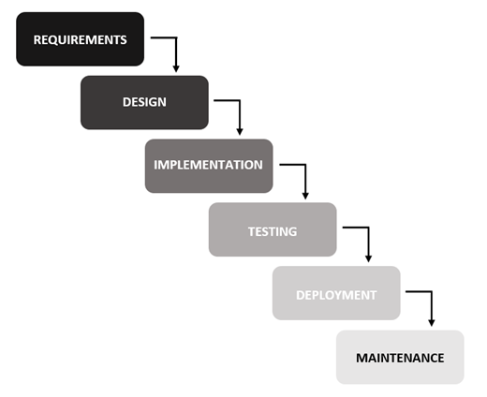

**Development.** The researchers generated small programs in the system, which they named units, at this step before combining them in the next level. The process of building and testing each unit for its functionality is referred to as unit testing.

**Testing.** The researchers will now integrate and test the website's existing features and functions. Uploading it to the server to allow to test the overall functionality.

**Deployment.** After researchers have completed and tested the project, the system is ready to be released to clients at this phase.

**Review.** The researchers checked the system's functionality and usability at this point. During the implementation phase, there were some problems, but the developer was able to resolve them eventually.

**Gantt chart**

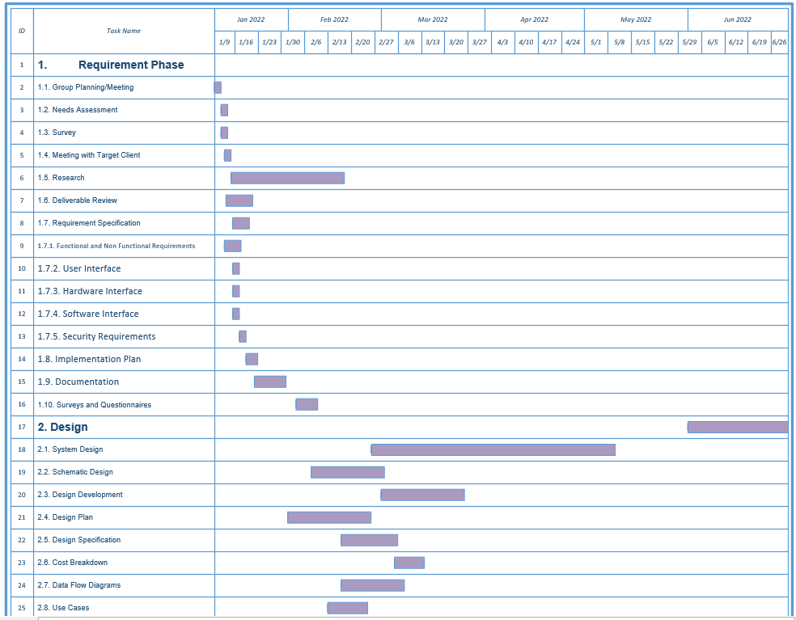

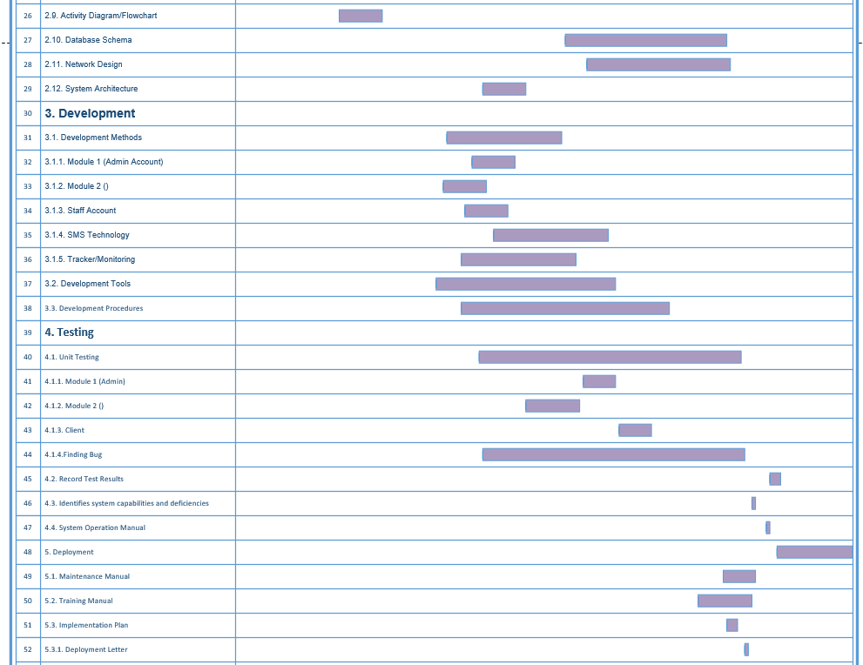

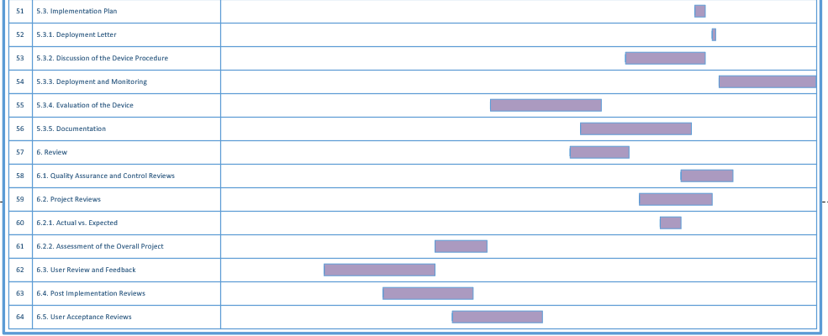

**Requirements Specifications**

This contains the software interface, user interface and functional requirements that were developed during the study’s development. The user must meet the project’s function in order to properly utilize the proposed project.

**Functional Requirements**

The functional requirement of the online system is to present the main need of our clients which is the file tagging. The staff will book a client and scan the requirements and the client will have its own folder with their documents. It also has a recommendation function if the client is in second time for asking an assistance in three months.

The researchers determined the requirements needed to construct the suggested website. The researchers acquire necessary facts and data regarding the manual system, the proposed website's features and functions, and the whole process specification of the website component at this stage.

**User Interface**

The Graphical User Interface (GUI) of the**,** HelpMe Tracker: OrMin Financial Assistance-Aide Management System with Tracker and File Tagging System is presented on the Website; it is where the staff/boss can see the status of the system. The following figures show the Dashboard, Data Analytics, Data Reports. These figures are the interface where the staff can view, control and make the process of the system.

**Hardware Interface**

There are several resources necessary for the system's development in order to finish the program creation. To complete the study's tasks, the researchers utilized their mobile phones and laptop/computer. The researchers would be unable to construct the,HelpMe Tracker, without these gadgets.

**Software Interface**

These are some of the technical terms used by the project's proponents. These features include PHP, which is a reflective programming language or server-side scripting language used by web developers, and MySQL, which is a relational database and a popular choice of database for use in website systems. The above-mentioned terminologies are the technology employed by the system's proponents.

**Security Requirements**

To secure the admin's password and prevent unauthorized usage of their account on the website, the researchers utilized encrypted password. Staff and admin both have access to the system, but staff are unable to access the admin because it needs the username and password of it.

**Technical Background**

The technical background provides important information about technical aspects of the project, making it easier for developers to define what is required in simple terms. The technology that the researcher used are: MySQL is an open-source relational database management system that we employed for my database. This MYSQL is a graphical database creation tool that is based on the structure query language and is used to add, remove, and alter information in the database. Google Chrome since it is an open-source tool that allows us to browse the World Wide Web and execute Web-based apps. The Google Chrome browser is capable of retrieving or fetching code, which is often written in HTML. Xampp control panel server it includes a simple UI with a management interface that allows you to start or stop the server with a single click.

**Hardware Specifications**

The researchers use a laptop with an Intel Core i5 10th generation processor running at 2.50GHz and 8GB of RAM. The researchers use a 10mbps PLDT Wi-Fi connection for their internet connection and a personal cell phone was also used to conduct research.

To run the system, all you need is a browser and an internet connection, as well as a minimum of 1 core CPU and 2GB RAM.

**Software Specifications**

As a default operating system, the researchers use Windows 10. Sublime Text as a text editor and source code editor, Bootstrap as a front-end web framework for typography, forms, buttons, navigation, and other interface components, XAMPP as a webserver for testing the web page without publishing it live on the internet, and Google Chrome as the browser used to run the website, and any device that can access internet can run this website such as smartphone (Android/IOS), laptop/computer.

**System Analysis and Design**

System analysis and design is a project process and the first step in the development of a software system. The project begins with initiation activities such as a feasibility study, benefit analysis, and project management. The first phase of the project is system analysis and design, which is considered an essential phase for software development. The system functions will be formally documented and detailed to the point where the system design can be completed. The system analysis and design process include identifying data entities and their attributes.

**System Overview**

HelpMe Tracker is an online website that Log the client with his/her requirements, and also have a Tracker and File Tagging System. The website benefits the users such as the staff, boss. HelpMe Tracker helps the staff and boss to easily save documents and search it to view or print. This system also helps the staff validate if the client already gets an assistance and it will also recommend other financial assistance program. And also, the system will help the staff/boss by easily monitor the client and generate reports that they can use in accreditation.

**System Architecture**

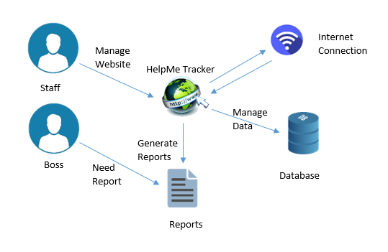Figure 1 shows how the system will work from the staff to the website up to main function of the system. Users will input information and it will direct to the database. All the information inputted by the boarding house owner and tenant will be shown in their corresponding webpage in the website. And the admin can view all the boarding house info and tenant info, also can generate reports based on the details they want.

**Figure 1. System Architecture**

**Use Case Diagram**

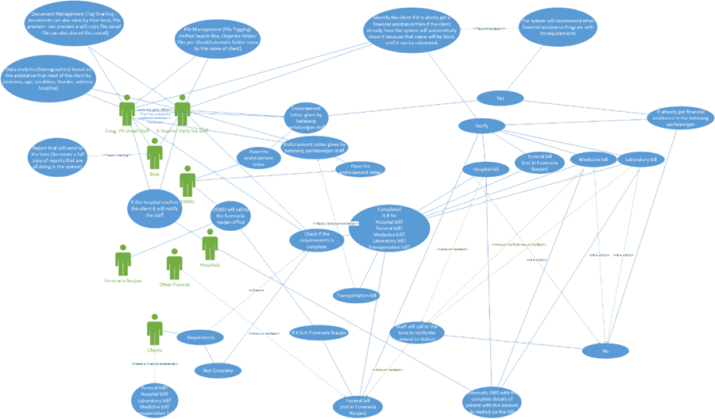Figure 2 shows the use case diagram of the whole system.

.

**Figure 2. Use Case of the Whole System**

**Activity Diagram**

Figure 3 shows the website flow and functions from the homepage through the system features. It shows the website conditions and process flow.

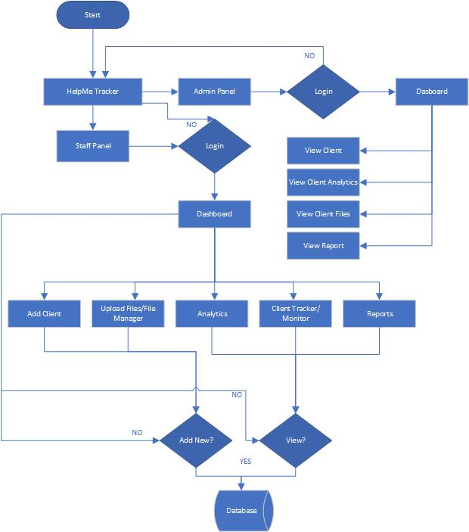

**Figure 3. System Flowchart**

**Data Flow Diagram (DFD**)

This section shows the different diagrams that describes how the data is processed within the system.

**Context Diagram**

Narrative Description of the Current System

The staff of Cong. PA Umali here in Oriental Mindoro First District has no existing system that have a file tagging, data analytics, file management, and a system that can track to confirm if the client use the assistance in the 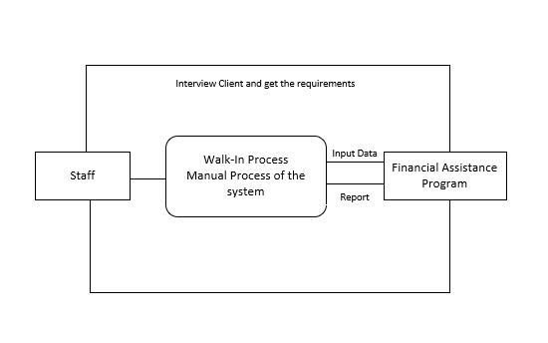hospital.

**Figure 4. Context Diagram of the Manual System**

Narrative Description of the Proposed System

The “HelpMe Tracker: OrMin Financial Assistance-Aide Management System with Tracker and File Tagging System” is the automated system of the manual system of our client. This system will be beneficial to our client. It will help big in our client to manage data easily by using this system and they don’t need to check one by one their recent list to check if the client already gets an assistance, it will also help them to have a organize file storage. Also, all features that our client needs are what the system has, like the file management, data analytics, generate reports, client assistance checker, etc.

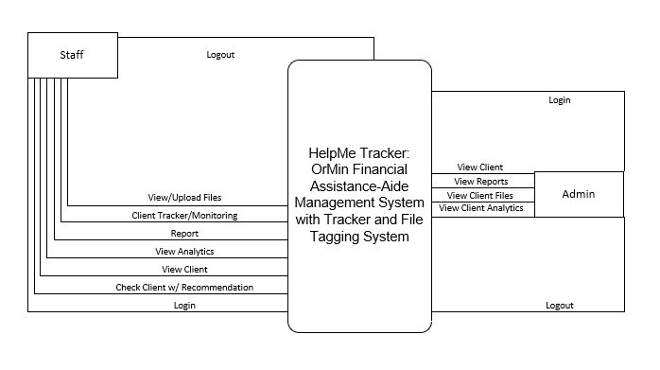

**Figure 5. Context Diagram of the Proposed System**

**Diagram 0**

Figure 6 diagram 0 shows the sequence of system in admin side. The system indicates all the functions that the admin can do. It includes the login, view client, view client analytics, view client file and view reports. Admin can select any of the following base on how he needs it and use the system.

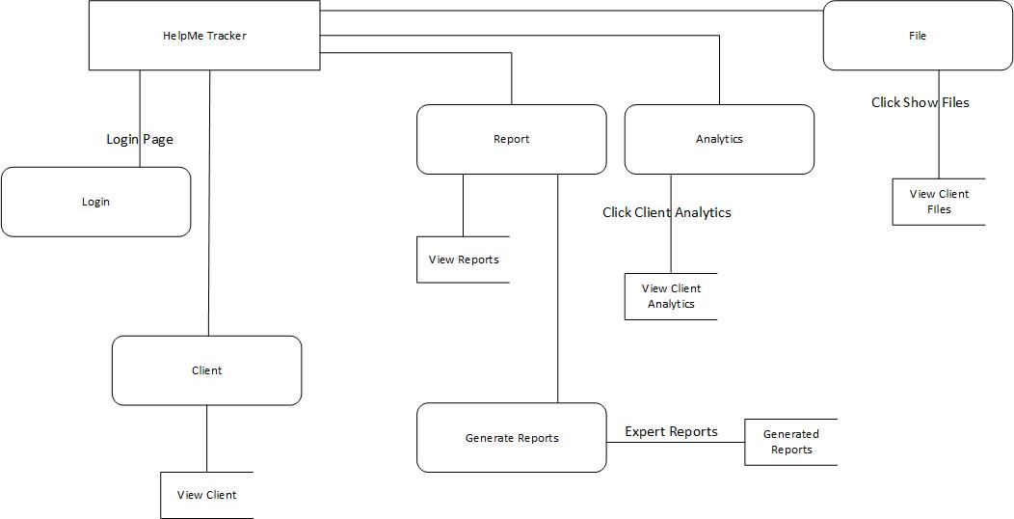

**Figure 6. Diagram 0 of Admin**

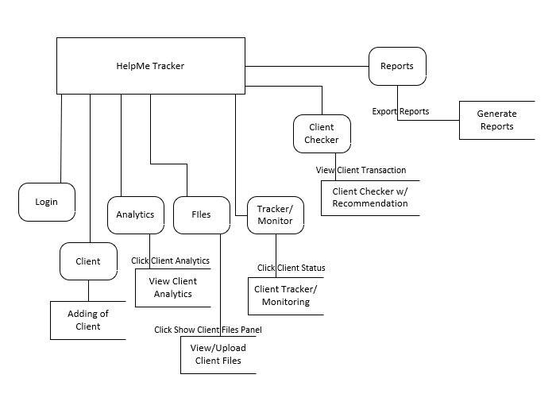Figure 7. Diagram 0 shows the system in staff side. The system indicates the function that the staff can do. It includes the login, adding of client, view analytics, view/upload files, client tracker/monitoring, client checker w/ recommendation, reports. Staff can select any of the following base on how he needs it and use the system.

**Figure 7. Diagram 0 of Staff**

**Database Schema**

Designing the system was one of the important phases in developing the study. This phase showed the features of the entities that are present in the system. This provides the user with the attributes among existing entities. It describes the data in the study.

This section depicts the table with fields for data type and description conformance.

**Table 1. Fields for Login**

|  |  |  |  |  |
| --- | --- | --- | --- | --- |
| **Field Name** | **Data Type** | **Size** | **Default** | **Description** |
| Id | int | 20 | NOT NULL | Refers to the id (PK) |
| FirstName | var  char | 191 | NOT NULL | Refers to User First name |
| MiddleName | var  char | 191 | NOT NULL | Refers to User Middle name |
| LastName | var  char | 191 | NOT NULL | Refers to User Last name |
| Username | var  char | 191 | NOT NULL | Refers to User Username |
| UserType | var  char | 10 | NOT NULL | Refers to UserType if admin/saff |

Table 1presents the attributes included in Login. This field contains the data needed when the user will login in the website.

**Table 2. Fields for Client**

|  |  |  |  |  |
| --- | --- | --- | --- | --- |
| **Field Name** | **Data Type** | **Size** | **Default** | **Description** |
| Id | int | 20 | NOT NULL | Refers to the id (PK) |
| FirstName | var  char | 191 | NOT NULL | Refers to Client First name |
| MiddleName | var  char | 191 | NOT NULL | Refers to Client Middle name |
| LastName | var  char | 191 | NOT NULL | Refers to Client Last name |
| Address | var  char | 191 | NOT NULL | Refers to Client Address |
| Age | var  char | 20 | NOT NULL | Refers to Client Age |
| Birthday | date | 50 | NOT NULL | Refers to Client Birthday |
| Gender | var  char | 10 | NOT NULL | Refers to Client Gender |
| Purpose | var  char | 191 | NOT NULL | Refers to Client Purpose |
| Created_at | timestamp |  | NULL | Refers to the date when client ask for assistance |

Table 2 shows the data in the field for the client. It contains id, firstname, middlename, lastname, address, age, birthday, gender, purpose, and created at where id is the primary key for the client.

**Testing and Evaluation**

The website is tested before examining the functionality of a software item, as well as identifying and assessing discrepancies between supplied input and expected results. Through trial and error, the researcher verifies that the website is efficient, dependable, and available within a certain time limit. The client's reaction and behavior are monitored to see if they are satisfied with the product and whether it meets their expectations. It will go through a testing and evaluation phase before being made public to ensure that it can be used.

**Participants of the Study**

The study was carried out for HelpMe Tracker: OrMin Financial Assistance-Aide Management System with Tracker and File Tagging System on their file tagging and tracker system. They employ a walk-in transaction process, which the researcher will use in this case as part of the project planning and development. In addition, the study's objectives must be met.

**Data Gathering Instrument**

In order to gather the necessary data for the study, the researchers used survey questionnaires. The information will come from the responders. 5-Strongly Agree, 4-Agree, 3-Moderately Agree, 2-Disagree, and 1-Strongly Disagree.

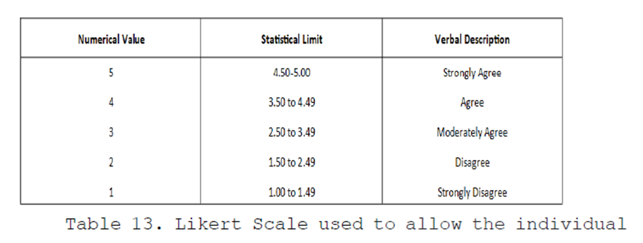

**Implementation Plan**

The researchers prepared an implementation plan if ever the company or their client decide to adopt the proposed system. If that's the case, they'll send over the system along with its documentation. It will act as a guide for the client who will be in charge of updating and maintaining the system.

There should be a letter of agreement that the system is freely given to the user and the researchers are not responsible for the project's updating and maintenance. The researchers will use a variety of tactics if the project is implemented.

**APPENDIX A**

**Project Team Assignment Form**

**Title: HelpMe Tracker: OrMin Financial Assistance-Aide Management System with Tracker and File Tagging System**

|  |  |  |
| --- | --- | --- |
| **Name and Signature** | **Project Role** | **Email and Number** |
| Carpel Sweet Dreams B. Lanto | Programmer  Database Manager  System Analyst | [lantocarpel1@gmail.com](mailto:lantocarpel1@gmail.com)  09365758796 |
| Princess M. Reig | Technical Writer  Researcher  Programmer |  |
| Jun Romar De Torres | Programmer  Database Manager  System Analyst |  |

**APPENDIX B**

**Capstone/Research Project Topic Proposal Form**

**APPENDIX C**

**NOTICE OF TITLE ACCEPTANCE**

**REVIEW OF RELATED LITERATURE/STUDIES MATRIX**

**Title: HelpMe Tracker: OrMin Financial Assistance-Aide Management System with Tracker and File Tagging System**

|  |  |  |  |
| --- | --- | --- | --- |
| **Reference** | **Title** | **Objectives** | **Findings** |
| **File tagging (2literature)** | | | |
| Wang, Y., Patel, A., & Jin, H. (2018).  A new concept of deep reinforcement  learning based augmented general  sequence tagging system. COLING  2018 - 27th International Conference on Computational Linguistics, Proceedings,  1683–1693. | A New Concept of Deep Reinforcement Learning based Augmented General Sequence Tagging System | 1. To demonstrate the new system’s outstanding performance on general tagging tasks. 2. To improve system performance by modeling the data with minority tag. | The design of DRL based augmented tagging (DAT) system is as given. Due to the differences of using augmented tagger in training and inference, we discuss these two parts separately. |
| Lee, S. E., & Han, S. (2007). Qtag:  Introducing the qualitative tagging  system. Hypertext 2007: Proceedings  of the Eighteenth ACM Conference on Hypertext and Hypermedia, HT’07,  35–36. https://doi.org/10.1145/1286240.1286250 | Qtag: Introducing the qualitative tagging system | 1. To provides tagging exceptional performance in the domains of IF (Information Filtering) and IR (Information Retrieval). 2. To presents Qtag, a qualitative tagging system that allows users to tag in order to rate and express opinions in more sharable vocabulary. | The strongest point of Qtag is that it retains the basic  characteristics and qualities of conventional tagging. The same quality is the weakest point as well, as Qtag does not solve classic problems of tagging itself such as the use of synonyms and instances of polysemy. |
| Furnas, G. W., Fake, C., Von Ahn, L., Schachter, J., Golder, S., Fox, K., Davis, M., Marlow, C., & Naaman, M. (2006). Why do tagging systems work? Conference on Human Factors in Computing Systems - Proceedings, 36–39. https://doi.org/10.1145/1125451.1125462 | Why do tagging systems work? | 1. To explore the relevance of the emerging tagging systems 2. To presents the behavioral, economic, and social models that underlie each tagging system | Demand answers to these questions and others from some of the pioneering practitioners and academics in the field. |
| Marchetti, A., Tesconi, M., & Ronzano, F. (2007).  SemKey: A Semantic Collaborative Tagging System.  WWW07 Workshop, Tagging and Metadata for Social  Information Organization, January. [http://scholar.google.com/scholar?num=100&#38;hl=en&#38;lr=&#38](http://scholar.google.com/scholar?num=100&#38;hl=en&#38;lr=&)  ;newwindow=1&#38;q=SemKey%3A+A+  Semantic+Collaborative  Tagging+System&#38; btnG=Search | SemKey: A Semantic Collaborative Tagging System ∗ Andrea | 1. analyzing the current structure and the usage patterns of collaborative tagging systems, we can find out many important aspects which still need to be improved. 2. To propose a new way to describe resources: the semantic tagging. | Each of them specifies a concept that describes a particular characteristic (or property) of the re- source to find. All the resources that are described by the set of generic semantic assertions specified by the user are considered to form search results. |
| Chen, C., Lin, I., Hsieh, J., & Sun, C. (2008). A Web-based Tagging Tool for Organizing Personal Documents on PCs. May 2014. http://works.bepress.com/lucemia/18/ | A Web-based Tagging Tool for Organizing Personal Documents on PCs | 1. To locate and find specific files stored deep within a hierarchy, therefore researchers are currently studying new mechanisms for file storage, organization, and retrieval. 2. To compare it with a traditional hierarchical folder system. | Our proposed system’s primary functions are tagging and searching. The tagging scenario includes file tag addition, deletion, and updating operations. Users can also choose from a list of existing tags. When using remote devices to connect to their own PCs, users can upload files and add related tags via the Web. |
| **Tracking/Monitoring (5 REFERENCES)** | | | |
| File Tracking System for University of Kashmir: Design Guidelines and Model Implementation Computers, Communicat ... File Tracking System for University of Kashmir: Design Guidelines and Model Implementation. (n.d.). https://doi.org/10.13140/RG.2.1.3856.5848 | File Tracking System for University of Kashmir: Design Guidelines and Model Implementation Computers, Communication File Tracking System for University of Kashmir: Design Guidelines and Model Implementation | 1. To develop and implement a file tracking-system for the University of Kashmir, this paper proposes a project-based implementation of File-Tracking System. 2. To discuss why existing file-tracking systems that are in place at various government organizations are not suitable for the University of Kashmir. | The system will pave a way towards adoption of complete e-governance wherein paperless file processing and its tracking is possible. Such a system is already in place at reputed Universities and Institutions. |
| Janavi, E., & Evaluation, P. (2020). Analysis of Indicators for Measuring and Evaluating the Fields of Technology and Innovation in the Country Policy Documents. 77. | Analysis of Indicators for Measuring and Evaluating the Fields of Technology and Innovation in the Country Policy Documents | 1. to extract the indicators of technology and innovation from upstream documents, to examine how they align with similar indicators in the National Report on Monitoring and Evaluation of Science, Technology and Innovation, and to examine the state of technology and innovation in Iran based on the goals of policy documents. | The proposed indicators and desirable quantities in both policy documents need to be updated with the current situation and aligned |
| Holst, J., Brock, A., Singer-Brodowski, M., & de Haan, G. (2020). Monitoring progress of change: Implementation of Education for Sustainable Development (ESD) within documents of the German education system. Sustainability (Switzerland), 12(10), 2015–2019. https://doi.org/10.3390/su12104306 | Monitoring progress of change: Implementation of Education for Sustainable Development (ESD) within documents of the German education system | 1. To contributes to a holistic transformation of education systems, fostering deeply rooted learning processes required to co-create a sustainable future for all. 2. To serve as groundwork for other independent, comprehensive, and supportive monitoring programs. | Throughout the GAP, the educational concept of ESD has increasingly been implemented within  the formal structures of the German education system. |
| Rodriguez, R. L., Serrano, E. A., & Balan, A. K. D. (2017). Anduyog: A web-based application for relief and casualty monitoring and early warning system for local government units in the Philippines. TENSYMP 2017 - IEEE International Symposium on Technologies for Smart Cities, November. https://doi.org/10.1109/TENCONSpring.2017.8070002 | Anduyog: A web-based application for relief and casualty monitoring and early warning system for local government units in the Philippines | 1. To adopt disaster risk reduction and management and climate change adaptation. 2. To shows that the system is useful in addressing some of the findings of the commission on audit assessment report in helping the local government unit in the Philippines in early warning for its constituents. | Based on the result of the testing the requirements set by  the user was met. The overall evaluation shows that the system is useful in addressing some of the findings of the COA assessment report in helping the local government unit in the Philippines in early warning for its constituents, setting up the database for all LGUs and monitoring of inventories for donors and reliefs including cash donations. |
| B. Caluza, L. J. (2017). Development of Electronic Document Archive Management System (EDAMS): A Case Study of a University Registrar in the Philippines. International Journal of Digital Information and Wireless Communications, 7(2), 106–117. https://doi.org/10.17781/p002280 | Development of Electronic Document Archive Management System (EDAMS): A Case Study of a University Registrar in the Philippines | 1. To study to provide a practical solution with this experience. 2. To reveal various issues and coping strategies mentioned by the participants, from a limited storage area to difficulty in document retrieval and monitoring, and from the utilization of logbook to misclassification of records. | The traditional method of data storage has shown its impact in managing documents from security, retrieval, and monitoring. |
| **Financial Assistance (5 REFERENCES)** | | | |
| Derogongan, R., Agosto, A., & Bariñan, R. (2019). Funeraria and Modern Funeral Homes: Change, Modernity and Sustainability. 353(IcoSIHESS), 387–393. https://doi.org/10.2991/icosihess-19.2019.67 | Funeraria and Modern Funeral Homes: Change, Modernity and Sustainability | 1. To compete with modern funeral homes owned by corporations. 2. . To sustain Funeraria, local government of Iligan must extend support and protect it against corporate funeral homes, against politicking and eventual loss of culture and family. | These modern funeral homes created a competitive market on the business and culture of dealing with the dead that includes funeral, burial services and wake preparations. |
| Kiang, M. V., Irizarry, R. A., Buckee, C. O., & Balsari, S. (2020). Every body counts: Measuring mortality from the COVID-19 pandemic. Annals of Internal Medicine, 173(12), 1004–1007. https://doi.org/10.7326/M20-3100 | Every body count: Measuring mortality from the COVID-19 pandemic | 1. To improve the tabulation of direct and indirect deaths on death certificates will require concerted efforts and consensus across medical institutions and public health agencies. | Correct attribution of direct and indirect deaths and estimation of excess mortality are complementary goals that are critical to our understanding of the pandemic and its effect on human life. |
| Fujioka, J. K., Mirza, R. M., McDonald, P. L., & Klinger, C. A. (2018). Implementation of Medical Assistance in Dying: A Scoping Review of Health Care Providers’ Perspectives. Journal of Pain and Symptom Management, 55(6), 1564-1576.e9. https://doi.org/10.1016/j.jpainsymman.2018.02.011 | Implementation of Medical Assistance in Dying: A Scoping Review of Health Care Providers’ Perspectives | 1. To evaluate the quality, consistency and efficacy of current practices. 2. To address the roles of diverse health care professionals in the provision of MAiD and professional challenges arise when confronted with MAiD requests. | Challenges included lack of clear guidelines/protocols, role ambiguity, evaluating capacity/consent, conscientious objection, and lack of interprofessional collaboration. |
| Trachtenberg, A. J., & Manns, B. (2017). Cost analysis of medical assistance in dying in Canada. Camp, 189(3), E101–E105. https://doi.org/10.1503/cmaj.160650 | Cost analysis of medical assistance in dying in Canada | 1. To enable more precise estimates of the impact of medically assisted death on health care spending and to enable further economic evaluation. 2. To calculate a predicted range of savings associated with the implementation of medical assistance in dying. | In sensitivity analyses, we noted that even if the potential savings are overestimated and costs underestimated, the implementation of medical assistance in dying will likely remain at least cost neutral. |
| Kobierecka, A., & Kobierecki, M. M. (2021). Coronavirus diplomacy: Chinese medical assistance and its diplomatic implications. International Politics, 58(6), 937–954. https://doi.org/10.1057/s41311-020-00273-1 | Coronavirus diplomacy: Chinese medical assistance and its diplomatic implications | 1. To put on assisting other countries that are still struggling with high numbers of infections and many difficulties, such as shortages in medical equipment or medical staff. 2. to determine what messages the Chinese government has been sending through those activities. | The pandemic of COVID-19 struck the world in early 2020. China, which is regarded as the source of the new disease was also the first one to overcome it. |

**APPENDIX D**

**ENDORSEMENT FOR FINAL DEFENSE**

**NOTICE OF TITLE ACCEPTANCE**

**C E R T I FI C A T I O N**

The undersigned members comprising the panel for oral examination hereby approve the Research Project entitled **HelpMe Tracker: OrMin Financial Assistance-Aide Management System with Tracker and File Tagging System** including its team members composed of CARPEL SWEET DREAMS B. LANTO, JUN ROMAR M. DE TORRES and, PRINCES M. REIG.

|  |  |
| --- | --- |
| DEZZA MARIE M. MAGSINO, *MSIT* | |
| **IT Research Methods, *Facilitator***  **Research Coordinator – CCS Calapan** | |
| RONALD M. MARASIGAN, *MSIT* | KRISTIANNE ALEZA MARIE L. JAVIER, *MSIT* |
| **Web Systems and Technology 2** | **System Integration and Architecture** |
| WILFRED V. PINE | |
| **Event Driven Programming** | |
|  |  |
| FRANKLIN G. LOPEZ, *MBA*, *MIS* | DEZZA MARIE M. MAGSINO, *MSIT* |
| **Subject Specialist** | **IT Research Methods** |
|  | |
| EPIE F. CUSTODIO, *MIT* | |
| **Program Chair, BSIT** | |
| LEONEL C. MENDOZA | |
| **Coordinator for Research, MinSU Calapan Campus** | |
|  | |
| JOHN EDGAR S. ANTHONY, *MSIT* | |
| **Dean, College of Computer Education** | |

**APPENDIX E**

**CERTIFICATE OF EDITING AND ORIGINALITY CHECK**