**COLLEGE OF COMPUTER STUDIES**

Bachelor of Science in Information Technology

January 13, 2022

**Pelita B. Lanto**

(Representative of Cong. PA UMALI for 2nd District)

**Toni Rose B. Lasic**

(Representative of A Teacher Party List Cong. Ma. Victoria "Bing" Umali)

Batasang Panlalawigan, Calapan,

Oriental Mindoro

Dear Ma’am:

Good Day!

We, Carpel Sweet Dreams B. Lanto, Jun Romar M. De Torres and Princes M. Reig, both 3rd year students taking Bachelor of Science in Information Technology at MinSCAT Calapan City Campus are presently working on our project entitled “HelpMe Tracker: OrMin Financial Assistance-Aide Management System with Tracker and File Tagging System” as a requirement to our course, Capstone Project 1.

In connection with this, our group would like to request your office to allow us conduct study

in your workplace.

The focus of this study is to develop a medical assistance that give assistance to the person for the deduction for the bill that will approve by the client of Batasang Panlalawigan by giving a guarantee letter. Funeral Assistance that helps the client by giving financial assistance. Can upload the requirements by client for safety and organize (Printable Copy). Automatic endorsement letter for Funeral, Hospital, Medicine, Laboratory and transportation assistance for DSWD that send via email. Automatic SMS notification for Hospital with information of the client. Admin and staff user account. Weekly, Monthly, Semi-Annual, Annual Report that can send via email. Daily Logbook. Organize Documents. Separate Panel for the Two Client. File Tagging System that arranges the files and folders by category, manage individual or group files such as special office documents and record and, administering a system that handles a data and records with similar information. Data Analytics - demographics of a client/patient, database illustration of patient illness, request assistance, location and condition. Recommendation System- seeks to predict the classification or the preference of a client and the system automatically conclude the clients’ preferences by monitoring the clients record and letter request.

We are hoping for your kind consideration and favorable response regarding this matter. Thank

you so much and God bless.

Respectfully yours,

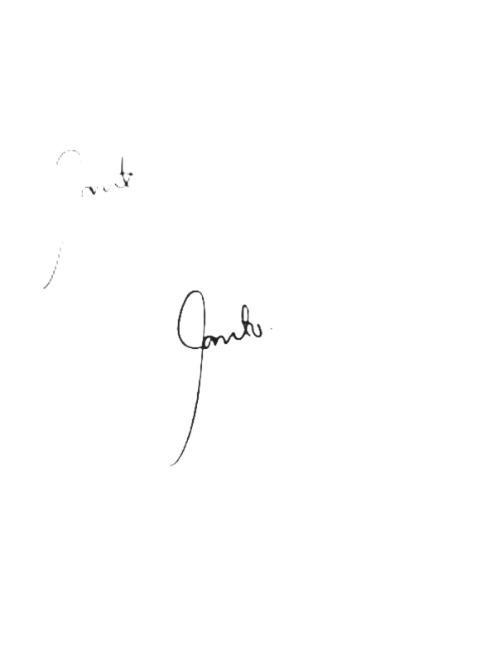

**Carpel Sweet Dreams B. Lanto Jun Romar M. De Torres Princes M. Reig**

Group Representative Group Representative Group Representative

Noted by:

**Dezza Marie Magsino**

Capstone Project Instructor



Approved:

**Pelita B. Lanto**

(Representative of Cong. PA UMALI for 2nd District)

**Toni Rose B. Lasic**

(Representative of A Teacher Party List Cong. Ma. Victoria "Bing" Umali)

**Features:**

* Medical assistance- give assistance to the person for the deduction for the bill that will approve by the client of Batasang Panlalawigan by giving a guarantee letter.
* Funeral Assistance - help the client by giving financial assistance.
* Can upload the requirements by client for safety and organize (Printable Copy)
* Automatic Endorsement Letter - for Funeral, Hospital, Medicine, Laboratory and transportation assistance for DSWD that send via email.
* Automatic SMS notification - for Hospital with information of the client.
* Admin and staff user account
* Weekly, Monthly, Semi-Annual, Annual Report that can send via email
* Daily Logbook
* Organize Documents
* Separate Panel for the Two Clients
* File Tagging System – Arranging the files and folders by category, manage individual or group files such as special office documents and record and, administering a system that handles a data and records with similar information.
* Data Analytics- demographics of a client/patient, database illustration of patient illness, request assistance, location and condition.
* Recommendation System- seeks to predict the classification or the preference of a client and the system automatically conclude the clients’ preferences by monitoring the clients record and letter request.