JoeMichael Rios

Assignment 05

Foundations of Programming

2020 – Feb – 27

CD Inventory with Dictionary

# Introduction:

This assignment was an improvement from the last one, building off of it with dictionary data storage, replacing the list format. The script allows one to add their cd data, save it to a text file, load the data from the text file, and finally delete it.

# Topic:

In this assignment we changed to list data storage into a dictionary data, using {} the dictionary can store data using key and values which are interconnected to one another. The adding function which contains the input for the dictionary as well as the list table that the dictionary is assigned to, contains the .append feature which adds to the dictionary each time the user inputs data. We can also see the strID being converted into an integer, as these inputs are composed of numbers. The inventory feature is not much different from the last assignment’s, but the loading and deleting data feature is new. While the loading data may be similar on the surface to the last assignment, the subliminal features of the code is not so. I found myself struggling with dicRow, when I tried to alleviate one part, another problem would come up. I tried to use the structure that Dirk showed us, but it will get the invalid literal for int at base 10 error, if I changed int(data[0]) to a string, there would be an issue with the index. The deleting function gave me more problems then the last, I understand what he is trying to say when he explains the code structure, but I cannot seem to get it to work.

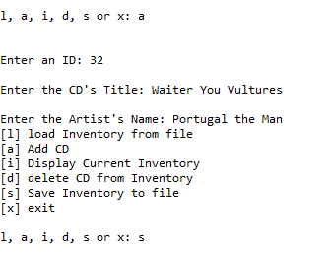

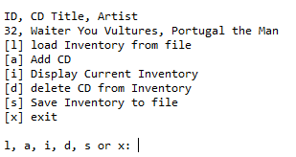

Listing 1 – Script utilizing saving and listing features in Spyder

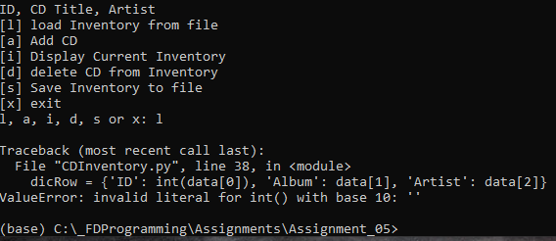

Listing 2 – Script giving invalid literal for int when loading function is used

# Summary:

This assignment was very difficult for me, I put in a lot more studying time this week then any other, while dealing with outside issues. I did have some fun with it, but I am disappointed that the concept still escapes me. Once more I believe that I am not understanding the previous concepts completely, which makes it difficult to catch up. I found this module to be the most interesting so far, and I will continue to study an experiment, that is all I can really do.

# Appendix:

[file:///C:/_FDProgramming/Modules/Mod_05/FDN_Py_Module_05.pdf](C://_FDProgramming/Modules/Mod_05/FDN_Py_Module_05.pdf) - Dirk Biesinger, module 05 page

<https://washington.zoom.us/rec/play/78Ylcev8rD83HtLGswSDVPV9W9W7f6us0SRLr_Rfzh63ASYLZAXyZLEXN7RCtu5dLA09uS8mJF8GGqos?continueMode=true> – Dirk Biesinger, IT FDN 100 B weekly classroom